Washing Mashines production

 | Double-tank washing machine 6.5 kg | Single-tank washing machine 6 kg | Mini washing machine 2,5 kg
 | 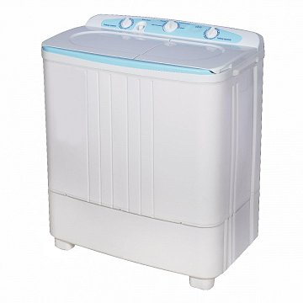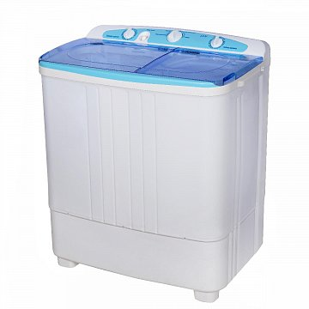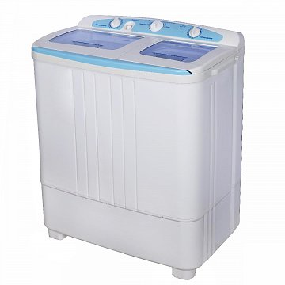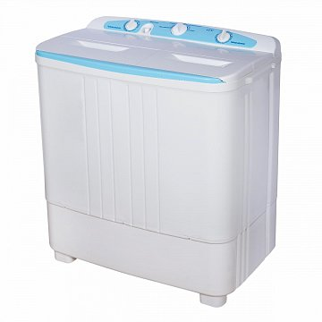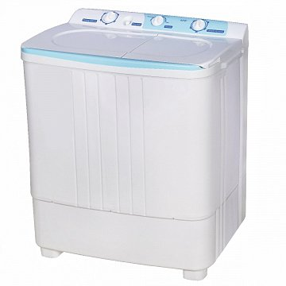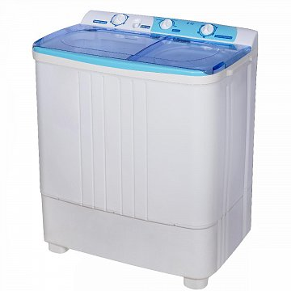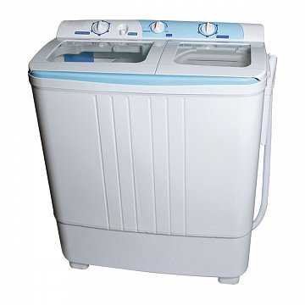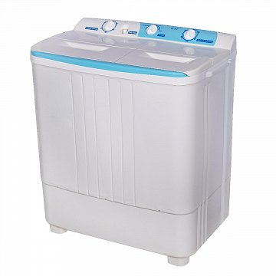 | 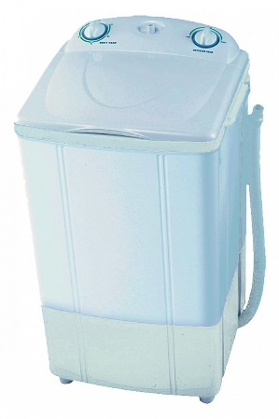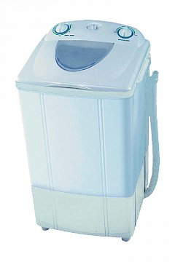 | 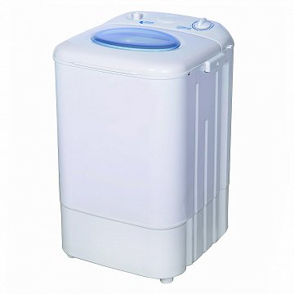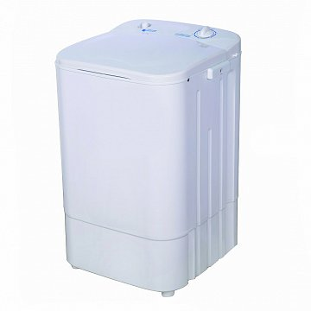
Models | ST-WK7601, 7602, 7603, 7605,7606, 7618 7613 7614 | ST-WK7600, 7607, 7616, 7617 | ST-WK1615, 1616
Maximum loading capacity, kg | 6,5 | 6 | 2,5
Maximum centrifuge load, kg | 3 | ─ | ─
Type of loading | Vertical | Vertical | Vertical
Type by functionality | Semi-automatic | Semi-automatic | Semi-automatic
Controls | Manual, mechanical | Manual, mechanical | Manual, mechanical
Type of motor | asynchronous | asynchronous | asynchronous
Washing drive | belt with gearbox | belt with gearbox | belt
Activator drive | direct | ─ | ─
Water heating | not available | not available | not available
Drying (condensation, ventilation) | not available | not available | not available
Energy consumption class | A+++ | A+++ | A+++
Washing noise level | 52 dB. | 52 dB.
Spinning noise level | 59 dB. | ─ | ─
Washing power , kW | 0,36 | 0,36 | 0,2
Spinning capacity , kW | 0,16 | ─ | ─
Water consumption per year , l | 18 700 | 17 200
Electricity consumption per year, kW | 20,70 | 16,10
Water consumption per cycle, l | Min: 70, Max: 120 | Min: 70, Max: 120 | Min: 30, Max: 70
Installation method | solo | solo | solo
Maximum spin speed, r/min | 1300 | ─ | ─
The presence of a pump | + | ─ | ─
Availability of a drain valve | + | only 7600, 7607 models | ─
Washing timer | 15 min | 15 min | 15 min
Centrifuge timer | 5 min | ─ | ─
Material of the tank | plastic | plastic | plastic
Maximum water temperature | 60° С | 60° С | 60° С
Operating voltage | 220-230 V., 50 Hz | 220-230 V., 50 Hz | 220-230 V., 50 Hz
Weight (± 0.2 kg) , kg | Brutto : 21 / Netto : 19 | Brutto : 13 / Netto : 12 | Brutto : 7 / Netto : 6,1
Product dimensions (LxWxH), cm | 77,5 х 43,5 х 86,5 | 48,0 х 44,0 х 84,0 | 44,0 х 36,0 х 66,0
Package dimensionsі (LxWxH), cm | 79,0 х 46,0 х 88,5 | 51,0 х 47,0 х 88,0 | 41,5 х 39,5 х 67,0

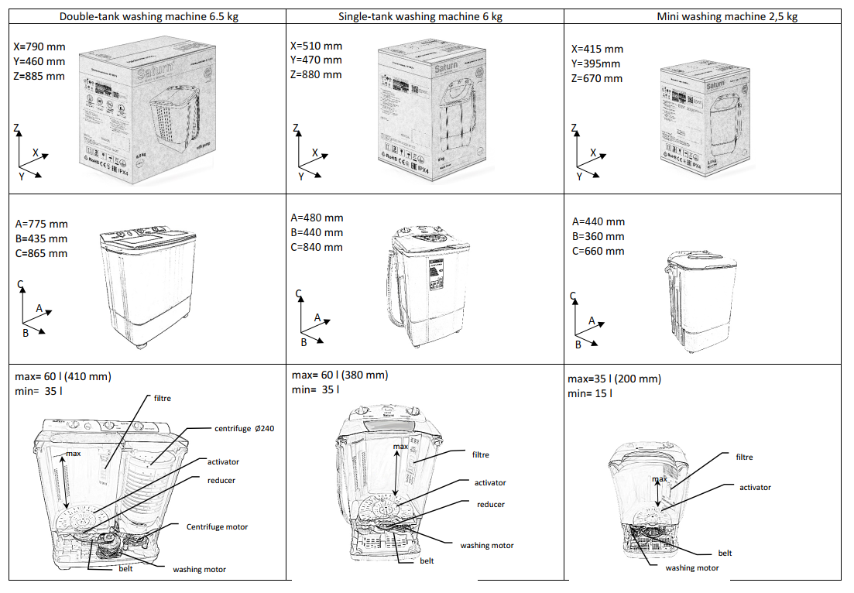

Injection molding equipment

Manufacture | Model | Type | Clamp  Tonnage, kN | Quantity, pcs.
HAITIAN | HTF86X | Horizontal | 860 | 6
HAITIAN | MA1200/G | Horizontal | 1200 | 1
HAITIAN | HTF160X | Horizontal | 1600 | 3
HAITIAN | HTF360X | Horizontal | 3600 | 4
HAITIAN | MA3800II/e | Horizontal | 3800 | 1
HAITIAN | HTF650X | Horizontal | 6500 | 2
HAITIAN | HTF1000X | Horizontal | 10000 | 1
HAITIAN | HTF1600X | Horizontal | 16000 | 1
JINTONG | JT850 | Vertical | 850 | 1

Manufacture | HAITIAN
Model | HTF86X
Photo front side | 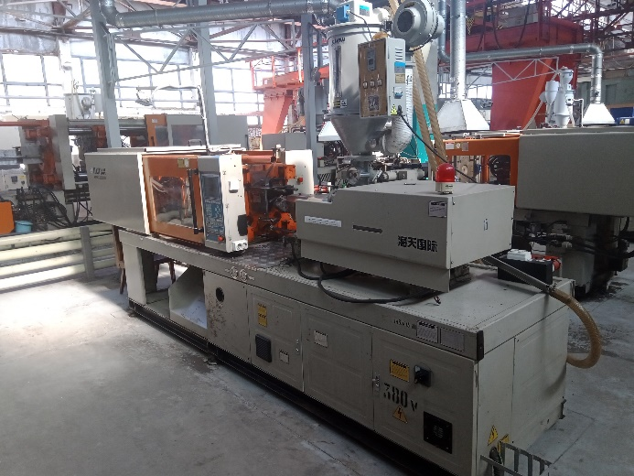
Photo back side | 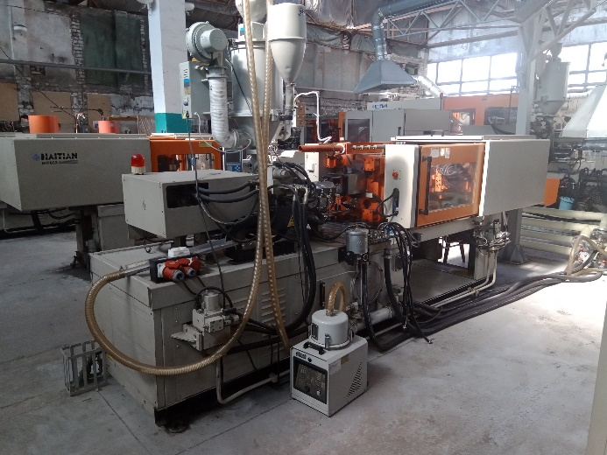
Quantity, pcs. | 6
Clamp Tonnage, KN | 860
Date | 2007
Calculated Injection volume, cm³ | 131, 147
Model Screw | A-D34, B-D36
Injection Pressure, MPa | 206, 183
Injection Stroke, mm | 144
Ejector Stroke, mm | 100
Power, KW | 19,2
Voltage | 380V, 50Hz
Space Between Tie Bar (HxV), mm | 360x360
Die-Height Available (min-max) | 150-360
Screw speed, r/min | 0-240
Dimension (LxWxH), m (without dryer) | 4,5x1,25x1,9
Weight, t | 3,45
Dryer* | SHINI SHD-25TM

Manufacture | HAITIAN
Model | MA1200/G
Photo front side | 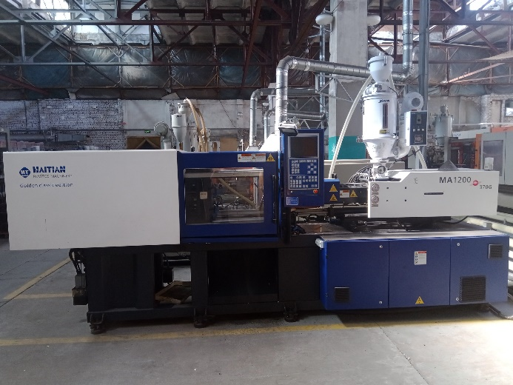
Photo back side | 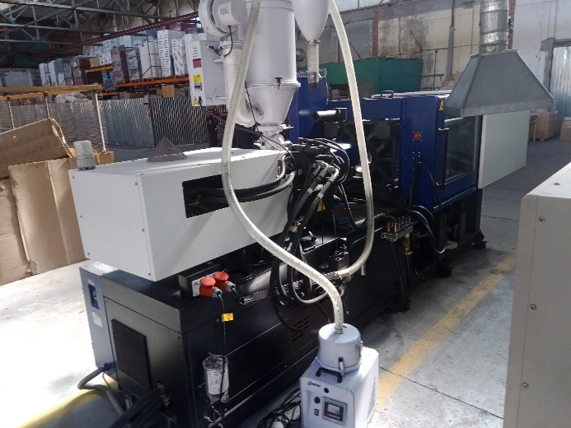
Quantity, pcs. | 1
Clamp Tonnage, KN | 1 200
Date | 2007
Calculated Injection volume, cm³ | 214
Model Screw | B-D40
Injection Pressure, MPa | 171
Injection Stroke, mm | 170
Ejector Stroke, mm | 120
Power, KW | 23
Voltage | 380V, 50Hz
Space Between Tie Bar (HxV), mm | 410x410
Die-Height Available (min-max) | 150-430
Screw speed, r/min | 0-190
Dimension (LxWxH), m (without dryer) | 4,82x1,26x1,98
Weight, t | 4,1
Dryer* | SHINI SHD-25TM

Manufacture | HAITIAN
Model | HTF160X
Photo front side | 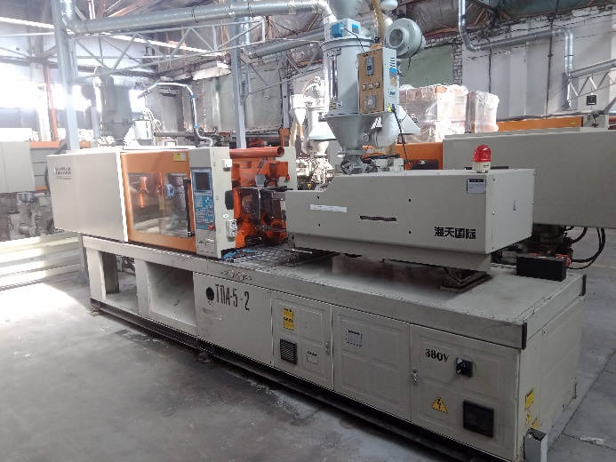
Photo back side | 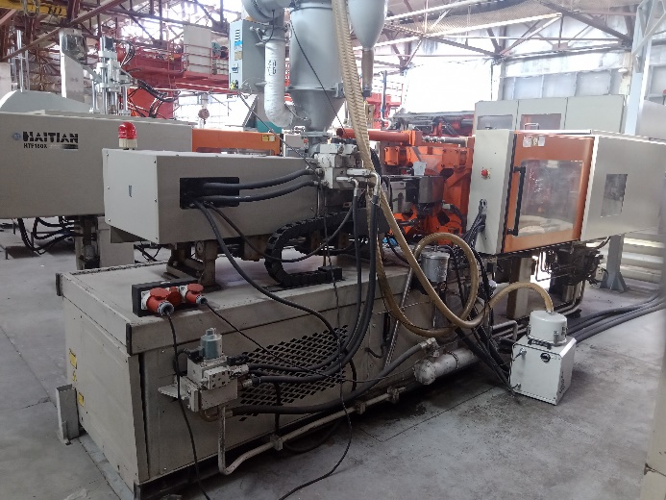
Quantity, pcs. | 3
Clamp Tonnage, KN | 1 600
Date | 2007
Calculated Injection volume, cm³ | 320
Model Screw | B-D45
Injection Pressure, MPa | 159
Injection Stroke, mm | 201
Ejector Stroke, mm | 140
Power, KW | 28,25
Voltage | 380V, 50Hz
Space Between Tie Bar (HxV), mm | 455x455
Die-Height Available (min-max) | 180-500
Screw speed, r/min | 0-230
Dimension (LxWxH), m (without dryer) | 5,4x1,45x2,05
Weight, t | 5
Dryer* | SHINI SHD-25TM

Manufacture | HAITIAN
Model | HTF360X
Photo front side | 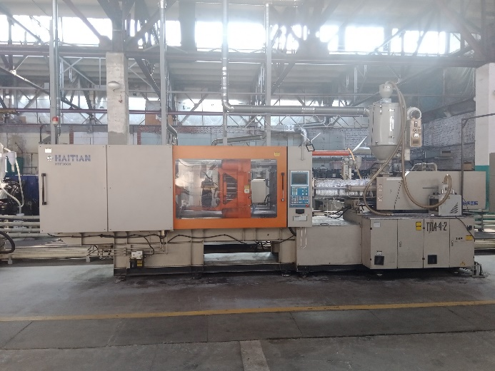
Photo back side | 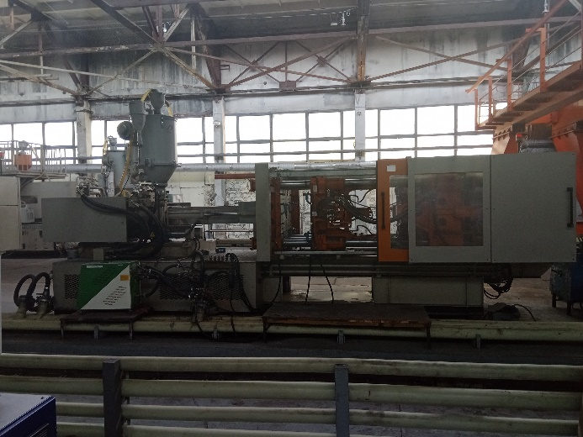
Quantity, pcs. | 4
Clamp Tonnage, KN | 3 600
Date | 2007
Calculated Injection volume, cm³ | 1068, 1239
Model Screw | A-D65, B-D70
Injection Pressure, MPa | 208, 180
Injection Stroke, mm | 322
Ejector Stroke, mm | 110
Power, KW | 61,85
Voltage | 380V, 50Hz
Space Between Tie Bar (HxV), mm | 710x710
Die-Height Available (min-max) | 250-710
Screw speed, r/min | 0-180
Dimension (LxWxH), m (without dryer) | 7,6x2,1x2,5
Weight, t | 15
Dryer* | SHINI SHD-100TM

Manufacture | HAITIAN
Model | MA3800II/e
Photo front side | 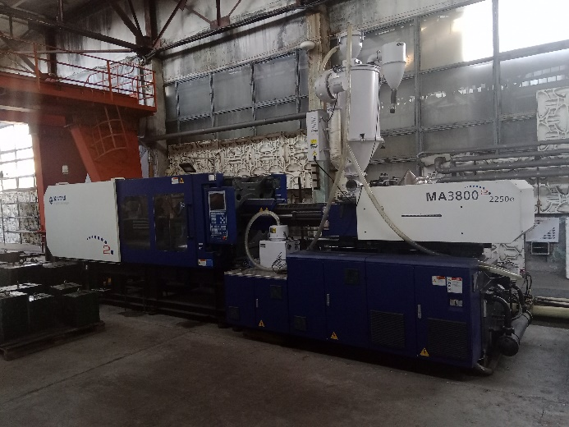
Photo back side | 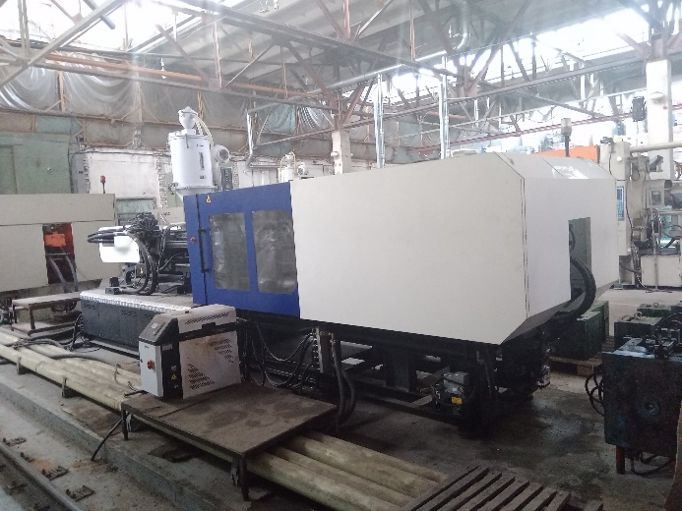
Quantity, pcs. | 1
Clamp Tonnage, KN | 3 800
Date | 2007
Calculated Injection volume, cm³ | 1239
Model Screw | B-D70
Injection Pressure, MPa | 182
Injection Stroke, mm | 322
Ejector Stroke, mm | 180
Power, KW | 70
Voltage | 380V, 50Hz
Space Between Tie Bar (HxV), mm | 730x730
Die-Height Available (min-max) | 280-730
Screw speed, r/min | 0-190
Dimension (LxWxH), m (without dryer) | 7,5x1,8x2,5
Weight, t | 15
Dryer* | SHINI SHD-100TM

Manufacture | HAITIAN
Model | HTF650X
Photo front side | 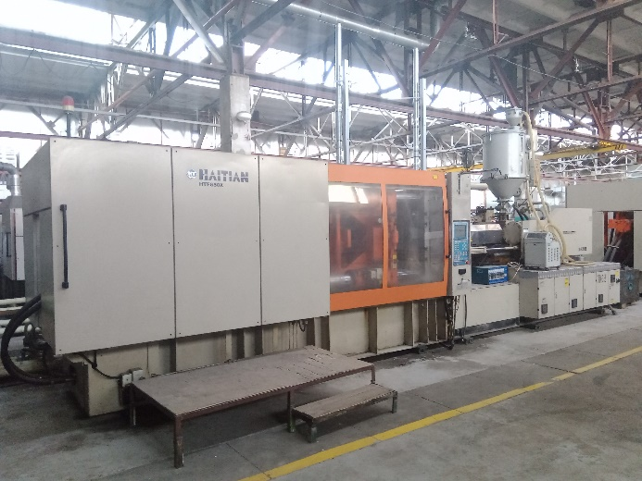
Photo back side | 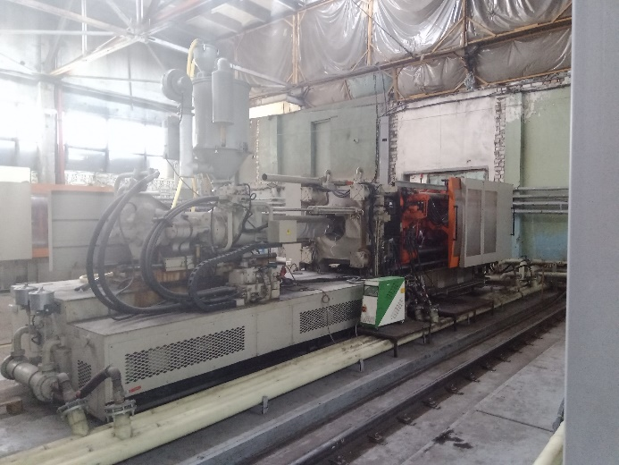
Quantity, pcs. | 2
Clamp Tonnage, KN | 6 500
Date | 2007
Calculated Injection volume, cm³ | 2576
Model Screw | B-D90
Injection Pressure, MPa | 177
Injection Stroke, mm | 405
Ejector Stroke, mm | 260
Power, KW | 109,25
Voltage | 380V, 50Hz
Space Between Tie Bar (HxV), mm | 895x895
Die-Height Available (min-max) | 400-900
Screw speed, r/min | 0-125
Dimension (LxWxH), m (without dryer) | 9,4x2,4x2,8
Weight, t | 31,3
Dryer* | SHINI SHD-200TM

Manufacture | HAITIAN
Model | HTF1000X
Photo front side | 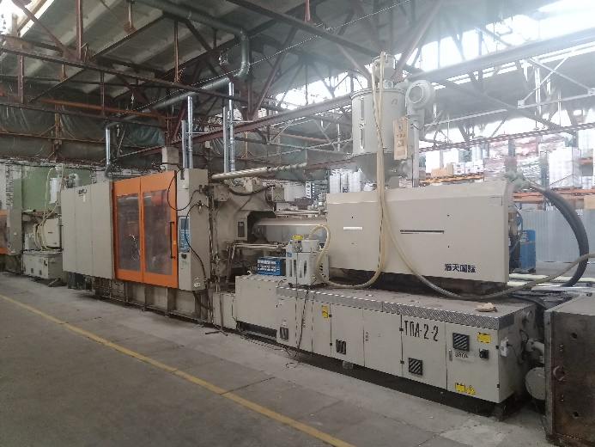
Photo back side | 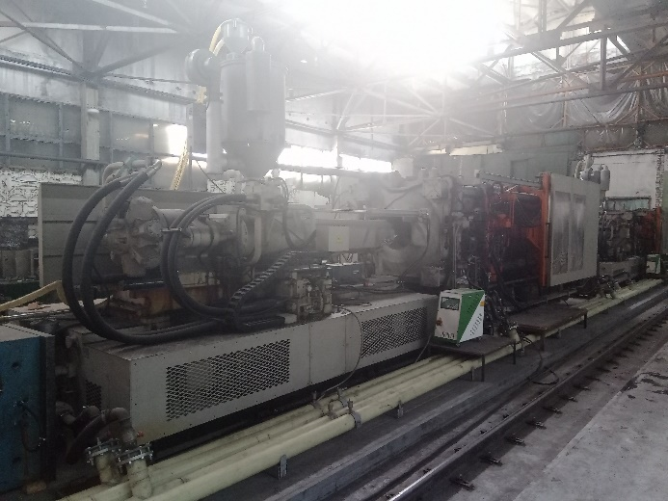
Quantity, pcs. | 1
Clamp Tonnage, KN | 10 000
Date | 2007
Calculated Injection volume, cm³ | 4562
Model Screw | B-D110
Injection Pressure, MPa | 174
Injection Stroke, mm | 480
Ejector Stroke, mm | 320
Power, KW | 158,75
Voltage | 380V, 50Hz
Space Between Tie Bar (HxV), mm | 1090x1090
Die-Height Available (min-max) | 500-1100
Screw speed, r/min | 0-110
Dimension (LxWxH), m (without dryer) | 11,5x2,8x4,0
Weight, t | 49
Dryer* | SHINI SHD-200TM

Manufacture | HAITIAN
Model | HTF1600X
Photo front side | 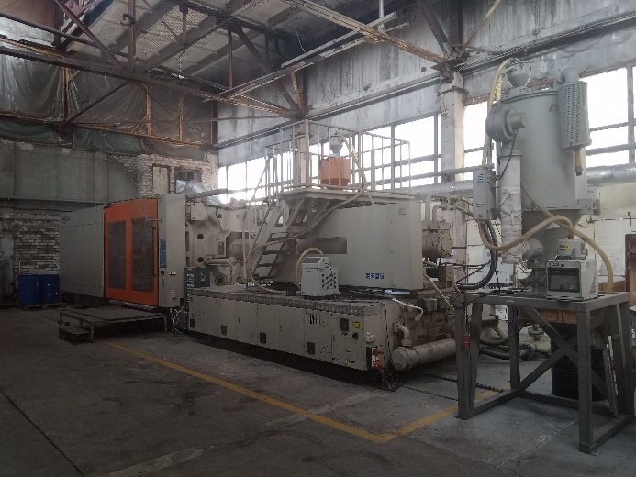
Photo back side | 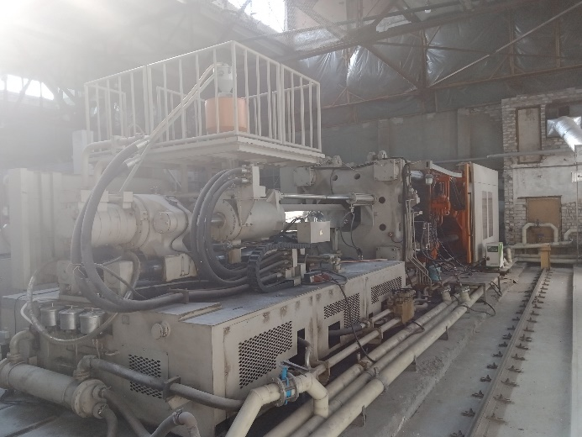
Quantity, pcs. | 1
Clamp Tonnage, KN | 16 000
Date | 2007
Calculated Injection volume, cm³ | 9067
Model Screw | B-D140
Injection Pressure, MPa | 142
Injection Stroke, mm | 590
Ejector Stroke, mm | 350
Power, KW | 230,05
Voltage | 380V, 50Hz
Space Between Tie Bar (HxV), mm | 1500x1350
Die-Height Available (min-max) | 700-1400
Screw speed, r/min | 0-99
Dimension (LxWxH), m (without dryer) | 14,4x3,5x4,2
Weight, t | 100
Dryer* | SHINI SHD-400TM

Manufacture | JINTONG
Model | JT850
Photo front side | 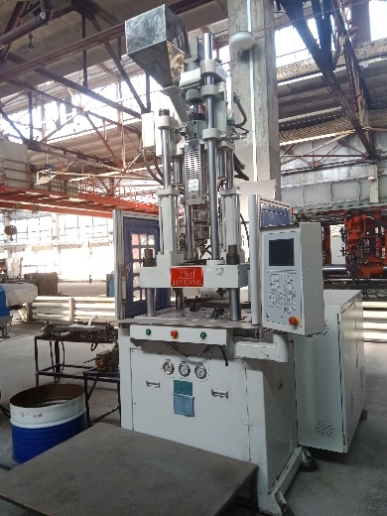
Photo back side | 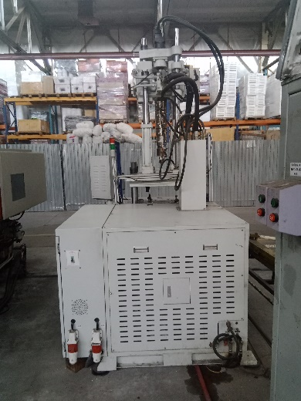
Quantity, pcs. | 1
Clamp Tonnage, KN | 850
Date | 2017
Calculated Injection volume, cm³ | 239
Model Screw | D40
Injection Pressure, MPa | 175
Injection Stroke, mm | 145
Ejector Stroke, mm | 75
Power, KW | 25
Voltage | 380V, 50Hz
Space Between Tie Bar (HxV), mm | 560x320
Min Mold Height, mm | 250/200
Mold dimension | 500x350
Screw speed, r/min | 0-197
Dimension (LxWxH), m (without dryer) | 1,8x1,3x3
Weight, t | 4,5

Dryers for thermoplast automat
Manufacture | SHINI | SHINI | SHINI | SHINI
Model | SHD-25TM | SHD-100TM | SHD-200TM | SHD-400TM
Drawing | 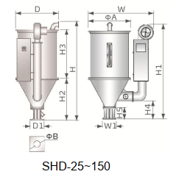 |  | 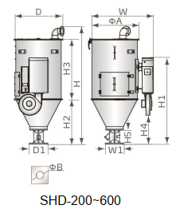
Quantity, pcs. | 8 | 4 | 3 | 1
*application for thermoplast automat | HTF86X,  MA1200/G,  HTF160X | HTF360X,  MA3800 | HTF650X,  HTF1000X | HTF1600X
Power, KW | 2,8-3,1 | 6
Loading Capacity, kg | 25 | 100 | 200 | 400
H (mm) | 1015 | 1340 | 1580 | 2170
D (mm) | 405 | 605 | 770 | 915
D1 (mm) | 158 | 238 | 238 | 345
ɸA (mm) | 385 | 595 | 750 | 910
ɸB (mm) | 55 | 90 | 90 | 105
Weight, kg | 40 | 70 | 100 | 165
Photo | 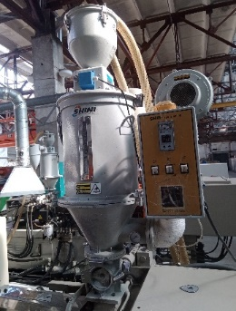 | 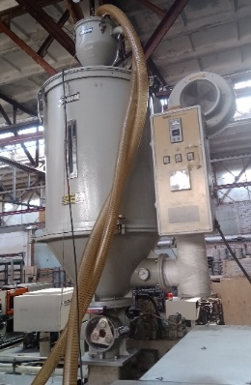 | 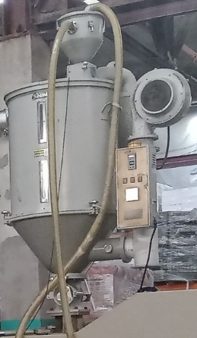 | 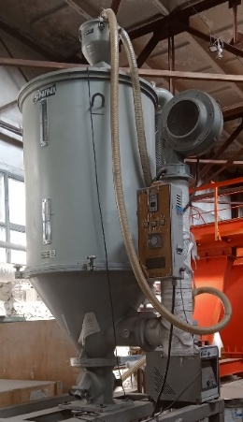

Thermocontrollers

Manufacture | Model | Q-ty | Photo | Year | Power, kW | Weight | Dimensions, cm
Green Box | TBS/4,5/W | 1 | 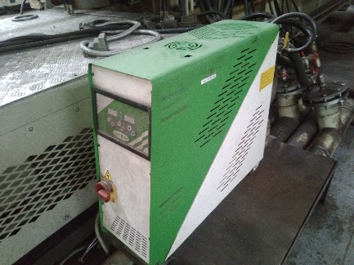 | 2007 | 4.5 | 57 | 70x24x65
Green Box | TB-M 9W HP1 | 1 | 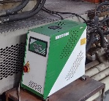 | 2009 | 9.9 | 65 | 70x30x65
Green Box | TB-M/9/W-HP | 1 | 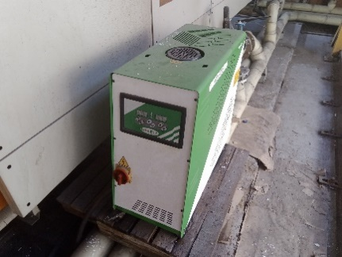 | 2010 | 9.9 | 65 | 70x30x65
Green Box | TB-M/12/W-HP | 1 | 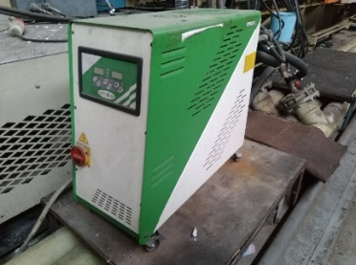 | 2009 | 12.6 | 60 | 70x30x65
SHINI | STM-910-0 | 1 | 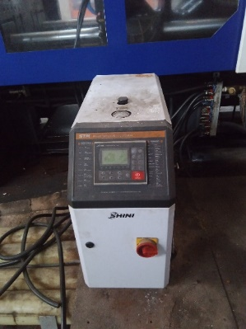 | 2017 | 9.75 | 70 | 63,5x32x74
Prom Service | PT-10627-B | 3 | 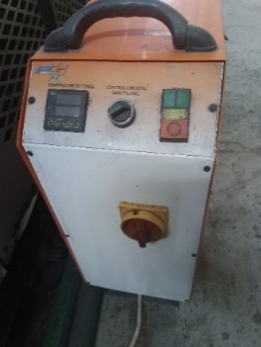 | 2009 | 12.6 | 60 | 70x30x65

Chillers

Manufacture | Green Box | Green Box
Model | FC600W | Multi 121
Type | Dry chiller (Free-cooler) | Chiller
Dimensions (m) | 8,85x1,18x1,75 | 5,6x2,1x2,1
Weight | 1,5/1,85 | 3,95
Power total | 23,6kW
Ventilarors power | MV 6x2kW
Pumps power | MP 2x11kW
Tank capacity (l) |  | 1200
Cooling capacity |  | 346000 kcal/h (404kW)
Copmressor power |  | 4x17,6kW
Axial fan motor power |  | 12x0,75kW
Axial fan motor air flow m³/h |  | 99.200
Nominal fan power |  | 94,5kW
Pump power |  | 11kW
Flow-rate, m3/h |  | 0-132
pressure, bar |  | 3,9-2,3
Photo | 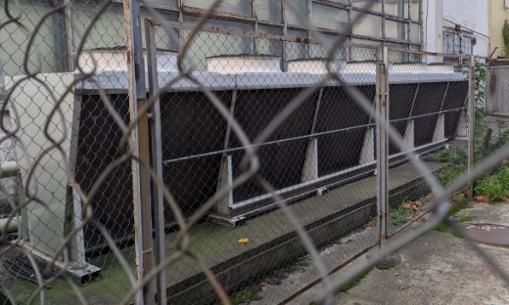 | 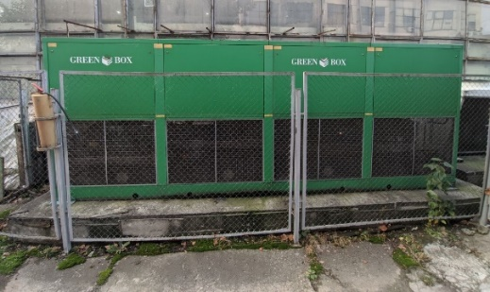
Photo | 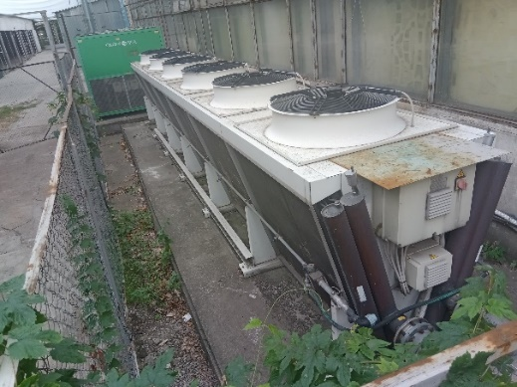 | 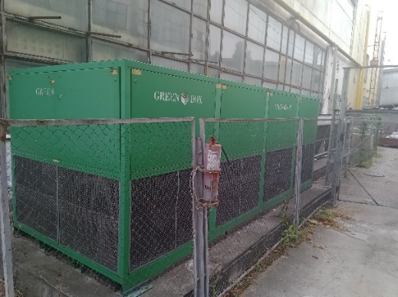
Photo | 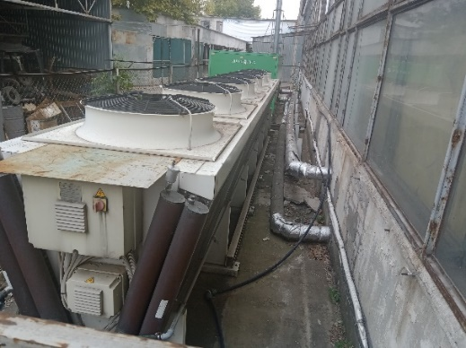 | 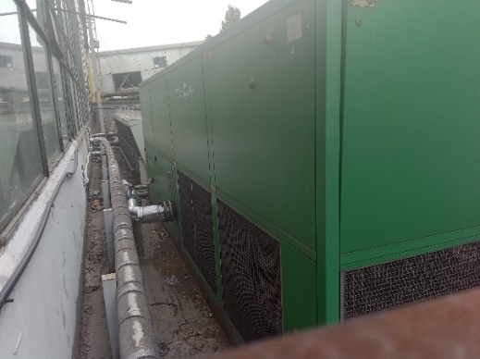

Crane

Manufacture | Henan Tieshan Hoisting Equipment Co. Ltd, China
Model | MG 20/5-13
Type | electric gantry crane
Control | remote
Year | 2007
Load capacity, main, t | 20
Lifting speed main, m/min | 5,8
Load capacity, auxiary, t | 5
Lifting speed auxiary, m/min | 12,16
Lifting height main/auxiary, m | 3,2/4
Length, m | 15,06
Span, m | 13
Width, m | 5,645
Height, m | 6,15
Weight, t | 21,95
Voltage | 380V, 50Hz
Power | 64kW
