Equipment for the production of domestic refrigerators and freezers
Equipment | Вартість, €
Casing production line | 713420
Machine for vacuum forming of the inner panel of the door with automatic feeding | 171175
The machine for vacuum forming the inner panel of the door | 133012
Camera vacuum forming machine | 753474
Sheet extrusion line | 520021
Line 8-position foaming of cases with polyurethane foam | 1137908
The machine is 8-position door foaming with polyurethane foam | 384645
The line for the production of the outer door panel | 528233
The production line of the lower bar | 208941
Medium bar production line | 196099
Line of transverse metal cutting | 302143
Line of longitudinal cutting of metal | 193781
Condenser tube cutting and bending line | 27230
3 pcs. pipe flaring installations. | 7529
Installation of pneumatic gluing of the evaporator | 41523
Two-position pneumohydraulic thermopress | 50393
Tube cutting line | 15766
Pneumohydraulic press | 45158
Roll laminator | 39209
Tube rolling installations 2 pcs. | 11616
Electromechanical guillotine scissors | 1715
Machine for winding heat exchangers | 57065
Automatic binding machine | 13861
Installation of pneumatic punching of holes and grooves in the chamber | 11295
Installation of guillotine trimming of HP cameras | 69541
Station for vacuuming and refueling with refrigerant HP | 185529
HP assembly line (conveyors) | 266234
Cyclopentane station | 55430
Station for mixing PPU components | 428779
Machines for molding plastics under pressure (thermoplastic machines) 4 pcs. | 362517
Vibrostand | 119128
Helium refueling and recovery station | 165034
Refrigeration testing station | 608094
Shredders for plastic 2 pcs. | 18183
Installation of hydraulic crimping of high-pressure hoses | 16702
The stationary air compressor station | 47271
The nitrogen station is stationary | 72649
Small-sized fan cooling tower ГМВ-60 | 26647
Machine for butt welding of copper and aluminum tubes UN3 | 10917
Installation of soldering tubes DH-25KW 3 pcs. | 41263
Vacuum forms of cameras 9 pcs. | 195335
Vacuum forms of door panels 9 pcs. | 154153
Punches for filling cabinets 9 pcs. | 89079
Forms of filling doors 9 pcs. | 91842
Stamps 22 pcs. | 198000
Forms for casting plastics 45 pcs. | 462768
Total | 9250307

CONTENTS
ENCLOSURE PRODUCTION LINE 4
VACUUM FORMING MACHINE FOR INNER DOOR PANEL WITH AUTOMATIC FEEDING 7
VACUUM FORMING MACHINE FOR INNER DOOR PANEL 10
CHAMBER VACUUM FORMING MACHINE 13
SHEET EXTRUSION LINE 17
8-POSITION LINE FOR FOAMING CASES WITH POLYURETHANE FOAM 22
МАШИНА 8-ПОЗИЦІЙНА ЗАПІНЕННЯ ДВЕРЕЙ ПІНОПОЛІУРЕТАНОМ 26
DOOR EXTERIOR PANEL MANUFACTURING LINE 29
BOTTOM BAR PRODUCTION LINE 32
PRODUCTION LINE OF THE MIDDLE BAR 35
CROSS-CUTTING LINE FOR METAL 38
LONGITUDINAL METAL CUTTING LINE 41
CUTTING AND BENDING LINE FOR CONDENSER TUBES 44
INSTALLATION OF FLARING TUBES 46
INSTALLATION OF PNEUMATIC GLUING OF THE EVAPORATOR 49
PNEUMATIC-HYDRAULIC TWO-POSITION HEAT PRESS 51
TUBE CUTTING LINE 53
PNEUMOHYDRAULIC PRESS 55
ROLL LAMINATOR 57
INSTALLATION OF TUBE ROLLING 60
ELECTROMECHANICAL GUILLOTINE SCISSORS Q11 62
HEAT EXCHANGER WINDING MACHINE 65
AUTOMATIC STRAPPING MACHINE 68
INSTALLATION OF PNEUMATIC PUNCHING OF HOLES AND GROOVES IN THE CHAMBER 70
INSTALLATION OF GUILLOTINE TRIMMING OF HP CAMERAS 72
VACUUM AND REFRIGERANT CHARGING STATION 74
CONVEYOR LINE (CONVEYORS) FOR ASSEMBLY 77
CYCLOPENTANE STATION 81
MIXING STATION FOR THE COMPONENTS OF THE PUMPING STATION 84
PLASTIC INJECTION MOLDING MACHINE 88
VIBRATING BENCH IRA60H/LS437A 93
INCLINED BELT CONVEYOR 95
HELIUM REFUELING AND RECOVERY STATION EQL-IN-12 97
TESTING STATION FOR REFRIGERATION DEVICES 100
CRUSHER FOR PLASTIC LH-300 106
INSTALLATION FOR HYDRAULIC CRIMPING OF HIGH-PRESSURE HOSES CDX-90 108
STATIONARY AIR COMPRESSOR STATION 110
STATIONARY NITROGEN STATION LCN-40 115
MACHINE FOR BUTT WELDING OF COPPER AND ALUMINUM TUBES UN3 122
INSTALLATION OF SOLDERING TUBES DH-25KW 3 PCS. 123

ENCLOSURE PRODUCTION LINE

Technical characteristics
The line is designed for the manufacture of refrigeration enclosures with a model range width of 550 and 600 mm, from a special steel sheet with a thickness of 0.5 mm. The main parameters of the cases manufactured on this line are given in Table 1.1, and the main characteristics of the line are given in Table 1.2.

Table 1.1 - Main parameters of manufactured enclosures
Parameter | Models XP 550, mm | Models XP 600, mm
Height, mm | min 989 / max 1610 | min 1713 / max 1973
Depth, mm | 512 | 562
Width, mm | 550 | 600
Workpiece, steel sheet RSM 0.5 mm | min 2224 x 630 mm | max 4586 x 679 mm

Table 1.2 - Main characteristics of the line
Technical characteristics of the line | Dimensional characteristics
Overall dimensions (length x width x height, mm) | 59660 x 2824 x 2600
Number of electric motors, pcs. | 10
Rated supply voltage, V | 380 (three-phase, variable)
Frequency, Hz | 50...60
Line readiness time, after switching on the GHS, min. | 5...10
Line productivity, units/hour
Number of GHS, pcs. | 2
Method of controlling the LPG | The control panel
Volume of oil of the hydraulic oil pump 1/2, l | 950 / 140
Number of stamps, pcs. | 14 (punching) + 1 (bending)
Temperature mode of line operation, ºС | +5...+50
Working pressure in pneumatic lines, MPa | 0,5...0,6
Working pressure in hydraulic lines, MPa | 16...21
Cooling of the hydraulic system | Water
Type of line | Stationary
Type of control of main technological parameters | Automatic
Method of controlling the main technological parameters | Control panel
Number of lubrication points (CPS) | 50
Number of centralized lubrication systems (pumps) | 4
Type of control of the centralized lubrication pump | Manual
Oil for the centralized lubrication system | UNIOL-2M-2
Compressed air for pneumatic systems | With 40 micron filtration with or without oil
Mineral hydraulic oil for hydraulic systems | MGE46-B
Mineral oil viscosity, cSt | 40...50
Oil purity class according to GOST 17216-81 | not coarser than 12
Presence of water and acids in the oil | Absence of
Filtration of oil before pouring into the tank | Particles with a diameter of more than 0.025...0.04 mm
Oil temperature during operation, ºС | +10...+50
Temperature regime of compressed air during operation, ºС | +5...+50
Number of operating personnel, persons / shift | 3
Dimensional accuracy, in the manufacture of housings, mm | ±1
Total power of electric motors of the line, kW | 45.8+GNS(18.5+5.5)= 69.8

Composition of the line
The line is built on a modular basis. The line is used to glue capacitors to the shell walls using aluminum adhesive tape.
The line consists of (Fig. 1.1):
- a loading position with vacuum grippers (automatic feeding of blanks made of special steel sheet, 0.5 mm thick), item 1;
- two 1/2 HPC, with water cooling of the working fluid, items 2 and 3;
- automatic line of cold sheet punching dies for punching holes, grooves, contours in the shell, item 4;
- automatic reloading position with a roller conveyor item 5;
- control panel item 6;
- automatic line for bending the shell shelves, item 7;
- automatic line for gluing capacitors to the shell walls using aluminum adhesive tape item 8;
- automatic line for bending the shell walls of item 9 (production of the finished part - the housing);
- automatic line of cold sheet stamping dies for punching holes for the upper hinges pos.10.

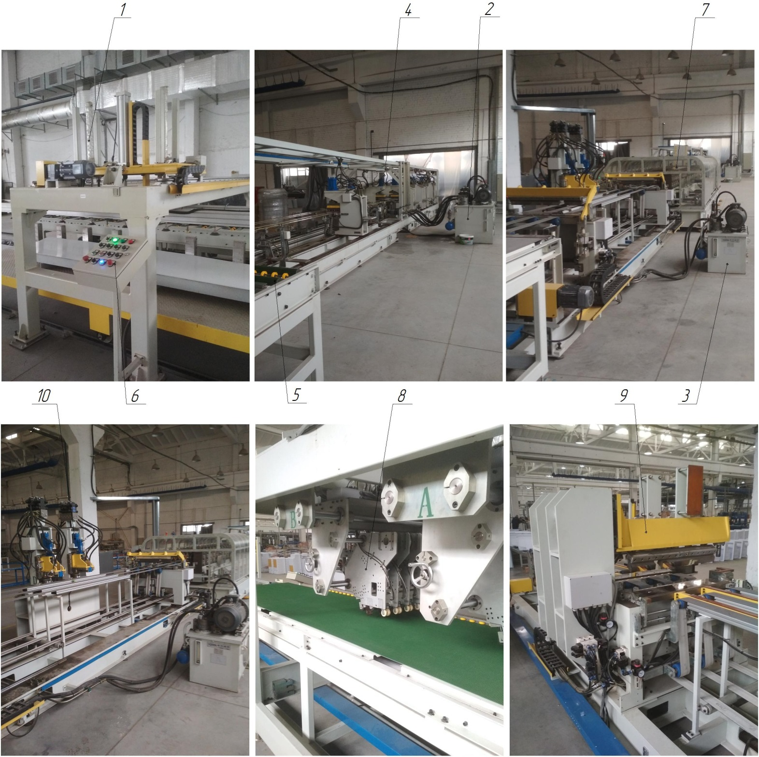

Figure 1.1 - Composition of the enclosure production line: 1 - loading position; 2 and 3 - GHS; 4 - punching line; 5 - reloading position; 6 - control panel; 7 - bending line; 8 - line for gluing capacitors to the shell walls; 9 - line for bending the shell walls; 10 - automatic punching line for punching holes for the upper hinges

VACUUM FORMING MACHINE FOR INNER DOOR PANEL WITH AUTOMATIC FEEDING

Technical characteristics
The VF machine is designed for the production of inner panels of MK and HC doors of refrigerators with automatic feeding of blanks (extruded polystyrene sheets with a thickness of 1.2 mm) by vacuum forming. The main parameters of MK and HC door inner panels manufactured on this VF machine are given in Table 1.1, and the main characteristics of the VF machine are given in Table 1.2.
Table 1.1 - Main parameters of MK and HC door interior panels produced by vacuum forming
Parameter | HC, mm | MK, mm
Height, mm | min 787 / max 1267 | min 357 / max 1343
Depth, mm | min 69 / max 75 | min 35 / max 44
Width, mm | min 538 / max 587 | min 538 / max 587
Workpiece, polystyrene sheet | min 959 x 709 mm / max 2012 x 766 mm

Table 1.2 - Main characteristics of the VF machine
Technical characteristics of the VF machine | Dimensional characteristics
Overall dimensions (length x width x height, mm) | 6980 x 6707 (3530) x 3900
Number of electric motors, pcs. | 6
Rated supply voltage, V | 380 (three-phase, variable)
Frequency, Hz | 50...60
Ready time of the VF machine, after switching on the HV, min. | 2...3
Productivity of the VF machine, pcs/h
Temperature mode of the VF machine, ºС | +10...+40
Working pressure in pneumatic lines, MPa | 0,4...0,6
Heating of the vacuum mold of the inner chamber panel | Water
Cooling of the vacuum mold of the inner chamber panel | Air
Type of the machine VF | Stationary
Type of control of main technological parameters | Automatic
Method of controlling the main technological parameters | Control panel
Availability of centralized lubrication systems (CPS) | Not available
Availability of a sheet loading chamber (automatic) | Present
Cooling of the inner chamber panel (parts) | Air supply.
Total power of electric motors of the VF machine, kW | 6*0.75+(HH=5.5)+(Tr=9.75) = 19.8
Compressed air for pneumatic systems | With 40 micron filtration with or without oil
Compressed air temperature during operation, ºС | +5...+50
Number of air receivers, pcs. (Q = 2.0 m3) | 1
Number of vacuum receivers, pcs. (Q = 2.0 m3)
Number of operating personnel, persons/shift | 2
Dimensional accuracy, in the manufacture of internal panels MK and HC, mm | ±1
Number of infrared quartz upper and lower emitters, pcs. | 170(w) + 170(n) = 340
Heating temperature of the sheet by means of IR, ºС | 180...200
Number of cooling centrifugal fans, pcs. | 6
Power of cooling fans, kW | 0,75
Number of thermostats for heating vacuum molds | 2

Composition of the VF machine
The VF machine is built on a modular basis. The VF machine automatically feeds the workpiece (polystyrene sheet) from the loading chamber and produces the inner panel of the doors of MK and HC refrigerators by vacuum forming.
The VF machine consists of (Fig. 1.1):
- loading chamber with automatic feeding of blanks (polystyrene sheet, 1.2 mm thick), item 1;
- control panel item 2;
- unit for vacuum forming of internal panels of MK and HC doors, item 3;
- Conveyor with vacuum grippers (suction cups) item 4 (not shown);
- lifter item 5 (not shown);
- punch of the lower form of item 6;
- lower chamber of position 7;
- upper punch of the upper form of the position 8;
- clamping frame item 9;
- middle table item 10;
- chamber of heating elements item 11;
- upper heating element item 12;
- lower heating element item 13;
- cooling unit for internal panels of MK and HK doors, item 14;
- vacuum receiver item 15;
- thermostats (2 pcs.) item 16;
- air receiver item 17;
- system of water and air supply pipelines to the lower mold punch (2 fittings - inlet, 2 fittings - outlet of water; 2 fittings - inlet, 2 fittings - outlet of air) item 18;
- skids for replacement of vacuum molds (complete), item 19;
- vacuum pump, item 20;
- system of cooling fans for internal panels of MK and HC doors, item 21;
- VF machine frame, item 22.

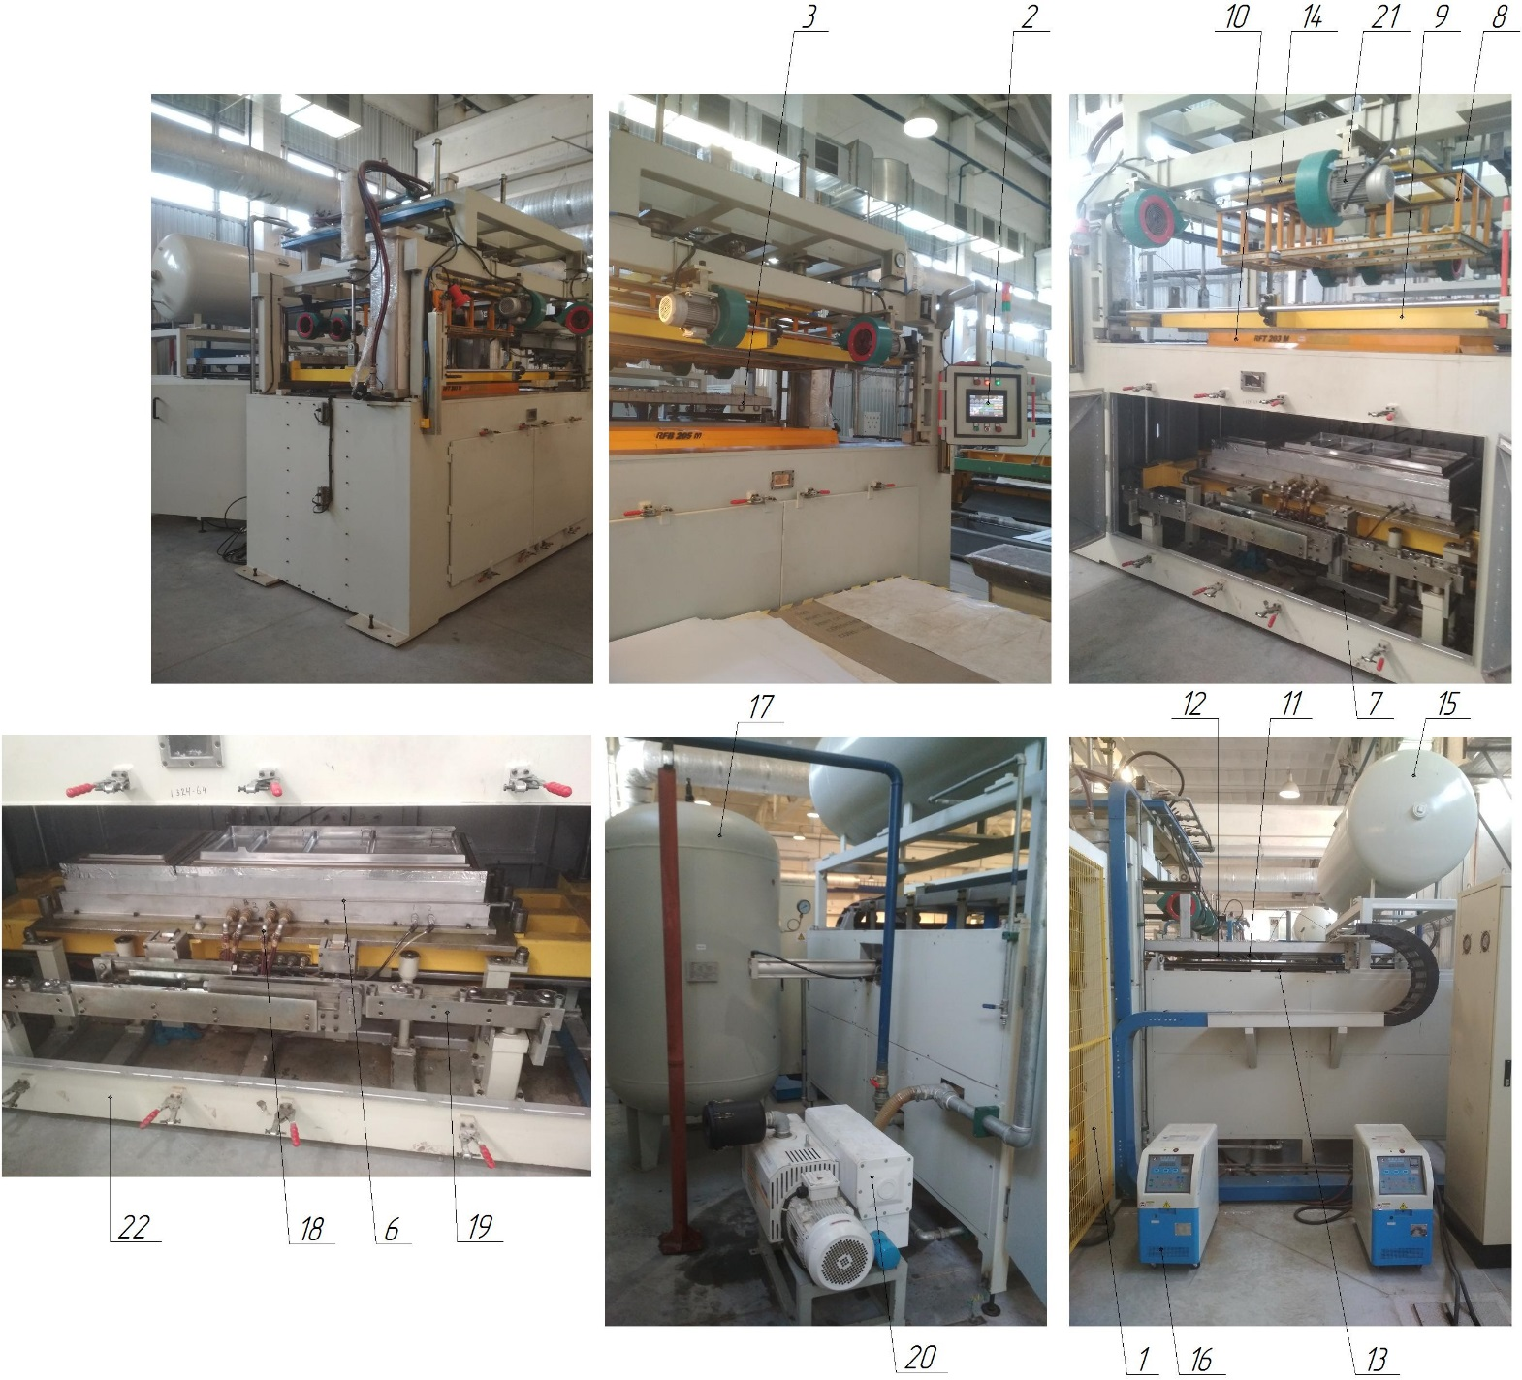

Figure 1.1 - Composition of the VF machine: 1. Loading chamber with automatic feeding of workpieces; 2. Control panel; 3. Vacuum forming unit for internal panels of MK and HC doors; 4. Conveyor with vacuum grippers (suction cups) (not shown); 5. Lift (not shown); 6. Punch of the lower form; 7. Lower mold chamber; 8. Punch of the upper form; 9. Clamping frame; 10. Middle table; 11. Chamber of heating elements; 12. Upper heating element; 13. Lower heating element; 14. Cooling unit for internal panels of MK and HC doors; 15. Vacuum receiver; 16. Thermostats (2 pcs); 17. Air receiver; 18. Water and air supply piping system to the lower mold punch; 19. Skids for replacing vacuum molds (assembled); 20. Vacuum pump; 21. System of cooling fans for internal panels of MK and HC doors; 22. Frame of the machine VF

VACUUM FORMING MACHINE FOR INNER DOOR PANEL

Technical characteristics
The VF machine is designed for manufacturing by vacuum forming the inner panels of MK and HC doors of refrigerators without automatic feeding of blanks (extruded polystyrene sheets with a thickness of 1.2 mm). The main parameters of the inner panels of MK and HC doors manufactured on this VF machine are given in Table 1.1, and the main characteristics of the VF machine are given in Table 1.2.
Table 1.1 - Main parameters of MK and HC door interior panels produced by vacuum forming
Parameter | HC, mm | МК, mm
Height, mm | min 787 / max 1267 | min 357 / max 1343
Depth, mm | min 69 / max 75 | min 35 / max 44
Width, mm | min 538 / max 587 | min 538 / max 587
Workpiece, polystyrene sheet | min 959 х 709 мм / max 2012 х 766 mm

Table 1.2 - Main characteristics of the VF machine
Technical characteristics of the VF machine | Dimensional characteristics
Overall dimensions (length x width x height, mm) | 6980 x 6707 x 3530
Number of electric motors, pcs. | 6
Rated supply voltage, V | 380 (three-phase, variable)
Frequency, Hz | 50...60
Ready time of the VF machine, after switching on the HV, min. | 2...3
Productivity of the VF machine, pcs/h
Temperature mode of the VF machine, ºС | +10...+40
Working pressure in pneumatic lines, MPa | 0,4...0,6
Heating of the vacuum mold of the inner chamber panel | Water
Cooling of the vacuum mold of the inner chamber panel | Air
Type of the machine VF | Stationary
Type of control of main technological parameters | Automatic
Method of controlling the main technological parameters | Control panel
Availability of centralized lubrication systems (CPS) | Not available
Availability of a sheet loading chamber (automatic) | Present
Cooling of the inner chamber panel (parts) | Air supply.
Total power of electric motors of the VF machine, kW | 6*0.75+(HH=5.5)+(Tr=9.75) = 19.8
Compressed air for pneumatic systems | With 40 micron filtration with or without oil
Compressed air temperature during operation, ºС | +5...+50
Number of air receivers, pcs. (Q = 2.0 m3) | 1
Number of vacuum receivers, pcs. (Q = 2.0 m3)
Number of operating personnel, persons/shift | 2
Dimensional accuracy, in the manufacture of internal panels MK and HC, mm | ±1
Number of infrared quartz upper and lower emitters, pcs. | 170(w) + 170(n) = 340
Heating temperature of the sheet by means of IR, ºС | 180...200
Number of cooling centrifugal fans, pcs. | 6
Power of cooling fans, kW | 0,75
Number of thermostats for heating vacuum molds | 2

Composition of the VF machine
The VF machine is built on a modular basis. The VF machine is used to produce the inner door panels of MK and HC refrigerators by vacuum forming.
The VF machine consists of (Fig. 1.1):
- loading chamber item 1;
- control panel item 2;
- vacuum forming unit for the inner panels of MK and HC doors pos.3;
- conveyor with vacuum grippers (suction cups) item 4 (not shown);
- lifter item 5 (not shown);
- punch of the lower form of item 6;
- lower chamber of position 7;
- upper punch of the upper form of the position 8;
- clamping frame item 9;
- middle table item 10;
- chamber of heating elements item 11;
- upper heating element item 12;
- lower heating element item 13;
- cooling unit for internal panels of MK and HK doors, item 14;
- vacuum receiver item 15;
- thermostats (2 pcs.) item 16;
- air receiver item 17;
- system of water and air supply pipelines to the lower mold punch (2 fittings - inlet, 2 fittings - outlet of water; 2 fittings - inlet, 2 fittings - outlet of air) item 18;
- skids for replacement of vacuum molds (complete), item 19;
- vacuum pump, item 20;
- system of cooling fans for internal panels of MK and HC doors, item 21;
- VF machine frame, item 22.

Figure 1.1 - Composition of the VF machine: 1. Loading chamber; 2. Control panel; 3. Vacuum forming unit for internal panels of MK and HC doors; 4. Conveyor with vacuum grippers (suction cups) (not shown); 5. Lift (not shown); 6. Punch of the lower form; 7. Lower mold chamber; 8. Punch of the upper form; 9. Clamping frame; 10. Middle table; 11. Chamber of heating elements; 12. Upper heating element; 13. Lower heating element; 14. Cooling unit for internal panels of MK and HC doors; 15. Vacuum receiver; 16. Thermostats (2 pcs); 17. Air receiver; 18. Water and air supply piping system to the lower mold punch; 19. Skids for replacing vacuum molds (assembled); 20. Vacuum pump; 21. System of cooling fans for internal panels of MK and HC doors; 22. Frame of the machine VF

CHAMBER VACUUM FORMING MACHINE

Technical characteristics
The VF machine is designed for simultaneous manufacturing by vacuum forming of freezer (FF) and refrigerator (RF) chambers of refrigerating appliances, with automatic feeding of blanks (extruded polystyrene sheets with a thickness of 3.9 mm). The main parameters of the freezing (MC) and refrigerating (HC) chambers manufactured on this VF machine are given in Table 1.1, and the main characteristics of the VF machine are given in Table 1.2.
Table 1.1 - Main parameters of freezers (FC) and refrigerators (HC) produced by vacuum forming
Parameter | МК, mm | ХК, mm
Height, mm | min 365 / 1356 max | min 798 / 1276 max
Depth, mm | min 435 / 490 max | min 456 / 515 max
Width, mm | min 542 / 592 max | min 542 / 592 max
Workpiece, polystyrene sheet | min 887 х 784 mm / max 2076 х 783 mm

Table 1.2 - Main characteristics of the VF machine
Technical characteristics of the VF machine | Dimensional characteristics
Overall dimensions (length x width x height, mm) | 12500 x 9000 x
Number of electric motors, pcs.
Rated supply voltage, V | 380 (three-phase, variable)
Frequency, Hz | 50...60
Ready time of the VF machine, after switching on the HV, min. | 2...3
Productivity of the VF machine, pcs/h
Productivity of the HP, m3/h | 300
Method of HP control | Control panel
Oil volume of the VF, l (min/max) | 7...9
HP motor power, kW | 5,5
Temperature mode of operation of the HP and the VF machine, ºС | +10...+40
Working pressure in pneumatic lines, MPa | 0,4...0,6
Heating of the vacuum mold of the chamber | Water
Cooling of vacuum molds MK and HC | Water
Type of the machine VF | Stationary
Type of control of main technological parameters | Automatic
Method of controlling the main technological parameters | The control panel
Availability of centralized lubrication systems (CLS) | Є
Number of centralized lubrication systems (CLS) | 1
Type of centralized lubrication system control | Automatic
Oil for the centralized lubrication system | UNIOL-2M-2
Availability of a loading chamber for sheets (automatic) | Є
Cooling of the chamber (parts) | Air supply
Compressed air for pneumatic systems | With 40 micron filtration with or without oil
Number of VN, pcs. | 3
Model of the VN | VSV-300
Type | Oil-filled single-stage rotary vane
Optimal pressure without gas ballast (vacuum), mbar | ≤ 8 х10-2
Connection of the high pressure pump (inlet / outlet), inch | 2''
Weight of the high pressure pump, kg | 205
Overall dimensions of the HP, mm | 1035 / 540 / 434
Rotation speed of the HP engine, rpm | 1440
Number of oil exhaust filters for HP, pcs. | 3
Vacuum oil for HP | ISO VG68
Vacuum oil viscosity, cSt | 61...75
Oil purity class according to GOST 17216-81 | not coarser than 12
Presence of water and acids in vacuum oil | Absence
Filtration of oil before pouring into the VN | Particles with a diameter of more than 0.025 mm
Temperature regime of vacuum oil during operation of the HP, ºС | +10...+40
Temperature regime of compressed air during operation, ºС | +5...+50
Volume of air receiver, m3 | 2,0
Number of air receivers, pcs. | 1
Vacuum receiver volume, m3 | 2,0/1,0
Number of vacuum receivers, pcs. | 2х2= 4
Number of operating personnel, persons/shift | 2
Dimensional accuracy in the manufacture of chambers, mm | ±1
Number of infrared ceramic upper and lower emitters, pcs. | 408
Heating temperature of the sheet by means of ICS, ºС | 180...200
Number of cooling centrifugal fans, pcs. | 8
Number of thermostats for vacuum molds heating | 3

Composition of the VF machine
The VF machine is built on a modular basis. The VF machine automatically feeds the workpiece (polystyrene sheet) from the loading chamber and produces the freezer (FF) and refrigerator (RC) chambers of the refrigerators by vacuum forming.
The VF machine consists of (Fig. 1.1):
- a loading chamber assembly with automatic feeding of blanks (polystyrene sheet, 3.9/4.2 mm thick), item 1;
- manipulator arm with suction cups item 2;
- chamber of heating elements item 3;
- vacuum forming unit for freezing (F) and refrigerating (RC) chambers, item 4;
- parts unloading unit item 5;
- control panel item 6;
- sheet orientation unit item 7;
- heating racks item 8 (2 pcs. + 1 removable);
- upper heating element item 9;
- lower heating element item 10;
- upper vacuum chamber item 13;
- cooling fans item 14 (8 pcs.);
- conveyor for transporting item 15;
- middle table item 16;
- punch with gate system (with pneumatic drive) item 17;
- air receiver item 18;
- vacuum receiver item 19 (2 pcs.);
- vacuum receiver item 20 (2 pcs.);
- chiller item 21;
- thermostats (3 pcs.) item 22;
- punch servo drive item 23;
- servo drive of the upper vacuum mold item 24.
- clamping frame item 25;
- system of water and air supply pipelines to the punch and heating racks (4 fittings - water inlet, outlet; 4 fittings - air inlet, outlet) item 26;
- trolley for replacement of vacuum molds (complete) item 27 (2 pcs.)
- vacuum pump, item 28 (3 pcs.).

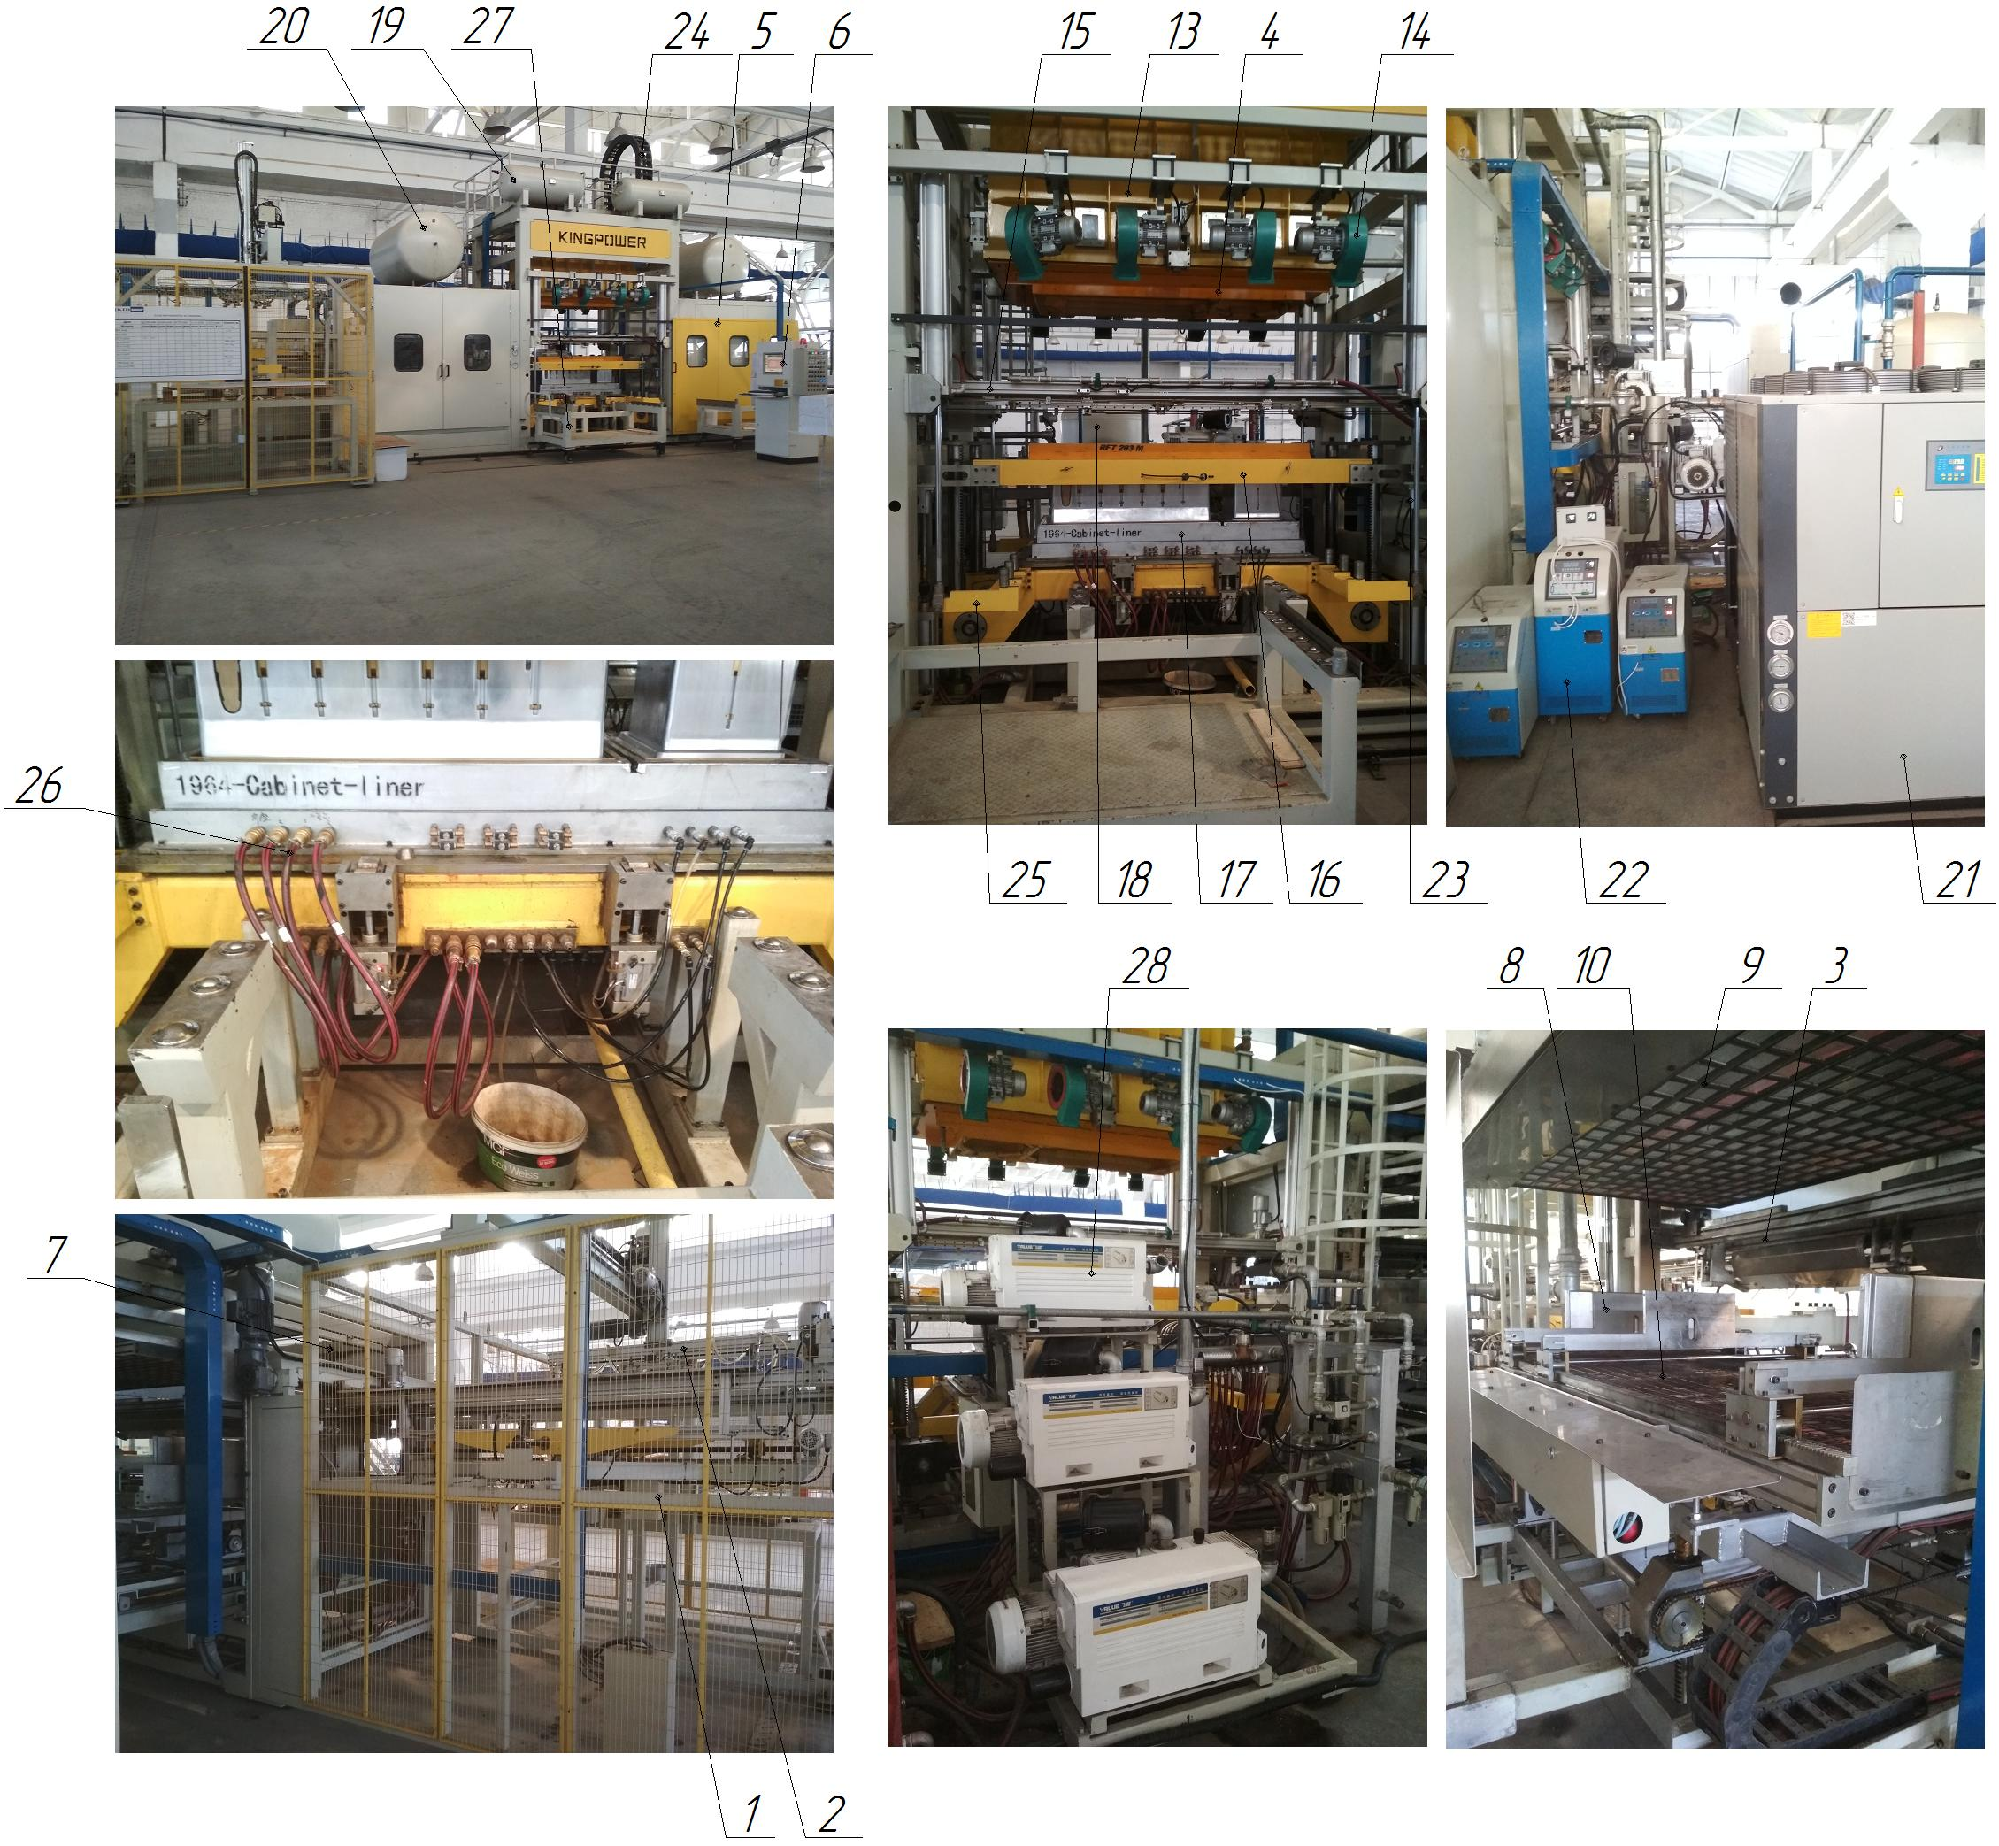

Figure 1.1 - Composition of the VF machine: 1 - loading chamber assembly with automatic feeding of blanks; 2 - manipulator arm with suction cups; 3 - heating element chamber; 4 - vacuum forming chamber assembly of freezing (MC) and refrigerating (HC) chambers; 5 - parts unloading unit; 6 - control panel; 7 - sheet orientation unit; 8 - heating racks; 9 - upper heating element; 10 - lower heating element; 13 - upper vacuum chamber; 14 - cooling fans; 15 - conveying conveyor; 16 - middle table; 17 - punch with a gate system (with pneumatic drive); 18 - air receiver; 19 - vacuum receiver; 20 - vacuum receiver; 21 - chiller; 22 - thermostats; 23 - punch servo drive; 24 - servo drive of the upper vacuum mold; 25 - clamping frame; 26 - system of water and air supply pipelines to the punch and heating racks; 27 - skids for replacing vacuum molds (assembled); 28 - vacuum pump

SHEET EXTRUSION LINE

Technical characteristics
The extrusion line is designed for the production of plastic products (impact-resistant HIPS polystyrene for vacuum forming) by extruding sheets with a width of up to 1600 mm, length from 20 mm to ∞ and thickness up to 5 mm. The main parameters of plastic sheets produced on this extrusion line are shown in Table 1.1, and its main characteristics in Table 1.2.
Table 1.1 - Main parameters of plastic sheets produced
Parameter | Sheet sizes for the production of MK and HC | Sheet sizes for interior panels
Thickness, mm | 3,9 / 4,2 | 1,2
Length, mm | From 20 to ∞ | From 20 to ∞
Width, mm | max 1600 | max 1600
Raw materials | HIPS granular plastic (primary raw material), secondary raw material, colorant | HIPS granular plastic (primary raw material), secondary raw material, colorant

Table 1.2 - Main characteristics of the extrusion line
Technical characteristics of the line | Dimensional characteristics
Overall dimensions (length x width x height, mm) | 27605 x 5210 x 5000
Number of electric motors, pcs. | 28
Rated supply voltage, V | 380 (three-phase, variable)
Power of the main extruder motor, kW | 160
Frequency, Hz | 50...60
Power of the main motor cooling fan, kW | 3,0
Screw rotation speed, rpm | 0...30
Dependence of shaft rotation speed:  - lower and middle calender  - upper calender  - extended | Same shaft speed  Higher by 0.015...0.020 Higher by 0.015...0.020  than the upper calender
Normal service life (service life) | 25
Line capacity, kg/h | 550
Number of GHS, pcs. | 2
Method of controlling the oil pump | The control panel
Volume of oil of the LPG, l | 100 / 110
Number of cooling fans m/cylinder, pcs. | 7 (main) + 5 (auxiliary)
Temperature mode of line operation, ºС | +5...+50
Working pressure in pneumatic lines, MPa | 0,5...0,6
Working pressure in hydraulic lines, MPa | 16...21
Cooling of the GFS | Air, natural
Type of line | Stationary
Type of control of main technological parameters | Automatic
Method of control of main technological parameters | Control panels
Availability of a centralized lubrication system (CLS) | None
Water ring vacuum pump (WRV) | SK-6D
Number of calenders, pcs. | 3
Calender shaft diameter, mm | 450
Diameter of the pulling rollers, mm | 250
Centrifugal water pump | DFL8-8FSWSR (3 pcs.)
Number of material cylinders, pcs. | 2
Number of hoppers, pcs. | 6
Main screw diameter, mm | 120
Auxiliary auger diameter, mm | 60
Number of distribution grids, pcs. | 2
Diameter of holes in the distribution grids, mm | 0,05
Extrusion head die height, mm | 5
Extrusion head die width, mm | 2000
Number of knives for longitudinal sheet cutting, pcs. | 3
Corona discharge station (HF) | Є
Guillotine (for transverse sheet cutting), pcs. | 1
Roller conveyor (roller conveyor), pcs. | 4
Compressed air for pneumatic systems | With 40 micron filtration with or without oil
Mineral hydraulic oil for hydraulic systems | MGE46-B
Mineral oil viscosity, cSt | 40...50
Oil purity class according to GOST 17216-81 | not coarser than 12
Presence of water and acids in the oil | Absence of
Filtration of oil before pouring into the tank | Particles with a diameter of more than 0.025...0.04 mm
Oil temperature during operation, ºС | +10...+50
Temperature regime of compressed air during operation, ºС | +5...+50
Number of operating personnel, persons/shift | 3
Max. dimensions of sheets, T x W x D, mm | 5 x 1600 x from 20 to ∞
Accuracy of tolerances for the size of sheets, in the manufacture:  length, width, mm  thickness, mm | ±2  ±0,1
Melt pressure of polymeric material, MPa | 60...80

Composition of the extrusion line
The extrusion line is built on a modular basis and is designed for the manufacture of plastic products by extruding sheets.
The extrusion line consists of (Fig. 1.1):
- raw material preparation unit item 1 (dryer);
- control panel for the raw material preparation unit item 2;
- technological platform item 3;
- dosing system unit (three-component) item 4 (platform);
- control panel of the raw material dosing system item 5;
- mixer-dispenser item 6;
- main loading hopper item 7;
- main auger drive (D120) item 8;
- main screw item 9;
- main material cylinder item 10;
- filtering element of raw material (distributing grid D120) item 11;
- raw material blower item 12;
- auxiliary auger drive (D60) item 13;
- auxiliary auger item 14;
- auxiliary material cylinder item 15;
- filtering element of raw material (distributing grid D60) item 16;
- feedstock blower item 17;
- extrusion head (slotted) item 18;
- die item 19;
- water cooling system for bearings of m/cylinder No.1, item 20;
- water cooling system for oil in gearbox No. 1, item 21;
- system of fans for cooling of m/cylinder No.1 item 22 (7 pcs.);
- water cooling system for bearings of m/cylinder No.2 item 23;
- water cooling system for oil in gearbox No.2, item 24;
- system of fans for cooling of m/cylinder No.2 item 25 (5 pcs.);
- calender assembly item 26 (calibration shaft, 3 pcs.);
- calender water heating unit item 27 (3 pumps);
- heating system of the m/cylinder No.1 item 28;
- heating system of m/cylinder No.2 item 29;
- GHS No.1 item 30 (units of raw material filtering elements);
- GHS No.2 item 31 (calender unit);
- longitudinal sheet cutting unit item 32 (knives, 3 pcs.);
- system of transporting rollers item 33 (roller conveyors);
- corona discharge station with control panel item 34 (HF);
- unit of broaching shafts, item 35;
- transverse sheet cutting unit P.36 (guillotine);
- belt conveyor for feeding cut sheets, item 37;
- sheet unloading table, item 38;
- vacuum station of raw material mixer item 39;
- water ring vacuum pump item 40 (degassing system);
- expansion tank of the calender heating system item 41;
- Extruder control panel item 42;
- control panel of the unloading table item 43;
- cooling fan for the main electric motor, item 44;
- cooling fan for the auxiliary electric motor, item 45.

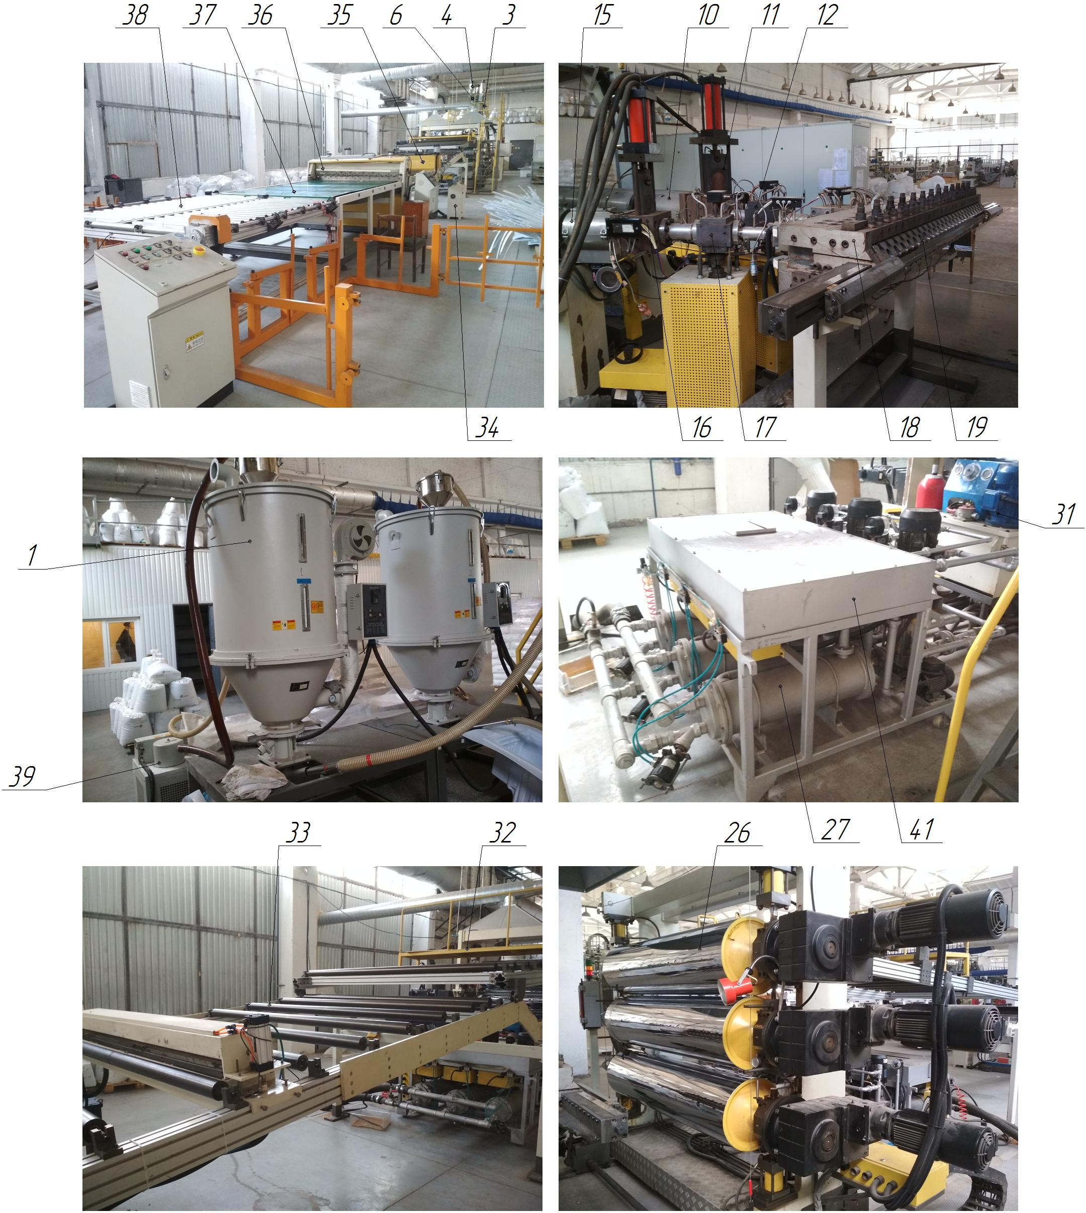

Figure 1.1 - Composition of the extrusion line: 1 - Feedstock preparation unit; 2 - Control panel of the feedstock preparation unit; 3 - Technological platform; 4 - Dosing system unit; 5 - Control panel of the feedstock dosing system; 6 - Mixer-dispenser; 7 - Main loading hopper; 8 - Main screw drive (D120); 9 - Main screw; 10 - Main cylinder; 11 - Feedstock filter element (D120); 12 - Feedstock blower; 13 - Auxiliary auger drive (D60); 14 - Auxiliary auger; 15 - Auxiliary cylinder; 16 - Filter element of raw materials (D60); 17 - Raw material blower; 18 - Extrusion head; 19 - Dies; 20 - Water cooling system for bearings of m/cylinder No. 1; 21 - Water cooling system for oil in gearbox No. 1; 22 - System of fans for cooling m/cylinder No. 1 (7 pcs. ); 23 - Water cooling system for bearings of m/cylinder No. 2; 24 - Water cooling system for oil in gearbox No. 2; 25 - System of fans for cooling m/cylinder No. 2 (5 pcs. ); 26 - Calender unit; 27 - Calender water heating unit; 28 - Heating system of m/cylinder No. 1; 29 - Heating system of m/cylinder No. 2; 30 - GHS No. 1 (raw material filter elements); 31 - GHS No. 2 (calender unit); 32 - Longitudinal sheet cutting unit; 33 - Transporting roller system; 34 - Corona discharge station with control panel (HF); 35 - Drawing shaft unit; 36 - Transverse sheet cutting unit; 37 - Belt conveyor for feeding cut sheets; 38 - Sheet unloading table; 39 - Vacuum station of the raw material mixer; 40 - Water ring vacuum pump; 41 - Expansion tank of the calender heating system; 42 - Extruder control panel; 43 - Unloading table control panel; 44 - Cooling fan of the main electric motor; 45 - Cooling fan of the auxiliary electric motor.

8-POSITION LINE FOR FOAMING CASES WITH POLYURETHANE FOAM

Technical characteristics
The 8-position polyurethane foam line is designed for the preparation, mixing and dosing of components (isocyanate, polyol and cyclopentane), loading/unloading and foaming of refrigeration cases with polyurethane foam (PUF) in automatic mode. The main parameters of the cases to be foamed on this polyurethane foam line are given in Table 1.1, and the main characteristics of the polyurethane foam line are given in Table 1.2.
Table 1.1 - Main parameters of cases for foaming polyurethane foam
Parameter | Розмірна характеристика, mm
Height, mm | min 512 / 562 max
Length, mm | min 817 / 1973 max
Width, mm | min 550 / 600 max

Table 1.2 - Main characteristics of the polyurethane foam line
Technical characteristics of the polyurethane foam line | Dimensional characteristics
Overall dimensions (length x width x height, mm) | 37500x16100x7000 (area)
Number of electric motors, pcs. | 43
Rated supply voltage, V | 380 (three-phase, variable)
Frequency, Hz | 50...60
Ready time of the polyurethane foam line, after switching on the GHS, min. | 5...10
Productivity of the polyurethane foam line, pcs/h
Number of GHS, pcs. | 1
Method of controlling the LPG unit | Control panel
Oil volume of the LPG, l | 100
Working pressure in the hydraulic line, MPa | 14...15
Cooling of the LPG system | Air, natural
Working pressure in pneumatic lines, MPa | 0,4...0,6
Heating / cooling of the masker mold | Water supply
Component mixing and dosing station, pcs. | 1
Component A + C | Polyol + cyclopentane
Component B | Isocyanate
Working pressure of components in the system (when mixing), bar | 100...180
Maximum pressure of components in the system, bar | 210
Type of polyurethane foam line | Stationary
Type of control of main technological parameters | Automatic
Method of controlling the main technological parameters | The control panel
Availability of centralized lubrication systems (CLS) | No
Availability of loading / unloading position of the cases on the line (automatic) | Є
Compressed air for pneumatic systems | With 40 micron filtration with or without oil
Temperature regime of compressed air during operation, ºС | +5...+50
Temperature mode of the line operation, ºС | +5...+40
Mineral hydraulic oil for hydraulic oil distribution systems | MGE46-B
Mineral oil viscosity, cSt | 40...50
Oil purity class according to GOST 17216-81 | not coarser than 12
Presence of water and acids in the oil | Absence of
Filtration of oil before pouring into the tank | Particles with a diameter of more than 0.025...0.04 mm
Oil temperature during operation, ºС | +10...+50
Number of loading positions of the polyurethane foam line | 8
Number of chillers for heating/cooling of masker molds | 2
Chiller 1 - for masker molds, no. | 1...4
Chiller 2 - for masker molds, no. | 5...8
Temperature mode of operation of the molds, ºС | 40...55
Time of heating of the masker molds to the operating temperature, hours | 1,5...2
Number of chillers for heating/cooling of tanks and system with components for the polyurethane foam line (site) | 1
Water temperature regime for tanks, ºС | 10...11
Chiller 3 - for heating/cooling of tanks and systems A+C, B | Polyol + cyclopentane, Isocyanate
Temperature mode of A+C, B components, ºС | 22...23
Heating time of A+C components to operating temperature, h | 1,5...2
Temperature mode of the enclosure heating chamber, ºС | 40...55
Heating time of the enclosure heating chamber, h | 1,5...2
Number of operating personnel, persons/shift | 2
Dimensional accuracy, in the manufacture of enclosures, mm | ±1
Mode of circulation and heating of components | Constant
Operation mode of the exhaust ventilation system | By gas analyzer

Composition of the polyurethane foam line
The polyurethane foam line is built on a modular basis. The polyurethane foam line is used for automatic loading, foaming and unloading of cases.
The polyurethane foam line consists of (Fig. 1.1):
1. Technological platform (height +8.5 m) item 11:
- mixing and dosing station for components (polyol, isocyanate) item 1;
- control cabinet item 2;
- container No. 1 (Polyol + cyclopentane) item 3;
- container No. 2 (isocyanate) item 4;
- thermostat No. 1 for heating of masker molds (1...4) item 5;
- thermostat No. 2 for heating of masker molds (4...8) item 6;
- chiller No. 3 - for heating/cooling of the container and systems A+C, B, item 7;
- unit of technological equipment for supplying components (flow meter, pump, mixing unit), 2 pcs, item 8;
- GFS (maintenance of the polyurethane foam filling manipulator), item 9;
- exhaust ventilation system, item 10.
2. Line for loading, foaming and unloading of cases item 26:
- control cabinet item 12 (2 pcs.);
- control panel item 13 (2 pcs.);
- heating chamber on the line of loading/unloading of cases item 14;
- 4-sectional area for accumulation of enclosures item 15 (for 12 enclosures, 3 roller conveyors);
- control panel for the enclosures transportation line, item 16;
- control panel for the enclosures accumulation area, item 17;
- roller rotary conveyor item 18;
- control panel for setting up the masker molds item 19;
- control panel for manipulator item 20;
- manipulator for injection of raw materials item 21;
- loading/unloading trolley item 22;
- masker mold punch item 23;
- masker mold matrix item 24;
- punch of the under-compressor niche of the housing item 25.
3. Line for shipment and transfer of housings to the assembly area Poz.27:
- control panel for the shipping line item 28.

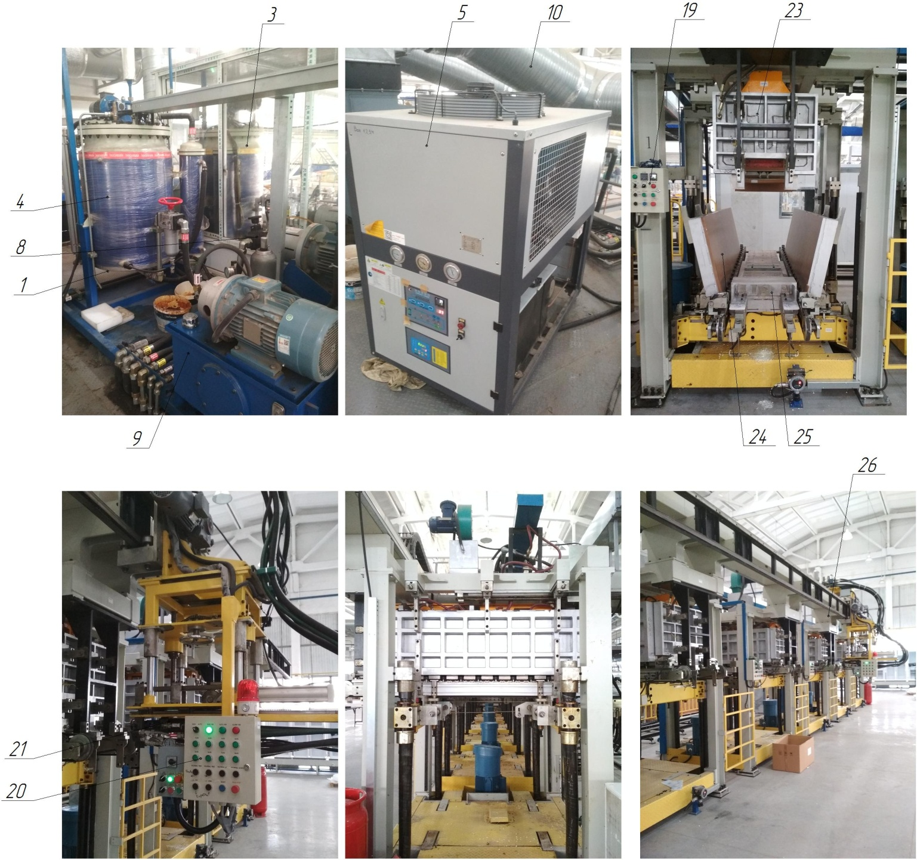

Figure 1.1 - Composition of the polyurethane foam line: 11. technological platform; 1. Component mixing and dosing station; 2. Control cabinet; 3. Tank No. 1; 4. Tank No. 2; 5. Thermostat №1; 6. Thermostat №2; 7. Chiller No. 3; 8. Unit of technological equipment for supplying components; 9. GAS DISTRIBUTION SYSTEM; 10. Exhaust ventilation system; 26. Line of loading, foaming and unloading of cases; 12. Control cabinet; 13. Control panel (2 pcs); 14. Heating chamber on the line of loading/unloading of cases; 15. Zone 4-section for the accumulation of cases; 16. Control panel for the transportation line of enclosures; 17. Control panel for the accumulation zone of cases; 18. Roller rotary conveyor; 19. Control panel for setting up masker molds; 20. Manipulator control panel; 21. Manipulator for injection of raw materials; 22. Loading/unloading trolley; 23. Masker mold punch; 24. Matrix of the masker mold; 25. Punch of the sub-compressor niche of the body; 27. Line of shipment and transfer of bodies to the assembly area; 28. Control panel of the shipment line

МАШИНА 8-ПОЗИЦІЙНА ЗАПІНЕННЯ ДВЕРЕЙ ПІНОПОЛІУРЕТАНОМ

Technical characteristics
The 8-position polyurethane foam machine is designed for preparation, mixing and dosing of components (isocyanate, polyol and cyclopentane), and foaming of refrigerator doors with polyurethane foam (PUF) in automatic mode. The main parameters of the doors to be foamed on this polyurethane foam machine are given in Table 1.1, and the main characteristics of the polyurethane foam machine are given in Table 1.2.
Table 1.1 - Main parameters of doors for foaming polyurethane foam
Parameter | Розмірна характеристика, mm
Height, mm | 60
Length, mm | min 390 / 1365 max
Width, mm | min 560 / 610 max

Table 1.2 - Main characteristics of the polyurethane foam machine
Technical characteristics of the polyurethane foam line | Dimensional characteristics
Overall dimensions (length x width x height, mm) | 4920x4000x7000 (area)
Number of electric motors, pcs. | 4 = 2 + 2 + 2dv.GTS
Rated supply voltage, V | 380 (three-phase, variable)
Frequency, Hz | 50...60
Ready time of the polyurethane foam line, after switching on the GHS, min. | 5...10
Productivity of the polyurethane foam line, pcs/h
Number of GHS, pcs. | 2
Method of controlling the LPG unit | Control panel
Oil volume of the LPG, l | 100 / 400
Working pressure in the hydraulic line, MPa | 14...15
Cooling of the LPG system | Air, natural
Working pressure in pneumatic lines, MPa | 0,4...0,6
Heating / cooling of the masker mold | Water supply
Component mixing and dosing station, pcs. | 1
Component A + C | Polyol + cyclopentane
Component B | Isocyanate
Working pressure of components in the system, bar | 100...180
Maximum pressure of components in the system, bar | 210
Type of polyurethane foam machine | Stationary
Version of the polyurethane foam machine | Drum type
Type of control of main technological parameters | Automatic
Method of controlling the main technological parameters | Control panel
Compressed air for pneumatic systems | With 40 micron filtration with or without oil
Compressed air temperature regime during operation, ºС | +5...+50
Temperature mode of machine operation, ºС | +5...+40
Mineral hydraulic oil for hydraulic systems | MGE46-B
Mineral oil viscosity, cSt | 40...50
Oil purity class according to GOST 17216-81 | not coarser than 12
Presence of water and acids in the oil | Absence of
Filtration of oil before pouring into the tank | Particles with a diameter of more than 0.025...0.04 mm
Oil temperature during operation, ºС | +10...+50
Number of loading positions of the polyurethane foam machine | 8
Number of chillers for heating/cooling of masker molds | 1
Temperature regime of the masker molds, ºС | 40...55
Time for heating of the masker molds to the operating temperature, hours | 1,5...2
Number of chillers for heating/cooling of tanks and system with components for the polyurethane foam line (site) | 1
Water temperature regime for tanks, ºС | 10...11
Chiller 4 for heating/cooling of tanks A+C, B | Polyol + cyclopentane, Isocyanate
Temperature mode of components A+C, B, ºС | 22...23
Heating time of A+C components to operating temperature, h | 1,5...2
Temperature mode of the door heating chamber, ºС | 40...55
Heating time of the door heating chamber, h | 1,5...2
Number of operating personnel, persons/shift | 2
Dimensional accuracy, in the manufacture of doors, mm | ±1
Mode of circulation and heating of components | Constant
Operation mode of the exhaust ventilation system | By gas analyzer

Composition of the polyurethane foam machine
The polyurethane foam machine is built on a modular basis. The polyurethane foam machine is used for manual loading, automatic foaming of polyurethane foam and manual unloading of doors.
The PU foam machine consists of (Fig. 1.1):
1. Technological platform (height + 8.5 m) item 1:
- mixing and dosing station for components (polyol, isocyanate) item 2;
- control cabinet item 3;
- container No. 3 (polyol + cyclopentane) item 4;
- container No. 4 (isocyanate) item 5;
- thermostat for heating of door masker-forms (1...8) item 6;
- chiller No. 4 - for heating/cooling of the tank and systems A+C, B, item 7;
- unit of technological equipment for components supply (flow meter, pump, mixing unit), 2 pcs, item 8;
- GHS1 (maintenance of the polyurethane foam filling manipulator), item 9;
- GHS2 (maintenance of the 8-position polyurethane foam filling drum) item 10;
- exhaust ventilation system item 11.
2. Foaming station for PU foam doors item 12:
- control cabinet item 13;
- control panel for setting up the masker molds item 14;
- door heating chamber item 15;
- belt conveyor item 16;
- control panel for manipulator item 17;
- manipulator for injection of raw materials item 18;
- masker mold punch item 19;
- masker mold matrix item 20.
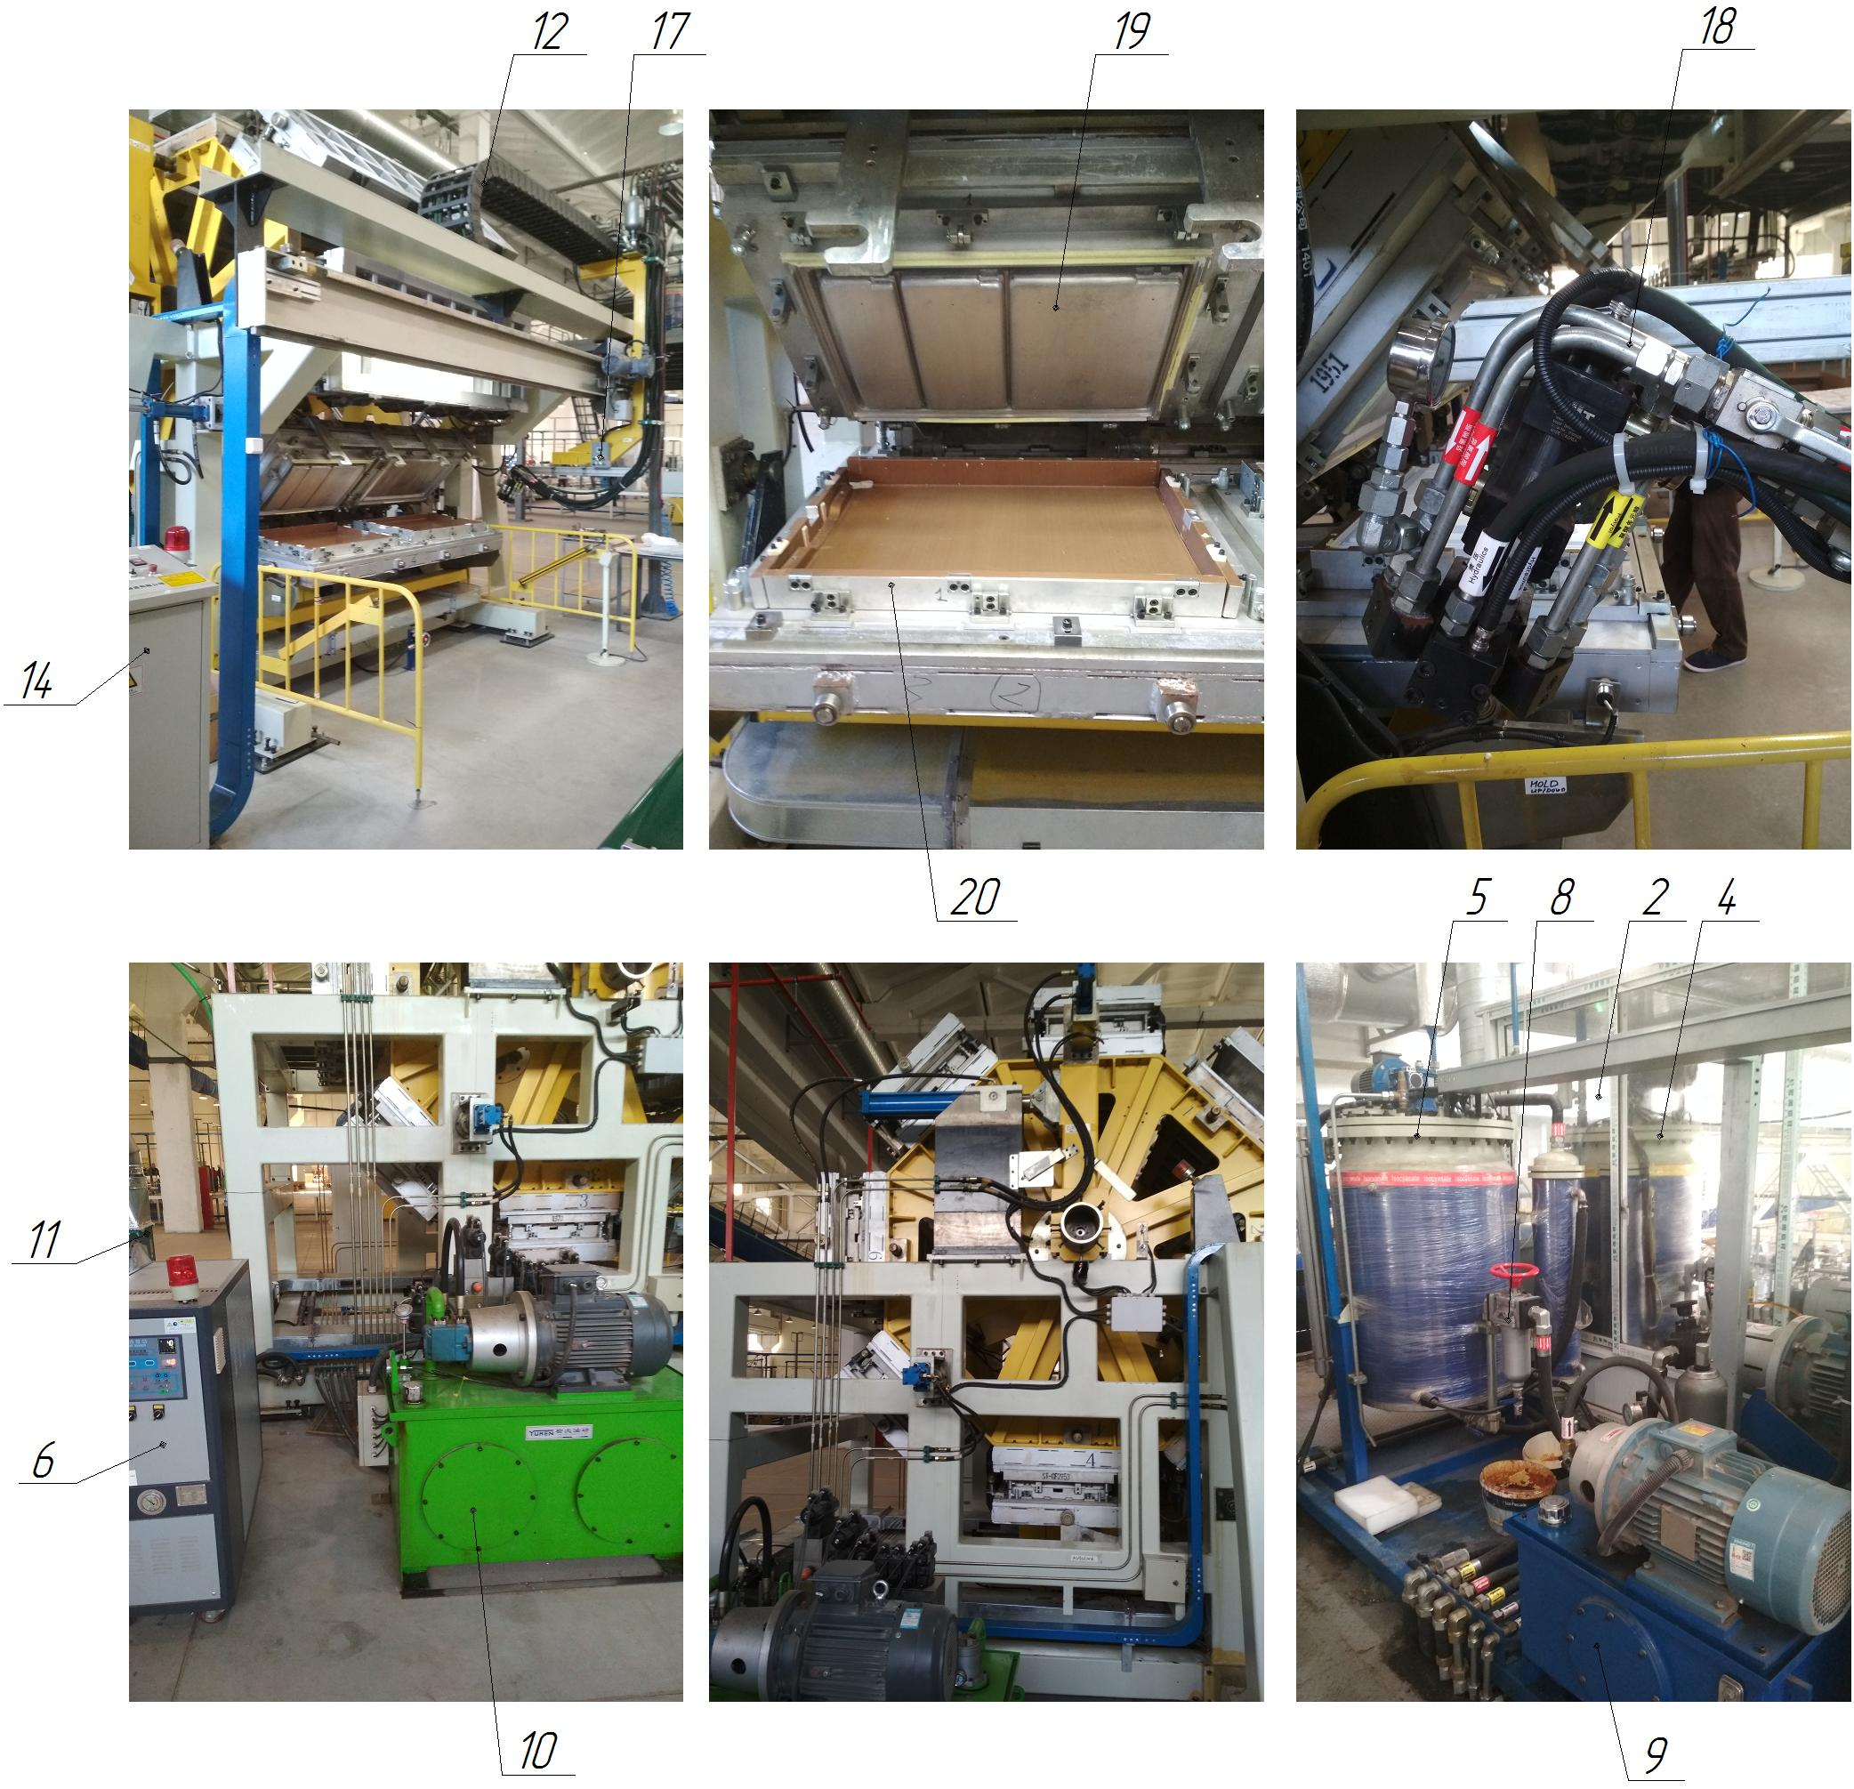

Figure 1.1 - Composition of the polyurethane foam machine: 1. technological platform; 2. mixing and dosing station of components (polyol, isocyanate); 3. control cabinet; 4. Tank No. 3 (Polyol + cyclopentane); 5. Tank No. 4 (Isocyanate); 6. Thermostat; 7. Chiller No. 4; 8. Unit of technological equipment for supplying components; 9. GHS1 (polyurethane foam manipulator); 10. GHS2 (polyurethane foam drum); 11. Exhaust ventilation system; 12. Foaming station for polyurethane foam doors; 13. Control cabinet; 14. Control panel for setting up masker molds; 15. Door heating chamber; 16. Belt conveyor; 17. Manipulator control panel; 18. Manipulator of raw material injection; 19. Masker mold punch; 20. Matrix of the maker mold.

DOOR EXTERIOR PANEL MANUFACTURING LINE

Technical characteristics
The line is designed for the production of outer door panels of HK and MK refrigerators with a model range width of 550 and 600 mm, from a special steel sheet with a thickness of 0.5 mm. The main parameters of the outer door panels manufactured on this line are shown in Table 1.1, and the main characteristics of the line are shown in Table 1.2.
Table 1.1 - Main parameters of the outer door panels produced
Parameter | Groove (bottom - HC, MK), mm | Spike (top - HC, MK), mm
Height, mm | 58 | 58
Length, mm | min 661 / 1357 max | min 384 / 1294 max
Width, mm | min 555 / 605 max | min 555 / 605 max
AhS billet, RSM steel sheet 0.5 mm | min 661 / 711 max | min 384 / 711 max

Table 1.2 - Main characteristics of the line
Technical characteristics of the line | Dimensional characteristics
Overall dimensions (length x width x height, mm) | 22385 x 5500 x 2200
Rated supply voltage, V | 380 (three-phase, variable)
Frequency, Hz | 50...60
Ready time of the line, after switching on the GHS, min. | 5...10
Line capacity, units/hour
Number of GHS, pcs. | 1
Method of controlling the LPG | Control panel
Volume of oil in the hydraulic oil system, l | 270
Number of stamps, pcs. | 2 (cut) + 1 (split)
Temperature mode of line operation, ºС | +5...+50
Working pressure in pneumatic lines, MPa | 0,5...0,6
Working pressure in hydraulic lines, MPa | 14...16
Cooling of the hydraulic system | Water
Type of line | Stationary
Type of control of main technological parameters | Automatic
Method of controlling the main technological parameters | Control panel
Number of lubrication points
Compressed air for pneumatic systems | With 40 micron filtration with or without oil
Mineral hydraulic oil for hydraulic oil distribution systems | MGE46-B
Mineral oil viscosity, cSt | 40...50
Oil purity class according to GOST 17216-81 | not coarser than 12
Presence of water and acids in the oil | Absence of
Filtration of oil before pouring into the tank | Particles with a diameter of more than 0.025...0.04 mm
Oil temperature during operation, ºС | +10...+50
Temperature regime of compressed air during operation, ºС | +5...+50
Number of operating personnel, persons / shift | 2
Dimensional accuracy in the manufacture of door panels, mm | ±1

Composition of the line
The line is built on a modular basis. The line produces the outer door panel of refrigerators.
The line includes (Fig. 1.1):
- a loading position with vacuum grippers (automatic feeding of blanks made of special steel sheet, 0.5 mm thick), item 1;
- automatic cold sheet metal stamping unit for cutting grooves in the outer door panel pos.2;
- roller conveyor (roller conveyor) item 3;
- automatic shelf bending line item 4;
- automatic stamping unit for dividing the workpiece into two parts, item 5;
- conveyor for feeding the finished part item 6;
- Hydraulic oil compressor with water cooling of working fluid item 7 (maintenance of automatic stamp units);
- control panel item 8;
- main drive of the bending line item 9;
- Belt conveyor (unloading table) Poz.10

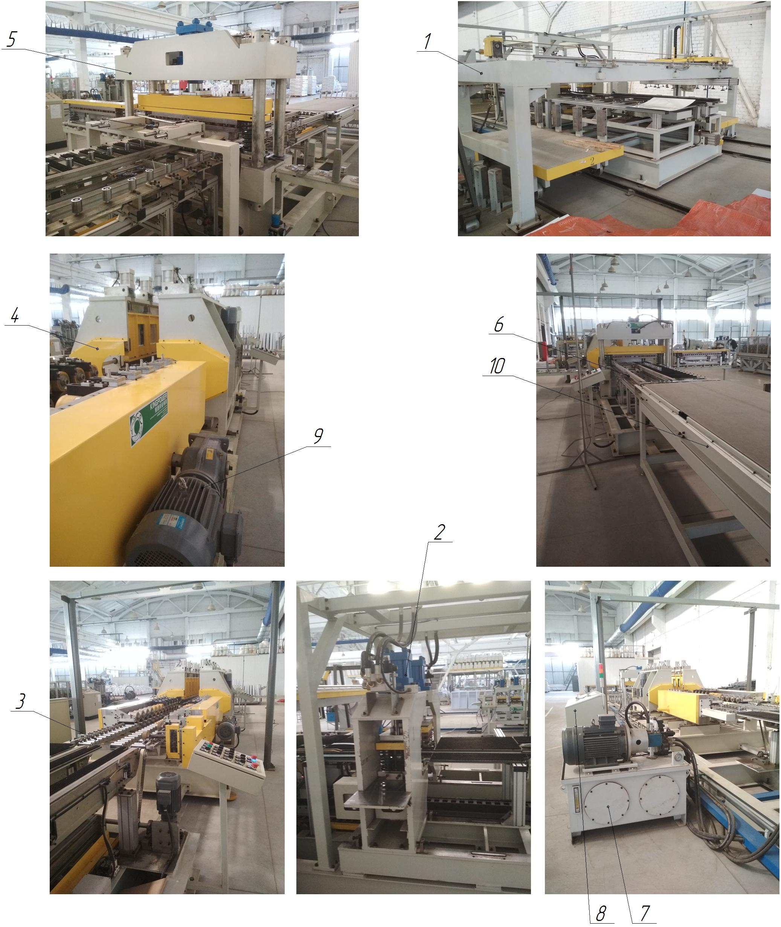

Figure 1.1 - Composition of the outer door panel production line: 1. Loading position with vacuum grippers; 2. Unit of automatic cold sheet stamping dies for cutting grooves of the outer door panel; 3. Roller conveyor (roller conveyor); 4. Automatic shelf bending line; 5. Automatic stamping unit for dividing the workpiece into two parts; 6. Finished part feeding conveyor; 7. GTS (maintenance of automatic stamp units); 8. control panel; 9. Main drive of the bending line; 10. Belt conveyor (unloading table).

BOTTOM BAR PRODUCTION LINE

Technical characteristics
The line is designed for the manufacture of the bottom bar of refrigerators with a width of 550 and 600 mm of the model range of refrigerators, from a special steel sheet with a thickness of 0.5 mm. The main parameters of the middle strips manufactured on this line are shown in Table 1.1, and the main characteristics of the line are shown in Table 1.2.
Table 1.1 - Main parameters of bottom strips produced
Parameter | Models XP 550, mm | HP 600 models, mm
Height, mm | 32,5 | 32,5
Length, mm | 543 | 593
Width, mm | 60 | 60
Workpiece, steel sheet RSM 0.5 mm | 548 x 141.6 mm Lg = 1106.5 x 141.6 | 598 x 141.6 mm Lg = 1206.5 x 141.6

Table 1.2 - Main characteristics of the line
Technical characteristics of the line | Dimensional characteristics
Overall dimensions (length x width x height, mm) | 20500 x 3100 x 1950
Rated supply voltage, V | 380 (three-phase, variable)
Frequency, Hz | 50...60
Ready time of the line, after switching on the GHS, min. | 5...10
Normative service life (service life) | 25 years
Number of GHS, pcs. | 3
Method of controlling the LPS | The control panel
Volume of oil of the LPG 1 / 2 / 3, l | 50 / 250 / 180
Number of stamps, pcs. | 2 (punching) + 2 (bending)
Temperature mode of line operation, ºС | +5...+50
Working pressure in pneumatic lines, MPa | 0,5...0,6
Working pressure in hydraulic lines, MPa | 12...14
Cooling of the hydraulic system | Water
Type of line | Stationary
Type of control of main technological parameters | Automatic
Method of control of main technological parameters | Control panel
Number of lubrication points | 30 knots x 4 = 120
Compressed air for pneumatic systems | With 40 micron filtration with or without oil
Mineral hydraulic oil for hydraulic systems | MGE46-V
Mineral oil viscosity, cSt | 40...50
Oil purity class according to GOST 17216-81 | not coarser than 12
Presence of water and acids in the oil | Absence of
Filtration of oil before pouring into the tank | Particles with a diameter of more than 0.025...0.04 mm
Oil temperature during operation, ºС | +10...+50
Temperature regime of compressed air during operation, ºС | +5...+50
Number of operating personnel, persons / shift | 2
Dimensional accuracy, in the manufacture of lower slats, mm | ±1

Composition of the line
The line is built on a modular basis. The line produces the bottom bar of refrigerators.
The line includes (Fig. 1.1):
- cantilever unwinder of coiled metal (strip) item 1;
- HNS1, with natural cooling of the working fluid, item 2 (maintenance of the cantilever unwinder);
- broaching and straightening device item 3;
- automatic cold sheet punching unit (2 pcs.) for punching holes and grooves in the lower bar, with feeding device P.4;
- GNS2, with water cooling of working fluid, item 5 (maintenance of automatic stampings unit);
- automatic line for bending the shelves of the lower bar Poz.6;
- control panel item 7;
- automatic stamping unit for separation (vertically) and bending of the lower strip shelves, item 8, with right-hand separation into two parts;
- GNS3, with water-cooled working fluid, item 9 (maintenance of the automatic stamp unit for bending the shelves);
- main drive of the shelf bending line item 10;
- drive of the conveyor for feeding the finished part item 11.

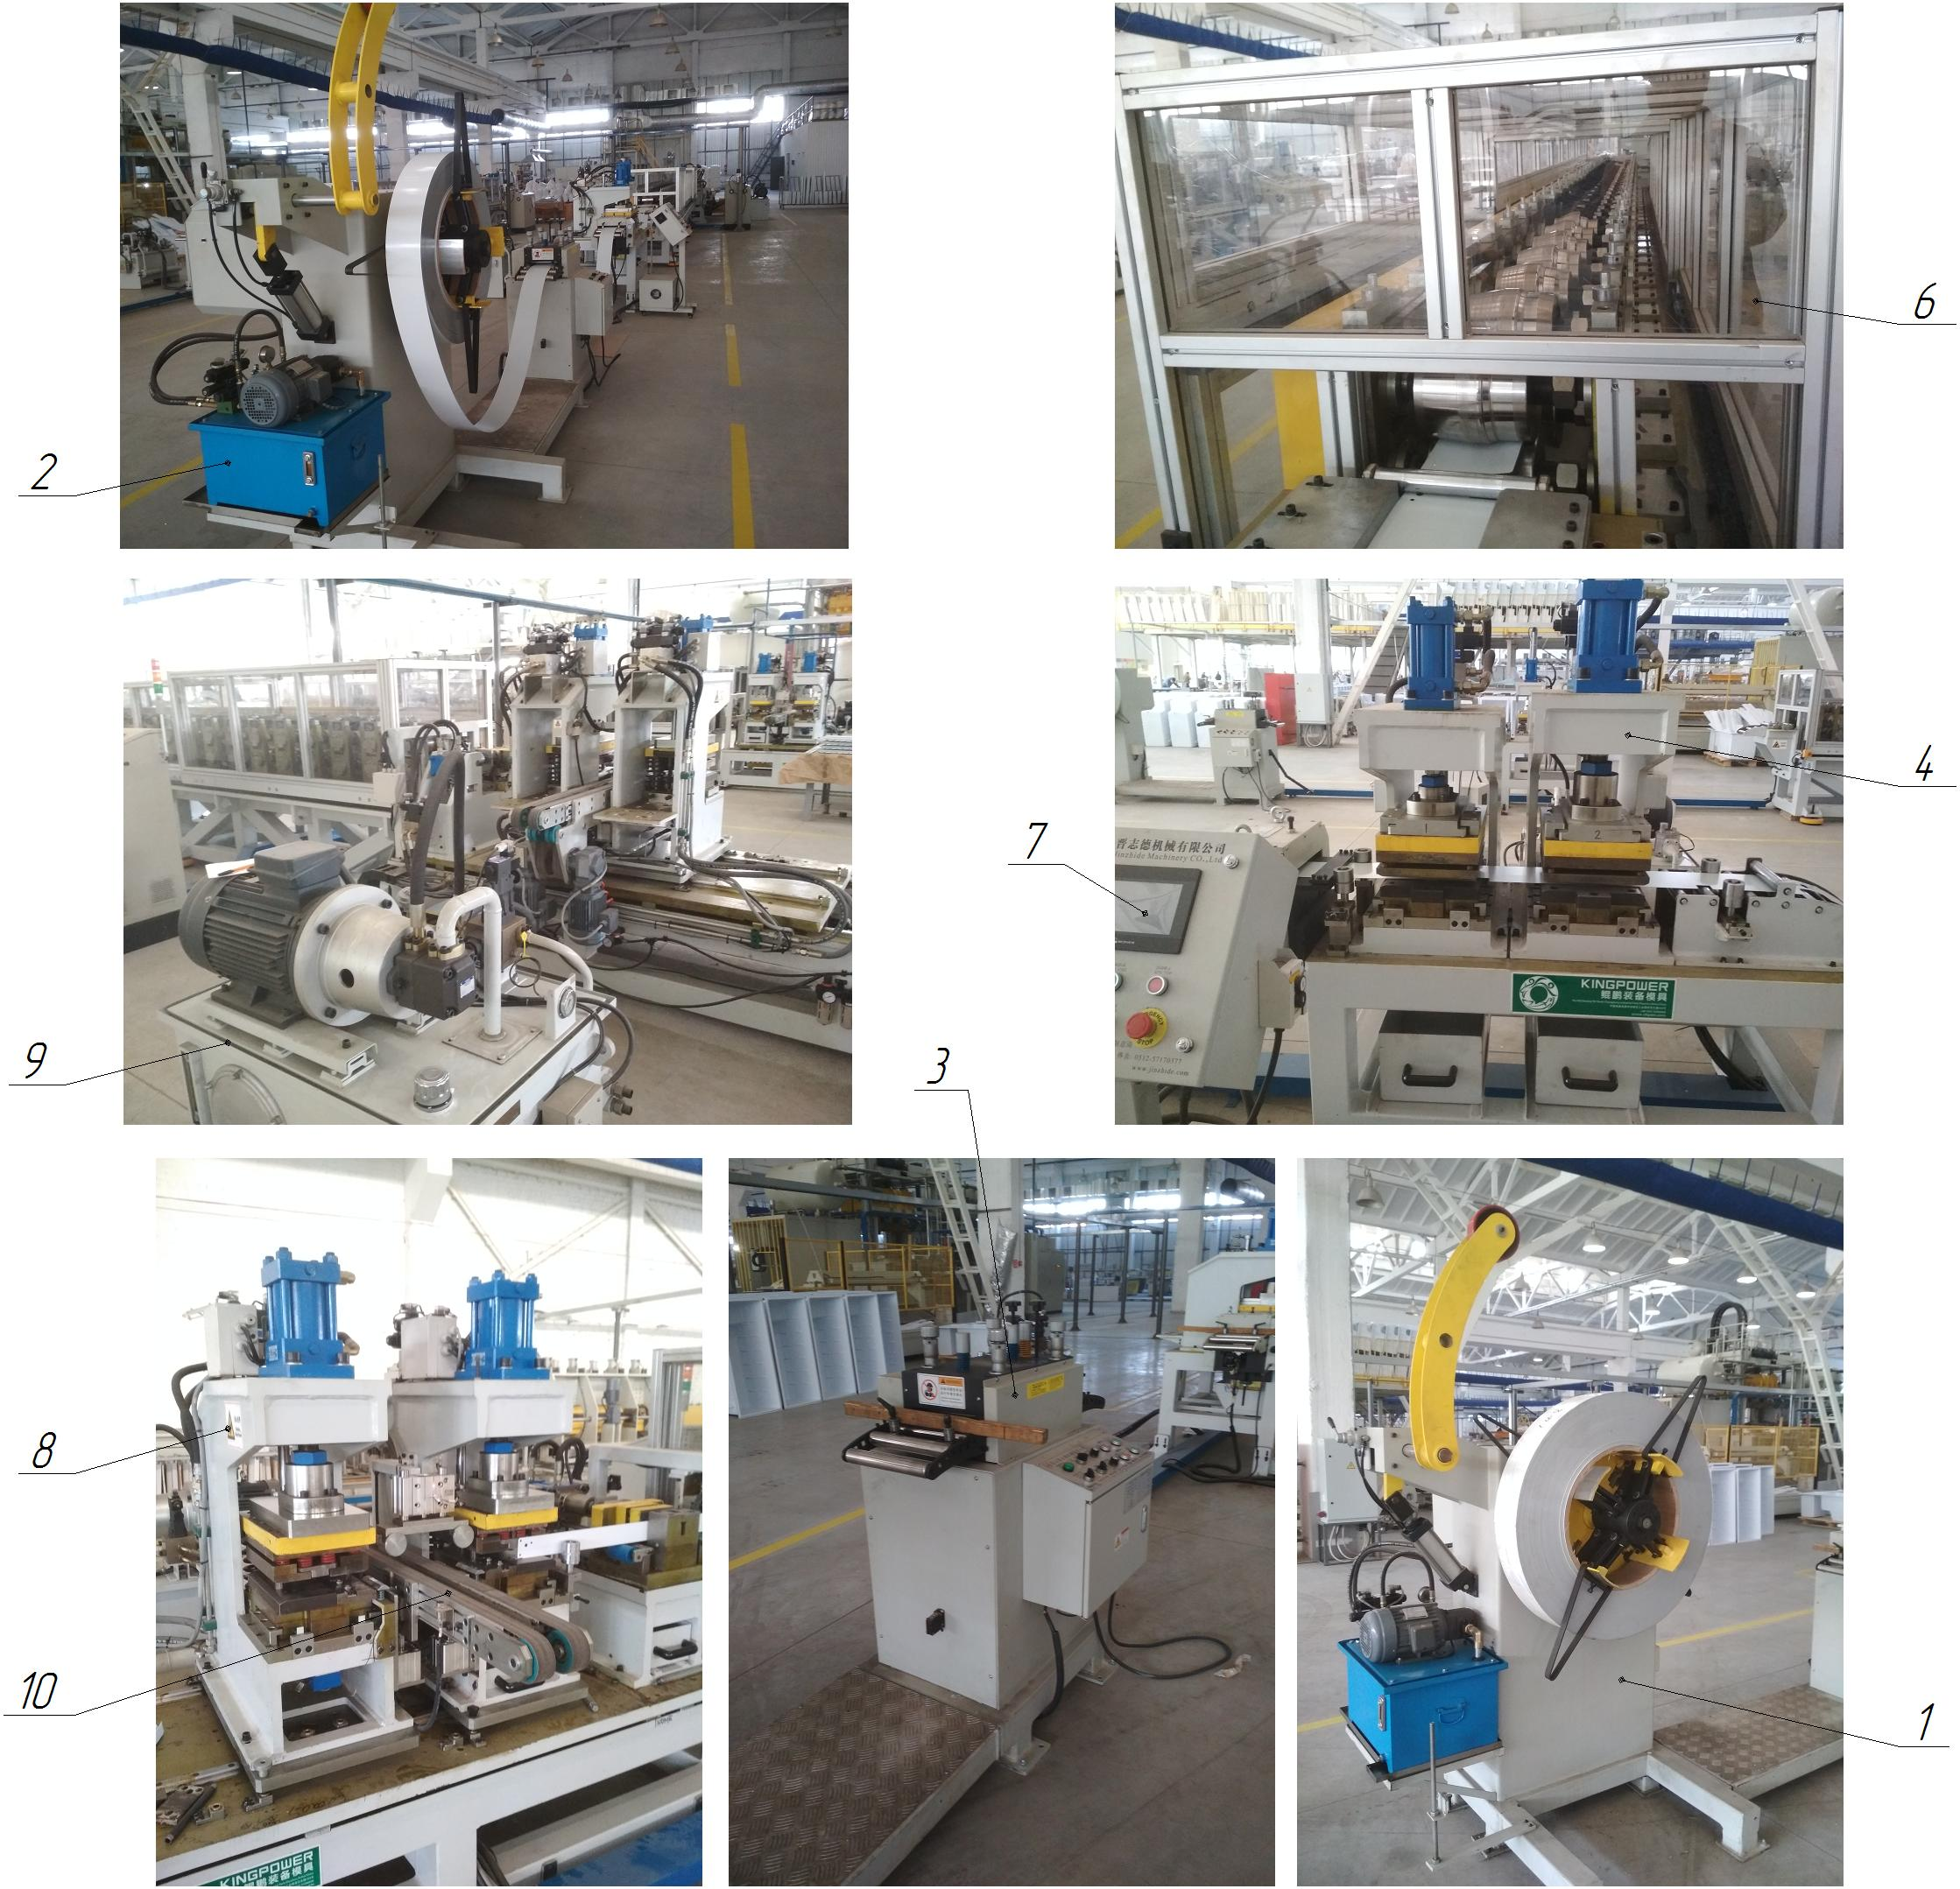

Figure 1.1 - Composition of the bottom strip production line: 1. Cantilever unwinder of rolled metal (strip); 2. GNS1 (maintenance of the cantilever unwinder); 3. Drawing and straightening device; 4. Unit of automatic stamps of cold sheet stamping (2 pcs.), for punching holes and grooves in the lower bar with a feeder; 5. GNS2 (maintenance of the automatic stamp unit); 6. Automatic line for bending the shelves of the lower bar; 7. Control panel; 8. Automatic stamping unit for separation (vertically) and bending of the lower strip shelves, with separation on the right into two parts; 9. GNS3 (maintenance of the automatic stamp unit for bending the shelves); 10. Main drive of the shelf bending line; 11. Drive of the conveyor for feeding the finished part

PRODUCTION LINE OF THE MIDDLE BAR

Technical characteristics
The line is designed for the production of the middle bar of refrigerators, with the width of the model range of refrigerators 550 and 600 mm, from a special steel sheet with a thickness of 0.5 mm. The main parameters of the middle strips produced on this line are given in Table 1.1, and the main characteristics of the line are given in Table 1.2.
Table 1.1 - Main parameters of medium strips produced
Parameter | Models XP 550, mm | Models XP 600, mm
Height, mm | 11 | 11
Length, mm | 533 | 585
Width, mm | 50 | 50
Workpiece, steel sheet RSM 0.5 mm | 538х147,5 Lg = 1086 | 590х147,5 Lg = 1190

Table 1.2 - Main characteristics of the line
Technical characteristics of the line | Dimensional characteristics
Overall dimensions (length x width x height, mm) | 20500 x 3200 x 1950
Rated supply voltage, V | 380 (three-phase, variable)
Frequency, Hz | 50...60
Ready time of the line, after switching on the GHS, min. | 5...10
Line capacity, units/hour
Number of GFS, pcs. | 3
Method of controlling the LPG | The control panel
Volume of oil of the LPG 1 / 2 / 3, l | 50 / 180 / 250
Number of stamps, pcs. | 1 (test) + 2 (bend, + left-hand split)
Temperature mode of line operation, ºС | +5...+50
Working pressure in pneumatic lines, MPa | 0,5...0,6
Working pressure in hydraulic lines, MPa | 12...14
Cooling of the hydraulic system | Water
Type of line | Stationary
Type of control of main technological parameters | Automatic
Method of control of main technological parameters | Control panel
Number of lubrication points | 30 knots x 4 = 120
Compressed air for pneumatic systems | With 40 micron filtration with or without oil
Mineral hydraulic oil for hydraulic systems | MGE46-V
Mineral oil viscosity, cSt | 40...50
Oil purity class according to GOST 17216-81 | not coarser than 12
Presence of water and acids in the oil | Absence of
Filtration of oil before pouring into the tank | Particles with a diameter of more than 0.025...0.04 mm
Oil temperature during operation, ºС | +10...+50
Temperature regime of compressed air during operation, ºС | +5...+50
Number of operating personnel, persons / shift | 2
Dimensional accuracy, in the manufacture of medium strips, mm | ±1

Composition of the line
The line is built on a modular basis. The line produces the middle bar of refrigerators.
The line includes (Fig. 1.1):
- cantilever unwinder of coiled metal (strip) item 1;
- HNS1, with natural cooling of the working fluid, item 2 (maintenance of the cantilever unwinder);
- broaching and straightening device item 3;
- automatic cold sheet punching unit for punching holes and cutting grooves, in the middle bar, with feeder item 4;
- GNS2, with water cooling of working fluid, item 5 (maintenance of the automatic stamp unit);
- automatic line for bending the shelves of the middle bar POS.6;
- control panel item 7;
- automatic stamping unit for bending the shelves of the middle strip and dividing it into two finished parts on the left side, item 8;
- GNS3, with water-cooled working fluid, item 9 (maintenance of the automatic stamp unit for bending the shelves);
- main drive of the shelf bending line item 10;
- drive of the conveyor for feeding the finished part from the stamping zone pos.11.

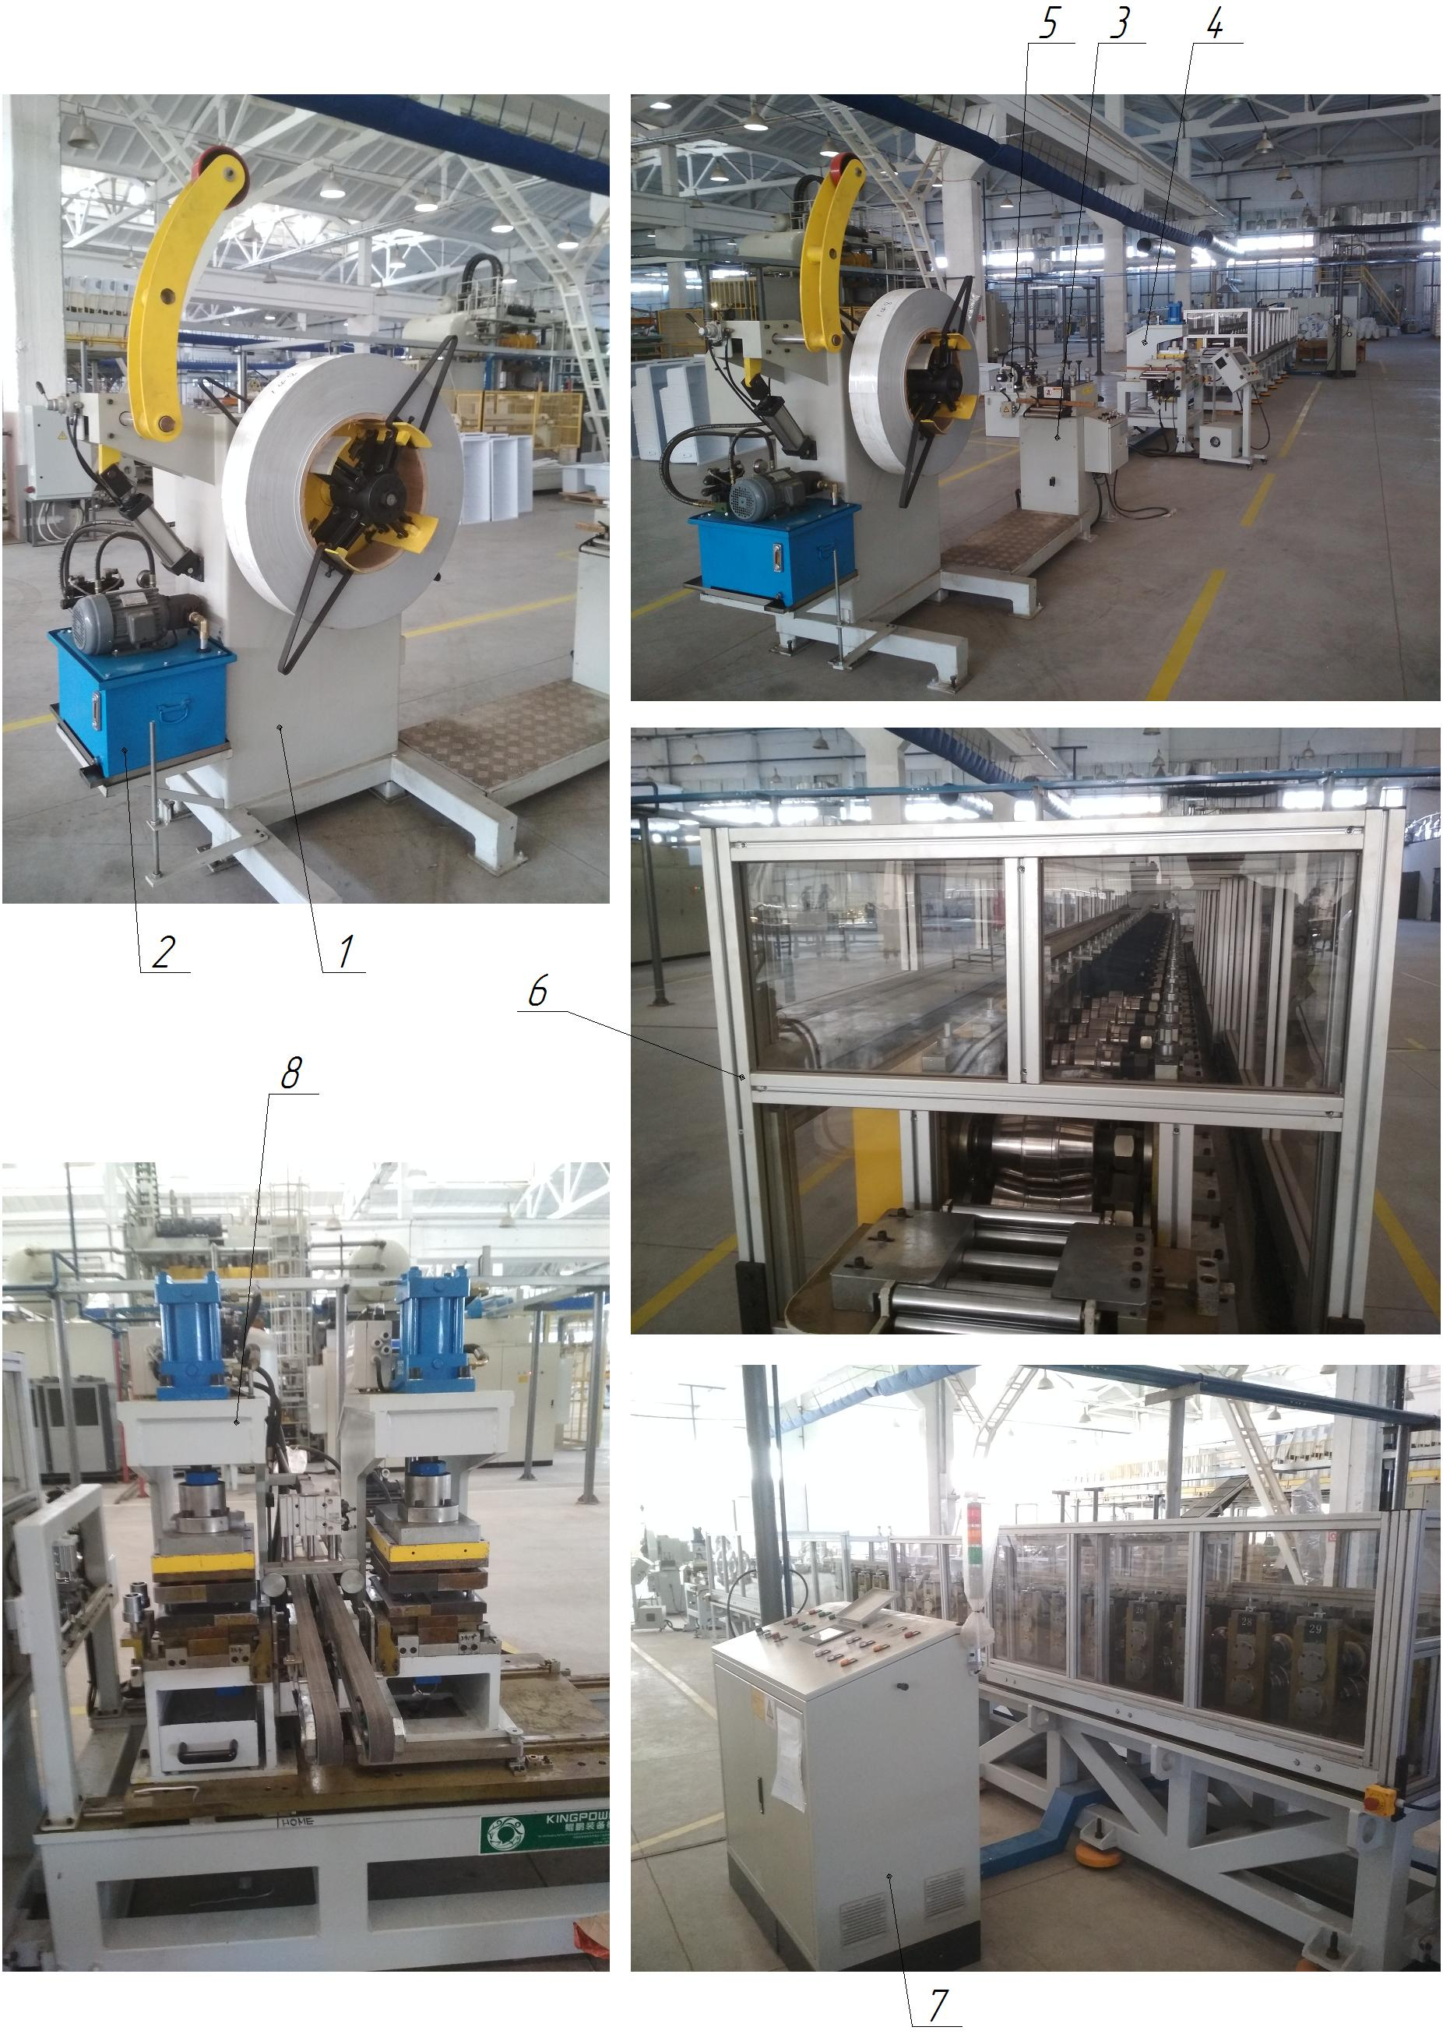
Figure 1.1 - Composition of the line for the production of the middle strip: 1. Cantilever unwinder of coiled metal; 2. GTS1 (maintenance of the cantilever unwinder); 3. Stretching and straightening device; 4. Automatic cold sheet stamping unit; 5. GTS2 (maintenance of the automatic stamp unit); 6. Automatic shelf bending line of the middle strip; 7. Control panel; 8. Automatic stamping unit for bending the shelves of the middle strip; 9. GNS3 (maintenance of the unit of automatic stamps for bending the shelves); 10. Main drive of the shelf bending line; 11. Drive of the conveyor for feeding the finished part from the stamping zone.

CROSS-CUTTING LINE FOR METAL

Technical characteristics
The line is designed for transverse cutting of sheet metal, special steel sheet with a thickness of 0.5 mm, folding and unloading in automatic mode. The main characteristics of the line are shown in Table 1.1.
Table 1.1 - Main characteristics of the line
Technical characteristics of the line | Dimensional characteristics
Overall dimensions (length x width x height, mm) | 24222 x 8850 x 2400
Rated supply voltage, V | 380 (three-phase, variable)
Frequency, Hz | 50...60
Ready time of the line, after switching on the GHS, min. | 5...10
Line capacity, units/hour
Number of GFS, pcs. | 1
Method of controlling the LPG | Control panel
Volume of oil in the hydraulic oil tank, l | 560
Electromechanical scissors for cross-sectional cutting of sheet, pcs. | Q11G-2x1300 (1)
Temperature mode of line operation, ºС | +5...+50
Working pressure in pneumatic lines, MPa | 0,5...0,6
Working pressure in hydraulic lines, MPa | 14...16
Cooling of hydraulic lines | Airborne
Type of line | Stationary
Type of control of main technological parameters | Automatic
Method of control of main technological parameters | Control panel
Number of lubrication points | Auto = 30 + manual = 2
Number of centralized lubrication systems (CLS) | Auto 1 + manual 1 = 2
Compressed air for pneumatic systems | With 40 micron filtration with or without oil
Mineral hydraulic oil for gas distribution systems | MGE-46V
Mineral oil viscosity, cSt | 40...50
Oil purity class according to GOST 17216-81 | not coarser than 12
Presence of water and acids in the oil | Absence of
Filtration of oil before pouring into the tank | Particles with a diameter of more than 0.025...0.04 mm
Oil temperature during operation, ºС | +10...+50
Temperature regime of compressed air during operation, ºС | +5...+50
Number of operating personnel, persons / shift | 2
Dimensional accuracy when cutting sheet metal, mm | ±1

Composition of the line
The line is built on a modular basis. The line performs cross-cutting of sheet metal, folding and unloading in automatic mode.
The line includes (Fig. 1.1):
- cantilever unwinder of coiled metal (strip) item 1 with a hydraulic coil unwinding device and a loading device;
- stretching and straightening device item 2;
- drive of the broaching and straightening device item 3;
- automatic lubrication station item 4 (of the stretching and straightening device);
- hydraulic table with conveyor rollers and loop compensator item 5;
- feeding device item 6;
- feeder drive item 7;
- electromechanical scissors for transverse cutting of metal item 8;
- manual lubrication station item 9 (guillotines);
- GFS, with air cooling of working fluid item 10;
- air receiver item 11 (1 pc.);
- belt conveyor item 12;
- centrifugal fan item 13;
- station for assembling and unloading of measuring metal sheets item 14;
- hydraulic lifting table item 15;
- transporting trolley item 16;
- control panel item 17 (assembly and unloading station);
- air receiver item 18 (2 pcs., assembly and unloading station);
- control panel item 19 (feeder, guillotine);
- control panel item 20 (cantilever unwinder of coiled metal).

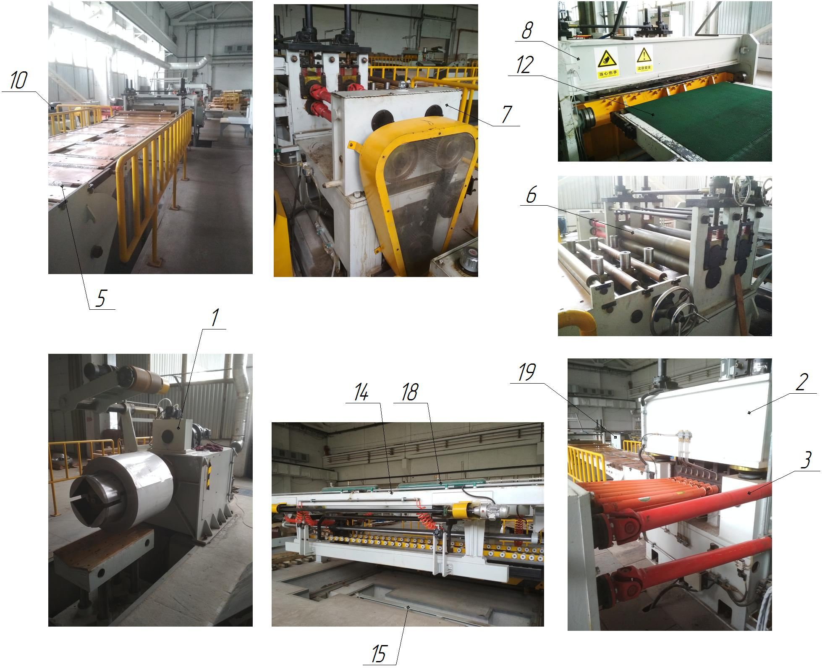

Figure 1.1 - Composition of a sheet metal cross-cutting line: 1 - cantilever unwinder of coiled metal (strip) with a loading device; 2 - broaching device; 3 - drive of the broaching device; 4 - automatic lubrication station; 5 - hydraulic table with conveyor rollers and a loop compensator; 6 - feeder; 7 - drive of the feeder; 8 - electromechanical scissors for cross-cutting metal; 9 - manual lubrication station; 10 - gas compressor station; 11 - air receiver; 12 - belt conveyor; 13 - centrifugal fan; 14 - station for assembling and unloading metal sheets; 15 - hydraulic lifting table; 16 - transport trolley; 17 - control panel (assembling and unloading station); 18 - air receiver; 19 - control panel (feeder, guillotine); 20 - control panel (cantilever unwinder of coiled metal)

LONGITUDINAL METAL CUTTING LINE

Technical characteristics
The line is designed for longitudinal and transverse cutting of sheet metal, special steel sheet with a thickness of 0.5 mm, winding and unloading of a roll of gauge metal in automatic mode. The main characteristics of the line are shown in Table 1.1.
Table 1.1 - Main characteristics of the line
Technical characteristics of the line | Dimensional characteristics
Overall dimensions (length x width x height, mm) | 21117 x 8612 x 2700
Rated supply voltage, V | 380 (three-phase, variable)
Frequency, Hz | 50...60
Ready time of the line, after switching on the GHS, min. | 5...10
Line capacity, units/hour
Number of GFS, pcs. | 1
Method of controlling the LPG | Control panel
Oil volume of the hydraulic shearing unit, l | 560
Hydraulic shears for transverse sheet cutting, pcs. | 1
Device for longitudinal sheet cutting, pcs. | 1
Temperature mode of line operation, ºС | +5...+50
Working pressure in pneumatic lines, MPa | 0,5...0,6
Working pressure in hydraulic lines, MPa | 14...16
Cooling of hydraulic lines | Airborne
Type of line | Stationary
Type of control of main technological parameters | Automatic
Method of controlling the main technological parameters | Control panel
Compressed air for pneumatic systems | With 40 micron filtration with or without oil
Mineral hydraulic oil for GHS | MGE-46V
Mineral oil viscosity, cSt | 40...50
Oil purity class according to GOST 17216-81 | not coarser than 12
Presence of water and acids in the oil | Absence of
Filtration of oil before pouring into the tank | Particles with a diameter of more than 0.025...0.04 mm
Oil temperature during operation, ºС | +10...+50
Temperature regime of compressed air during operation, ºС | +5...+50
Number of operating personnel, persons / shift | 2
Dimensional accuracy when cutting sheet metal, mm | ±1

Composition of the line
The line is built on a modular basis. The line is used for longitudinal and transverse cutting of sheet metal, coiling and unloading of a roll of measuring metal in automatic mode.
The line includes (Fig. 1.1):
- cantilever unwinder of coiled metal (strip) pos.1 with hydraulic coil unwinding device and loading device (trolley)
- drawing device item 2;
- drive of the broaching device item 3;
- hydraulic scissors for transverse cutting of metal item 4;
- hydraulic table with conveyor rollers and loop compensator item 5;
- guide device for sheet metal item 6;
- longitudinal cutting station for metal item 7;
- drive of the station for longitudinal cutting of metal item 8;
- sheet metal cleaning device item 9;
- hydraulic table with conveyor rollers and loop compensator item 10;
- device for reeling in waste metal (edge reeler), item 11 (left and right);
- tensioning station with separating disks Poz.12;
- cantilever coiler of coiled metal (strip), item 13 with hydraulic coil unclamping device, separating disks and unloading device (trolley);
- drive of the cantilever coil winder of coiled metal Item 14;
- Hydraulic oil compressor, with air cooling of working fluid, item 15;
- control panel item 16.

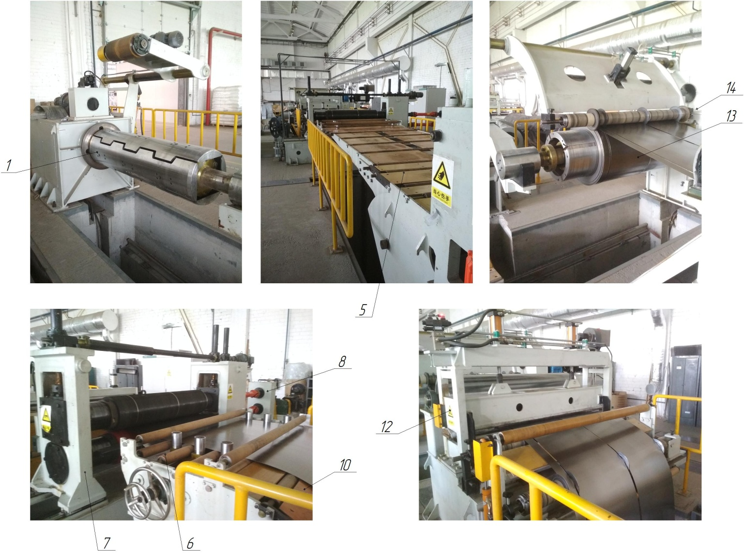

Figure 1.1 - Composition of a longitudinal sheet metal cutting line: 1 - cantilever unwinder of coiled metal (strip); 2 - broaching device; 3 - drive of the broaching device; 4 - hydraulic scissors for transverse cutting of metal; 5 - hydraulic table with conveyor rollers and loop compensator; 6 - guide device for sheet metal; 7 - longitudinal cutting station; 8 - drive of the longitudinal cutting station; 9 - sheet metal cleaning device; 10 - hydraulic table with conveyor rollers and loop compensator; 11 - waste coiler (edge coiler) for sheet metal; 12 - tensioning station with separating discs; 13 - cantilever coiler of coiled metal (strip); 14 - drive of the cantilever coiler of coiled metal; 15 - gas station; 16 - control panel

CUTTING AND BENDING LINE FOR CONDENSER TUBES

Technical characteristics
The line is designed for cutting and bending of steel condenser tubes in automatic mode. The main characteristics of the line are shown in Table 1.1.
Table 1.1 - Main characteristics of the line
Technical characteristics of the line | Dimensional characteristics
Overall dimensions (length x width x height, mm) | 25500 x 2500 x 1500
Rated supply voltage, V | 380 (three-phase, variable)
Frequency, Hz | 50...60
Line capacity, pcs/h
Condenser tube bending unit, pcs. | 1
Number of simultaneous bending of tubes, pcs. | 1...10
Condenser tube cutting unit, pcs. | 1
Number of simultaneous tubes cutting, pcs. | 1
Material of condenser tubes for cutting and bending | Steel
Diameter of condenser tubes for cutting and bending, mm | 4
Temperature mode of line operation, ºС | +5...+40
Working pressure in pneumatic lines, MPa | 0,5...0,6
Type of line | Stationary
Type of control of main technological parameters | Automatic
Method of control of technological parameters | Control panel
Compressed air for pneumatic systems | With 40 micron filtration with or without oil
Compressed air temperature during operation, ºС | +5...+50
Length of the storage tray, mm | 17000
Number of operating personnel, persons/shift | 2
Tube feeding for cutting and bending | Automatic
Dimensional accuracy, when cutting tubes, mm | ±1
Dimensional accuracy when bending tubes, mm | ±1

Composition of the line
The line is built on a modular basis. The line is used for cutting and bending of steel capacitor tubes in automatic mode.
The line consists of (Fig. 1.1):
- tube unwinder item 1;
- length straightening device item 2;
- drive of the stretching and straightening device item 3;
- automatic tube cutting device item 4;
- drive of the tube cutting device item 5;
- storage tray item 6;
- control panel item 7;
- device for automatic bending of the tube item 8;
- drive of the device for bending the tube item 9;
- table of the device for bending the tube item 10;
- control panel item 11.

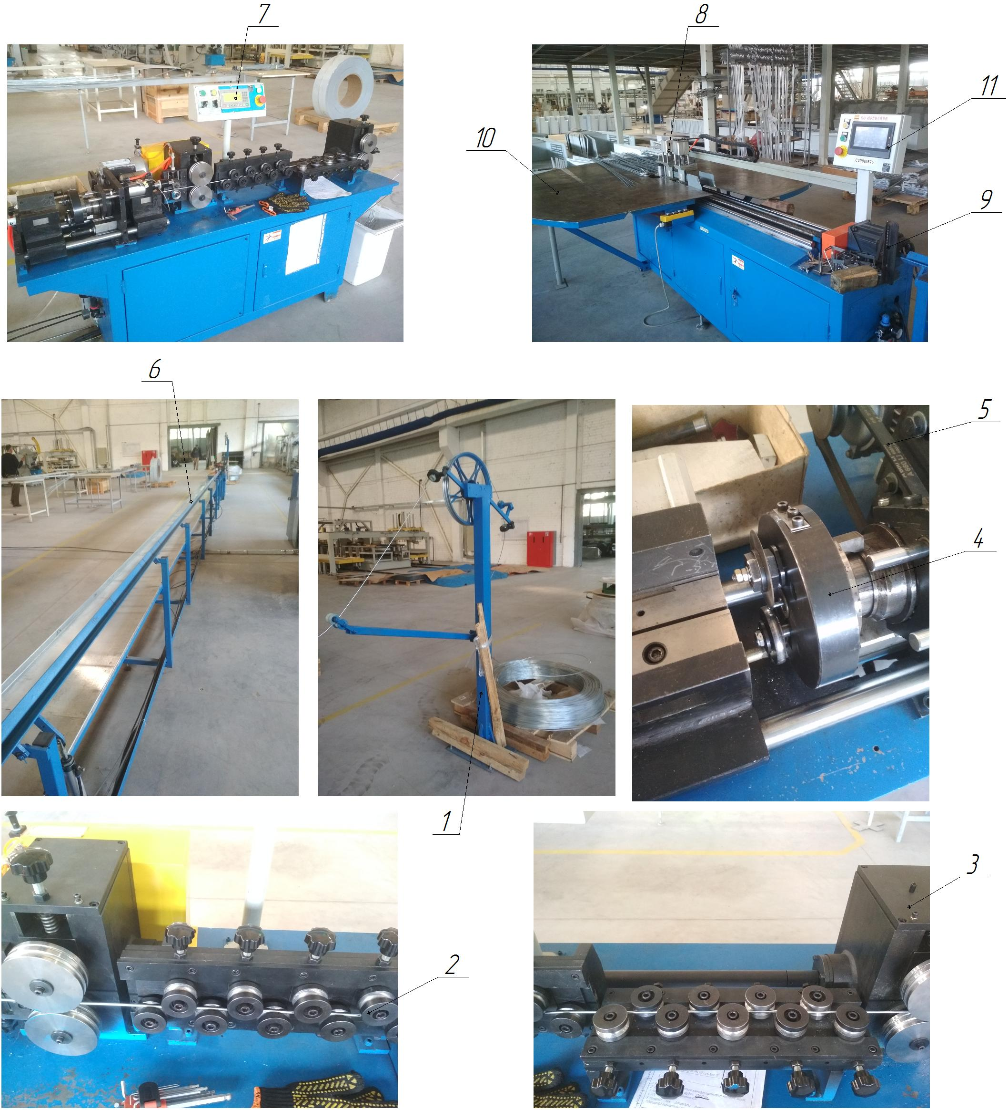

Figure 1.1 - Composition of the condenser tube cutting and bending line: 1 - tube unwinder; 2 - stretching and straightening device; 3 - stretching and straightening device drive; 4 - automatic tube cutting device; 5 - tube cutting device drive; 6 - storage tray; 7 - control panel; 8 - automatic tube bending device; 9 - tube bending device drive; 10 - tube bending device table; 11 - control panel

INSTALLATION OF FLARING TUBES

Technical characteristics
The machine is designed for flaring tubes in semi-automatic mode. The main characteristics of the machine are given in Table 1.1.
Table 1.1 - Main characteristics of the machine
Technical characteristics | Dimensional characteristics
Overall dimensions (length x width x height, mm) | 910 x 510 x 1015 (2 pcs) 850 x 550 x 860 (1 pc)
Rated supply voltage, V | 220
Frequency, Hz | 50...60
Service life (term of standard use) | 25
Evaporator tube material | Aluminum
Evaporator tube diameter, mm | Ø7
Evaporator tube diameter after flaring, mm | Ø6,1
Condenser tube material | Steel
Condenser tube diameter, mm | Ø4
Condenser tube diameter after flaring, mm | Ø4,1
Temperature mode of the unit operation, ºС | +5...+40
Working pressure in the pneumatic line, MPa | 0,5...0,6
Type of installation | Stationary
Type of control of main technological parameters | Automatic
Method of control of main technological parameters | Control panel
Compressed air for the pneumatic system | With 40 micron filtration with or without oil
Compressed air temperature during operation, ºС | +5...+50
Number of operating personnel, persons/shift | 1
Tube feeding during flaring | Manual
Dimensional accuracy during flaring, mm | +0,1
Flaring depth, mm | 10...15
Tool for flaring | Punch

Structure and operation of the machine
This unit (Fig. 1.1) is used for flaring tubes in semi-automatic mode. A Ø7 evaporator tube or a Ø4 mm condenser tube is installed in the clamping unit 2 (technological tooling - jaws) along the pneumatic stop 6. The clamping unit 2 is located on the table 9. The drive of the clamping unit is pneumatic. After clamping the tube, the stop 6 is withdrawn and the flaring unit 4 is put into operation, the drive of 5 and 7 of these units is pneumatic. After flaring the tube with the help of a punch, the unit 4 and the stop 6 are returned to their original position.
The unit consists of (Fig. 1.1):
- body, item 1;
- tube clamping unit (jaws - set of 2 pcs.), item 2;
- drive of the tube clamping unit (pneumatic), item 3;
- tube flaring unit (punch - Ø6.1 or Ø4.1), item 4;
- drive of the tube flaring unit (pneumatic), item 5;
- tube stop, item 6;
- stop drive (pneumatic), item 7;
- pneumatic installation system, item 8;
- table, item 9.

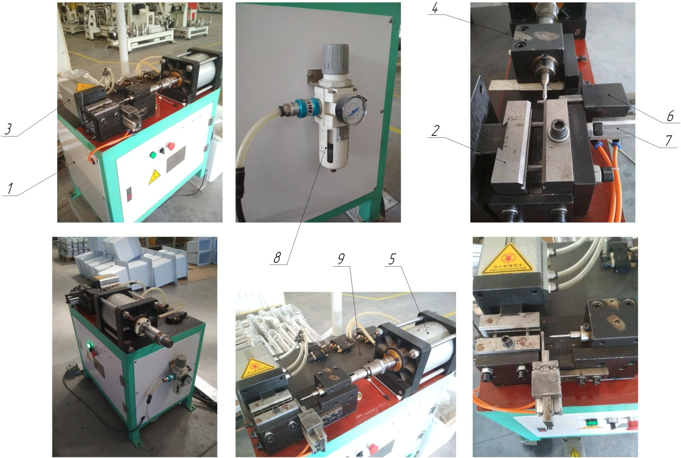

Figure 1.1 - Composition of the tube flaring unit: 1 - body; 2 - tube clamping unit; 3 - tube clamping unit drive; 4 - tube flaring unit; 5 - tube flaring unit drive; 6 - tube stop; 7 - stop drive; 8 - pneumatic installation system; 9 - table

INSTALLATION OF PNEUMATIC GLUING OF THE EVAPORATOR

Technical characteristics
The unit is designed for gluing the evaporator to the refrigerating chamber in a semi-automatic mode. The main characteristics of the unit are given in Table 1.1.
Table 1.1 - Main characteristics of the unit
Technical characteristics | Dimensional characteristics
Overall dimensions (length x width x height, mm) | 2400 x 1440 x 1900
Rated supply voltage, V | 220
Frequency, Hz | 50...60
Service life (term of normative use) | 30
Temperature mode of the unit, ºС | +5...+40
Working pressure in the pneumatic line, MPa | 0,5...0,6
Type of installation | Stationary
Type of control of main technological parameters | Automatic
Compressed air for pneumatic system | With 40 micron filtration with or without oil
Temperature regime of compressed air during operation, ºС | +5...+50
Number of operating personnel, persons/shift | 1
Installation and removal of the CP chamber | Manual
Base of the CP chamber | On the punch
Force of pressing the evaporator to the CP chamber, N | 7000...7500
Type of adhesive double-sided tape | Duplocoll
Double-sided adhesive tape width, mm | 380...390
Pneumatic cylinder diameter, mm | 125
Type of clamping plate drive | Pneumatic
Method of clamping plate drive | Direct action

Structure and operation of the unit
This installation (Fig. 1.1) is used for gluing the evaporator plate (evaporator assembly) to the refrigerating chamber (RC) using adhesive double-sided tape. The chamber is installed on the punch 3 and stops 6, which is fixed on the movable table 4, the film is removed from the adhesive double-sided tape and the evaporator plate assembly is installed. Next, the punch 3, in automatic mode, together with the chamber, moves along the guides 11 to the gantry stand 2. The pressure plate 5, on which the buffer rubber plate 10 is fixed, presses the evaporator plate to the refrigerating chamber using the pneumatic system of the installation 7 (pneumatic cylinder). After the operation of gluing the evaporator, the punch 3 moves along the guides 11 to the initial position in which the chamber with the glued evaporator is freely removed from it.
The installation includes (Fig. 1.1):
- frame, item 1;
- portal stand, item 2;
- punch (replaceable, for each CP model separately), item 3;
- movable table, item 4;
- pressure plate, item 5;
- guide stops (for basing the KP chamber), item 6;
- pneumatic installation system, item 7;
- control panel, item 8;
- protective fence, item 9;
- buffer rubber plate, item 10;
- guides of the moving table, item 11.

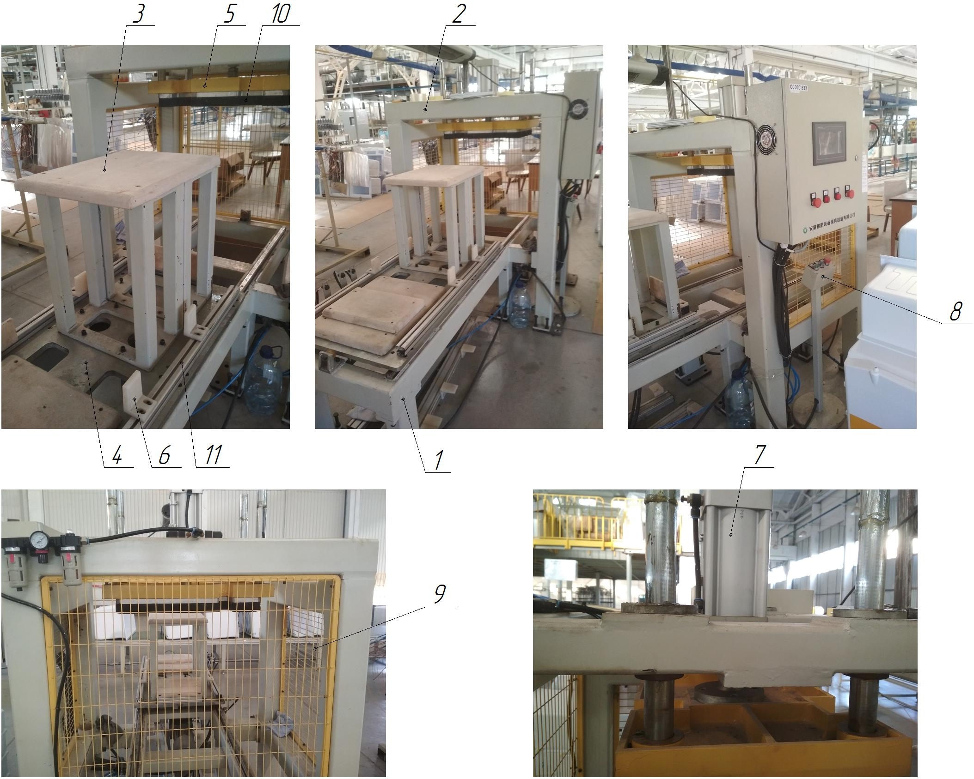

Figure 1.1 - Composition of the installation for gluing the evaporator plate to the CP chamber: 1 - frame; 2 - gantry stand; 3 - punch; 4 - movable table; 5 - pressure plate; 6 - guide stops; 7 - pneumatic installation system; 8 - control panel; 9 - protective fence; 10 - buffer rubber plate; 11 - movable table guides

PNEUMATIC-HYDRAULIC TWO-POSITION HEAT PRESS

Technical characteristics
The heat press is designed for gluing laminated aluminum plates to the evaporator tube in a special technological equipment in a semi-automatic mode. The main characteristics of the heat press are given in Table 1.1.
Table 1.1 - Main characteristics of the heat press
Technical characteristics of the line | Dimensional characteristics
Overall dimensions (length x width x height, mm) | 3500 x 850 x 2800
Rated supply voltage, V | 380 (three-phase, variable)
Frequency, Hz | 50...60
Service life (term of standard use) | 25 years
Dimensions of the movable table, WxD, mm | 500х600
Dimensions of the clamping plate, WxD, mm
Dimensions of the heating plate, WxD, mm | 560х600
Number of clamping plates, pcs. | 2
Number of heating plates, pcs. | 1
Number of movable tables, pcs. | 2
Type of table | Movable
Heating plate power, kW | 3,0
Temperature mode of heating plate, ºС | 160...180
Temperature mode of the heat press, ºС | +10...+50
Working pressure in the pneumatic line, MPa | 0,5...0,6
Type of heat press | Stationary
Type of control of main technological parameters | Automatic
Method of controlling the main technological parameters | Control panel
Compressed air for the pneumatic system | With 40 micron filtration with or without oil
Compressed air temperature during operation, ºС | +5...+50
Number of operating personnel, persons/shift | 1
Time range, s | 0...999
Temperature accuracy, %. | ± 0,5
Lowering and raising the heating plate | Automatic
Heating plate drive | Pneumatic
Drive of tables | Pneumatic
Type of control of the main technological process | Semi-automatic
Weight, kg | 480

Construction and operation of the heat press
The heat press is built on a modular basis. The heat press glues laminated aluminum plates to the evaporator tube in a semi-automatic mode.
The tablet heat press is equipped with a timer and automatically turns on when the clamping and heating plate is lowered and turns off when it is raised. Large plate size, powerful reliable design with a floating head (clamping and heating plate) that ensures even pressure, and two movable tables below.
The heat press consists of (Fig. 1.1):
- frame, item 1;
- left movable table, item 2;
- movable right table, item 3;
- heating plate (floating head), item 4;
- clamping plate left (floating head), item 5;
- clamping plate, right (floating head), item 6;
- Pneumatic system of the heat press, item 7.

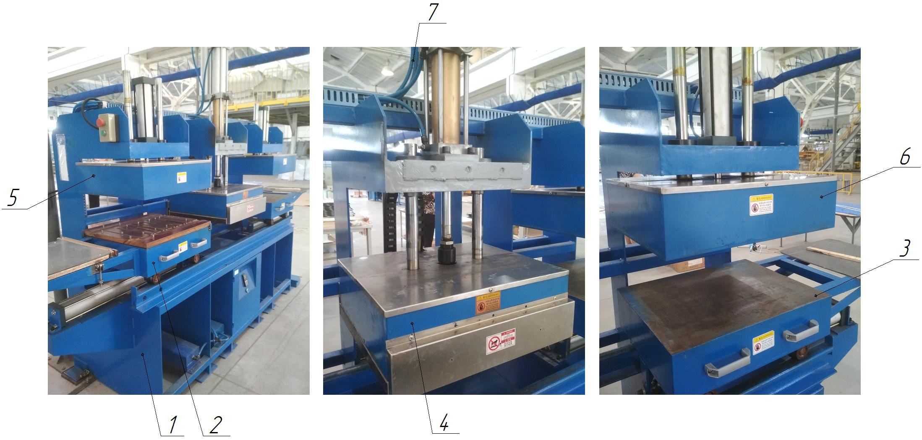

Figure 1.1 - Structure of the heat press: 1 - frame; 2 - left movable table; 3 - right movable table; 4 - heating plate; 5 - left clamping plate; 6 - right clamping plate; 7 - pneumatic system of the heat press

TUBE CUTTING LINE

Technical characteristics
The line is designed for cutting copper tubes in automatic mode. The main characteristics of the line are given in Table 1.1.
Table 1.1 - Main characteristics of the line
Technical characteristics of the line | Dimensional characteristics
Overall dimensions (length x width x height, mm) | 10000 x 1000 x 1500
Rated supply voltage, V | 380 (three-phase, variable)
Frequency, Hz | 50...60
Line capacity, pcs/h
Tube cutting unit, pcs. | 1
Number of simultaneous tubes cutting, pcs. | 1
Material of tubes for cutting | Copper
Diameter of tubes for cutting, mm | 3...6
Temperature mode of line operation, ºС | +5...+40
Working pressure in pneumatic lines, MPa | 0,5...0,6
Type of line | Stationary
Type of control of main technological parameters | Automatic
Method of controlling the main technological parameters | Control panel
Compressed air for pneumatic systems | With 40 micron filtration with or without oil
Compressed air temperature during operation, ºС | +5...+50
Length of the storage tray, mm | 5000
Number of operating personnel, persons / shift | 1
Feeding tube for cutting | Automatic
Dimensional accuracy when cutting tubes, mm | ±1

Composition of the line
The line is built on a modular basis. Copper tubes are cut automatically on the line.
The line consists of (Fig. 1.1):
- tube unwinder item 1;
- length straightening device item 2;
- drive of the length-correcting device item 3;
- automatic tube cutting device item 4;
- drive of the tube cutting device item 5;
- storage tray item 6;
- control panel item 7.

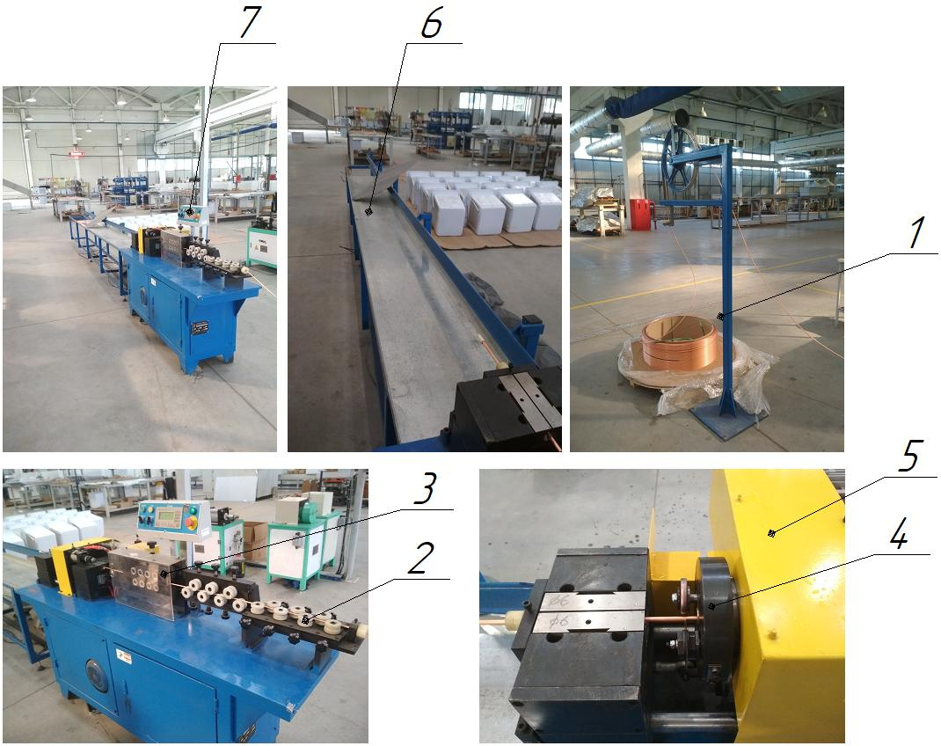

Figure 1.1 - Composition of the tube cutting line: 1 - tube unwinder; 2 - stretching and straightening device; 3 - drive of the stretching and straightening device; 4 - automatic tube cutting device; 5 - drive of the tube cutting device; 6 - storage tray; 7 - control panel

PNEUMOHYDRAULIC PRESS

Technical characteristics
The press is designed for simultaneous punching of holes in the evaporator plate in semi-automatic mode. The main characteristics of the press are given in Table 1.1.
Table 1.1 - Main characteristics of the press
Technical characteristics | Dimensional characteristics
Overall dimensions (length x width x height, mm) | 690 x 1140 x 1900
Rated supply voltage, V | 220
Frequency, Hz | 50...60
Service life (term of standard use) | 25
Evaporator plate material | Aluminum
Evaporator plate thickness, mm | 0,45...0,5
Evaporator plate base | On the stops
Number of stops, pcs. | 3
Tool for punching holes | Punch
Number of punches, pcs. | 12
Temperature mode of the unit, ºС | +5...+40
Working pressure in the pneumatic line, MPa | 0,2...0,7
Type of built-in stamp | Punching
Type of press | Stationary
Method of control of main technological parameters | Control panel
Compressed air for the pneumatic system | With 40 micron filtration with or without oil
Compressed air temperature during operation, ºС | +5...+50
Number of operating personnel, persons / shift | 1
Evaporator plate feeding | Manual
Pneumatic cylinder diameter, mm | 80
Press drive, mm | Pneumohydraulic, direct action
Gas-liquid amplifier | STA-80-100-10-5T
Type of installation of the gas-liquid amplifier | Vertical
Total stroke, mm | 100
Total stamping force, t | 25

Structure and operation of the press
On the press (Fig. 1.1), 12 holes are simultaneously punched in the evaporator plate. The evaporator plate is installed in the punch 3 along the stops 7. The punch 3 is fixed on the cantilever plate 6 and the press table 2. Then, with the help of a direct-acting pneumohydraulic drive 4, the cantilever plate 6 with punches is lowered, thus simultaneously punching 12 holes in the evaporator plate. After raising the cantilever plate 6 by unclamping the springs of the die, the evaporator plate is removed from the die 3.

The press consists of (Fig. 1.1):
- frame, item 1;
- table, item 2;
- punch (built-in), item 3;
- stops (3 pcs.).
- pneumatic-hydraulic drive (direct action), item 4;
- Pneumatic press system, item 5;
- cantilever plate, item 6;
- stops (3 pcs.), item 7.

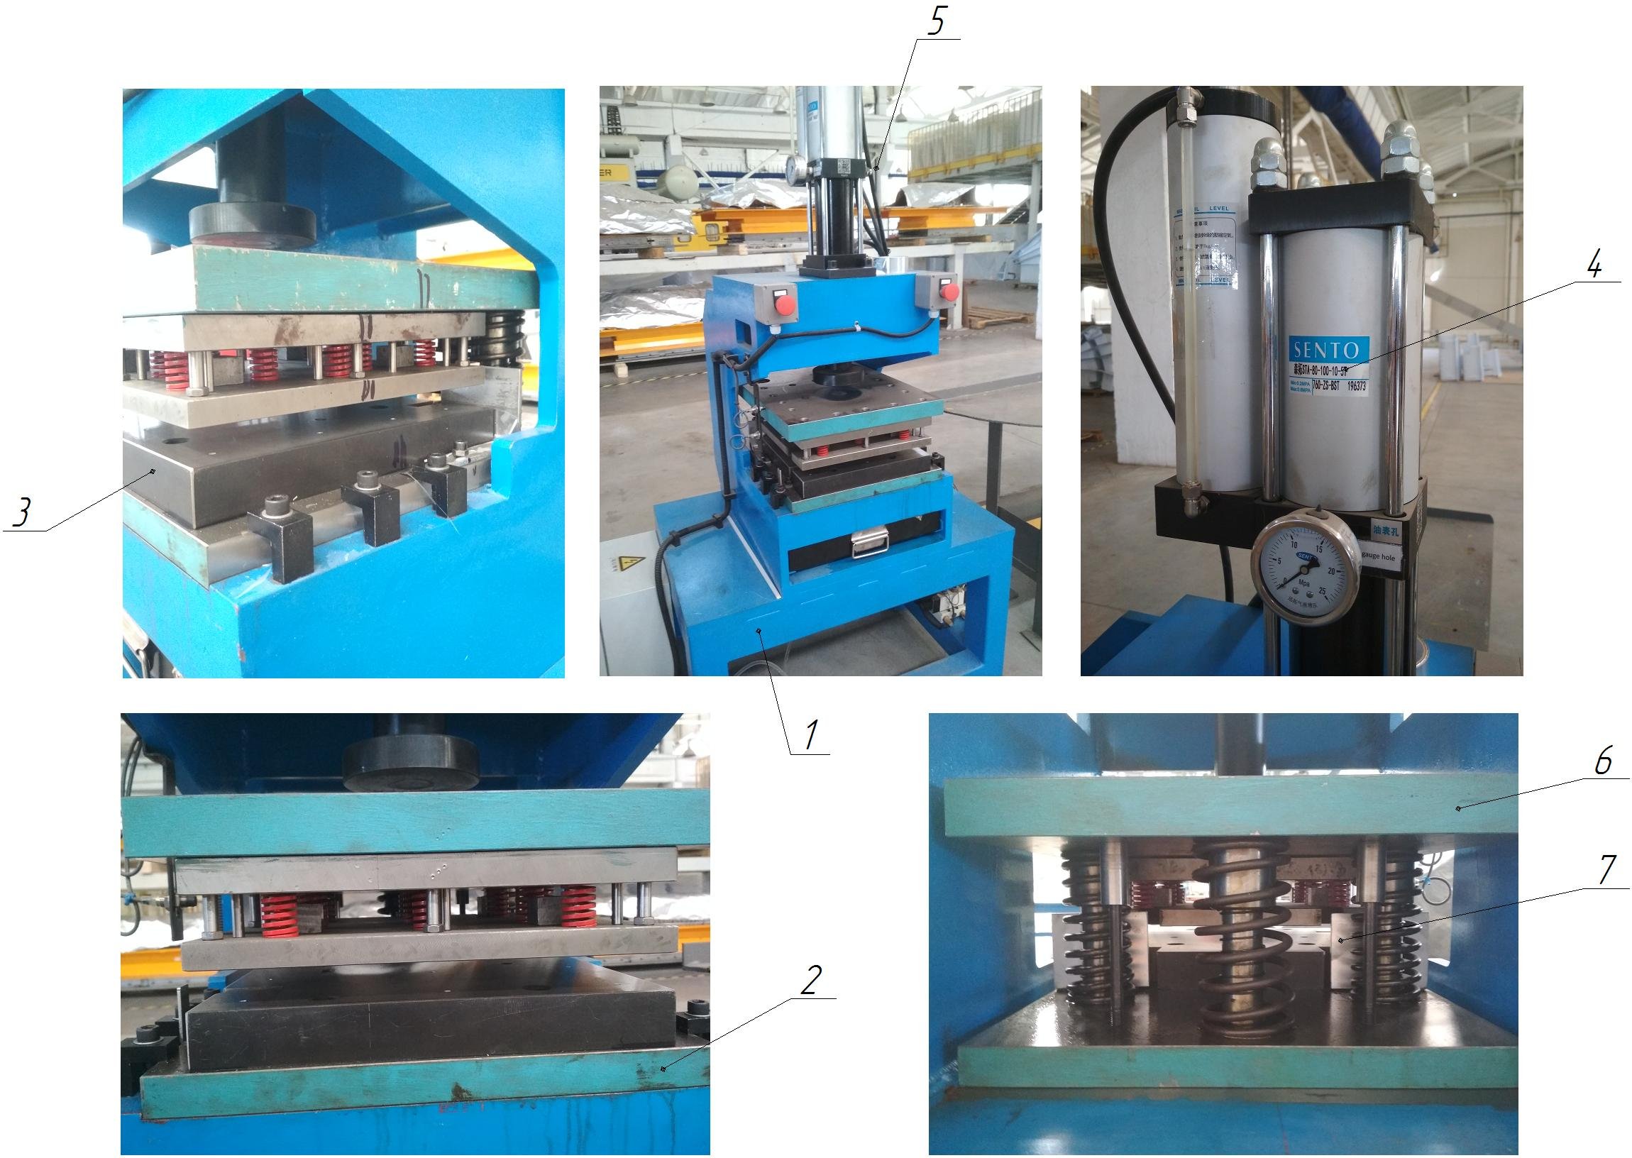

Figure 1.1 - Composition of the punching press: 1 - frame; 2 - table; 3 - punch; 4 - pneumatic cylinder; 5 - pneumatic system of the press; 6 - cantilever plate; 7

ROLL LAMINATOR

Technical characteristics
The laminator is designed for applying (laminating) thermal film to aluminum plates in automatic mode. The main characteristics of the laminator are given in Table 1.1.
Table 1.1 - Main characteristics of the laminator
Technical characteristics of the line | Dimensional characteristics
Overall dimensions (length x width x height, mm) | 1300 x 1150 x 1400
Rated supply voltage, V | 220
Frequency, Hz | 50...60
Service life (term of standard use) | 25 years
Plate feeding | Automatic
Plate feeding method | Conveyor
Laminator operating temperature, ºС | +10...+30
Type of machine | Stationary
Type of control of the main technological parameters | Automatic
Method of controlling the main technological parameters | Control panel
Number of operating personnel, persons / shift | 1
Material of the plates | Aluminum
Plate thickness for lamination, mm | 0,5
Number of heating fans, pcs. | 3
Type of pressing steel rollers | Hydraulic
Type of manual hydraulic pump | SYB-1
Maximum lamination width, mm | 720
Laminating speed, m/min | 0...15
Maximum heating temperature, ºС | 160
Maximum lamination thickness, mm | 2
Heating power, W | 5400
Motor power, W | 400
Laminator weight, kg | 550
Heating method | Infrared heating
Steel roller diameter, mm | 200
Rubber roller diameter, mm | 150
Covering of rubber rollers | Heat-resistant silicone rubber
Number of rubber rollers, pcs. | 2
Type of film to be applied | Thermal film (film-glue)

Structure and operation of the laminator
The laminator is built on a modular basis. The laminator applies (laminates) thermal film to aluminum plates (see Fig. 1.1) in automatic mode.
From the loading position - unwinder 6, the thermal film is fed, which is heated in the heating unit 11, an aluminum plate is fed along the conveyor 2, which passes between the steel hot shafts of external heating (the lower shaft is pressed to the upper one by means of a manual hydraulic pump 4), thus laminating the thermal film onto aluminum plates. The film is rolled to the plate by cold rubber rollers 9 at the outlet. In the roll laminator, the rolls are heated externally by a special cylindrical segment with an integrated nichrome or ceramic heater (infrared heating with hot air). A hydraulic pressure system provides high and stable pressure to guarantee good lamination quality. Fans 7 heat the thermal film before it is rolled onto the aluminum plate, in front of the rubber rollers 9.

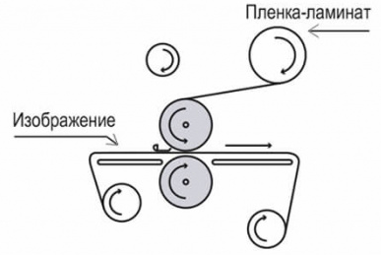

Figure 1.1 - Scheme of lamination of metal plates

The machine consists of (Fig. 1.2):
- frame, item 1;
- conveyor, item 2;
- steel roller, item 3;
- manual hydraulic pump, item 4;
- control panel, item 5;
- unwinder with thermal film, item 6;
- heating fans, item 7 (3 pcs.);
- roller drive, item 8;
- rubber roller, item 9;
- winder, item 10;
- heating unit, item 11;
- stabilizer (roller), item 12.

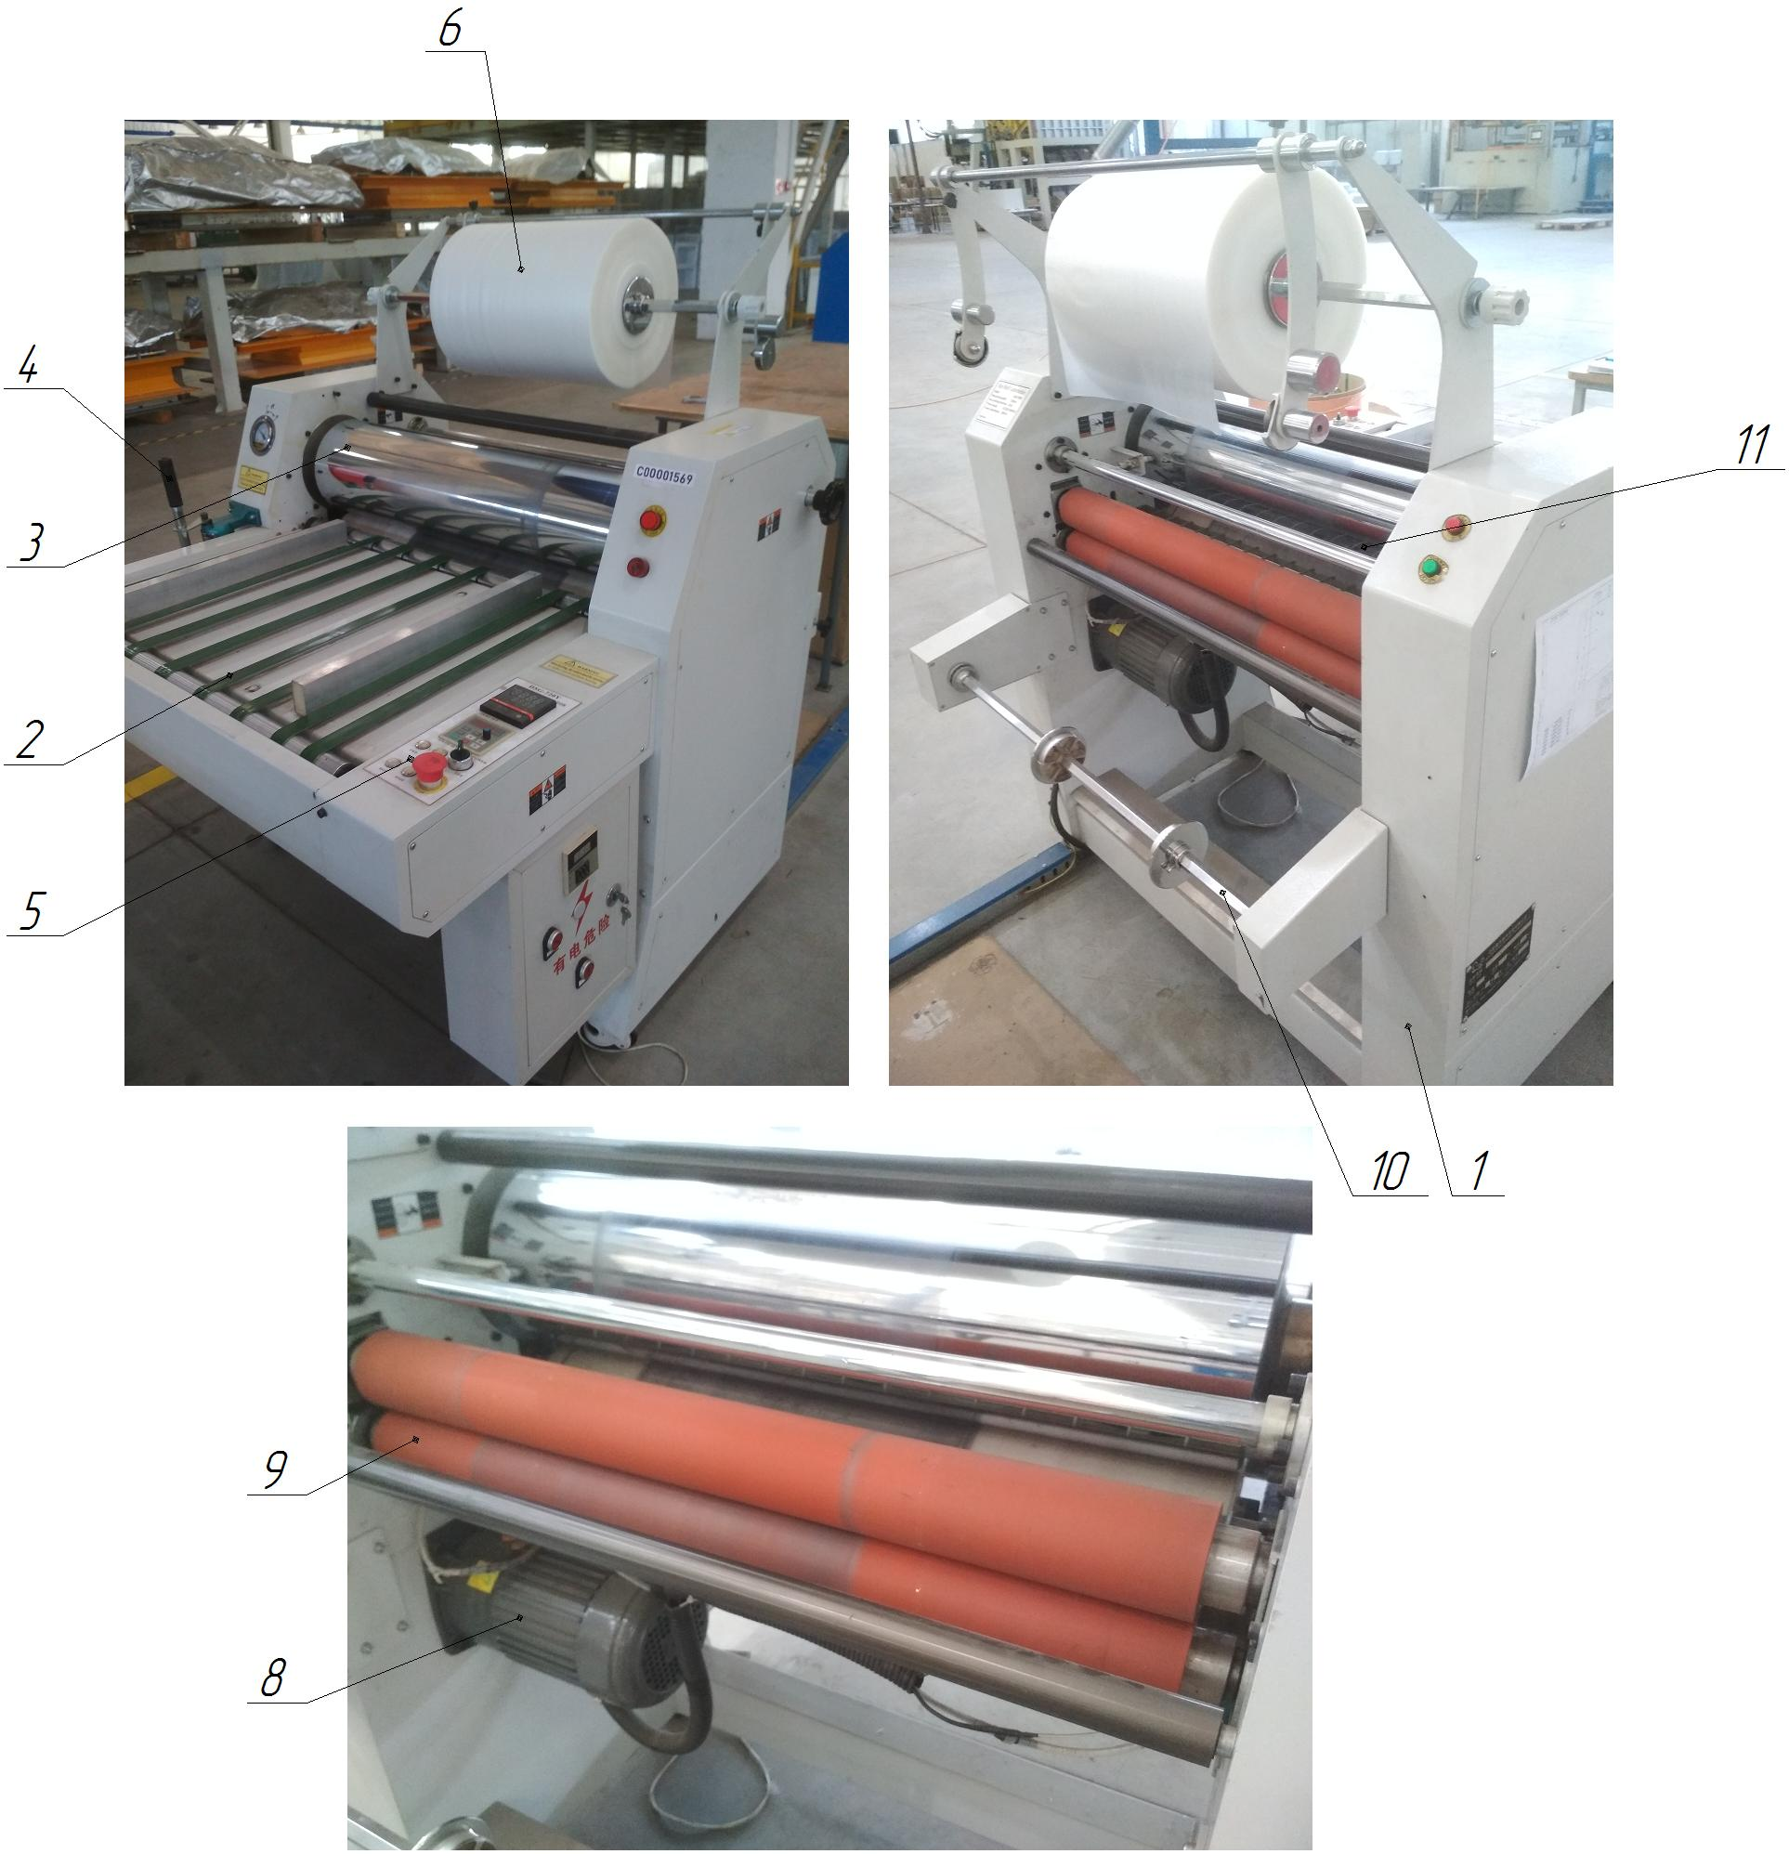

Figure 1.2 - Structure of the machine: 1 - frame; 2 - conveyor; 3 - steel roller; 4 - manual hydraulic pump; 5 - control panel; 6 - unwinder with thermal film; 7 - heating fans; 8 - roller drive; 9 - rubber roller; 10 - coiler; 11 - heating unit; 12 - stabilizer (roller)

INSTALLATION OF TUBE ROLLING

Technical characteristics
The machine is designed for rolling tubes in semi-automatic mode. The main characteristics of the machine are given in Table 1.1.
Table 1.1 - Main characteristics of the plant
Technical characteristics | Dimensional characteristics
Overall dimensions (length x width x height, mm) | 480 x 530 x 1030
Rated supply voltage, V | 220
Frequency, Hz | 50...60
Service life (term of standard use) | 25
Evaporator tube material | Aluminum
Evaporator tube diameter, mm | Ø7
Evaporator tube diameter after rolling, mm | Ø6
Compensator tube material | Copper
Compensator tube diameter, mm | Ø6
Inner diameter of the compensator tube after rolling, mm | Ø3,1
Temperature mode of the unit, ºС | +5...+40
Type of installation | Stationary
Number of operating personnel, persons/shift | 1
Tube feeding during rolling | Manual
Dimensional accuracy, during rolling, mm | +0,1
Tool for rolling | Rollers
Rolling depth, mm | 10...15
Rated supply voltage, V | 220
Frequency, Hz | 50...60
Drive of the rolling mechanism | Electromechanical
Tool for rolling | Rollers and punch

Structure and operation of the machine
This unit (Fig. 1.1) performs tube rolling in a semi-automatic mode. The Ø7 evaporator tube or Ø6 mm compensator tube is installed in the rolling unit 2, the drive of this unit 3 is electromechanical. The tube is rolled using rollers and a punch.
The unit consists of (Fig. 1.1):
- body, item 1;
- tube rolling unit, item 2;
- drive of the tube rolling unit (electromechanical), item 3.

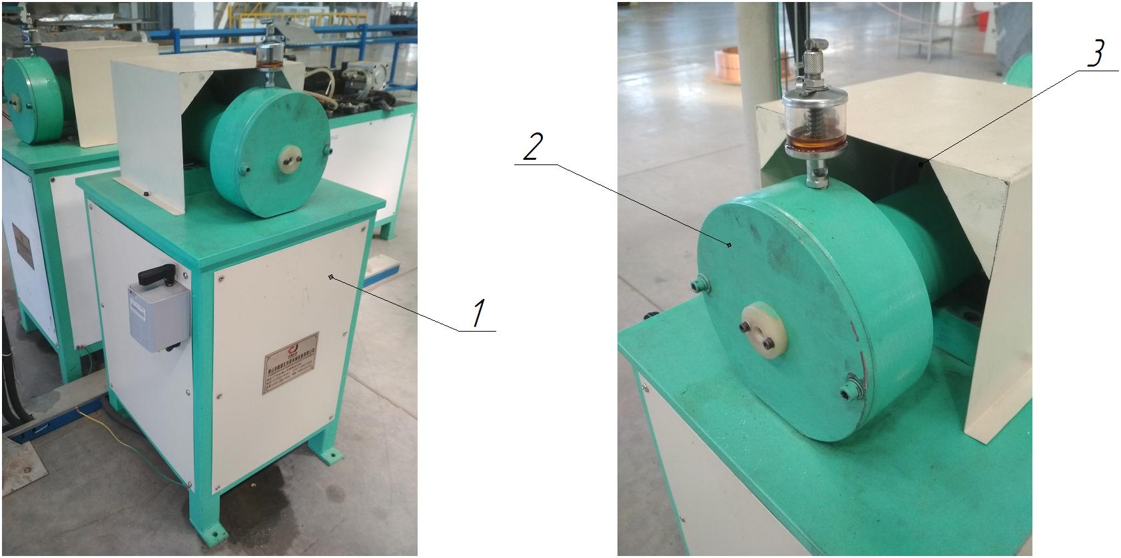

Figure 1.1 - Composition of the tube rolling unit: 1 - housing; 2 - tube rolling unit; 3 - drive of the tube rolling unit (electromechanical)

ELECTROMECHANICAL GUILLOTINE SCISSORS Q11

Technical characteristics
The scissors are designed for cold cutting of sheet material (polystyrene sheet with a thickness of 1.2...4.2 mm). The main characteristics of the scissors are given in Table 1.1.
Table 1.1 - Main characteristics of the scissors
Technical characteristics of the scissors | Q11-1/2 | Q11-3
Overall dimensions (length x width x height, mm) | 3250 x 1350 x 1300 | 2250 x 1200 x 1100
Rated supply voltage, V | 380 (3f, variable) | 380 (3f, variable)
Frequency, Hz | 50...60 | 50...60
Maximum dimensions when cutting, mm | 4 х 2100 | 1 х 1000
Normal service life (service life) | 30 years | 30 years
Number of cutting edges of the knife | 4 | 4
Table dimensions, mm | 2690 х 320 | 1510 х 460
Number of knives, upper/lower, pcs. | 2/2 = 4 | 1/1 = 2
Temperature mode of scissors operation, ºС | +5...+50 | +5...+50
Electric motor power, kW | 5,5 | 3
Electric motor speed, rpm | 1440 | 1440
Number of points of automatic lubrication system | 4 | -
Type of scissors | Stationary | Stationary
Type of control | Pedal | Pedal
Number of operating personnel, persons / shift | 1 | 1
Dimensional accuracy when cutting, mm | ±1 | ±1
Availability of a centralized lubrication system (CPS) | Є | Absent
Weight, kg | 2100 | 850
Structure and operation of the scissors
The scissors' frame is prefabricated and welded, which increases the rigidity of the structure, and consists of two posts and a table. The table rests on the uprights and the traverse. Adjustment of the gap between the knives of the knife beam and the frame is carried out by moving the table, depending on the thickness of the material to be cut. The racks have bore holes in them, in which a crank shaft with connecting rods is mounted on rolling bearings.
The Q11-1/2 scissors are driven by an electric motor mounted on the turntable, through a V-belt transmission to the gearbox drive shaft and then to the crank shaft. The Q11-3 scissors are driven from the gear motor to the crank shaft. See Fig. 1.1 for the location of the scissors components.
Guillotine shears Q11-1/2 consist of (Fig. 1.1):
- frame, item 1;
- electromechanical drive, item 2;
- electromechanical drive fence, item 3;
- knife beam, POS.4;
- guillotine knives, item 5 (4 pcs.);
- table, item 6;
- drive shaft, item 7;
- Cylindrical spur gear, item 8 (open gearbox);
- spur gear guard, item 9;
- eccentric shaft, item 10;
- connecting rods, item 11;
- mechanism for locking and switching on the shears, item 12;
- scissors lubrication system, item 13;
- workplace lighting, item 14;
- spring balancer, item 15;
- control panel, item 16.

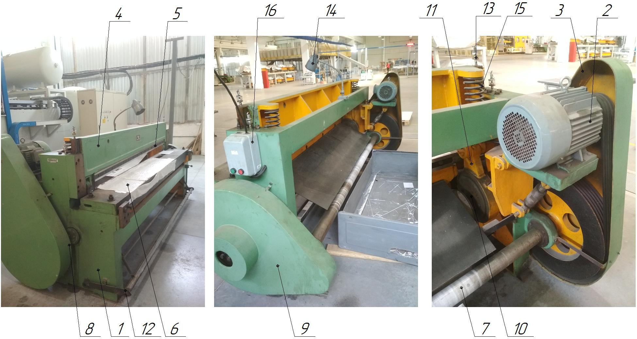

Figure 1. 1 - Location of the components of the Q11-1/2 scissors: 1 - frame; 2 - electromechanical drive; 3 - electromechanical drive guard; 4 - knife beam; 5 - guillotine knives (4 pcs.); 6 - table; 7 - drive shaft; 8 - spur gear; 9 - fence of the cylindrical spur gear; 10 - eccentric shaft; 11 - connecting rods; 12 - mechanism for locking and switching on the scissors; 13 - scissors lubrication system; 14 - workplace lighting; 15 - spring balancer; 16 - control panel

Guillotine scissors Q11-3 include (Fig. 1.2):
- frame, item 1;
- electromechanical drive, item 2 (gear motor);
- knife beam, POS.3;
- guillotine knives, item 4 (2 pcs.);
- table, item 5;
- eccentric shaft, item 6;
- connecting rod, item 7 (2 pcs.);
- scissors shutdown mechanism, item 8;
- clamping beam, item 9;
- spring balancer, item 10;

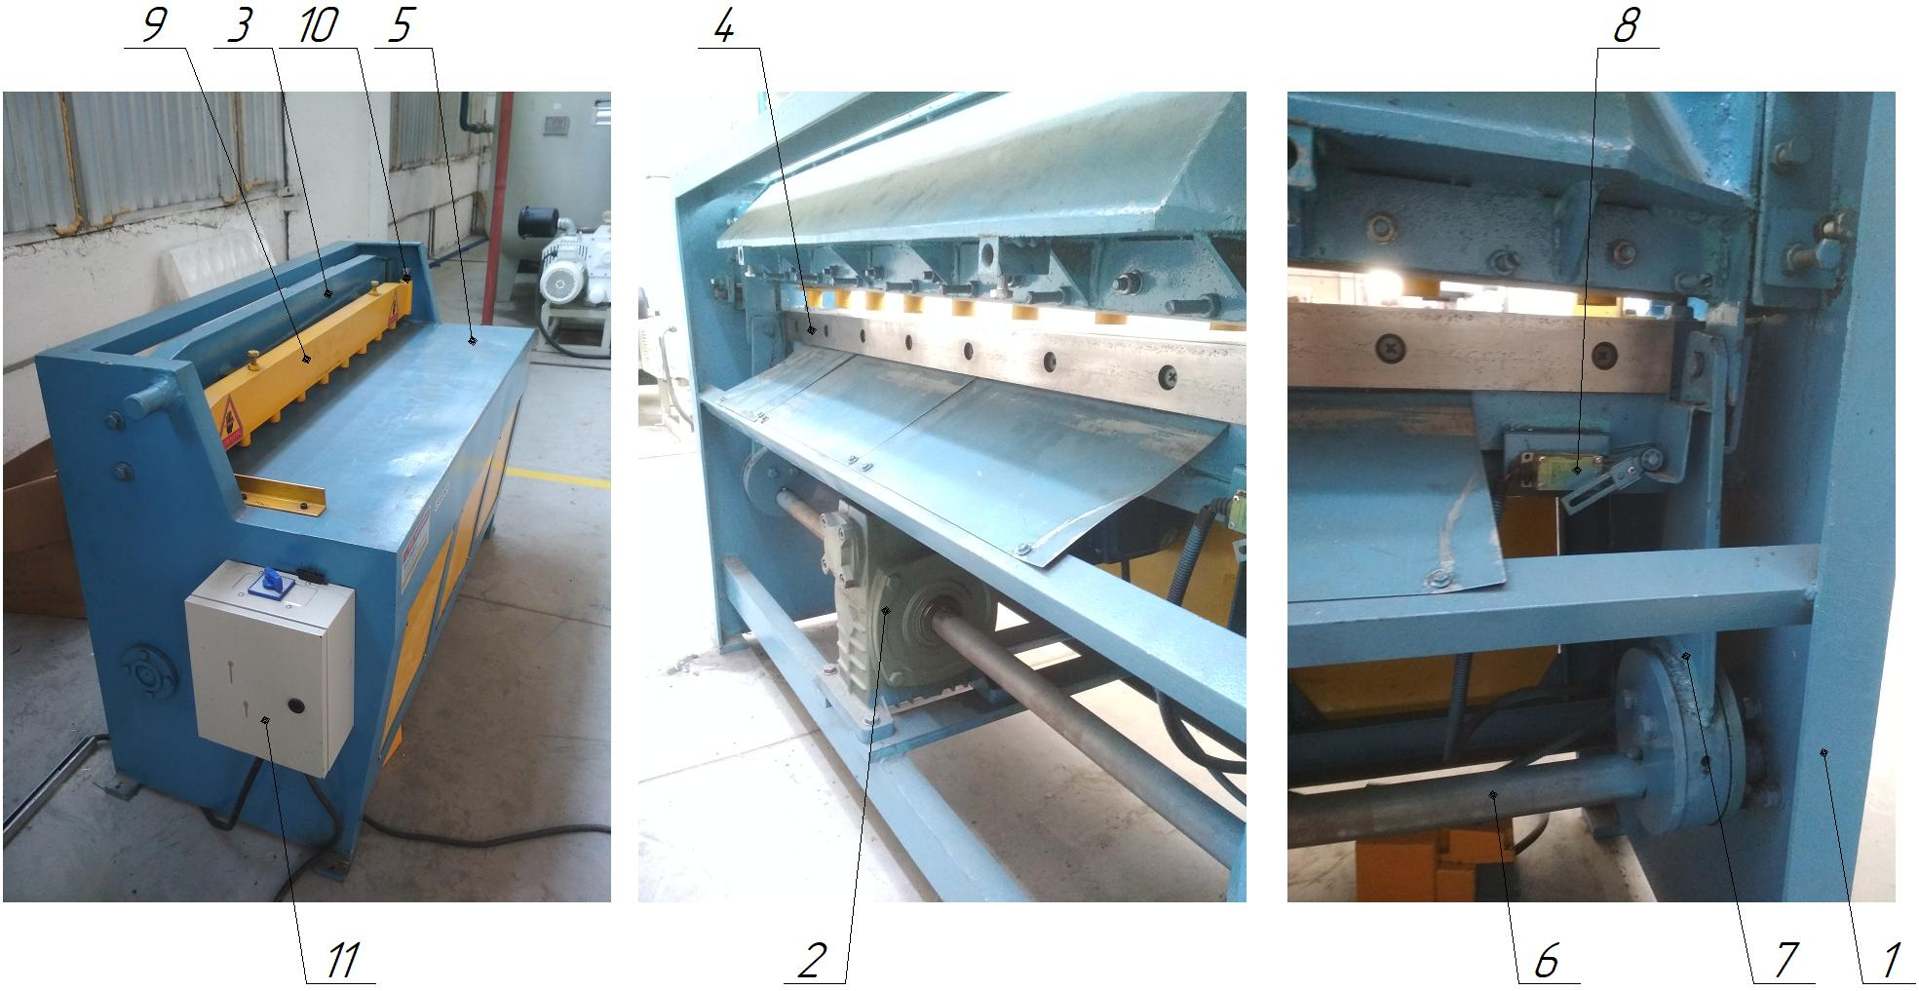

Figure 1.2 - Location of the components of the Q11-3 scissors: 1 - frame; 2 - electromechanical drive (gear motor); 3 - knife beam; 4 - guillotine knives (2 pcs.); 5 - table; 6 - eccentric shaft; 7 - connecting rod (2 pcs.); 8 - scissors switch-off mechanism; 9 - clamping beam; 10 - spring balancer; 11 - control cabinet

The cutting mechanism consists of a clamping beam and a knife beam. During the working stroke, the knife and clamping beams are lowered simultaneously.
The clamping beam is of a cantilevered design that swings: the knife beam moves in its straight guides. The sheet is pressed down by the force of the compressed springs and the beam's own weight. The clamping beam and the shear beam are connected to each other by a system of levers, which is connected to the shear drive. The upper part of the clamping beam is equipped with screw stops that serve to return it to the upper position.
The rear stop mechanism is mounted on the knife beam and consists of two slide screws with a fixed (hinged) stop bar. For cutting thin sheet metal, the scissors are equipped with a support.
To protect the operator's hands in the cutting area, a protective grille is used that locks with the scissors' trigger.
The length of the workpiece to be cut is set by the backstop handwheel, along a ruler located on the guide rails of the backstop mechanism.

HEAT EXCHANGER WINDING MACHINE

Technical characteristics
The machine is designed for winding and simultaneous fixing (gluing) of heat exchangers (aluminum evaporator tubes) on the walls of freezers of refrigerators, using aluminum adhesive tape, in automatic mode. The main characteristics of the machine are shown in Table 1.1.
Table 1.1 - Main characteristics of the machine
Technical characteristics of the line | Dimensional characteristics
Overall dimensions (length x width x height, mm) | 6500 x 2200 x 2450
Rated supply voltage, V | 220
Frequency, Hz | 50...60
Service life (term of normative use) | 25 years
Tube feeding for winding | Automatic
Dimensional accuracy, when cutting tubes, mm | ±1
Dimensional accuracy, when winding tubes, mm | ±1
Temperature mode of the machine, ºС | +10...+50
Working pressure in the pneumatic line, MPa | 0,5...0,6
Type of machine | Stationary
Type of control of main technological parameters | Automatic
Method of control of main technological parameters | Control panel
Compressed air for the pneumatic system | With 40 micron filtration with or without oil
Compressed air temperature during operation, ºС | +5...+50
Number of operating personnel, persons / shift | 1
Material of evaporator tubes for winding | Aluminum
Diameter of evaporator tubes for winding, mm | 7

Structure and operation of the machine
The machine is built on a modular basis. The machine is used for winding and simultaneous fixing (gluing) of heat exchangers (aluminum evaporator tubes) on the walls of freezers of refrigerators, using aluminum adhesive tape, in automatic mode.
From the loading position (see Fig. 1.1), with the help of the tube unwinder pos.1, the blank of aluminum tube with a diameter of 7 mm is fed into the broaching and straightening device pos.2, and then into the device for automatic feeding and cutting of aluminum adhesive tape pos.7. In this unit, the adhesive aluminum tape is glued to the heat exchanger tube, then the tube with the tape is fed to the device for automatic winding and fixing of the heat exchanger tube (Fig. 8). The freezer is installed on the turntable of item 9 with the punch of item 11 in accordance with the model of the refrigerator. The main technological parameters are controlled in automatic mode, all data is entered directly from the control panel of item 6. The drive of the turntable item 10 consists of a gear motor. The rotary table item 9 and the device for automatic winding and fixing of the heat exchanger tube item 8 are switched on. The heat exchanger tube winding is performed with a given step, then, at the end of the tube winding, the device stops, and two devices for automatic tube cutting (item 4) and cutting of adhesive aluminum tape (item 7) are switched on. The automatic tube cutting device item 4 cuts the tube using high-speed steel disk knives. The drive of the tube cutting device of item 5 consists of an electric motor and a belt drive. The finished freezer with the coiled and fixed heat exchanger tube is removed from the punch item 11, and then a new freezer is installed.
The tube winding parameters can be programmed. Set the winding parameters: number of turns, speed, direction of rotation of the winding shaft, distance between layout steps, distance between positions (transition step in mm), transition direction, dynamic brake mode. Select the winding program, bring the machine mechanism to the zero winding mark, then wind the first row tightly, the pitch is set automatically. There is an automatic stop function when the specified number of turns is reached. Acceleration and stopping of the spindle occurs gradually, the speed in different areas is maintained automatically, according to the program.
Functions performed by the operator: filling the tube on the chamber (punch); setting the winding parameters: number of winding turns per section, winding speed, number of winding turns (winding speed reduction mode), number of start turns, winding shaft rotation direction, winding speed and winding speed, layout step, layout direction, layout mode (orthocyclic or normal), distance between sections (transition step), transition direction, direction of counting turns, winding sequence of sections, cutting of the tube; removal of the finished product (chamber) from the punch.
The machine includes (Fig. 1.1):
- tube unwinder item 1;
- stretching and straightening device (1) item 2;
- drive of the length-correcting device item 3;
- automatic tube cutting device item 4;
- drive of the tube cutting device item 5;
- length straightening device (2) item 6;
- drive of the length straightening device item 7;
- control panel item 8;
- device for automatic feeding and cutting of adhesive aluminum tape item 9;
- device for automatic winding and fixing of the heat exchanger tube item 10;
- rotary table item 11;
- rotary table drive item 12;
- punch for the freezer item 13.

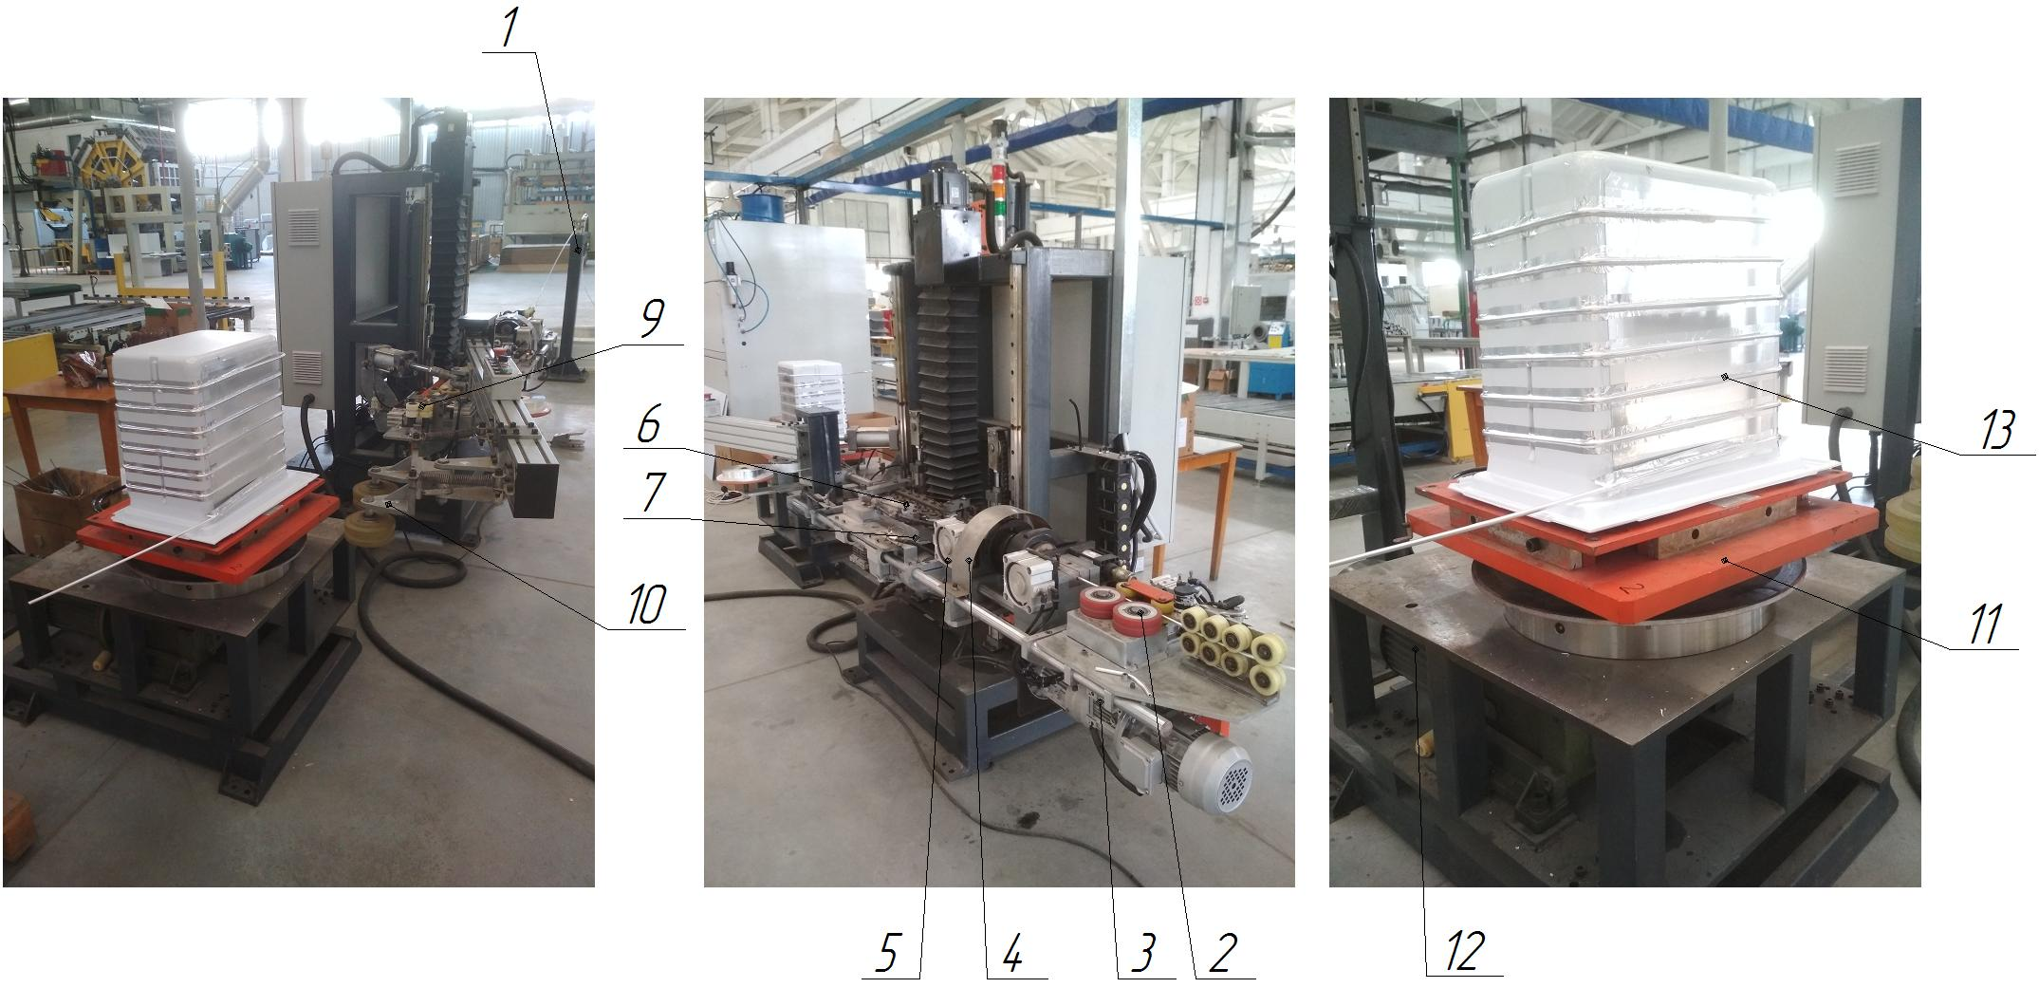

Figure 1.1 - Structure of the machine: 1 - tube unwinder; 2 - stretching and straightening device (1); 3 - drive of the stretching and straightening device; 4 - automatic tube cutting device; 5 - drive of the tube cutting device; 6 - stretching and straightening device (2); 7 - drive of the stretching and straightening device; 8 - control panel; 9 - device for automatic feeding and cutting of adhesive aluminum tape; 10 - device for automatic winding and fixing of the heat exchanger tube; 11 - rotary table; 12 - rotary table drive; 13 - punch for the freezer

AUTOMATIC STRAPPING MACHINE

Specifications.
The machine is designed for tying the KP packaging with a special tape in automatic mode. The main characteristics of the machine are given in Table 1.1.
Table 1.1 - Main characteristics of the machine
Technical characteristics | Dimensional characteristics
Overall dimensions (length x width x height, mm) | 620 x 2000 x 2800
Rated supply voltage, V | 380
Frequency, Hz | 50...60
Service life (term of normative use) | 25
Temperature mode of the machine, ºС | +0...+40
Working pressure in the pneumatic line, MPa | 0,5...0,6
Type of installation | Stationary
Type of control of main technological parameters | Automatic
Compressed air for the pneumatic system | With 40 micron filtration with or without oil
Compressed air temperature regime during operation, ºС | +5...+50
Number of operating personnel, persons / shift | 1
Total power of the machine, kW | 1,3
Belt feed speed, s | 2,5
Tape tightening force (adjustable), kg | 0...60
Carrying capacity of the machine table, kg | 100
Material of strapping tape | Polypropylene
Tape width, mm | 9...15 ± 1
Tape thickness, mm | 0,55...1,0 ± 0,1
Maximum tensile strength of the strap, kg | 150
Working table height, mm | 450
Machine weight, kg | 330
Operating noise, dB | Up to 85
Relative humidity during machine operation, %. | Up to 90
Characteristics of the seam to be bonded  - bonding surface, %  - bonding width, %  - deviation of the bonding position, mm | ≥ 90  ≥ 20  ≤ 2
Method of gluing the seam | Hot melt

Structure and operation of the machine
This machine is used for tying the KP packaging with a special tape in automatic mode.
The strapping tape is fed from the cassette 2 along the guides to the tape feeder 7, then through the strapping frame 4 and to the tape heating and cutting unit 8. The packaged CP is fed along the conveyor to the table 5, where the machine is fully automatic, tying the CP package twice with tape. The machine is controlled from the control panel 3. The tape feeding unit 7 and the tape heating and cutting unit 8 are located under the hinged covers of the table 6.
The machine consists of (Fig. 1.1):
- body, item 1;
- tape cassette, item 2;
- control panel, item 3;
- tying frame, item 4;
- table, item 5;
- hinged table covers (2 pcs.), item 6;
- tape feeding unit, item 7;
- unit for heating and cutting the tape, item 8;
- pneumatic system of the machine, item 9.

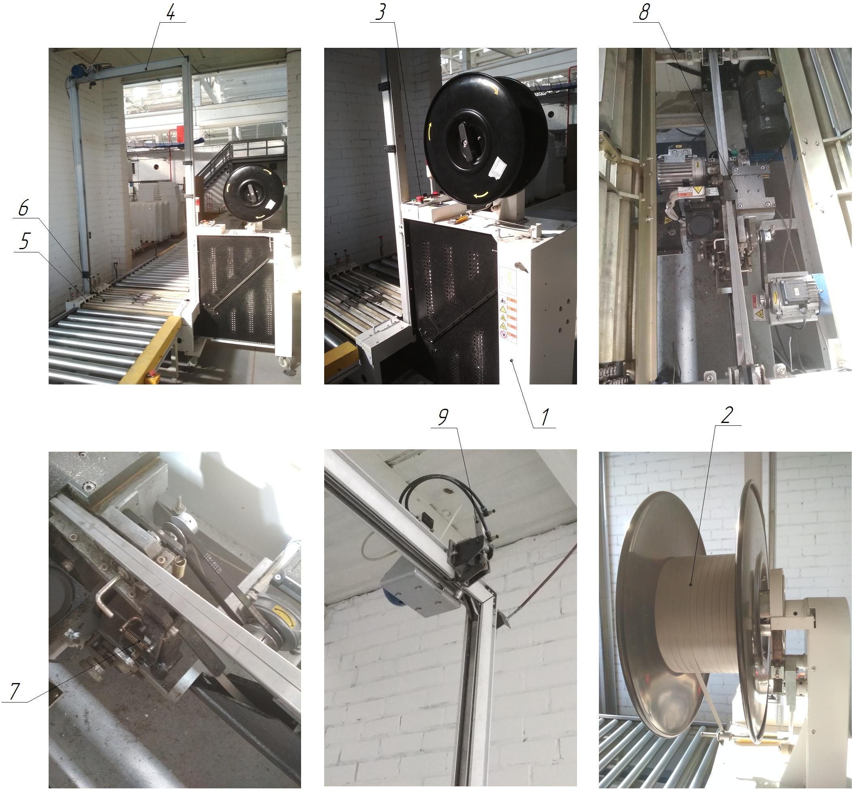

Figure 1.1 - Composition of the machine for tying the packaging KP: 1 - body; 2 - cassette with tape; 3 - control panel; 4 - tying frame; 5 - table; 6 - hinged table covers (2 pcs.); 7 - tape feeding unit; 8 - tape heating and cutting unit; 9 - pneumatic system of the machine

INSTALLATION OF PNEUMATIC PUNCHING OF HOLES AND GROOVES IN THE CHAMBER

Technical characteristics
The machine is designed for punching holes and grooves in the CP chambers in automatic mode. The main characteristics of the machine are given in Table 1.1.
Table 1.1 - Main characteristics of the machine
Technical characteristics | Dimensional characteristics
Overall dimensions (length x width x height, mm) | max 2500 x 1250 x 1120  min 920 x 1260 x 980
Rated supply voltage, V | 220
Frequency, Hz | 50...60
Service life (standard service life) | 25
Material of chambers CP | Polystyrene
Temperature mode of the installation, ºС | +5...+40
Working pressure in the pneumatic line, MPa | 0,5...0,6
Type of installation | Stationary
Type of control of main technological parameters | Automatic
Compressed air for the pneumatic system | With 40 micron filtration with or without oil
Temperature regime of compressed air during operation, ºС | +5...+50
Number of operating personnel, persons/shift | 1
Feeding of the CP chamber during punching | Manual
Dimensional accuracy, when punching, mm | ±0,1
Thickness of material (chambers) for punching, mm | 3,8...4,2
Punching tool | Punch / die

Structure and operation of the machine
This installation (Fig. 1.1) is used for punching holes and grooves in the CP chambers. The CP chamber is installed on the base bars 6, which are fixed on the table 4. Next, the CP chamber is pressed against the strips 6 with the help of clamping clamps 3. The holes and grooves in the CP chamber are pierced by the punching die 5 (die and punches). After the punching operation, the clamps 3 press the chamber and it is freely removed from the strips 6.
The installation consists of (Fig. 1.1):
- frame, item 1;
- stand, item 2;
- clamps for clamping the CP chamber (pneumatic drive), item 3;
- table, item 4;
- punch (matrix and punches), item 5;
- base bars of the CP chamber, item 6;
- pneumatic system of the installation, item 7;
- pneumatic equipment of the installation, item 8.

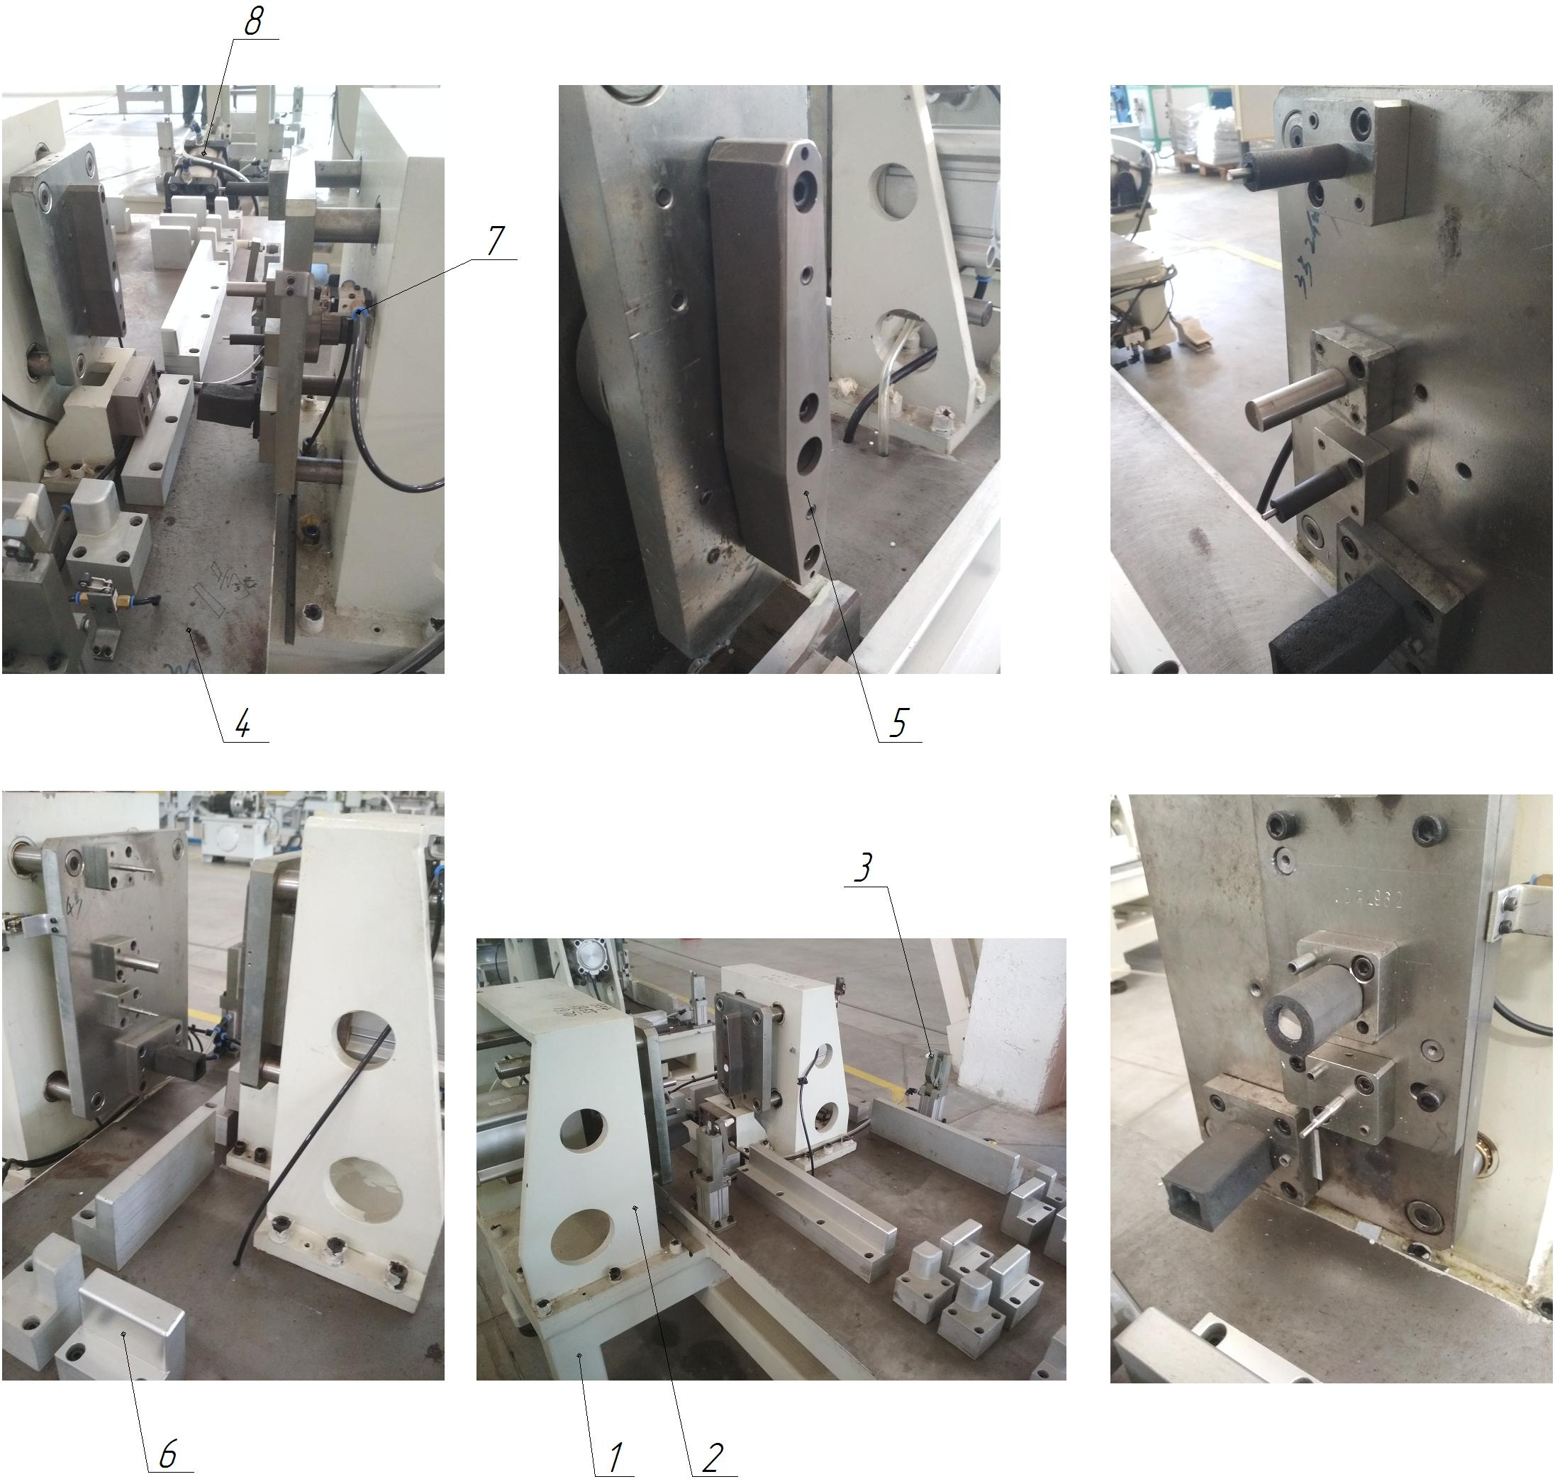

Figure 1.1 - Composition of the installation for punching holes and grooves in CP chambers: 1 - frame; 2 - rack; 3 - clamps for clamping the CP chamber (pneumatic drive); 4 - table; 5 - punching stamp (matrix and punches); 6 - base bars of the CP chamber; 7 - pneumatic system of the installation; 8 - pneumatic equipment of the installation

INSTALLATION OF GUILLOTINE TRIMMING OF HP CAMERAS

Technical characteristics
The machine is designed for cold cutting (trimming) of polystyrene chambers (polystyrene thickness 3.8...4.2 mm). The main characteristics of the machine are given in Table 1.1.
Table 1.1 - Main characteristics of the machine
Technical characteristics | Parameters
Overall dimensions (length x width x height, mm) | 3500 x 4200 x 1800
Rated supply voltage, V | 380 (3f, variable)
Frequency, Hz | 50...60
Maximum dimensions when cutting, mm | 4,5 х 2150
Normal service life (service life) | 25 years
Number of cutting edges of the knife | 1
Dimensions of the movable rotary table (punch panels), mm | max 1250 x 570  min 770 x 510
Table rotation angle, deg | 360
Type of installation of cameras KP | On removable punch panels
Number of removable punch panels (for KP models) | 9
Number of knives, upper/lower, pcs. | 9 / 9 = 18
Temperature operating mode of the unit, ºС | +5...+50
Electric motor power, kW/rev/min  - table  - guillotine shears | 1,5 / 1430  5,5 / 1450
Total power of electric motors of the installation, kW | 7,0
Number of points of automatic lubrication system | 2
Type of installation | Stationary
Working pressure in pneumatic lines, MPa | 0,5...0,6
Number of operating personnel, persons/shift | 1
Dimensional accuracy when cutting, mm | ±1
Availability of a centralized lubrication system (CLS) | Є
Type of control of main technological parameters | Automatic
Method of controlling the main technological parameters | The control panel
Number of centralized lubrication systems (CLS) | 1
Type of control of the centralized lubrication system pump | Automatic
Oil for the centralized lubrication system | UNIOL-2M-2
Compressed air for pneumatic systems | With 40 micron filtration with or without oil
Working pressure in pneumatic lines, MPa | 0,5...0,6

Structure and operation of the machine
The unit consists of guillotine shears and a movable rotary table. The scissors frame is prefabricated and welded, which increases the rigidity of the structure, and consists of two racks. The gap between the knives of the lower knife beam is adjusted by moving the upper knife beam, depending on the thickness of the material to be cut. The scissors are driven by an electric motor mounted on the plate, through a gear motor and then to a crank with a connecting rod. See Fig. 1.1 for the location of the machine components.
The machine includes (Fig. 1.1):
- guillotine shears, item 1;
- upper knife beam (fixed), item 2;
- lower knife beam (movable), item 3;
- upper knife (9 pieces), item 4;
- lower knife (9 pieces), item 5;
- scissors drive, item 6;
- movable rotary table, item 7;
- rotary table drive, item 8;
- punch panel (9 pieces), item 9;
- control panel, item 10;
- guides of the movable rotary table, item 11;
- centralized lubrication system, item 12;
- fence, item 13;
- spring stop (9 pieces), item 14;
- control cabinet, item 15;
- technological container (for waste), item 16.
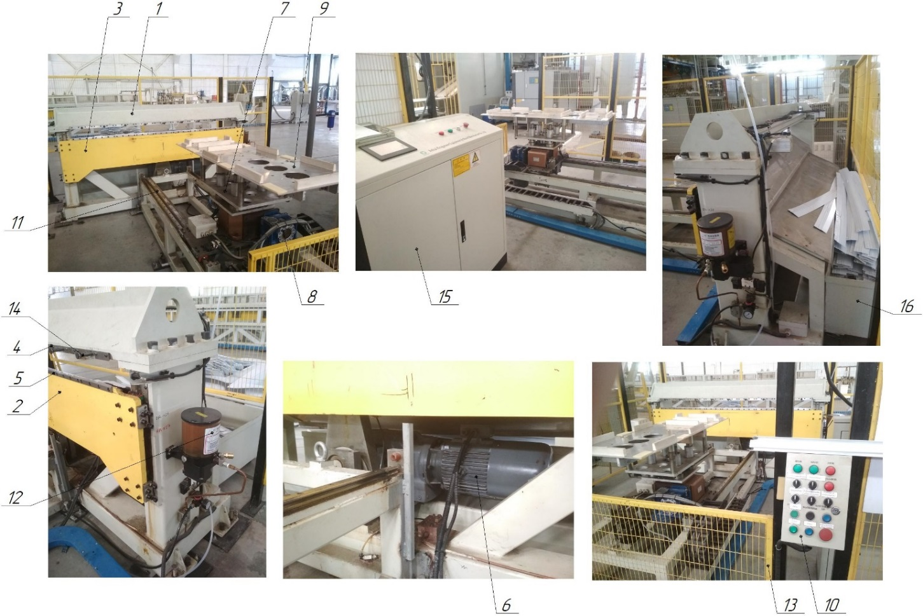
Figure 1.1 - Location of the installation components: 1 - guillotine scissors; 2 - upper knife beam (fixed); 3 - lower knife beam (movable); 4 - upper knife (9 pieces); 5 - lower knife (9 pieces); 6 - scissors drive; 7 - movable rotary table; 8 - movable rotary table drive; 9 - panel-punch (9 pieces); 10 - control panel; 11 - guides of the rotary table; 12 - centralized lubrication system; 13 - fence; 14 - spring stop (9 pieces); 15 - control cabinet; 16 - technological container (for waste).

VACUUM AND REFRIGERANT CHARGING STATION

Technical characteristics
The station is designed for vacuuming and charging refrigerant (R600a) for refrigeration devices. The main characteristics of the station are given in Table 1.1.
Table 1.1 - Main characteristics of the station
Technical characteristics of the station | Dimensional characteristics
Overall dimensions (length x width x height, mm) | 15000 x 6700 x 3100
Rated supply voltage, V | 380 (three-phase, variable)
Frequency, Hz | 50...60
Station readiness time, after switching on the mains, min. | 2...3
Service life (standard service life) | 25
Temperature mode of the station, ºС | +10...+40
Operating pressure in pneumatic lines, MPa | 0,4...0,6
Availability of exhaust system | Є
Refrigerant for charging of the CP | R600a (isobutane)
Refrigerant storage method R600a | Cylinder, 6.5 kg
R600a refrigerant leak detector (detector) | HLD6000 INFICON
Installation of ultrasonic welding of metals | Branson Ultra Seal 20 4Kw
Refrigerant charging machine | CA-788C-S6C
Comprehensive electrical safety tester | AN9651F Ainuo
Type of station | Stationary
Type of control of main technological parameters | Automatic
Method of control of main technological parameters | The control panel
Number of vacuum pumps (VP), pcs. | 22
Type of vacuum pumps | VDN301 ULVAC
Power of VP, kW | 1,5
Total power of electric motors of the station, kW | 29,4
Compressed air for pneumatic systems | With 40 micron filtration with or without oil
Compressed air temperature during operation, ºС | +5...+50
Number of operating personnel, persons/shift | 2
Number of exhaust centrifugal fans, pcs. | 2
Power of exhaust fans, kW | 1,1

Composition of the station
The station is built on a modular basis. The station is used for vacuuming and charging refrigerant (R600a) for refrigeration devices.
The station consists of (Fig. 1.1):
- charging box, item 1;
- Suspended conveyor, item 2;
- vacuum pump (22 pcs), item 3;
- suspended conveyor drive, item 4;
- Plate conveyor, item 5;
- Refrigerant charging machine, item 6;
- exhaust ventilation system, item 7;
- ultrasonic metal welding unit, item 8;
- refrigerant leakage detector KP, item 9;
- Plate conveyor drive, item 10;
- test bench for Hansen couplings, item 11;
- complex electrical safety tester, item 12.

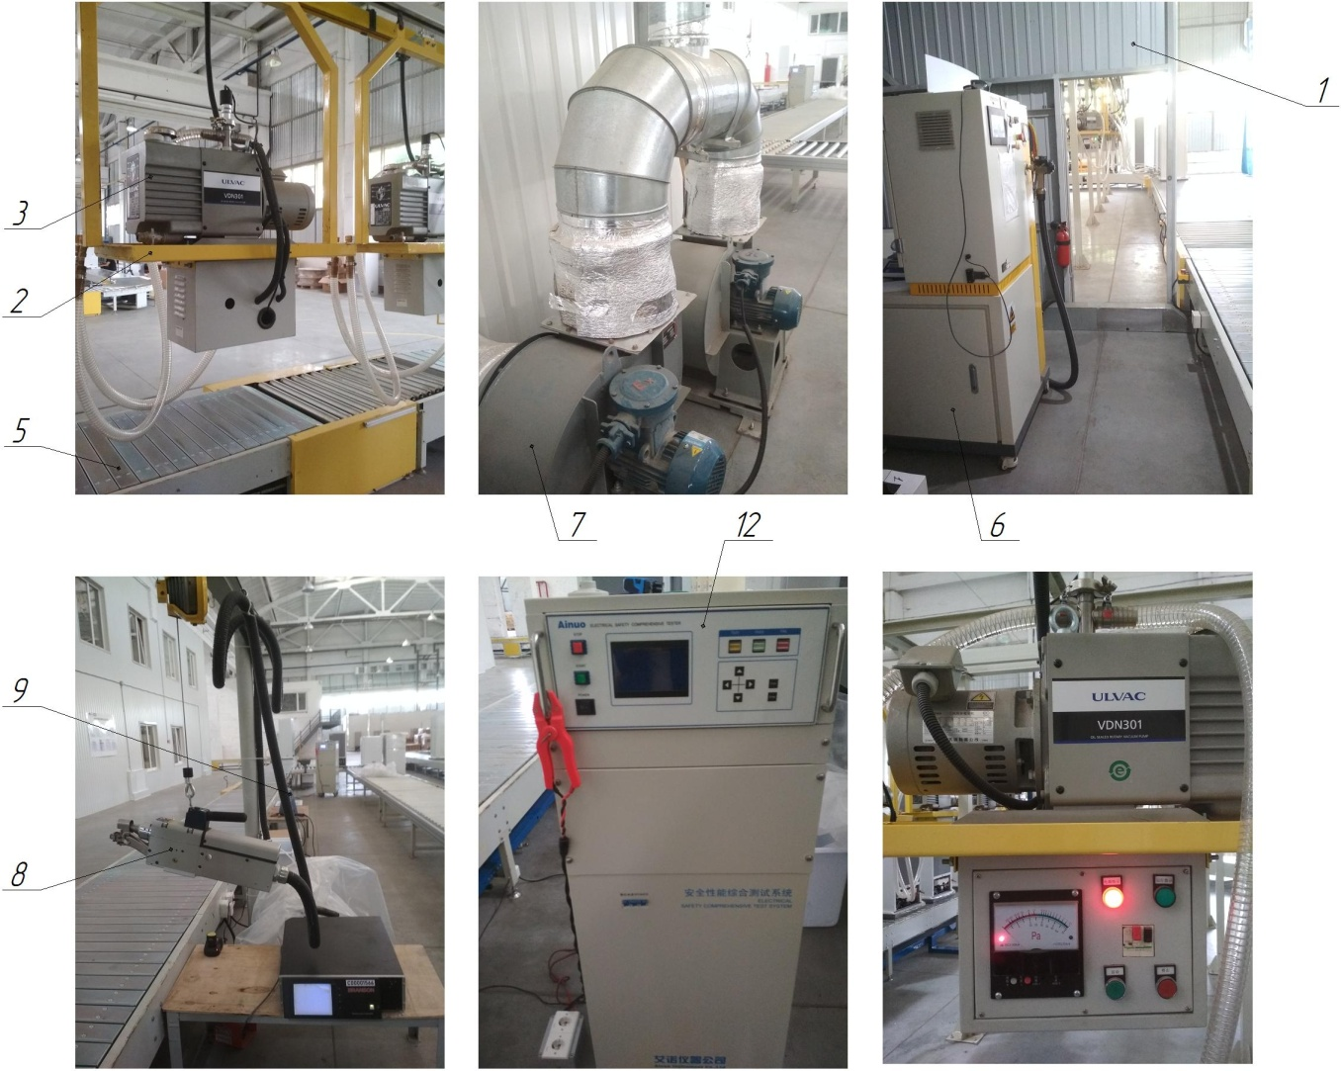

Figure 1.1 - Composition of the vacuum and filling station: 1 - charging box; 2 - overhead conveyor; 3 - vacuum pump (22 pcs.); 4 - overhead conveyor drive; 5 - plate conveyor; 6 - refrigerant charging machine; 7 - exhaust ventilation system; 8 - ultrasonic metal welding unit; 9 - refrigerant leakage detector; 10 - plate conveyor drive; 11 - Hansen coupling test bench; 12 - comprehensive electrical safety tester

Structure and operation of the station
The coolants are supplied to the vacuum and refrigerant charging station via the plate conveyor 5. Before vacuuming, the CP system is purged with compressed nitrogen to remove possible condensation (moisture). With the help of Hansen filler couplings, the CP is connected to the vacuum pumps 3, which are placed on the trolleys of the overhead conveyor 2 (up to 22 CP can be vacuumed at the same time), and the CP system is vacuumed, while they move along the plate conveyor 5. After evacuation, the COPs are fed to the charging box 1, where the refrigerant charging machine 6 is located. After charging with refrigerant (controlled dose) using Hansen charging couplings, the CPs are fed to the ultrasonic metal welding unit 8, where the ends of the tubes are welded, thus achieving the sealing of the CP system. After welding the ends of the tubes, the CPs are fed along the plate conveyor 5 to the refrigerant leak detector 9. The drive of the suspended conveyor 4 consists of a gear motor and a chain drive. The Hansen couplings are returned to the bench 11 to check for leaks. The refrigerant (freon) is stored and transported to the station in 6.5 kg cylinders. There is also a separate storage space and a system for supplying refrigerant (via a pipeline) to the vacuum and charging station. In case of an increased level of gas contamination in the charging box 1, the exhaust ventilation system 7 is switched on.

CONVEYOR LINE (CONVEYORS) FOR ASSEMBLY

Technical characteristics
The CP assembly line (belt, plate, roller conveyors) is designed to move CP. The main characteristics of the line are given in Tables 1.1, 1.2, 1.3.
Table 1.1 - Main characteristics of the assembly line No. 1
Technical characteristics | Dimensional characteristics of the assembly line №1
Technical characteristics | Conveyor 01 | Conveyor 02 |  | Conveyor 03
Overall dimensions (width x height, m) | 0,9 х 0,6 | 0,9 х 0,6 |  | 0,9 х 0,6
Belt width, m | 0,8 | 0,8 |  | 0,8
Total length, m | 20,4 | 34,0 |  | 9,3
Rated supply voltage, V | 380 | 380 |  | 380
Frequency, Hz | 50...60 | 50...60 |  | 50...60
Service life (standard service life), years | 40
Type of conveyor | Tape | Plate |  | Tape
Material of belt / plates / rollers | Rubber fabric | Plastic |  | Rubber fabric
Conveyor operating temperature, ºС | +5...+40
Number of operating personnel, persons / shift | 1
Conveyor drive | Gear motor | Gear motor |  | Gear motor
Number of gear motors, pcs. | 1 | 3 |  | 1
Drive gear, (gear ratio) | Chain | Chain |  | Chain
Type of conveyor | Horizontal | Horizontal |  | Horizontal
Conveyor speed, rpm (m/s) | 0,03 | 0,03 |  | 0,03
Availability of a rotary table | - | - |  | -
Availability of a rotary table | - | - |  | -
Availability of a lifting-moving table | - | 1 (roller) |  | -
Working pressure in the pneumatic line, MPa | 0,5...0,6
Method of conveyor control | Control panel
Compressed air for the pneumatic system | With 40 micron filtration with or without oil
Compressed air temperature during operation, ºС | +5...+50
Number of connection points to the pneumatic system, pcs. | 6 |  | 11 |  | 1

Table 1.2 - Main characteristics of assembly line No. 2
Technical characteristics | Dimensional characteristics of the assembly line №2
Technical characteristics | Conveyor 04,06,08,12,14 | Conveyor 05,07,09,11,13,15 |  | Conveyor 10,16
Overall dimensions (width x height, m) | 0,9 х 0,55 | 0,9 х 0,55 |  | 0,9 х 0,55
Belt width, m | 0,8 | 0,8 |  | 0,8
Total length, m | 147 | 17 |  | 21
Rated supply voltage, V | 380 | 380 |  | 380
Frequency, Hz | 50...60 | 50...60 |  | 50...60
Service life (standard service life), years | 40
Type of conveyor | Plate | Roller swivel |  | Roller
Material of belt / plates / rollers | Plastic | Steel |  | Steel
Conveyor operating temperature, ºС | +5...+40
Number of operating personnel, persons / shift | 1
Conveyor drive | Gear motor | Gear motor |  | Gear motor
Number of gear motors, pcs. | 5 | 6 |  | 2
Drive gear, (gear ratio) | Chain | Chain |  | Chain
Type of conveyor | Horizontal | Horizontal |  | Horizontal
Conveyor speed, rpm (m/s) | 0,03 | 0,03 |  | 0,03
Availability of a rotary table | 1 | - |  | -
Availability of a rotary table | 1 | - |  | -
Availability of a lifting-moving table | - | - |  | -
Working pressure in the pneumatic line, MPa | 0,5...0,6
Method of conveyor control | Control panel
Compressed air for the pneumatic system | With 40 micron filtration with or without oil
Compressed air temperature during operation, ºС | +5...+50
Number of connection points to the pneumatic system, pcs. | 16 |  | 1 |  | 1

Table 1.3 - Main characteristics of assembly line No. 3
Technical characteristics | Dimensional characteristics of the assembly line №3
Technical characteristics | Conveyor 17 | Conveyor 18 |  | Conveyor 19
Overall dimensions (width x height, m) | 0,9 х 0,55 | 0,9 х 0,55 |  | 0,9 х 0,55
Belt width, m | 0,8 | 0,8 |  | 0,8
Total length, m | 12 | 38 |  | 15
Rated supply voltage, V | 380 | 380 |  | 380
Frequency, Hz | 50...60 | 50...60 |  | 50...60
Service life (standard service life), years | 40
Type of conveyor | Plate | Plate |  | Plate
Material of belt / plates / rollers | Plastic | Plastic |  | Plastic
Conveyor operating temperature, ºС | +5...+40
Number of operating personnel, persons / shift | 2
Conveyor drive | Gear motor | Gear motor |  | Gear motor
Number of gear motors, pcs. | 1 | 1 |  | 1
Drive gear, (gear ratio) | Chain | Chain |  | Chain
Type of conveyor | Horizontal | Horizontal |  | Horizontal
Conveyor speed, rpm (m/s) | 0,03 | 0,03 |  | 0,03
Availability of a rotary table | - | - |  | -
Availability of a rotary table | - | - |  | -
Availability of a lifting-moving table | 1 | - |  | -
Working pressure in the pneumatic line, MPa | 0,5...0,6
Method of conveyor control | Control panel
Compressed air for the pneumatic system | With 40 micron filtration with or without oil
Compressed air temperature during operation, ºС | +5...+50
Number of connection points to the pneumatic system, pcs. | 1 |  | 3 |  | 1

Structure and operation of the line
Structure and operation of the line. On the KP assembly line No. 1 (belt, plate, roller conveyors), the KP chambers are moved to the case assembly area and then the already assembled cases are moved to the accumulation station for their further polyurethane foam. On the KP assembly line No. 2 (belt, plate, roller conveyors), the already foamed polyurethane foam cases are moved to the assembly station for further assembly, vacuuming and charging with KP refrigerant, and their delivery to the test station. On the assembly line of the COU No. 3 (belt, plate, roller conveyors), the already tested COUs are moved and fed for assembly, packaging and storage. The conveyor drive 1 consists of a gear motor and a chain drive with a protective cover 10. From the drive of the conveyor 1, the torque is transmitted to the drive drum 3 (master), on which, in turn, the conveyor belt or plates 4 are mounted (or through the chain transmission to the roller conveyor). On the other hand, there is a driven drum 5 and a tensioning device 6. To support the belt 4, lower 7 and upper 9 roller supports are mounted. The conveyor is mounted on a support frame 8. Tensioning of the belt 4 is performed by adjusting the tensioning device 6.
The line consists of (Fig. 1.1):
- conveyor drive, item 1 (gear motor, chain transmission);
- control panel, item 2;
- drive drum (master), item 3;
- conveyor belt / plates / rollers, item 4;
- drum driven, item 5;
- tensioning device, item 6;
- lower roller support (tensioning), item 7;
- support frame, item 8;
- upper roller support, item 9;
- protective cover, item 10;
- rotary / rotary-inclined / lifting-moving table, item 11.

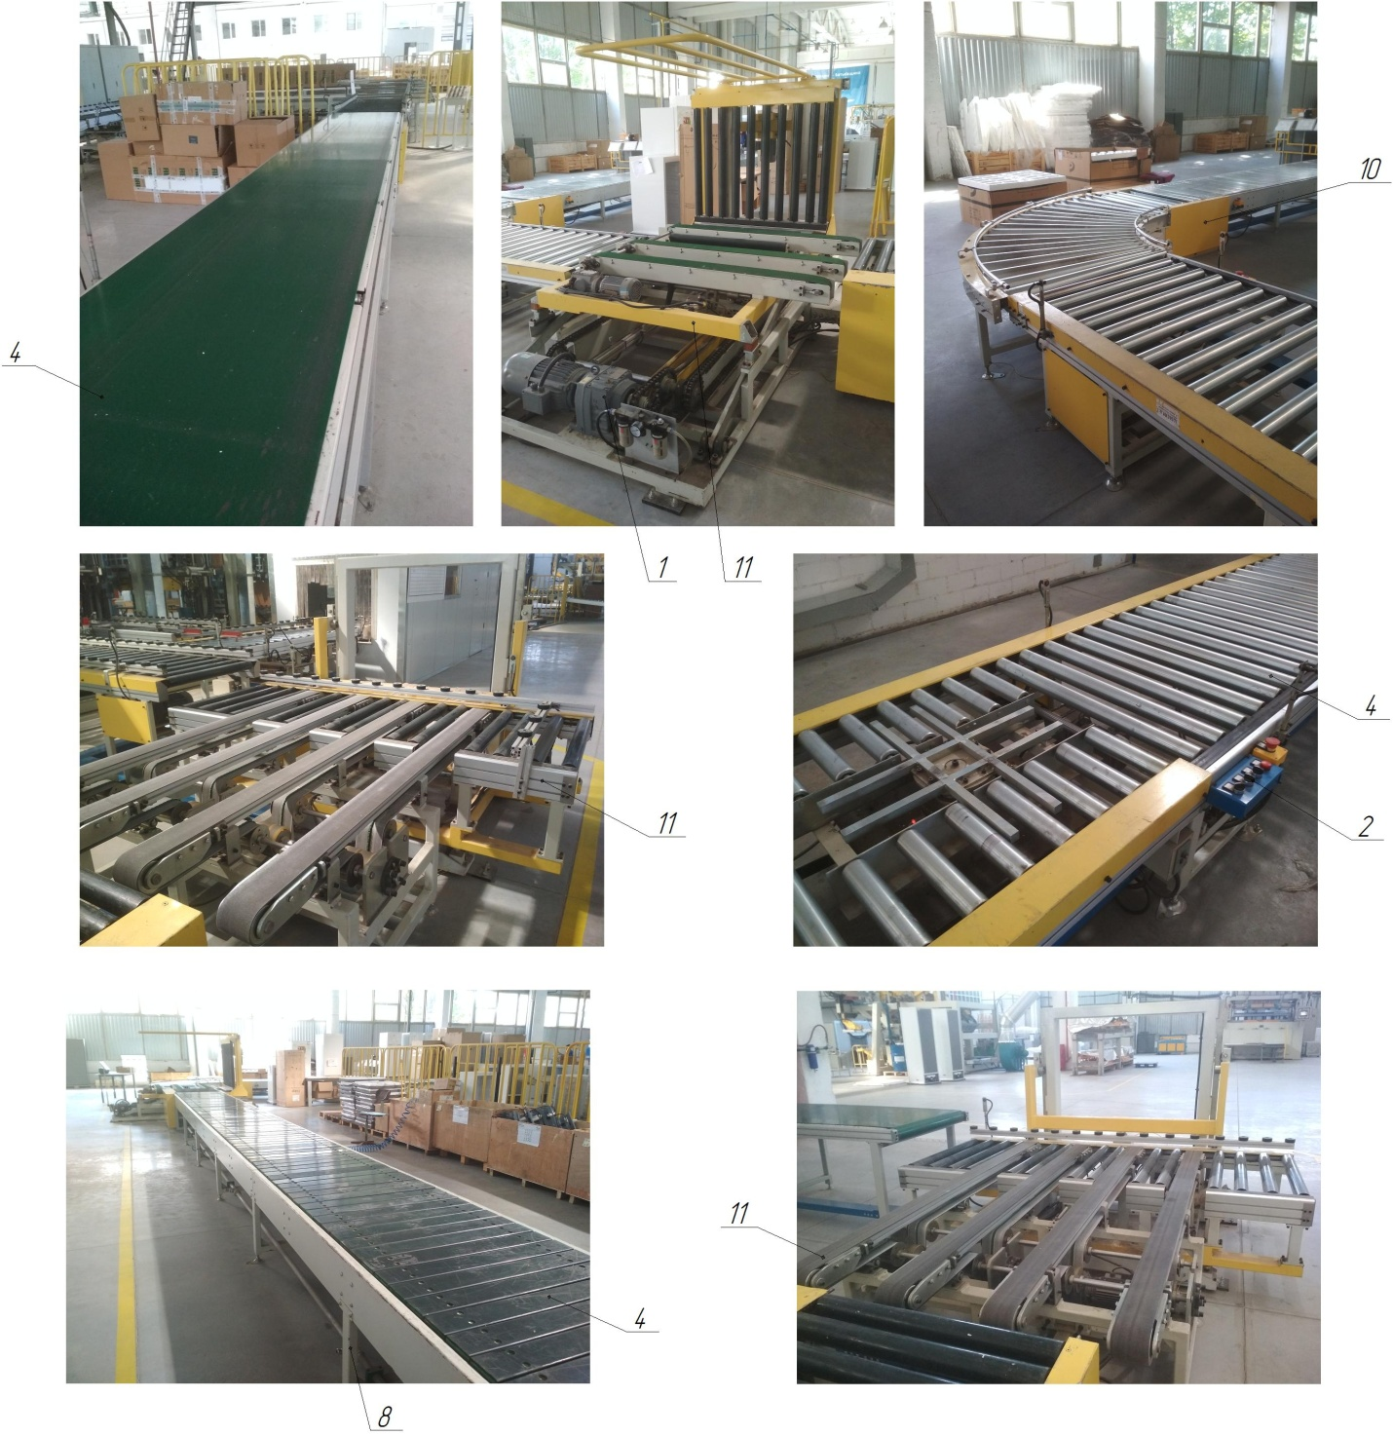

Figure 1.1 - Line composition: 1 - conveyor drive; 2 - control panel; 3 - drive drum (master); 4 - conveyor belt / plates / rollers; 5 - driven drum; 6 - tensioning device; 7 - lower roller support (tensioning); 8 - supporting frame; 9 - upper roller support; 10 - protective casing; 11 - rotary / rotary-inclined / lifting-moving table

CYCLOPENTANE STATION

Technical characteristics
The station is designed for storage and supply of cyclopentane to the station for mixing polyurethane foam components (polyol with cyclopentane). The main characteristics of the station are given in Table 1.1.
Table 1.1 - Main characteristics of the station
Technical characteristics of the station | Dimensional characteristics
Overall dimensions of the station (length x width x height, mm) | 14000 x 10500 x 4500
Overall dimensions of the pit (length x width, mm) | 11200 х 7300
Service life (standard service life) | 30
Temperature mode of the station operation, ºС | +10...+40
Working pressure in pneumatic lines, MPa | 0,4...0,6
Availability of exhaust system | At the station of polyurethane foam components
Component for storage and supply | Cyclopentane (C5H10)
State of the stored component | Volatile liquid
Method of cyclopentane storage | Capacity, 25 m3
Method of station placement | Open area (natural ventilation)
Method of placement of the cyclopentane storage tank | Underground
Method of placement of station control automation | Surface
Number of cyclopentane storage tanks, pcs. | 1
Type of station | Stationary
Type of control of the main technological parameters | Automatic
Method of control of the main technological parameters | The control panel
Compressed air for pneumatic systems | With 40 micron filtration with or without oil
Compressed air temperature regime during operation, ºС | +5...+50
Number of operating personnel, persons/shift | 1
Number of exhaust centrifugal fans, pcs. | -
Power of exhaust fans, kW | -
Inert gas for creating the "Cushion" in the container with the CP | Nitrogen
Nitrogen pressure at the supply to the container with CP, MPa (Bar) | 0,02 (0,2)
Category of the station premises by explosion and fire hazard according to PUE | A (increased explosion and fire hazard)
Class of fire hazardous area of the station according to PUE | P-I (areas in rooms where flammable liquids with a flash point above 61 °C are located)

Composition of the station
The station is built on a modular basis. The station stores and supplies cyclopentane to the polyurethane foam mixing station (P+CF).
The station consists of (Fig. 1.1):
- storage tank for CP, item 1;
- system of technological pipelines for nitrogen, item 2 (for nitrogen cushion);
- system of technological pipelines for CP supply, item 3;
- safety valve, item 4;
- Shut-off and control valves, gas analyzers (instrumentation and control), item 5;
- emergency pipeline for pressure relief from the CP tank (spark plug), with ball valve, item 6;
- electric valve for CP supply to the CCS components station, item 7;
- pit, item 8;
- fence, item 9.

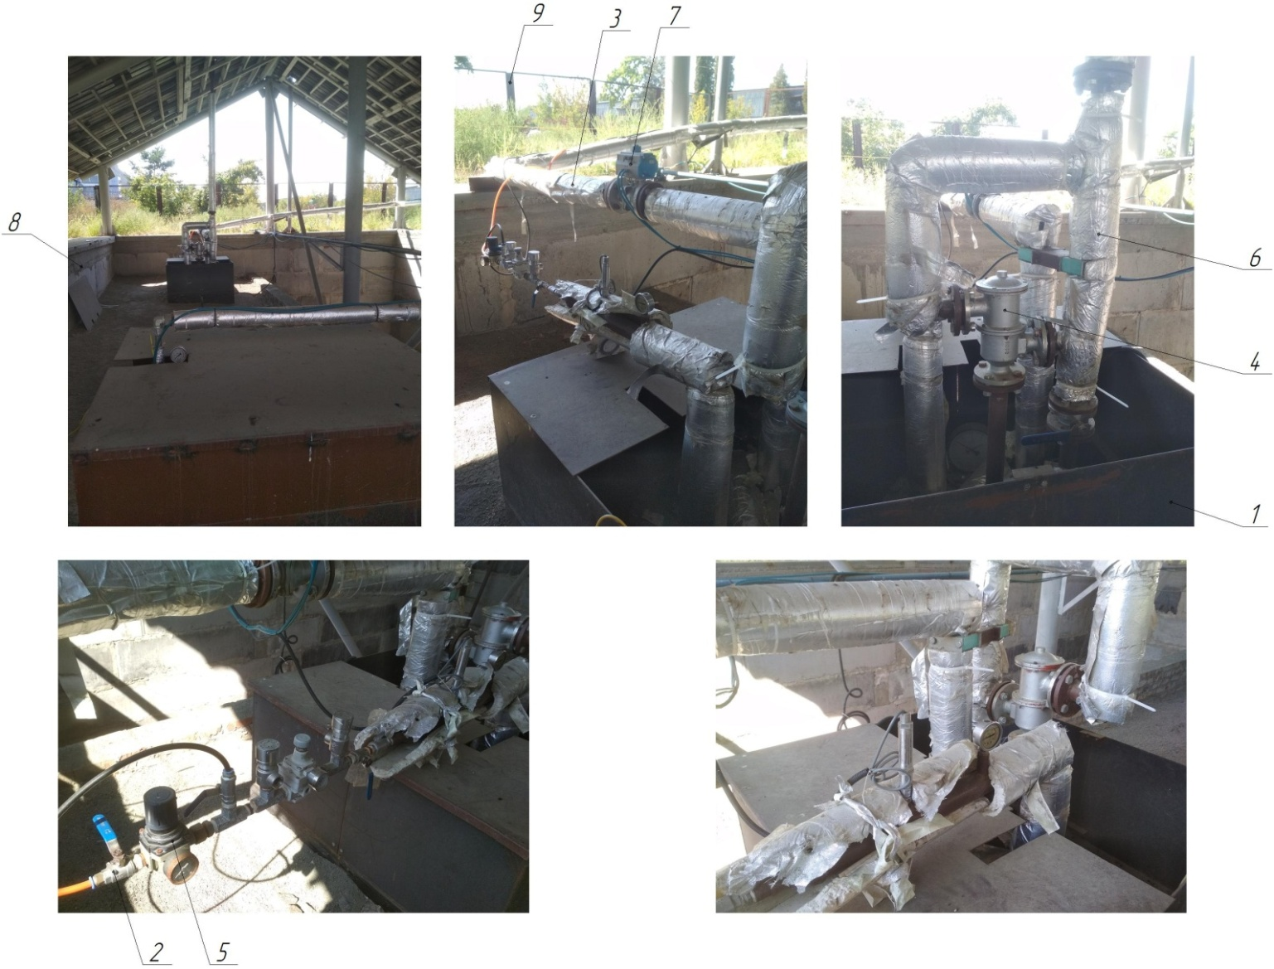

Figure 1.1 - Composition of the cyclopentane station: 1 - CP storage tank; 2 - system of technological nitrogen pipelines; 3 - system of technological pipelines for CP supply; 4 - safety valve; 5 - shut-off and control valves, gas analyzers (instrumentation and control); 6 - emergency pressure relief pipeline from the CP tank (spark plug), with a ball valve; 7 - electric valve for supplying CP to the station of CCS components; 8 - pit; 9 – fence

Structure and operation of the station
The station is used for storage and control of cyclopentane in tank 1, automatic regulation of nitrogen supply to this tank to create a nitrogen "cushion" under a pressure of 0.02 MPa. The cyclopentane is supplied by a pump located at the mixing station of polyurethane foam components (P+CF). Tank 1 with the CP is located in pit 8. The CP station has no free passage and is closed by a fence 9. Nitrogen is supplied to tank 1 through the process pipeline system 2 from the nitrogen station. The CP is supplied to the mixing station of the PU components (P+CP) through the process pipeline system 3. When the pressure in the tank 1 rises, the safety valve 4 is activated and an emergency pressure relief occurs from the CP tank, through the pipeline (spark plug), with a ball valve 6. The process media are controlled by shut-off and control valves, gas analyzers 5 (instrumentation and control).

Description and operation of the station components
The station uses only stainless steel valves. Stainless steel coupling ball valve 1/2 inch, BB, AISI 304, DN 15.
AR4000-04 is a pressure regulator (pressure reducing valve) designed for preliminary (rough) regulation of nitrogen pressure supplied to the CP storage tank. Nitrogen is needed to create a "nitrogen cushion" in the container with the CP. The main characteristics of the pressure regulator are given in Table 1.2.
IR3000-04BG is a pressure regulator (pressure reducing valve) designed for fine control of nitrogen pressure supplied to the CPU storage tank. The main characteristics of the pressure regulator are shown in Table 1.3.
Table 1.2 - Main characteristics of the pressure regulator
Parameters | Dimensional characteristics
Flow rate, l/min | 4000...6000
Temperature of the working medium (nitrogen), ºС | 0...+60
Working pressure range, MPa | 0...1,0
Maximum inlet pressure, MPa | 1,2
Connection size, inch | G1/2
Connection size of the pressure gauge, inch | G3/8
Pressure control range, Bar | 0,5...9,5
Working environment | Nitrogen
Construction | Membrane type regulator
Weight, kg | 0,84

Table 1.3 - Main characteristics of the pressure regulator (fine control)
Parameters | Dimensional characteristics
Flow rate, l/min | 3000
Temperature of the working medium (nitrogen), ºС | 0...+60
Maximum working pressure, MPa | 1,0
Connection size, inch | G1/2
Manometer connection size, inch | G1/8
Pressure control range, Bar | 0,01...0,2
Working environment | Nitrogen
Operating temperature range, ºС | -5...+60
Weight, kg | 0,64

MIXING STATION FOR THE COMPONENTS OF THE PUMPING STATION

Technical characteristics
The station is designed for storage, mixing (polyol with cyclopentane) and supply of polyurethane foam components (polyol + cyclopentane and isocyanate) through pipelines to the cabin and door filling area. The main characteristics of the station are shown in Table 1.1.
Table 1.1 - Main characteristics of the polyurethane foam components station
Technical characteristics of the station | Dimensional characteristics
Overall dimensions of the station (length x width x height, mm) | 15600 x 10100 x 2800
Service life (standard service life) | 30
Temperature mode of the station, ºС | +10...+40
Working pressure in pneumatic lines, MPa | 0,4...0,6
Availability of exhaust systems | Є
Components for storage and supply | Polyol + Cyclopentane, Isocyanate
Condition of stored components | Liquid
Components for mixing | Polyol + Cyclopentane
Method of storage of components | Tank container, 25 m3
Method of station location | Closed area (forced ventilation)
Method of placement of storage tanks for components | Surface
Method of station control automation placement | Surface
Number of containers for storage of polyurethane foam components, pcs:  - polyol (main, tank container)  - isocyanate (main, tank container)  - polyol + cyclopentane (No. 4, intermediate)  - polyol (No. 3, intermediate)  - isocyanate (No. 2, intermediate)  - cyclopentane (No. 1, intermediate) | 1  1  1  1  1  1
Type of station | Stationary
Type of control of main technological parameters | Automatic
Heating of the main container-tanks | Thermostat VTM-06W
Number of thermostats, pcs. | 2
Cooling of intermediate tanks with polyurethane foam components | Chiller AC-05A
Number of chillers, pcs. | 3
Method of control of main technological parameters | The control panel
Compressed air for pneumatic systems | With 40 micron filtration with or without oil
Compressed air temperature regime during operation, ºС | +5...+50
Number of operating personnel, persons/shift | 1
Number of exhaust centrifugal fans, pcs. | 4
Power of exhaust fan, kW | 1,5
Inert gas for creating the "Pillow" in containers with components | Nitrogen
Mixing of polyurethane foam components: polyol + cyclopentane | Closed box with exhaust ventilation
Placement of an intermediate container with cyclopentane | Closed box with exhaust ventilation
Pressure in containers with components, MPa | 0,3...0,4
Explosion and fire hazard category of the plant premises according to PUE | B (fire hazardous areas)
Class of fire hazardous area of the plant according to PUE | P-I (zones in rooms where flammable liquids with a flash point above 61 ºС are located)

Composition of the station
The station is built on a modular basis. The station is used for storage, mixing (polyol and cyclopentane) and supply of polyurethane foam components (polyol + cyclopentane and isocyanate) through pipelines to the section for filling cabins and doors.
The station includes (Fig. 1.1):
- container-tank (CT) for polyol storage, item 1;
- container-tank (CT) for storage of isocyanate, item 2;
- intermediate tank No. 1 for storage of cyclopentane, item 3;
- intermediate tank No. 2 for storage of isocyanate, item 4;
- intermediate tank No. 3 for storage of polyol, item 5;
- intermediate container No. 4 for storage of polyol + cyclopentane, item 6;
- closed box for mixing components: polyol + cyclopentane, item 7;
- closed box for intermediate storage of cyclopentane, item 8;
- system of supply pipelines for polyurethane foam components, item 9;
- exhaust ventilation system for closed boxes, item 10 (4 fans);
- chillers for cooling intermediate containers with polyurethane foam components, item 11 (3 pcs.)
- thermostats for heating of the main tank containers with PU foam components, item 12 (2 pcs.);
- control cabinet, item 13

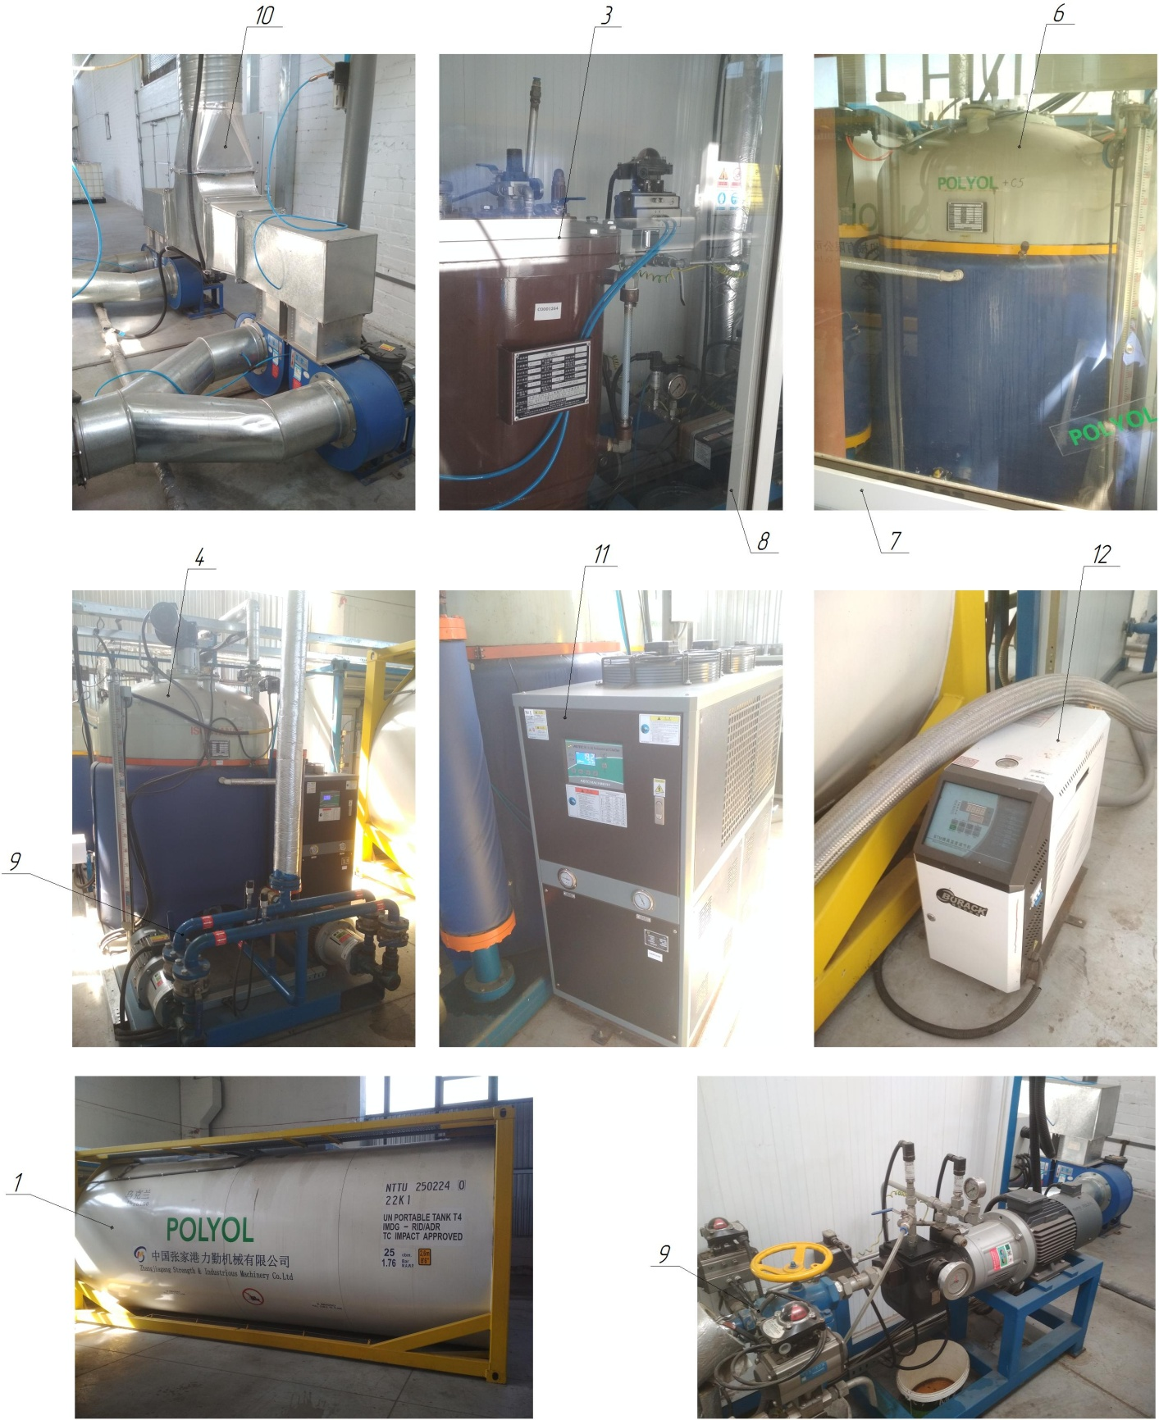

Figure 1.1 - Composition of the polyurethane foam components station: 1 - container-tank for storage of polyol; 2 - container-tank for storage of isocyanate; 3 - intermediate tank No. 1 for storage of cyclopentane; 4 - intermediate tank No. 2 for storage of isocyanate; 5 - intermediate tank No. 3 for storage of polyol; 6 - intermediate tank No. 4 for storage of polyol + cyclopentane; 7 - closed box for mixing components: polyol + cyclopentane; 8 - closed box for intermediate storage of cyclopentane; 9 - system of pipelines for supplying polyurethane foam components; 10 - exhaust ventilation system of closed boxes; 11 - chillers for cooling intermediate tanks with polyurethane foam components; 12 - thermostats for heating the main container-tanks with polyurethane foam components; 13 - control cabinet

Structure and operation of the station
The station is used for storage, mixing (polyol and cyclopentane) and supply of polyurethane foam components (polyol + cyclopentane and isocyanate) through pipelines to the cabin and door filling area. Polyol and isocyanate are stored in container tanks 1 and 2. Cyclopentane is stored at the cyclopentane station, from where it is pumped to intermediate tank 3 (No. 1), which is located in a closed box 8. Isocyanate is pumped to intermediate tank 4 (No. 2), polyol to intermediate tank 5 (No. 3) through the system of pipelines for supplying PU foam components 9. Further, polyol from tank 5 and cyclopentane from tank 3 are fed for mixing into intermediate tank 6 (No. 4), which is located in a closed box 7. Intermediate tanks No. 2, 3, 4 have mixers for mixing the PU foam components driven by gear motors. Three chillers 11 are used to cool intermediate tanks 2, 3, 4 with polyurethane foam components. Two thermostats 12 are used to heat the main tank containers with polyurethane foam components 1 and 2. Mixing and dosing operations are controlled and regulated by a control cabinet 13 and a touch screen monitor.
The exhaust ventilation system 10 is connected to closed boxes 7 and 8, which contain: intermediate tank 6 (No. 4) for storing polyol + cyclopentane, and intermediate tank 3 (No. 1) for storing cyclopentane. Gas analyzers are connected in the working areas of the tanks and boxes. In case of an increased level of gas contamination during the mixing of the two components, the gas analyzer gives a command to turn on the exhaust ventilation system. In emergency cases, the ventilation system alarm is triggered. After the polyol + cyclopentane and isocyanate components are prepared, they are pumped through pipelines to the polyurethane foam sections for filling cabins and doors. Also, the nitrogen supply to the tanks is automatically regulated to create a nitrogen "cushion".

PLASTIC INJECTION MOLDING MACHINE

Technical characteristics
An injection molding machine (IMM) is used to manufacture parts from thermoplastics by injection molding. The main characteristics of an injection molding machine are shown in Table 1.1.
Table 1.1 - Main characteristics of injection molding machines
Technical characteristics of the injection molding machine | Dimensional characteristics
Rated supply voltage, V | 380 (three-phase, variable)
Frequency, Hz | 50...60
Line readiness time, after switching on the LPG system, min. | 5...10
Number of tanks of the LPG system, pcs. | 1
Method of controlling the LPG system | Control panel
Temperature mode of injection molding machine operation, ºС | +0...+40
Working pressure in pneumatic lines, MPa | 0,5...0,6
Working pressure in hydraulic lines, MPa | 14...16
Type of machine | Stationary
Type of control of main technological parameters | Automatic
Method of controlling the main technological parameters | Control panels
Air humidity in the working area of the machine, not more than %. | 75
Availability of a centralized lubrication system | Є
Compressed air for pneumatic system | With 40 micron filtration with or without oil
Mineral hydraulic oil for the hydraulic system | MGE-46V
Mineral oil viscosity, cSt | 40...50
Oil purity class according to GOST 17216-81 | not coarser than 12
Presence of water and acids in the oil | Absence of
Filtration of oil before pouring into the tank | Particles with a diameter of more than 0.025...0.04 mm
Operating temperature of hydraulic oil, ºС | +10...+55
Optimum operating temperature of the oil during operation, ºС | +45
Compressed air temperature during operation, ºС | +5...+50
Number of operating personnel, persons / shift | 1
Accuracy of tolerances for the size of parts, in the manufacture:  length, width, mm  thickness, mm | ±0,1  ±0,1

The auxiliary technical characteristics of the injection molding machine are shown in Table 1.2.
Table 1.2 - Auxiliary characteristics of the injection molding machine
INJECTION UNIT | MA1200/370G Haitian | MA3800 ІІ/2250е Haitian | MA6000 ІІ/4500 Haitian
Screw diameter, mm | 40 | 75 | 85
Screw ratio, L / D | 21 | 18,7 | 20,7
Injection size (theoretical), cm3 | 214 | 1423 | 2497
Injection weight (PS), g | 195 | 1295 | 2272
Injection speed (PS), g / s | 110 | 385 | 568
Injection pressure, MPa | 171 | 158 | 182
Plasticization rate (PS), g/s | 13,9 | 65,7 | 71,5
Screw rotation speed, rpm | 0…190 | 0...190 | 0...145
CLAMPING UNIT
Clamping force, kN (t) | 1200 (120) | 3800 (380) | 6000 (600)
Opening stroke, mm | 350 | 700 | 900
Distance between ties, mm | 410х410 | 730х730 | 880х880
Maximum mold height, mm | 430 | 730 | 880
Minimum mold height, mm | 150 | 280 | 380
Ejector stroke, mm | 120 | 180 | 240
Ejector force, kN | 33 | 110 | 158
OTHERS
Maximum pump pressure, MPa | 16 | 16 | 16
Pump motor power, kW | 13 | 37 | 55
Heater power, kW | 9,75 | 28,2 | 42,35
Machine size (L x W x H), m | 4,82х1,26х1,98 | 7,46х1,84х2,19 | 9,6х2,1х2,65
Machine weight, t | 4,1 | 14,7 | 29
Hopper capacity, kg | 25 | 50 | 200
Oil tank capacity, l | 220 | 690 | 940

Composition of the injection molding machine
The injection molding machine is built on a modular basis and is designed to manufacture parts from thermoplastics by injection molding.
The injection molding machine consists of (Fig. 1.1):
- a clamping unit with an ejection unit item 1;
- mold (PF) item 2;
- control unit item 3;
- plasticization (injection) unit item 4;
- loading hopper item 5;
- hydraulic pumping station (HPS) item 6;
- thermostat item 7 (for heating of the PF).

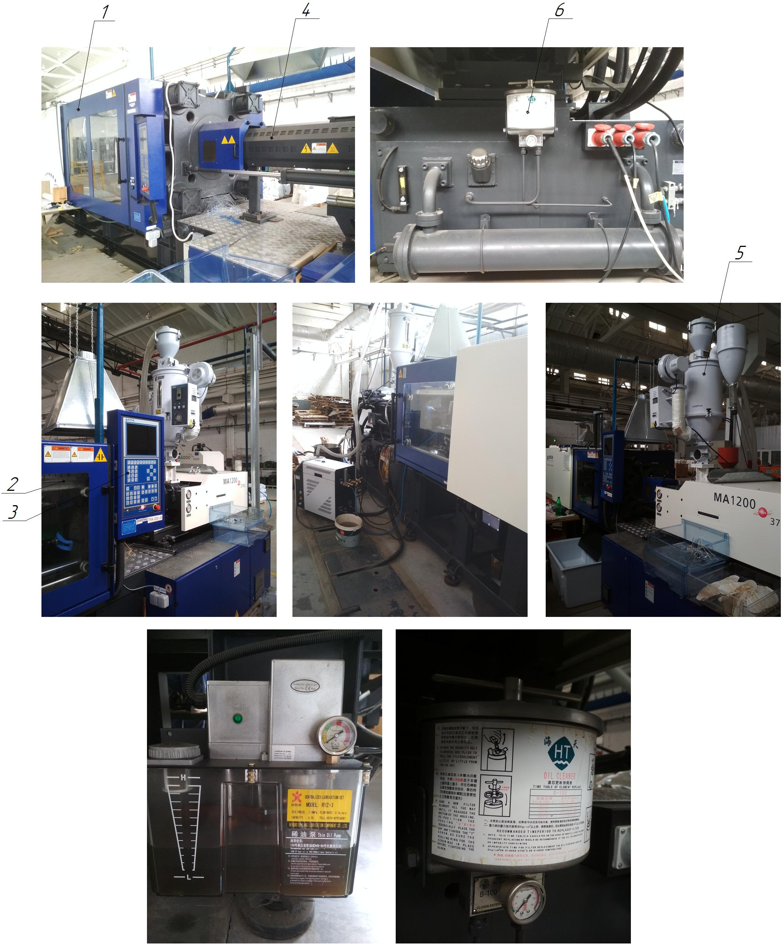

Figure 1.1 - Composition of the injection molding machine: 1 - clamping unit; 2 - mold; 3 - control unit; 4 - plasticization unit; 5 - loading hopper; 6 - hydraulic pumping station; 7 - thermostat.
Structure and operation of injection molding machines
The injection molding machine performs the casting cycle using a mold. The injection molding machine consists of two main parts: the plasticization unit and the closure unit (Fig. 1.2). All movements of these units are performed by a hydraulic drive. The processes are controlled by a central controller, which not only sets all the parameters of the casting cycle, but can also control external devices: electric and hydraulic drives, heaters.
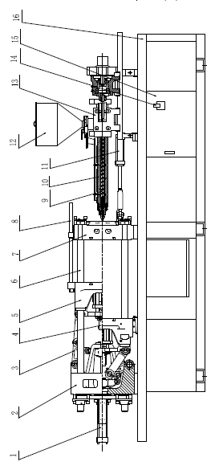

Figure 1.2 - Structure of the injection molding machine: 1. Closing cylinder; 2. Adjustable platen; 3. Knee-lever mechanism; 4. Movable plate; 5. Pusher cylinder; 6. Guide column; 7. Fixed plate; 8. Mechanical safety column; 9. Screw; 10. Material cylinder; 11. Cylinder of the carriage of the injection unit; 12. Hopper; 13. Injection cylinder; 14. Power supply; 15. Electrical cabinet; 16. Machine bed

The plasticization unit is the main unit for the entire casting process (Fig. 1.3). Its function is to melt the polymer and feed it into the mold. The principle of the plasticizing unit is as follows: the polymer material is poured into the hopper, then enters the material cylinder, where the screw moves it to the nozzle while rotating. In the cylinder, the material is heated by ring heating elements and injected into the mold in a molten state. To prevent the polymer from flowing back into the hopper, the screw has a check valve that blocks the movement of the material during injection.
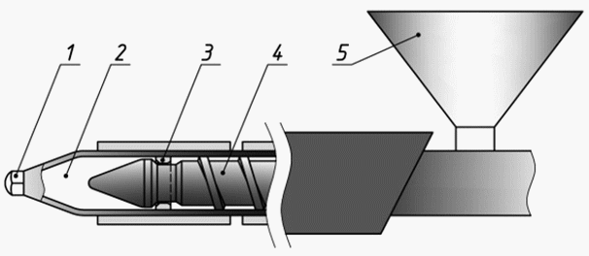
Figure 1.3 - Schematic of the plasticization unit: 1. Nozzle; 2. Screw chamber; 3. Check valve; 4. Screw; 5. Loading hopper
The cycle of the injection molding machine can be represented as a pie chart, which shows the period of each of the stages of injection molding (Fig. 1.4).
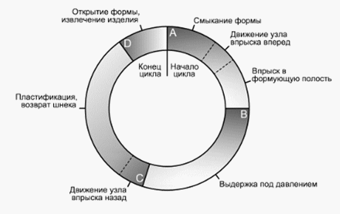
Рисунок 1.4 - Цикл лиття під тиском
The diagram shows that the bulk of the cycle time is taken up by the pressure holding and cooling processes. The greater the weight of the product and the thicker its walls, the longer these two processes take. In thin-walled products, on the contrary, the accelerated characteristics of the injection molding machine and the "dry cycle" time become more critical.
The clamping unit is powered by a hydraulic cylinder. The movable plate moves along four steel columns. The movable platen is also controlled by a hydraulic cylinder. The movable plate is equipped with a hydraulically driven ejector. The equipment is equipped with a centralized lubrication system. The injection unit moves along prismatic linear guides and is driven by two hydraulic cylinders that ensure precise alignment of the nozzle with the mold. The structure of the injection unit is shown in Fig. 1.5.
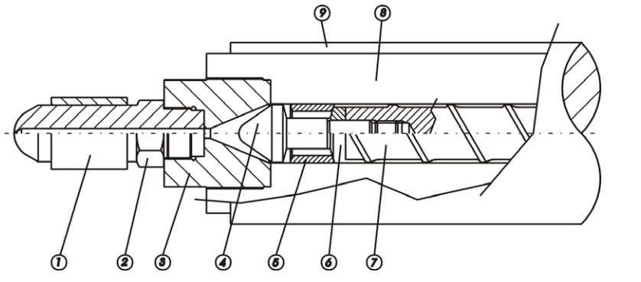

Figure 1.5 - Structure of the injection unit: 1. Nozzle heater; 2. Nozzle; 3. Plasticization chamber gearbox; 4. Screw tip; 5. Sealing valve; 6. Sealing ring; 7. Screw; 8. Plasticization chamber; 9. Heating element of the plasticization chamber

VIBRATING BENCH IRA60H/LS437A

Technical characteristics
The vibration tester is designed for vibration testing of the CP in automatic mode. The main characteristics of the vibration stand are given in Table 1.1.
Table 1.1 - Main characteristics of the vibration test bench
Technical characteristics of the stand | Dimensional characteristics
Overall dimensions (length x width x height, mm) | 10000 x 10000 x 2200
Rated supply voltage, V | 380 (three-phase, variable)
Frequency, Hz | 50
Service life (term of standard use) | 25 years
Dimensions of the vibrating table, LxD, mm | 1500х1500
Sinusoidal thrust, kg | 4000
Random thrust, kg | 4000
Shock thrust, kg | 8000
Maximum acceleration, m/s2 | 981
Maximum speed, m/s | 2
Nominal frequency range, Hz | 2...2500
Type of table | Movable
Impact displacement, mm | 100
Maximum static load, kg | 500
Temperature mode of operation of the vibrating bench, ºС | 0...+40
Table top diameter, mm | 370
Type of vibrating stand | Stationary
Type of control of the main technological parameters | Automatic
Method of controlling the main technological parameters | Control panel
Load connection point | Ø150 mm 8 pcs Ø300 mm 8 pcs
Compressed air temperature during operation, ºС | +5...+40
Number of operating personnel, persons / shift | 1
Thread size of the tabletop | М10
Humidity during the operation of the vibration stand, %. | 0...90 relative humidity (without condensation)
Protection systems: | - overcurrent protection
Protection systems: | - cooling
Type of process control | Automatic
Vibration generator | LS437A
Centrifugal fan | HP-3A
Fan power, kW | 7,5
Fan capacity, m3/h | 1700...4100
Total fan pressure, Pa | 2600...1601
Rotation angle, deg | 90
Pulse power amplifier | IRA60N
Frequency of axial vibration isolation, Hz | 3
Shaker weight, kg | 2800
Permissible eccentricity moment, Nm | 960
Effective quality of the dynamic coil, kg | 40

Structure and operation of the vibration tester
The vibration bench is designed for vibration testing of the CP in automatic mode. The bench consists of a LS437A vibration generator, HP-3A centrifugal fan with forced draft (with a silencer at the air outlet to reduce noise), and an IRA60N pulse power amplifier (power utilization rate of more than 90%). The system can perform vertical vibration tests. The air-cooled noise is low, and the operation is stable and reliable. The stroke of the vibrating table is 80 mm, the table speed is up to 2 m/s, and the waveform distortion is small. The vibrating table can be used for impact testing.
The vibration bench consists of (Fig. 1.1):
- vibrating table, item 1;
- vibration generator, item 2;
- fan with a pipeline, item 3;
- pulse power amplifier, item 4.

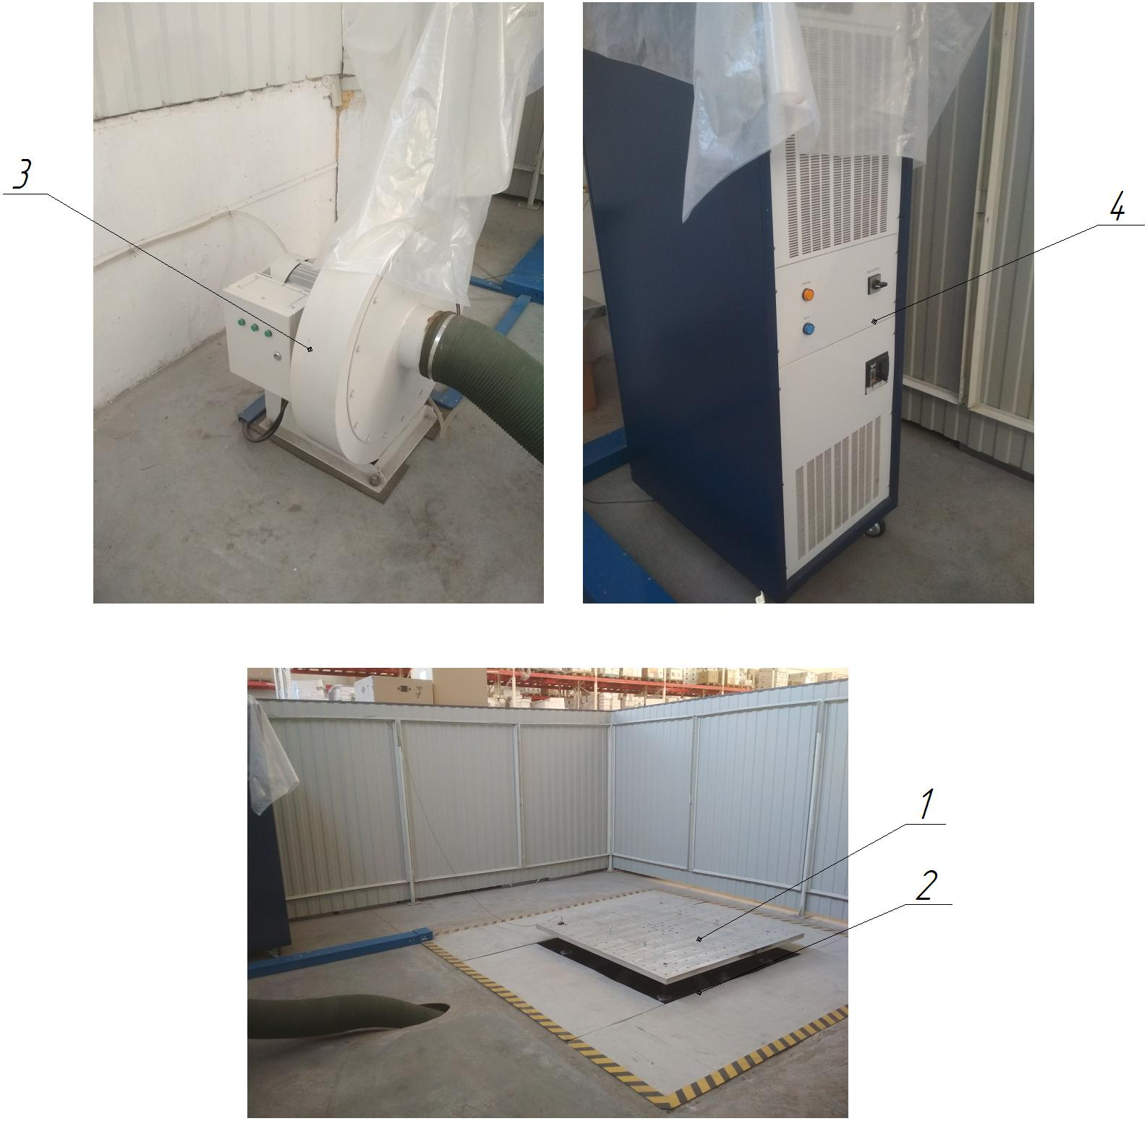

Figure 1.1 - Structure of the vibration test bench: 1 - vibrating table; 2 - vibration generator; 3 - fan with pipeline; 4 - pulse power amplifier

INCLINED BELT CONVEYOR

Technical characteristics
The conveyor is designed to move the CP chambers to the accumulation area. The main characteristics of the conveyor are given in Table 1.1.
Table 1.1 - Main characteristics of the conveyor
Technical characteristics | Dimensional characteristics
Overall dimensions (length x width x height, mm) | 6100 x 800 x 3100
Rated supply voltage, V | 380
Frequency, Hz | 50...60
Service life (standard service life) | 40
Belt material | Rubber fabric
Conveyor operating temperature, ºС | +5...+40
Number of operating personnel, persons / shift | 1
Conveyor drive | Gear motor
Type of gear motor | ZG0 KMRB 56 G.4
Drive gear, (gear ratio) | Chain, (U = 1.0)
Drive power, kW | 0,18
Type of conveyor | Inclined
Angle of inclination, degree | 50
Conveyor belt speed, rpm (m/s) | 40 (0,67)

Structure and operation of the conveyor
The inclined conveyor (Fig. 1.1) moves the CP chambers to the accumulation zone. The conveyor drive 1 consists of a gear motor and a chain drive with a protective cover 10. From the drive of the conveyor 1, the torque is transmitted to the drive drum 3 (master), on which, in turn, the conveyor belt 4 is mounted. On the other side there is a driven drum 5 and a tensioning device 6. To support the belt 4, the lower 7 and upper 9 roller supports are mounted. The conveyor is mounted on a support frame 8. Tensioning of the belt 4 is performed by adjusting the lower rollers 7.
The conveyor consists of (Fig. 1.1):
- conveyor drive, item 1 (gear motor, chain transmission);
- control panel, item 2;
- drive drum (master), item 3;
- conveyor belt, item 4;
- drum driven, item 5;
- tensioning device, item 6;
- lower roller support (tensioning), item 7;
- support frame, item 8;
- upper roller support, item 9;
- protective cover, item 10.

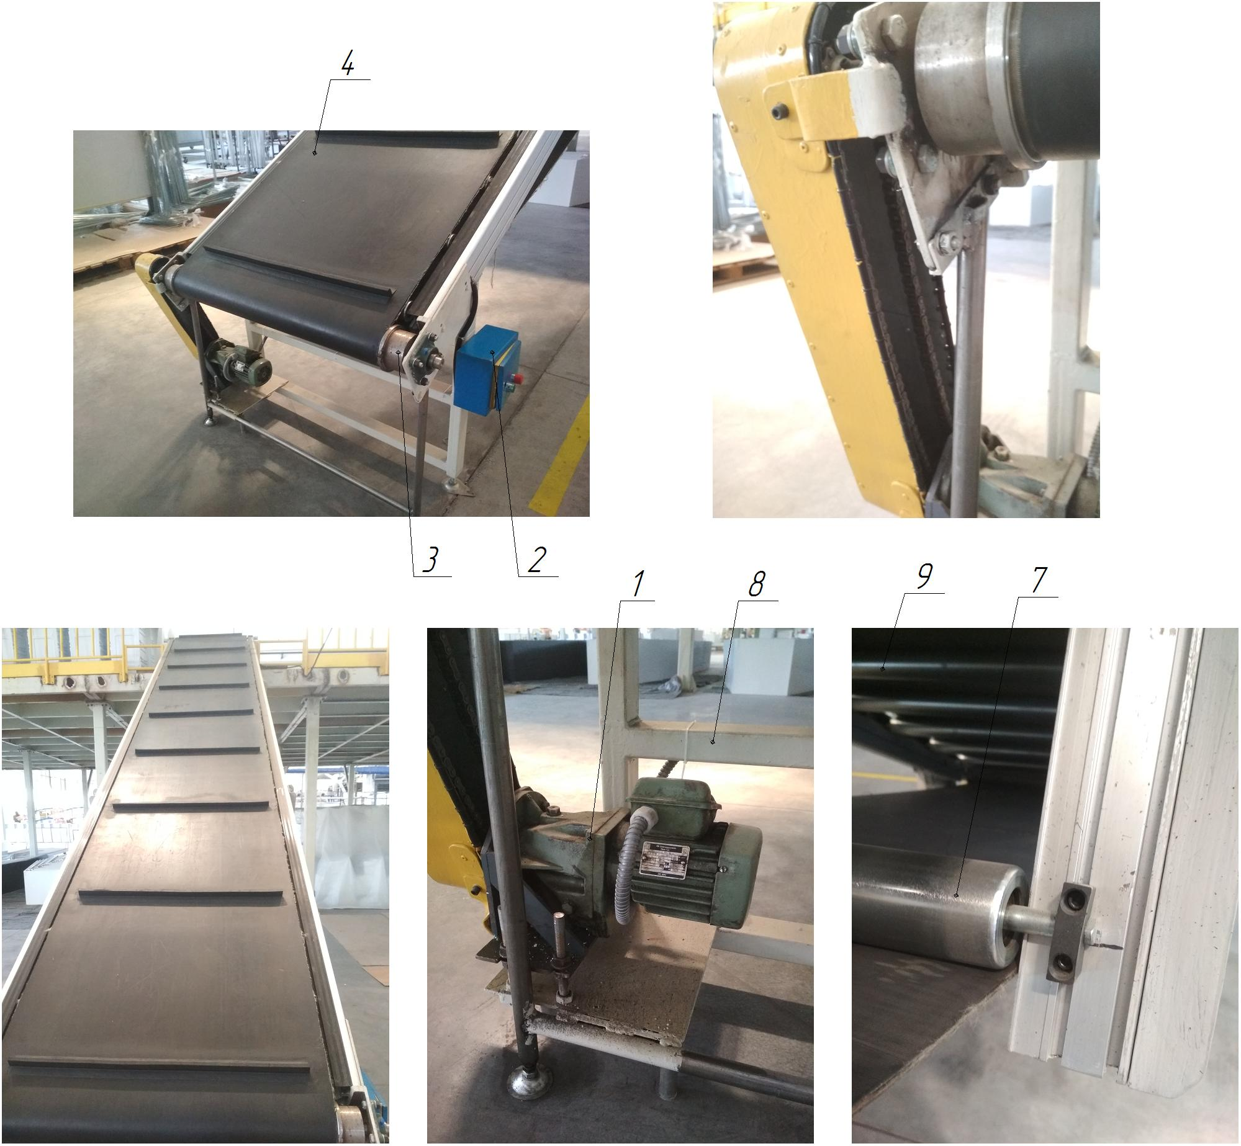

Figure 1.1 - Composition of the conveyor for moving the CP chambers: 1 - conveyor drive (gear motor, chain transmission); 2 - control panel; 3 - drive (master) drum; 4 - conveyor belt; 5 - driven drum; 6 - tensioning device; 7 - lower roller support (tensioning); 8 - supporting frame; 9 - upper roller support; 10 - protective casing

HELIUM REFUELING AND RECOVERY STATION EQL-IN-12

Technical characteristics
The station is designed for refueling, purification and recovery of helium, and for its reuse. The main characteristics of the station are given in Table 1.1.
Table 1.1 - Main characteristics of the station
Technical characteristics of the station | Dimensional characteristics
Overall dimensions of the station (length x width x height, mm) | 3000 x 2100 x 2500
Rated supply voltage, frequency | 380 V, 50...60 Hz
Station productivity, h.p./h | 90
Service life (term of normative use) | 30 years
Temperature mode of the station, ºС | +5...+40
Compressed air, fresh, dry, MPa | 0,55...0,7
Leak detection device (helium) | Phoenix L300i
Control device | Microprocessor
Inlet pressure of the equipment, MPa | Up to 0.1
Nominal flow rate, Nl/min | 75
Indicator gas | Helium
Type of vacuum pump | SOGEVAK SV25B
Number of vacuum pumps | 3
Availability of compressed helium cylinder | Є
Availability of compressor (for compressed helium) | Є
Type of station | Stationary
Filter brand of the filtration system | QU-H10X3P
Filter element | HX10X3Q
Number of filters, pcs. | 6
Pressure regulator filter | AW30-03BE B
Pneumatic distributor | 4М310-08
Number of pneumatic distributors, pcs. | 6
Type of control of main technological parameters | Automatic
Method of controlling the main technological parameters | Control panel
Compressed air for pneumatic systems | With 40 micron filtration, without oil
Compressed air temperature regime during operation, ºС | +5...+45
Number of operating personnel, persons/shift | 1
Number of exhaust centrifugal fans, pcs. | 1
Inert gas (can be used instead of air) | Nitrogen
Nitrogen pressure at the supply to the container with the CP, MPa | 0,2
Maximum volume of the part, l | ≤ 3
Maximum leakage pressure, bar | 3.0 (adjustable pressure), actual use 0.8, control unit 0.1
Nitrogen outlet pressure, bar | 1.2 (adjustable pressure), actual use 0.9
Straight pipe at the workpiece joint | Outer diameter 6 mm, inner diameter 4.7 mm
Absolute vacuum for vacuuming the workpiece | ≤ 1000 Pa
Power consumption of the station, kW | 6,0

Composition of the station
The station is designed for refueling, purification and recovery of helium, and for its reuse.
The station consists of (Fig. 1.1):
- equipment cabinet, item 1;
- power supply cabinet, item 2;
- control panel, item 3;
- compressed helium cylinder, item 4;
- compressed nitrogen cylinder, item 5;
- pipelines for air and nitrogen supply to the station, item 6;
- helium leak detector, item 7;
- helium supply pipelines and shut-off valves, item 8;
- exhaust fan, item 9;
- helium purification and recovery system, item 10.

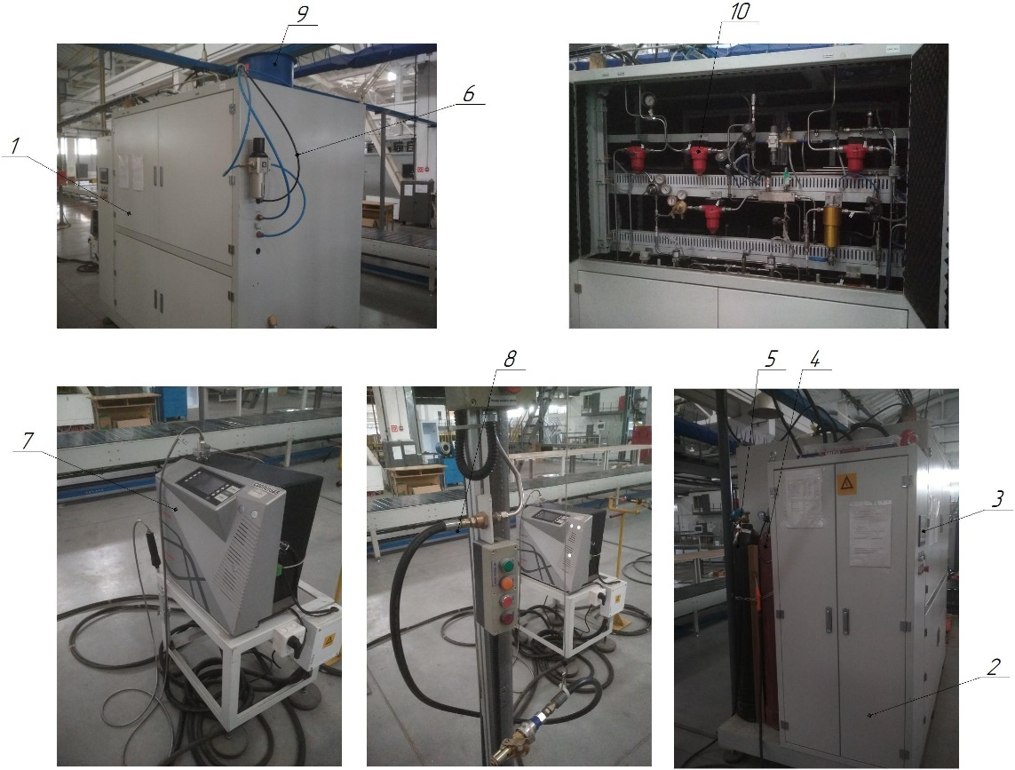
Figure 1.1 - Composition of the station: 1 - cabinet with equipment; 2 - power supply cabinet; 3 - control panel; 4 - compressed helium cylinder; 5 - compressed nitrogen cylinder; 6 - pipelines supplying air and nitrogen to the station; 7 - helium leak detector; 8 - helium supply pipelines and valves; 9 - exhaust fan; 10 - helium purification and recovery system

Structure and operation of the station
The station recovers, stores at low pressure (maximum pressure 10 bar) and reuses helium used for leak detection. The station automatically restores helium losses by refilling new helium from a 15 MPa helium cylinder. In addition, it automatically maintains a stable operating pressure in the high-pressure storage and measures the helium concentration. The system consists of a single compression stage without a high vacuum recovery line. The system is designed for small production lines with helium test pressures below 8 bar. The system provides means for analyzing the helium concentration in the tanks, which allows the device to maintain the purity of the supplied helium at the required level. Alarm sensors are installed in case of possible anomalies. The station interacts with the Phoenix L300i leak detection device to ensure full integration between the low-pressure line systems. The leak detector is equipped with a special probe to monitor the tightness of products filled with helium or a mixture of gases containing helium. The operating procedure is reduced to the inspection of the outer surface of the tested volume with a probe. Fig. 1.1 shows a diagram of the probe test.

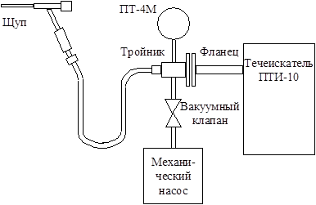

Figure 1.1 - Scheme of testing by the probe method

TESTING STATION FOR REFRIGERATION DEVICES

Technical characteristics
The station is designed for performing electrical (measuring insulation resistance, current, etc.), heat and power, and other tests of refrigeration devices. The main characteristics of the station are given in Table 1.1.
Table 1.1 - Main characteristics of the station
Technical characteristics of the station | Dimensional characteristics
Overall dimensions (length x width x height, mm) | 15000 x 6700 x 3100
Rated supply voltage, frequency | 220 V, 50...60 Hz
Number of places for testing of the CP, pcs. | 240
Capacity of the station, f.p.h. | 160
Service life (term of normative use) | 25 years
Temperature mode of the station, ºС | +20...+30
Working pressure in pneumatic lines, MPa | 0,4...0,6
Availability of exhaust and air conditioning system | Є
Availability of conveyors at the station | Є
Integrated electrical safety tester | AN9651F Ainuo
Refueling stand KP | Universal
Type of station | Stationary
Type of control of the main technological parameters | Automatic
Method of controlling the main technological parameters | Control panel
Compressed air for pneumatic systems | With 40 micron filtration with or without oil
Compressed air temperature regime during operation, ºС | +5...+50
Number of operating personnel, persons/shift | 3
Purpose and composition of the station
The station is built on a modular basis. The station performs electrical (measurement of insulation resistance, current) and thermal power tests of the heat exchangers. The operational properties of the fuel assemblies are determined by their thermal energy parameters (TEP), such as the ability to maintain the required temperatures in different compartments simultaneously, electricity consumption, etc. The same parameters also determine the energy efficiency of the refrigeration unit - the energy consumption class of the refrigeration unit. For this purpose, automated systems of different purpose, technical characteristics and structure are used, such as: 1. Automated system of testing of refrigeration devices (ASRD) - for conducting acceptance tests (AT) of all the COPs coming from the assembly lines of the refrigerator assembly production; 2. Selective control station for TEPs of the COP (SCS) - for selective quality control of the ACT by automated refinement of the TEPs of the COP that have passed the ACT; 3. Automated system for thermal and energy tests of the COP (ASTEV COP) - for research and all types of control tests of the COP.
ASTEV KP is a distributed information and measurement system. The system architecture is shown in Figure 1.1
The operator's workstation implements the functions of collecting, registering, processing, and presenting information that best meet the requirements for the system's application software.

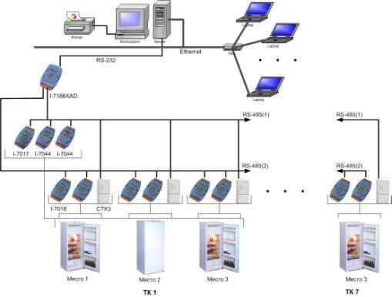

Figure 1.1 - Architecture of ASTEV HP

The station consists of (Fig. 1.2):
- roller conveyor, item 1;
- roller conveyor drive, item 2;
- plate conveyor, item 3;
- drive of the plate conveyor, item 4;
- posts for testing of CP, item 5;
- stand for cyclic tests of opening and closing of doors ХП, POS.6;
- KP refueling stand (universal), item 7;
- Laboratory for testing KP, item 8;
- Glass shelves testing unit ХП, item 9;
- ventilation and air conditioning system, item 10;
- comprehensive electrical safety tester, item 11;
- control panel, item 12;
- control cabinet, item 13.

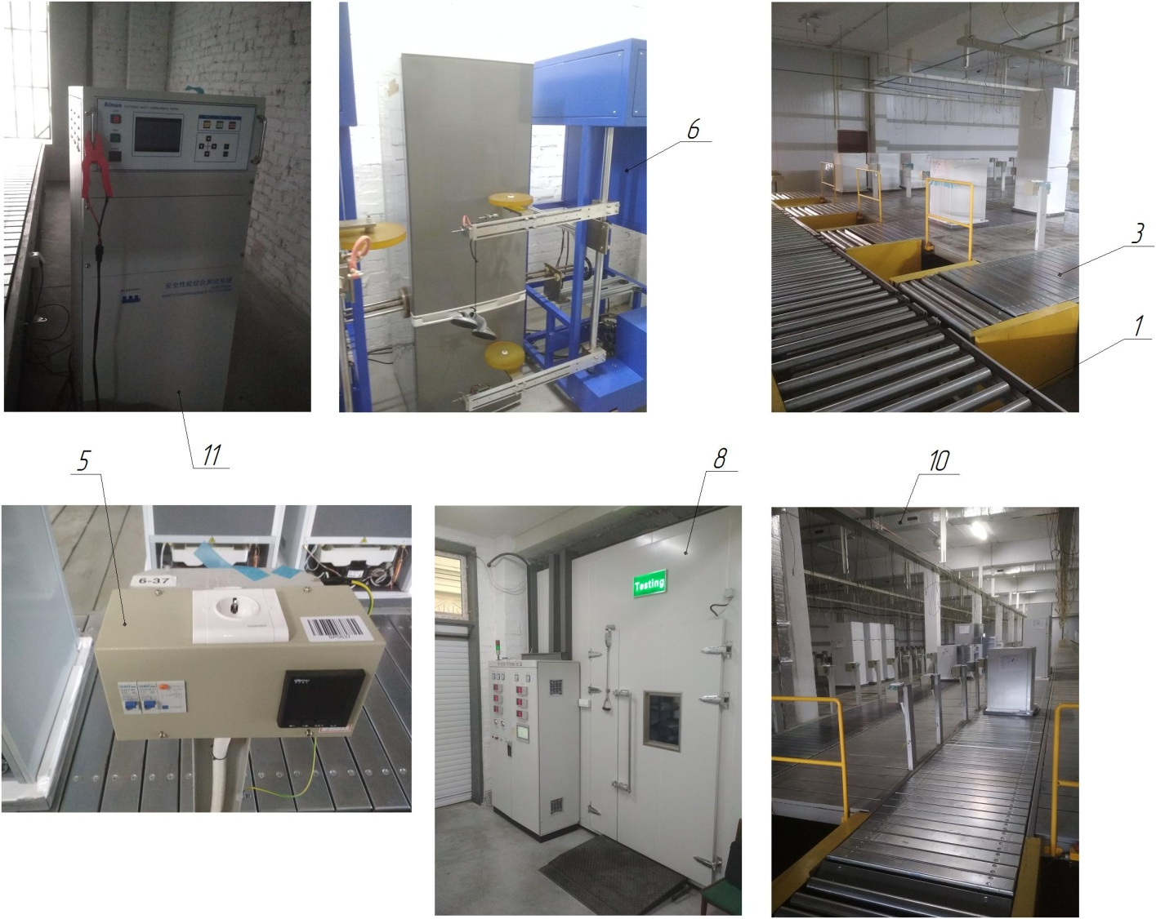

Figure 1.2 - Composition of the test station: 1 - roller conveyor; 2 - roller conveyor drive; 3 - plate conveyor; 4 - plate conveyor drive; 5 - posts for testing the KP; 6 - stand for cyclic tests of opening-closing the KP doors; 7 - KP refueling stand (universal); 8 - KP testing laboratory; 9 - KP glass shelf testing unit; 10 - ventilation and air conditioning system; 11 - comprehensive electrical safety tester; 12 - control panel; 13 - control cabinet

Operation of the station: The CP is fed to the test station via roller conveyor 1. Then to the plate conveyor 3 and connected to the test stations 5. After the tests, the CPs are fed by the roller conveyor to the packaging section, and the CPs that failed the tests to the repair section to identify the cause.

Existing technology for checking the thermal performance of the device during the CCD
Each COE manufactured by the assembly plant is subjected to a CCD test at the testing station, which includes checking the thermal performance (power consumption, number of cycles, temperature in the freezer (FC) and refrigerator (RC) for a specified test time). The procedure and duration of the tests are specified in the acceptance test methodology for a specific model of the refrigeration device. After transporting the COP to the test line, the controller places resistance thermometers in the middle part of the COP door on the barrier shelf and in the geometric center of the evaporator bottom of the MC before switching on the refrigerator. Turn the thermostat knob to the "**" position and turn on the refrigerator. After a specified time, the readings of the I440 electricity meter and the SEI-1 cycle counter are recorded in the log as the initial readings for the "control time" - the next test time of the cold storage unit, during which the temperatures in the chambers and compartments, electricity consumption and the number of "work/stop" cycles are monitored. Temperatures in the chambers and compartments are determined by resistance thermocouples TSM-6114 or TSM-0987 (NSX 50M) with a portable digital thermometer EDT as a secondary device after the end of the "control time" of the test, i.e. one measurement is taken. The power consumption and the number of cycles during the same "control time" are determined by the difference between the final and initial readings of the devices. The refrigerating device has passed the test if, at a certain ambient air temperature, the temperature in the chambers and compartments and the number of cycles correspond to those given in the methodology for the corresponding model of the CP. Structurally, the electricity meter, cycle counter and means of connecting the CP to the power grid are arranged in a measuring column installed at each test point of the test line. The number of test locations and, accordingly, measuring columns (with a margin for repair and maintenance) determines the throughput of the test station.
Thus, the existing equipment of the test station and the technology based on it for checking the CFCs during the RCD uses manual operations to control the test time, record measurement data, process them, make decisions on test results and document them.
The station is equipped with a ventilation and air conditioning system to maintain the required temperature in the room.
Comprehensive electrical safety tester AN9651F Ainuo. Meets the requirements of CCC, IEC EN, VED, BS, UL, JIS standards. The latest international standard: maximum AC power 500 VA (5 kV/100 mA AC), short-term replacement output current pre-increase 200 mA. Built-in optional MD network card for leakage current testing, meeting the requirements of various industrial standards up to 64 A.
6 in 1: AC current, insulation countermeasure, ground connection countermeasure, leakage current, operating power, low voltage start. Standby power consumption, low to 0.5 W minimum, 0.2% accuracy. Simple operation: LED screen with backlight. Built-in isolated transformer, power supply with AC frequency converter, power supply with frequency converter and industrial PC combination. The main characteristics of the electrical safety tester are shown in Table 1.2.
Input power: AC 220 V-240 V 50/60 Hz 5.5 kVA MAX.

Table 1.2 - Main characteristics of the electrical safety tester
AC Hipot тест
Rated output power of the amplifier |  | 500 VA ( 5000 V / 100 mA )
Maximum short-circuit current of the amplifier |  | > 200 mA
Output waveform |  | Sine wave, <3% ( pure resistance, 5000 V / 1 mA ), <3% ( from empty load to full load )
Output voltage setting | 500 ~ 5000V | 500 ~ 5000V
Output voltage setting | 5В | 5В
Output voltage setting | ± ( 3% × setting + 10 V ) | ± ( 3% × setting + 10V )
Frequency setting | 50 Hz / 60 Hz | 50 Hz / 60 Hz
Frequency setting | ± 0.1% × setpoint | ± 0.1% × setpoint
Установка тревожных пределов | 0:10 ~ 99.99 mA | 0:10 ~ 99.99 mA
Установка тревожных пределов | 0:00 ~ 10.00 mA | 0:00 ~ 10.00 mA
Настройка тока компенсации | 0.00 ～10.00mA, automatic test, compensation can be enabled/disabled | 0.00 ～10.00mA, automatic test, compensation can be enabled/disabled
Настройки времени | 1 ~ 999 с | 1 ~ 999 с
Настройки времени | 1 ~ 100 с | 1 ~ 100 с
Настройки времени | ± ( 0.1% + × 1 count setting ) | ± ( 0.1% + × 1 count setting )
Тревога пробоя | 0:10 ~ 99.99 mA | 0:10 ~ 99.99 mA
Тревога пробоя | ± ( 3% × reading + 3 counts ) | ± ( 3% × reading + 3 counts )
Insulation resistance test
Rated output power |  | 2VA ( 1000 V / 2 mA )
Output voltage regulation |  | <3% ( no-load to full load )
Output voltage ripple |  | <1%
Output voltage setting | Range | DC 500Vor1000V
Output voltage setting | Accuracy | ± ( 3% × setting + 3 counts )
Setting alarm limits | Upper resistance limit range | 0.0 ~ 99.9 megohms , 100 ~ 2000 megohms ( if the upper limit is set to 0, it will not detect the upper limit )
Setting alarm limits | Lower resistance limit range | 0.3 ~ 99.9 megohm, 100 ~ 2000 megohm
Time settings | Range | 1 ~ 999 с
Time settings | Accuracy | ± ( 0.1% + × 1 count setting )
Measuring insulation resistance | Range | 0.0 ~ 99.9 MOhm, 100 ~ 2000 MOhm
Measuring insulation resistance | Accuracy | ≤200 MOhm: ± ( 3% × reading + 3 counts )
Measuring insulation resistance | Accuracy | > 200 Mohm : ± ( 8% × reading + 8 counts )
Ground resistance test
Output voltage without load |  | <12v span = "">
Output current setting | Range | 3 ~ 30 А
Output current setting | Accuracy | ± ( 3% × setting + 0.2 A )
Output current setting | Instruction for the current range | Optional: test current 3 ~ 64 A
Current frequency setting | Range | Sine waveform 50 Hz / 60 Hz
Current frequency setting | Accuracy | ± 0.1% × setpoint
Test time setting | Range | 1 ~ 999 с
Test time setting | Accuracy | ± ( 0.1% + × set 1 count )
Results display mode |  | Ground resistance or voltage
Ground resistance display mode
Setting alarm limits | Range of upper resistance limit | 3A≤ output current≤10A: 10 ~ 600 mOhm
Setting alarm limits | Lower resistance limit range | 0 ~ 100 mOhm
Setting compensation resistance | Range | 0 ~ 200 mOhm, automatic testing, compensation can be enabled/disabled
Measuring ground resistance | Range | 10 ~ 600 mOhm
Measuring ground resistance | Accuracy | ± （3% × reading +

CRUSHER FOR PLASTIC LH-300

Technical characteristics
The crusher is designed for recycling (crushing) used plastic products into raw materials. The main characteristics of the crushers are shown in Table 1.1.
Table 1.1 - Main characteristics of crushers
Technical characteristics | Dimensional characteristics
Technical characteristics | LH-300 | LH-400 |  | РС-960
Overall dimensions (length x width x height, mm) | 1030х750х1200 | 1100х860х1330 | 2500х2000х3000
Rated supply voltage, frequency | 380 V, 50...60 Hz
Crusher capacity, kg/h | 200...250 | 300...450 | 800…900
Service life (standard service life) | 25 years | 25 years | 25 years
Electric motor power, kW | 5,5 | 7,5 | 55
Rotation frequency, rpm | 1500 | 1500 | 1480
Loading window, mm | 230 х 300 | 245 х 400 | 500 х 600
Total number of knives, pcs: movable fixed | 11 9 2 | 14 12 2 | -
Weight, kg | 480 | 660 | 860
Temperature mode of the crusher, ºС | +5...+40
Method of controlling the main parameters | The control panel
Number of operating personnel, persons / shift | 1
Plastic feeding | Manual
Type of crusher | Mobile, low-speed, rotary
Method of placing moving knives | Cascade
The use of the crusher | For shredding thick-walled plastic waste
Gap between movable and fixed knives, mm | 0,15...0,7 (0,3…0,4)
Gap between movable knives and mesh, mm | 3,5...5,5

Structure and operation of the crusher
A crusher consists of a feed hopper, a crushing chamber, a rotor with knives (movable), fixed knives, a drum with a sieve, an electric motor, a receiving tray, and other components. The material fed through the feed hopper enters the grinding chamber, where it is crushed between the moving rotor knives and the stationary knives, and sifted through the sieve into the receiving tray. Depending on the material, the size of the fraction can be adjusted by changing the mesh and the distance between the knives, which allows for the crushing of any type of plastic.
The crusher consists of (Fig. 1.1):
- feed hopper item 1;
- shredding chamber item 2;
- rotor with knives (movable), item 3;
- fixed knives, item 4;
- drum with a sieve, item 5;
- crusher drive (electric motor, belt drive), item 6;
- receiving tray, item 7.

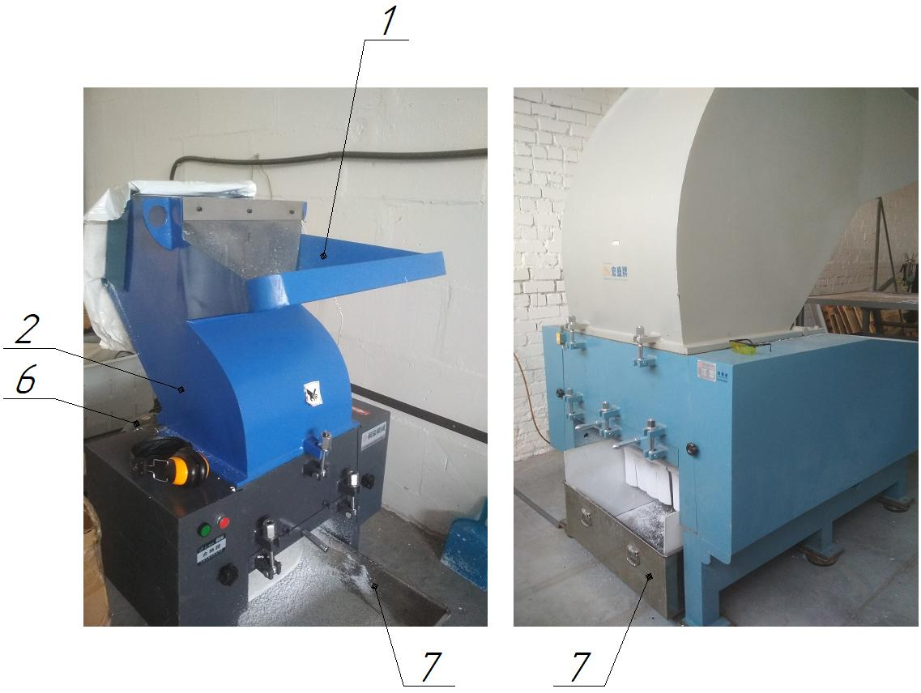

Figure 1.1 - Composition of the crusher: 1 - feed hopper; 2 - crushing chamber; 3 - rotor with knives (movable); 4 - fixed knives; 5 - drum with sieve; 6 - crusher drive (electric motor, belt drive); 7 - receiving tray

INSTALLATION FOR HYDRAULIC CRIMPING OF HIGH-PRESSURE HOSES CDX-90

Technical characteristics
The machine is designed for crimping high-pressure hoses in semi-automatic mode. The main characteristics of the unit are given in Table 1.1.
Table 1.1 - Main characteristics of the unit
Technical characteristics | Dimensional characteristics
Overall dimensions (length x width x height, mm) | 900 x 450 x 1100
Rated supply voltage, frequency | 380 V, 50...60 Hz
Service life (standard service life) | 30 years
Ready time of the unit, after switching on the GHS, min. | 5...10
Productivity of the unit, units/h | 120
Method of controlling the LPG system | The control panel
Volume of oil in the LPG system, l | 50
Temperature mode of the unit, ºС | +5...+50
Operating pressure in hydraulic lines, MPa | 12...14
Cooling of the GFS | Natural
Type of installation | Stationary
Electric motor power, kW | 3,0
Electric motor rotation speed, rpm | 1420
Type of electric motor | GL-100L2-4 B5
Mineral hydraulic oil for hydraulic filling stations | MGE-46B
Pressure in the system, MPa | 31,5
Pump capacity, l/min | 19
Presence of water and acids in the oil | Absence
Oil filtration before pouring into the tank | Particles with a diameter of more than 0.025...0.04 mm
Oil temperature during operation, ºС | +10...+50
Installation weight, kg (without oil) | 240
Set of cams (press washers), pcs. | 4
Maximum pressing pressure, kN (t) | 5300 (530)

Structure and operation of the unit
The unit is designed for crimping (for hose crimping using various crimping couplings) of high-pressure hoses in semi-automatic mode. Thanks to the crimping, a tightness between the hose and metal fittings is achieved. This device can be used to crimp pressure washers, hoses and pipes with an internal cross-section of 6-51 mm, and the outer diameter should vary from 10 to 74 mm. The unit is supplied with 4 types of magnetic press washers that differ in size. The device provides a maximum pressure of up to 31.5 MPa.
The unit consists of (Fig. 1.1):
- installation body, item 1;
- hydraulic pumping station, item 2;
- electric motor, item 3;
- control panel, item 4;
- crimping head, item 5;
- press washer, item 6.

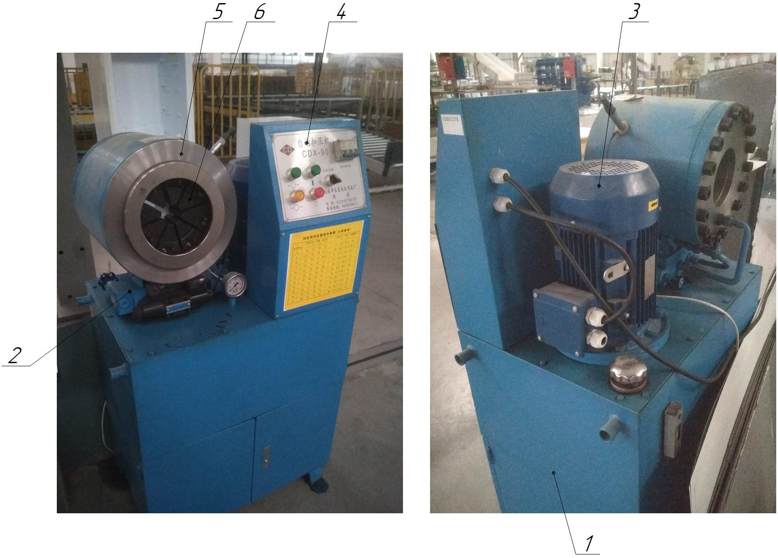

Figure 1.1 - Composition of the unit: 1 - plant body; 2 - hydraulic pumping station of the GTS; 3 - electric motor; 4 - control panel; 5 - crimping head; 6 - press washer

STATIONARY AIR COMPRESSOR STATION

Technical characteristics
The station is designed to receive, purify and dry compressed air at the outlet and maintain its set pressure in the main pipeline of the enterprise in automatic mode.
Table 1.1 - Main characteristics of the station
Technical characteristics of the station | Dimensional characteristics
Overall dimensions of the compressor (length x width x height, mm) | 2300 x 1400 x 1560
Number of air compressors, pcs. | 2 (1 backup)
Rated supply voltage, V | 380 (three-phase, variable)
Frequency, Hz | 50...60
Ready time of the station, after switching on the compressor, min. | 5...10
Capacity of the station (compressor), m3/min | 14,1
Operating pressure in the discharge line, MPa | 0,7
Type of air compressor | Oil-filled screw type
Compressor model | JLS-75F
Compressor drive | Straight, coupling
Compressor power, kW | 75
Type of station | Stationary
Type of control of main technological parameters | Automatic
Method of control of main technological parameters | Control panel
Compressed air temperature at the compressor outlet, ºС | +70...+95
Compressed air for pneumatic systems | With 40 micron filtration, without oil
Temperature regime of the station operation, ºС | +5...+45
Number of operating personnel, persons/shift | 1
Air exchange mode of the station | Natural
Model of refrigerated compressed air dryer | JLS-17RD
Power of the dryer, kW | 2,5
Number of dryers, pcs. | 2
Service life of the station (standard service life) | 25 years
Total power of the station, kW | 77,5
Overall dimensions of the dryer (length x width x height, mm) | 1250 x 600 x 1120
Refrigerant for the dryer | R410A
Compressed air purification before the dryer:  - moisture separator  - compressed air filter | VO-080A  FSV-O-840
Quantity, pcs:  - moisture separator  - compressed air filter | 2  2
Availability of a system of pipelines for condensate drainage | є
Mode of operation of the condensate drainage system | Automatic
Capacity of the condensate drain tank, m3 | 1
Availability of a receiver | no
Operating temperature of the oil, ºС | +60...+80
Air humidity at the compressor inlet | no more than 90%
Operating temperature of the refrigerated dryer, ºС | +1...+45

Composition of the station
The station is built on a modular basis. The station is designed to receive, purify and dry the compressed air at the outlet and maintain its set pressure in the main pipeline of the enterprise in automatic mode.
The station consists of (Fig. 1.1):
- air compressor No. 1, item 1;
- air compressor No. 2, item 2;
- compressed air dryer No. 1, item 3;
- compressed air dryer No.2, item 4;
- main pipeline system with shut-off valves, item 5;
- control cabinet, item 6;
- system of pipelines for condensate drainage, item 7;
- compressed air purification system (filter, oil and moisture separator) of compressor No.1, item 8;
- Compressed air purification system (filter, oil and moisture separator) of compressor No. 2, item 9;
- condensate tank, item 10;
- control panel, item 11.

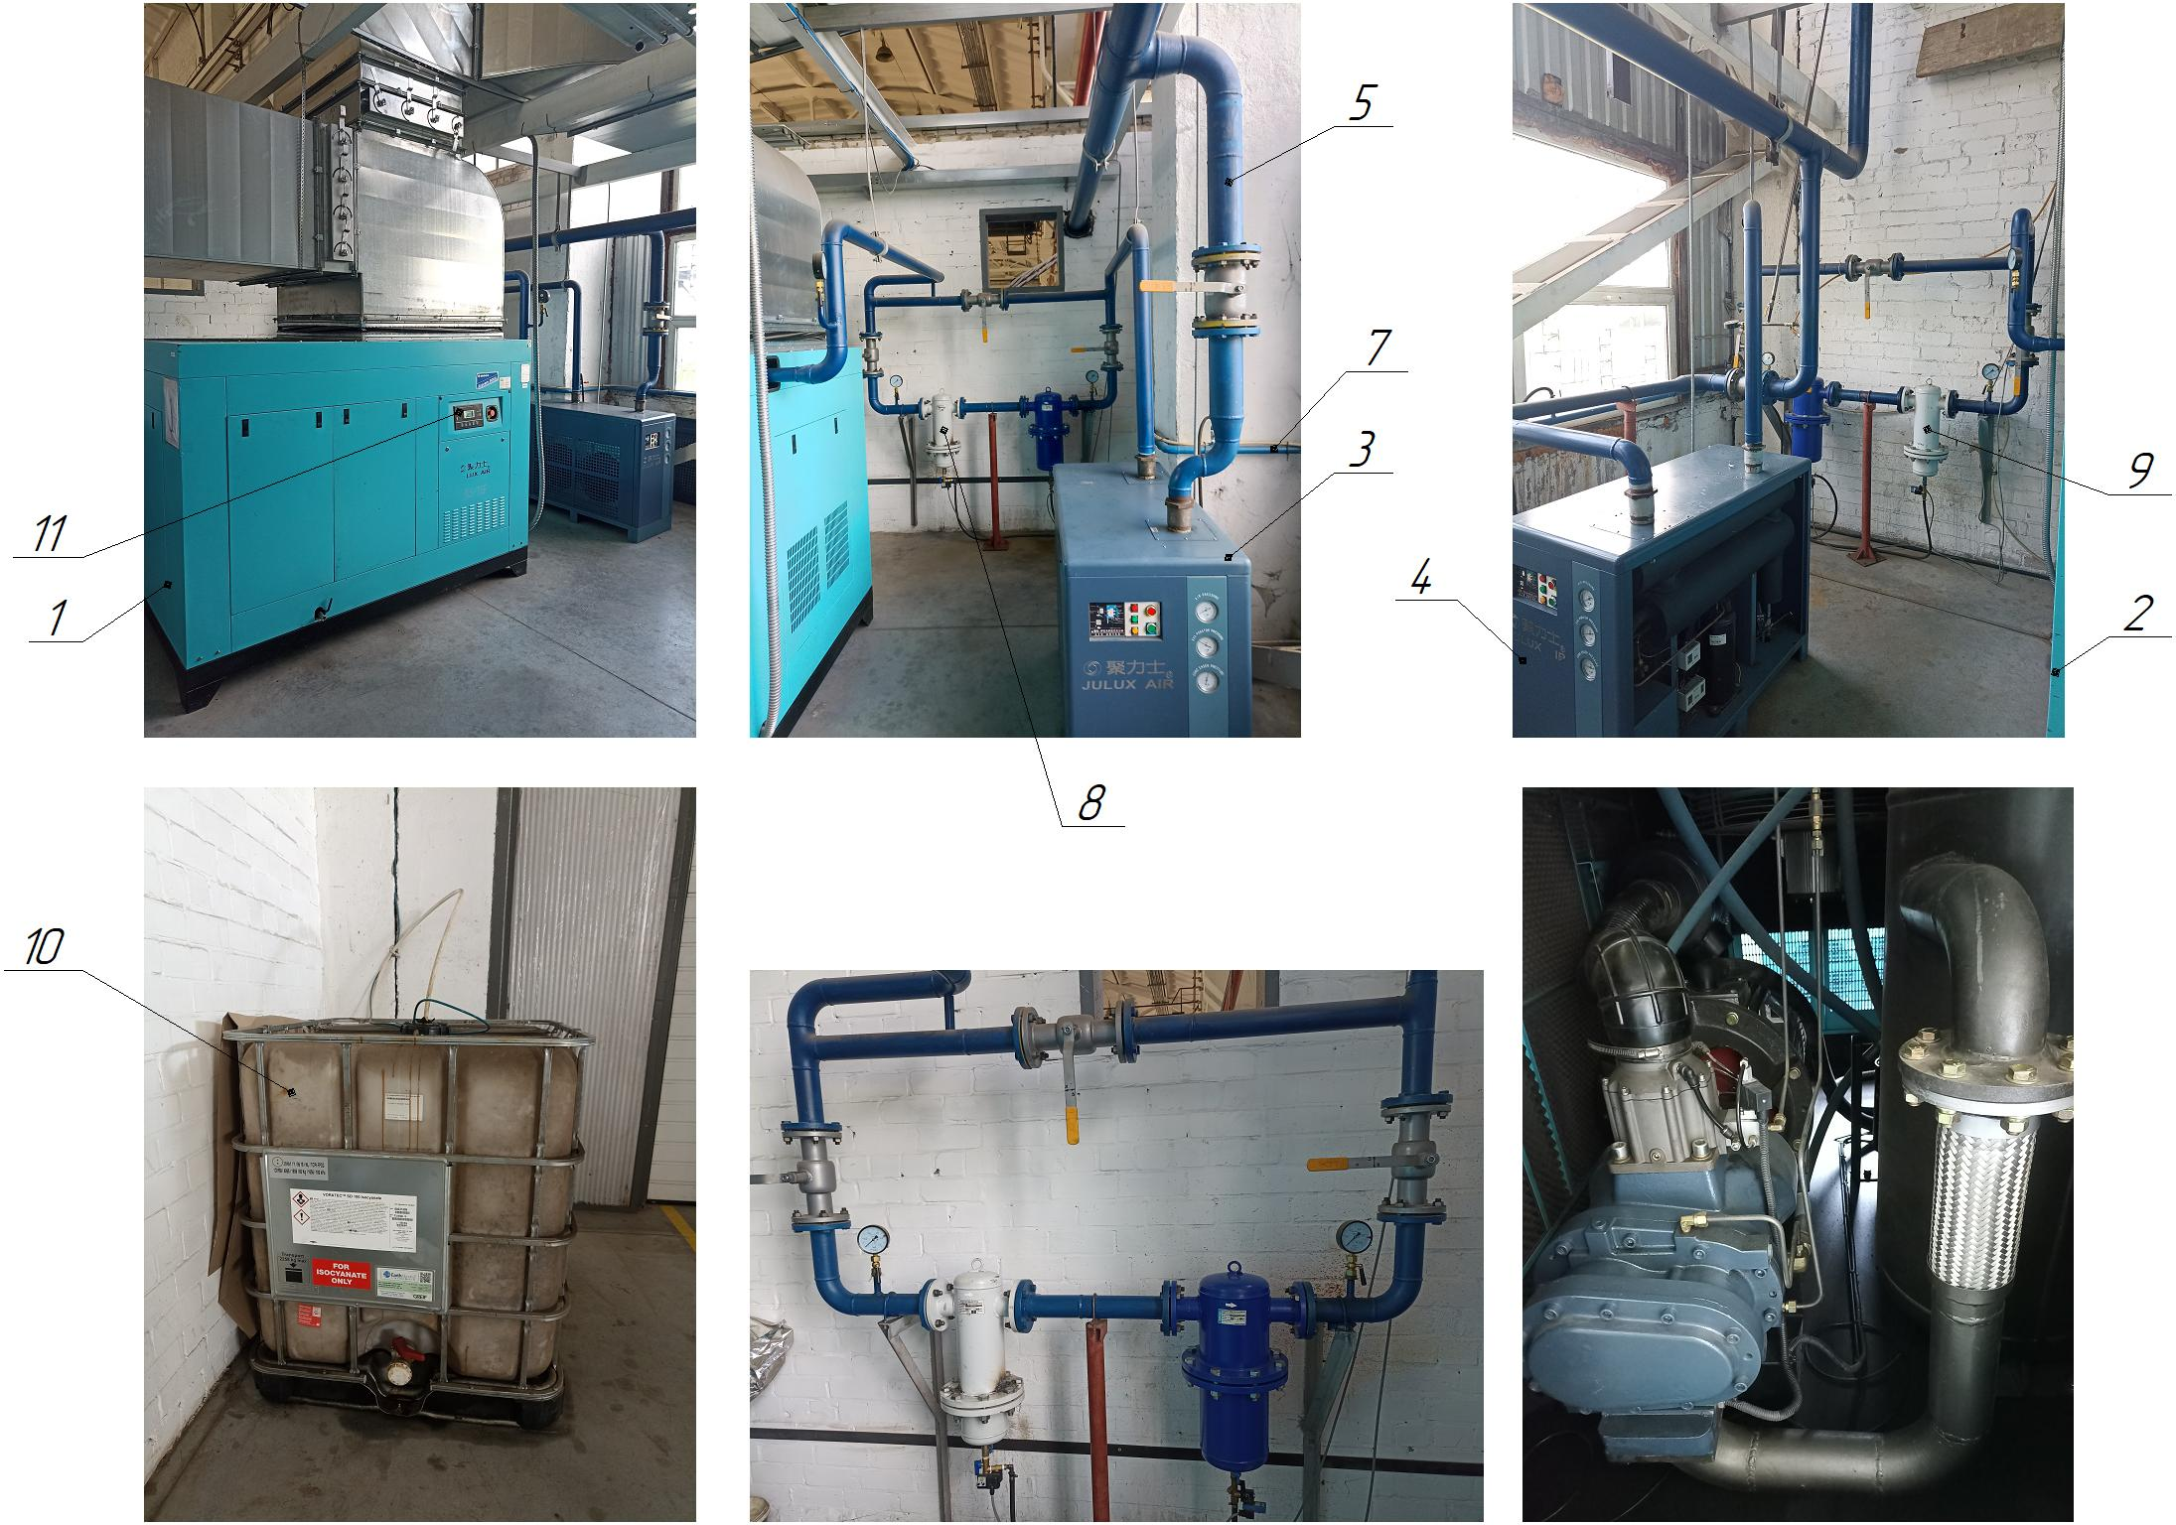

Figure 1.1 - Composition of the station: 1 - air compressor No. 1; 2 - air compressor No. 2; 3 - compressed air dryer No. 1; 4 - compressed air dryer No. 2; 5 - main pipeline system with shut-off valves; 6 - control cabinet; 7 - condensate drainage pipeline system; 8 - compressed air purification system (filter, oil and moisture separator) of compressor No. 1; 9 - compressed air purification system (filter, oil and moisture separator) of compressor No. 2; 10 - condensate tank; 11 - control panel
Structure and operation of the station
The station (Fig. 1.1) is designed to receive, purify and dry compressed air at the outlet and maintain its set pressure in the main pipeline of the enterprise using a compressor in automatic mode. The principle of operation of the screw compressor 1 or 2 (№1,2): atmospheric air is cleaned from dust, dirt, and foreign small objects through the air filter. Air and oil immediately enter the chamber of the screw unit. The rotary screw pair is driven by a direct coupling transmission. An air-oil mixture is formed in the rotary pair, which is compressed to the desired pressure. The compressed mixture is transported through a pipeline system to a separator, where it is separated. The oil goes to the oil cooler and then returns to the system, while the air enters the air cooler, where it is cooled to the optimum temperature. Further, cold and oil-free air is supplied through the compressed air purification system (filter, oil and moisture separator) 8 (#1) or 9 (#2) and the compressed air dryer 3 (#1) or 4 (#2) to the connected consumer through the main pipeline system with shut-off valves 5. Condensate is discharged through the piping system 7 to the condensate tank 10.
Screw air compressor JLS-75F LUX AIR (2 pcs) - is designed to inject compressed air into the main pipeline. The main characteristics of the compressor are shown in Table 1.2.
Table 1.2 - Main characteristics of the compressor
Parameter | Dimensional characteristics
Model | JLS-75F
Electric motor power, kW | 75
Rated supply voltage, V | 380 (three-phase, variable), 50Hz
Rotation speed, rpm | 2980
Oil for the compressor | Syprem 8000S
Number of fans, pcs. | 1
Noise level, dB | 65
Overall dimensions (LxWxH), mm | 2300 x 1400 x 1560
Weight, kg | 1800
Compressor capacity, m3/min | 14,1
Maximum pressure, MPa | 0,8
Operating pressure, MPa | 0,7
Maximum ambient temperature, ºС | 40
Type of rotary compressor | Screw type
Rotary compressor type by oil application | Oil type
Rotary compressor type by mobility | Stationary
IP degree of protection | 54
Pressure regulation | є
Automatic protection system | є
Compressor cooling system | Aerial
Suction valve | AIV-85B-F
Oil filter (180 l/min, pressure up to 14 bar, purity up to 15 microns, temperature up to 120 °C, filter paper F5, thread G1 1/2''-16 UNF, dimensions Ø136x302 mm) | W 13145 Y.T.F.
Air filter | є
Compressed air outlet pipeline | Du60

Moisture separator VO-080A is designed to separate moisture from compressed air and remove it through an automatic discharge valve into a condensate drainage pipe. The main characteristics of the moisture separator are given in Table 1.3.
Table 1.3 - Main characteristics of the moisture separator
Parameter | Dimensional characteristics
Model | VO-080A
Nominal air flow rate, m3/min. | 25
Weight, kg | 55
Tank capacity, l | 3,5
Degree of separation by particles not less than 20 microns, %, not less than | 90
Availability of condensate drain | є
Hydraulic resistance, bar | 0,05
Operating pressure, MPa | 0,63
Maximum pressure, MPa | 1,0
Dimensions (LxHxD), mm | 300x820x280
Number of moisture separators at the station, pcs. | 2

The FSV-O-840 compressed air filter is a device that removes solid particles, oil vapor, and water from compressed air. As a filter material for the manufacture of elements, needle-punched fiber and glass fiber with high porosity (up to 96%) are used. The main characteristics of the filter are shown in Table 1.4.
Table 1.4 - Main characteristics of the filter
Parameter | Dimensional characteristics
Model | FSV-O-840
Capacity, m3/min (m3/h) | 14,0 (840)
Weight, kg | 57
Type of filter | The main one
Connection, mm | DN65
Filter element | EO-250
Number of filter elements, pcs. | 3
Dimensions of the filter element (BxD), mm | 250х74
Operating pressure, MPa | 1,0
Test pressure, MPa | 1,3
Number of filters at the station, pcs. | 2

Refrigerated compressed air dehumidifier JLS-17RD (2 pcs) is a refrigeration dehumidifier used in pneumatic compressed air treatment systems where the temperature of the working medium does not fall below the dew point temperature guaranteed by the dehumidifier (+3C). The dryer is designed to remove vaporized moisture from compressed air. It is used in heated rooms. The main characteristics of the dehumidifier are shown in Table 1.5.
Table 1.5 - Main characteristics of the dryer
Parameter | Dimensional characteristics
Model | JLS-17RD
Nominal inlet volume flow, m3/min | 17
Inlet temperature, С°. | ≤ 45
Type of dehumidifier | Refrigerated
Dew point at nominal pressure, C°. | +2...+10
Operating pressure, MPa | 0,4...1,3
Drive power, kW | 2,5
Rated supply voltage, V | 380 (three-phase, variable)
Frequency, Hz | 50...60
Refrigerant for the dehumidifier | R410A
Dimensions of the dehumidifier (LxWxH), mm | 1250 x 600 x 1120
Weight, kg | 145
Number of dehumidifiers at the station, pcs. | 2

STATIONARY NITROGEN STATION LCN-40

Technical characteristics
The station is designed to produce nitrogen gas with a purity of 99.99% from atmospheric air by the method of short-cycle non-heating adsorption (PSA), accumulate and maintain its set pressure in the main pipeline of the enterprise in automatic mode.
Table 1.1 - Main characteristics of the plant
Technical characteristics of the station | Dimensional characteristics
Overall dimensions of the compressor (length x width x height, mm) | 1280 x 1035 x 1380
Number of air compressors, pcs. | 1
Rated supply voltage, V | 380 (three-phase, variable)
Frequency, Hz | 50...60
Ready time of the station after switching on the compressor, min. | 5...10
Station capacity (nitrogen), m3/h | 40
Working pressure of nitrogen in the discharge line, MPa | 0,6
Type of air compressor | Screw oil-filled
Compressor model | TN-30A/10
Compressor drive | Belt transmission
Compressor power, kW | 30
Type of station | Stationary
Type of control of main technological parameters | Automatic
Method of control of main technological parameters | Control panel
Compressed air temperature at the compressor outlet, ºС | +70...+95
Adsorption nitrogen generator (PSA) | LCN-40
Nitrogen gas purity at the outlet, %. | 99,99
Temperature regime of the station operation, ºС | +2...+40
Number of operating personnel, persons/shift | 1
Air exchange mode of the station | Forced
Number of centrifugal fans at the station, pcs. | 2
Model of refrigerated compressed air dryer | LGZ-4
Power of the dryer, kW | 1,2
Number of dryers, pcs. | 1
Service life of the station (standard service life) | 25 years
Total power of the station, kW | 31,2
Refrigerant for the dryer | -
Compressed air purification before the refrigerated dryer: - water-oil separator | LCG-4
Compressed air purification after the refrigerated dryer: - adsorption dryer | є
Number of adsorption dryers (A, B), pcs. | 2
Compressed air purification after the adsorption dryer: - activated carbon filter | LCH-4
Number of activated carbon filters, pcs. | 1
Number of adsorption columns (A, B), pcs. | 2
Number of intermediate tanks, pcs: - air - nitrogen | 1 1
Availability of piping system for condensate drainage | є
Operation mode of the condensate drainage system | Automatic
Availability of a condensate drainage tank | є
Capacity of the condensate drain tank, m3 | 1
Number of receivers, pcs: - air - nitrogen | 1 1
Operating oil temperature, ºС | +60...+80
Air humidity at the compressor inlet | no more than 90%
Operating temperature of the refrigerated dryer, ºС | +1...+45

Composition of the station
The station is built on a modular basis. The station is designed to obtain nitrogen gas with a purity of 99.99% from the atmospheric air, accumulate and maintain its set pressure in the main pipeline of the enterprise in automatic mode.
The station includes (Fig. 1.1):
- air compressor, item 1;
- air receiver, item 2;
- water-oil separator, item 3;
- refrigerated compressed air dryer, item 4;
- adsorption dryer of compressed air No. 1 (A), item 5;
- adsorption dryer of compressed air No. 2 (B), item 6;
- activated carbon filter, item 7;
- intermediate air tank, item 8;
- adsorption column No. 1 (A), item 9;
- adsorption column No. 2 (B), item 10;
- intermediate nitrogen tank, item 11;
- main pipeline system with shut-off valves, item 12;
- control cabinet, item 13;
- system of pipelines for condensate drainage, item 14;
- condensate tank, item 15;
- nitrogen receiver, item 16;
- centrifugal fan, item 17 (2 pcs.).

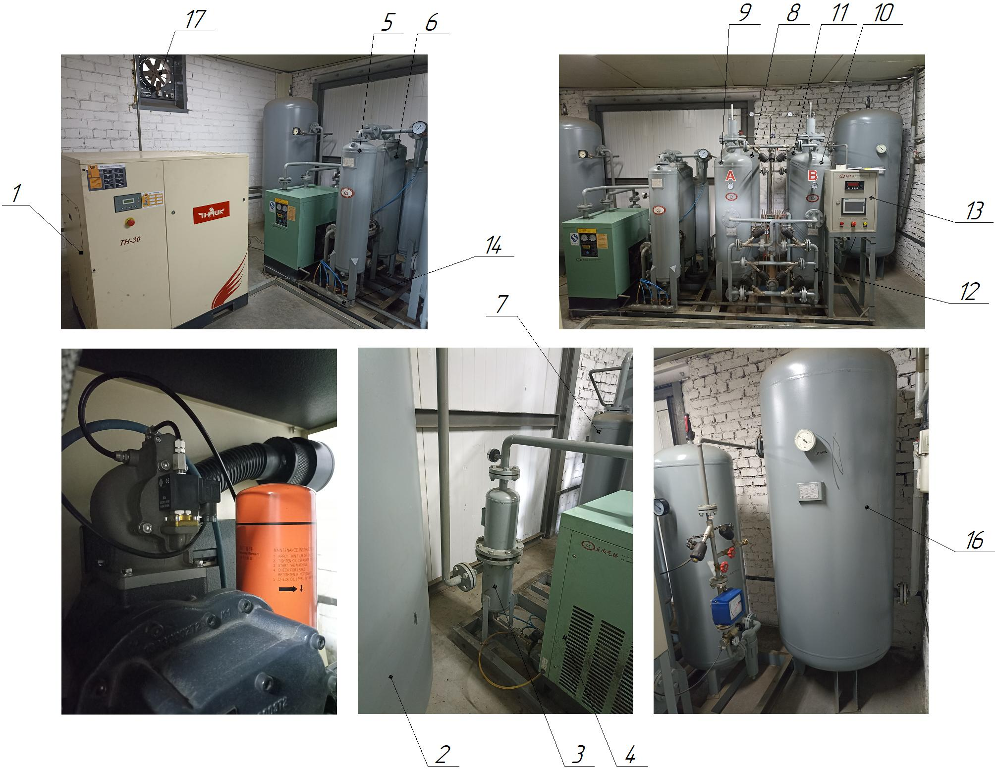

Figure 1.1 - Nitrogen station: 1 - air compressor; 2 - air receiver; 3 -
water-oil separator; 4 - refrigerated compressed air dryer; 5
- adsorption dryer of compressed air No. 1 (A); 6 - adsorption dryer of compressed air No. 2 (B); 7 - activated carbon filter; 8 - intermediate air tank; 9 - adsorption column No. 1 (A); 10 - adsorption column No. 2 (B); 11 - intermediate nitrogen tank; 12 - system of main pipelines with shut-off valves; 13 - control cabinet; 14 - system of pipelines for condensate drainage; 15 - condensate tank; 16 - nitrogen receiver; 17 - centrifugal fan
Structure and operation of the station
The station (Fig. 1.1) is designed to obtain nitrogen gas with a purity of 99.99% from the atmospheric air, accumulate and maintain its set pressure in the main pipeline of the enterprise, in automatic mode, using a compressor and receivers. The principle of operation of the screw compressor 1: atmospheric air is cleaned from dust, dirt, and foreign small objects through an air filter. Air and oil immediately enter the chamber of the screw unit. The rotary screw pair is driven by a direct coupling transmission. An air-oil mixture is formed in the rotary pair, which is compressed to the required pressure. The compressed mixture is transported through a pipeline system to a separator, where it is separated. The oil goes to the oil cooler and then returns to the system, while the air enters the air cooler, where it is cooled to the optimum temperature. Further, cold and oil-free air is sent through the air receiver 2, a compressed air purification and drying system: water-oil separator 3, refrigerated compressed air dryer 4, adsorption compressed air dryers 5 or 6 with adsorbent (No. 1 or No. 2), activated carbon filter 7, enters the adsorption nitrogen generator: through an intermediate air tank 8, it enters the adsorption column 9 or 10 (No. 1 or No. 2) from the bottom up. Thus, nitrogen molecules pass through the adsorbent and oxygen is captured by it. At the next stage, the oxygen from the adsorbent is released into the atmosphere. In automatic mode, the nitrogen generator controls the operation of the adsorbers by switching them: one group of adsorbers is engaged in oxygen absorption, the other in regeneration. The process is repeated many times, ensuring constant and uninterrupted nitrogen production. Next, nitrogen enters the nitrogen receiver 16 through an intermediate nitrogen tank 11, a system of main pipelines with shut-off valves 12. Condensate is discharged through the condensate drainage pipeline system 14 into the condensate tank 15. Heat exchange in the plant premises is carried out by centrifugal fans 17.
Description of the station components
Air screw compressor TN-30A/10 is designed to inject compressed air into the air receiver. The main characteristics of the compressor are given in Table 1.2.
Table 1.2 - Main characteristics of the compressor
Parameter | Dimensional characteristics
Model | TN-30A/10
Electric motor power, kW | 30
Rated supply voltage, V | 380 (three-phase, variable), 50 Hz
Rotation speed, rpm | -
Oil for the compressor | Syprem 8000S
Number of fans, pcs. | 1
Noise level, dB | 65
Overall dimensions (LxWxH), mm | 1280 x 1035 x 1380
Weight, kg | 580
Compressor capacity, m3/min | 3,8
Maximum pressure, MPa | 1,0
Operating pressure, MPa | 0,8
Maximum ambient temperature, ºС | 45
Type of rotary compressor | Screw type
Rotary compressor type by oil application | Oil type
Rotary compressor type by mobility | Stationary
IP degree of protection | 54
Pressure regulation | є
Automatic protection system | є
Compressor cooling system | Air
Air-oil separator | External
Oil filter | є
Air filter | є
Compressed air outlet pipeline | DN40
Compressor operating temperature, ºС | +1...+45
Type of drive | Belt type

Air receiver - used to accumulate and store compressed air, equalize and maintain pressure in pipelines, mitigate pulsations caused by compressor operation, maintain the required operating mode of the compressor and reduce the number of its restarts, primary cooling of compressed air, and condensate collection and removal. The main characteristics of the air receiver are shown in Table 1.3.
Table 1.3 - Main characteristics of the air receiver
Parameter | Dimensional characteristics
Maximum air pressure, MPa | 1,02
Service life (term of standard use), years | 10
Volume of the air receiver, m3 | 1,0
Serial number | 16В08026
Air temperature during operation, ºС | +1...+45

Water-oil separator LCG-4 is used to remove condensate (water, oil) from compressed air. The main characteristics of the water-oil separator are shown in Table 1.4.
Table 1.4 - Main characteristics of the water-oil separator
Parameter | Dimensional characteristics
Working air pressure, MPa | 0,8
Weight, kg | 70
Service life (standard service life), years | 10
Throughput capacity, m3/min | 4
Serial number | LC20170822
Air humidity, %. | ≥ 99
Inlet air temperature, ºС | ≤ 50
Availability of automatic condensate drain | Є
Number of filters, pcs. | 2
Filter material | Polypropylene
Drainage tube inside the filter | Є
Material of the air tube | PVC

Refrigerated compressed air dryer LGZ-4 is a refrigeration dryer used in pneumatic compressed air treatment systems where the temperature of the working medium does not fall below the dew point temperature guaranteed by the dryer (-50°C). The dryer is designed to remove vaporized moisture from compressed air. The main characteristics of the dryer are given in Table 1.5.
Table 1.5 - Main characteristics of the dryer
Parameter | Dimensional characteristics
Model | LGZ-4
Nominal inlet volume flow, m3/min | 4
Inlet temperature, °С | ≤ 45
Type of dehumidifier | Refrigerated
Dew point at rated pressure, °С | -50
Operating pressure, MPa | 0,8
Drive power, kW | 1,2
Rated supply voltage, V | 220
Frequency, Hz | 50
Refrigerant for the dryer | -
Weight, kg | 300
Serial number | LC20170822

An adsorption compressed air dryer (with cold regeneration) is an adsorption device used in pneumatic compressed air treatment systems to maximize compressed air drying. Its main characteristics are shown in Table 1.6.
Table 1.6 - Main characteristics of the dryer
Parameter | Dimensional characteristics
Operating air pressure, MPa | 1,02
Design air pressure, MPa | 1,53
Design temperature, °С | 150
Type of dehumidifier | Adsorption.
Dew point at rated pressure, °С | -
Service life (standard service life), years | 10
Working medium volume, l | 60
Weight, kg | 63
Serial number | 17В08901
Housing material | Q235B
Number of dehumidifiers, pcs. | 2
Marking of dehumidifier columns | A, B
Availability of air muffler | Є
Inlet temperature, °С | +1,5...+50
Adsorbent | Silica gel SD4 (dew point - 20C) Alumogel AAD4 (dew point - 40C) Molecular sieve MSD4 (dew point - 70C)
Type of control of main technological parameters | Automatic

Activated carbon filter LCH-4 - used to clean compressed air from traces of oil and collect particulate matter, while the use of carbon helps to clean the air from gaseous pollutants. The main characteristics of the filter are shown in Table 1.7.
Table 1.7 - Main characteristics of the filter
Parameter | Dimensional characteristics
Model | LCH-4
Nominal inlet volume flow, m3/min | 4
Inlet temperature, °С | ≤ 50
Type of filter | With activated carbon
Working pressure, MPa | 0,8
Cleaning fineness, microns | ≤ 0,01
Weight, kg | 55
Serial number | 17В09002
Working air pressure, MPa | 1,02
Design air pressure, MPa | 1,53
Design temperature, °С | 150
Housing material | Q235B
Volume of working medium, l | 52
Service life (standard service life), years | 10
Adsorbent | Activated carbon

Intermediate air tank (receiver) - is used for accumulation and storage of compressed purified dried air, equalization, pressure maintenance in pipelines, condensate collection and removal. The main characteristics of the intermediate air tank are shown in Table 1.8
Table 1.8 - Main characteristics of the intermediate air tank
Parameter | Dimensional characteristics
Operating air pressure, MPa | 1,02
Design air pressure, MPa | 1,53
Design temperature, °С | 150
Service life (standard service life), years | 10
Tank volume, l | 300
Serial number | 17В08704
Operating temperature, ºС | +1...+45
Material of the body | Q235B
Weight, kg | 98

MACHINE FOR BUTT WELDING OF COPPER AND ALUMINUM TUBES UN3

Basic Technical Parameters:
1, Power Supply: 380-440 VAC 50-60Hz (single phase);
2, Rated Capacity: 35 KVA-100KVA;
3, Welding Tube Diameter: Aluminum Tubes: φ4.0-22.0mm+Copper Tubes: φ4.0-22.0 mm; 4, Clamping Cylinder Space: ≥ 20 mm;
5, Horizontal Cylinder Space: 5-100 mm (adjustable);

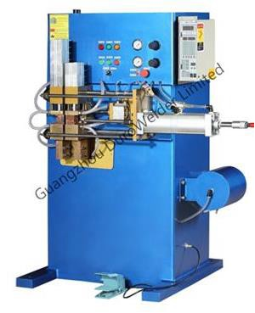

Controlling System:
The controlling system is divided into two units, the Action Process of Logical Unit adopt the Programmable Logic Controller(PLC) which can reach to fourteen points, built-in computer programme can not be adjusted, there are two kinds of operating methods: Manual Way and Automatic Way. By the manual way can be manually control welding clamping cylinder and start the process of welding; By the Automatic Way, only need to start footswitch controller, then the equipment will accomplish the entire weld process.
The Welding Process Controlling Unit adopt the Model: UN3-2008B special welding microcomputer controller (Please refer to User’s Manual of Controller for specific adjustment method in Detail), the controller’s panel is very easy to use and operate, furthermore it can set up the welding process parameters precisely.

INSTALLATION OF SOLDERING TUBES DH-25KW 3 PCS.

Application:
The High Frequency Induction Heating Machine is an ideal device for small hardware heating, welding, forging, and small size, light weight, energy saving especially. It’s power consumption is only quarter of the Tube Type HF Machine with similar heating speed. It used very safe and no electric shock risk.

Main Technical Parameter:

TYPE | DH-25KW
Input voltage | Three phase 380V±5%50－60HZ
Output power | 25KW
Fluctuating frequency | 30-100KHZ
Heating current | 200-1000A
Keep warm current | 200-1000A
Heating time | 1-99S（Auto）or N hours
Keep warm time | 1-99S（Auto）
Pressure of cooling water | 0.05-0.2mpa
Duty cycle | 30℃ (room temperature)
Water temperature | <40℃

