Equipment for the production of electric ovens
Equipment | Вартість, €
Strong 3000 dyeing line | 574890
Crank press K2130b (100t) 2 pcs. | 60578
Crank press KE2130 (100t) 3 pcs. | 90868
Crank press AKKD212803 (63t) | 22017
Double-crank press ARS-250 (250t) | 150403
YAN 32-160 hydraulic press (160t) | 57825
Press hydraulic YQ-300 160 kH | 27848
Table press 2T KAY1609 | 2076
Bending machine pneumatic kay-1607 | 22521
Bending machine pneumatic kay-1602 | 19313
Cutting machine EMK-600 kay-1606 | 51401
RS-1250e strip cutter | 1957
Spot welding machine kay-1610 | 4732
Desktop threading machine swj 12 | 4819
Vertical drilling machine 2Н135 | 2524
Vertical drilling machine 2H125 | 1216
Grinding machine 3B634 | 1836
Grinding machine 3B634 | 5369
Electromechanical guillotine scissors ND3314G | 4267
K-50-8 air compressor | 19129
Compressor JLS-37F | 4039
Air compressor JLS-45F | 4929
Compressed air dryer JLS-6.5 RD | 903
Compressed air dryer JLS-6.5 RD | 1029
Sheet metal profiling lines | 38987
Machine for manual trimming of the inner body of the door - 1 | 41591
Machine for manual trimming of the inner body of the door - 2 | 41591
Edge cutting and rolling machine KAY 1606 | 112229
KAY 1608 body bending machine | 16439
KAY1701 stove bending machine | 9122
Correct equipment 400 mm | 50240
Correct equipment 800 mm | 53336
Stamps 104 pcs. | 936000
Forms for casting plastics 31 pcs. | 341000
Total | 2777024
CONTENTS
STRONG 3000 PAINTING LINE 3
CRANK PRESS K2130B (100T) 8
CRANK PRESS KE2130 (100 TONS) 11
CRANK PRESS AKKD212803 (63T) 15
DOUBLE CRANK PRESS ARS-250 (250T) 23
HYDRAULIC PRESS YAN 32-160 (160T) 27
BENCH PRESS JB04-2 (2T) 34
PNEUMATIC BENDING MACHINE KAY-1607 37
PNEUMATIC BENDING MACHINE KAY-1602 40
TRIMMING MACHINE EMK-600 KAY-1606 43
STRIP CUTTER RS-1250E 46
SPOT WELDING MACHINE KAY-1610 47
TABLE THREADING MACHINE SWJ 12 52
VERTICAL DRILLING MACHINE 2N135 54
GRINDING AND SHARPENING MACHINE 3B634 61
ELECTROMECHANICAL GUILLOTINE SCISSORS ND3314G 66
COMPRESSOR K-50-8 REMEZA 70

STRONG 3000 PAINTING LINE

Technical characteristics
The line is designed for electrostatic powder coating of any surface. Thanks to its extremely stable pressure structure and spraying system, it provides convenient and high-quality painting. The main components of the line and their characteristics.

Washing line
The interior of the jet washer is made entirely of stainless steel sheet. Substances that are cleaned under a certain pressure or temperature and chemicals that change the surface structure and increase corrosion resistance and facilitate paint adhesion are used to remove grease, welding impurities, etc. that occur on the surface of materials to be painted. The parts, which move suspended on the conveyor, pass through the active sections inside the spray tunnel and are subjected to a chemical reaction for a certain time, pressure and temperature. The system is tunnel-shaped, and the materials to be cleaned
pass through the tunnel by means of a horizontal loading gimbal conveyor with pressurized chemicals into the main line and clean the product under a pressure of 1-2 bar. At the next stage, the product entering the washing tunnel is completely cleaned of oil and dust and is ready for painting.
 | Number of rings | Number of nozzles
Tank-1 | 9 | 108
Tank-2 | 6 | 72
Tank-3 | 9 | 108
Tank-4 | 6 | 72

1. Production line
2. Oil drainage tank
3. Rinsing tank
4. Tank with iron phosphate and motor
5. Pump motor
6.Passivation tank
7.Air shower
8.Exhaust fan
9. Overpressure tunnel

Drying oven
Drying oven. Impurities from welding and other dirt that may appear during the production process are removed from the surface before painting and the product passes through the drying oven before being painted inside the cabinet by electrostatic method.

1.Air curtain fan
2.Kiln for firing
3.Circulation fan
4.Outlet pipe
5.Air curtain fan
General properties of the drying oven
Heating power | 250000 kcal/h
Circulation fans kW 650 Pa | 5000m3/h 2.2 kW 650 Pa
Kiln for firing | 150000 kcal/h
Air curtain fans | 4500 m3/h 1.5 kW 200 Pa
Insulation thickness | 150 mm
Dimensions of the drying furnace | 12 000 x 1 000 x h: 2 800 mm
Air curtains | 2 pcs inlet and outlet)

Firing line
Powder paint is used to burn off the parts that have been electrostatically painted inside the cabinet and is used to complete the painting job. The powder coating is fired by a stream of hot air entering all parts of the furnace. To ensure that the most suitable furnace is selected, parameters such as size, shape, thickness, construction material, production speed, operating costs, powder paint to be used, and similar factors for the parts to be painted must be considered. Adjusting the temperature in the furnace before feeding the parts into the furnace electrostatically, setting the firing time after feeding the parts, are of great importance for proper and qualified service. The paint is processed by hot drying only when it is properly fired and then has the desired surface and strength. Air curtains are installed at the inlet and outlet of the kiln to minimize heat loss.

1.Air curtain fan
2. Outlet pipe
3. Burner
4. Circulation fan
General properties of the firing furnace
Heating power | 500000 kcal/h
Circulation fans | 12000 m3/h 7.5 KW 1200 PA
Burners | 500000 kcal/h
Burner | Doğalgaz
Air curtain fans | 4500 m3/h 1.5 KW 200 PA
Insulation thickness | 150 mm
Dimensions of the drying kiln | 16 000 x 2 300 x h: 2 800 mm
Air curtains | 2 pcs. at inlet and outlet

Uniaxial robot
The Strong 3000 Uniaxial Robot is used for automatic coating of powder paints and enamels. You can apply powder coatings by swinging the gun holder handle along the entire Z-axis between a certain length depending on the uniaxial robot's drive belt and at the required feed rate. The synchronization belt provides movement between the gears connected to the motor gearbox and the gear pulley in the roller bearing. There are 4 wheels on the side barriers of the robot. You can move the powder coating robot to the required distance along the X-axis using a bakelite wedge.

1.Drive belt
2.Synchronization drive belt
3.Robot weight balancer
4.Synchronization drive belt connection sheet
5.Bakelite lifting
6.Robot socket
7.Robot trolley side support
8.Asynchronous motor with reducer
9.The wheel
10.Sensor connecting apparatus
11.Lower sensor
12.Manipulator arm holder
13.Robot's flywheel
14.Aluminum profile
15.Upper sensor
16.Stopper
17.Roller bearing

CRANK PRESS K2130B (100T)

K2130 single-crank open non-rotating double-rack presses are designed for manufacturing parts by cold sheet metal stamping operations: bending, notching, punching, shallow drawing, etc., including as part of automated systems.
K2130 single-crank presses are used at enterprises of various industries, in workshops and at cold sheet metal forming sites. They are widely used in any type of production: small batch, serial, mass production.
The K2130 presses are designed to operate both on single and continuous strokes when equipped with automatic feeders (roller, roller, gate, etc.).
Main technical data of the K2130 single-crank press:
The K2130 has been in mass production since 1973.
Developer - Barnaul Mechanical Press Plant, BZMP, (PA AltaiPressMash), Barnaul. Barnaul.
Manufacturer - Barnaul Plant of Mechanical Presses, BZMP, (AltaiPressMash PAO), Barnaul, Frunzezenskiy district. Barnaul, Frunze Machine-Building Plant named after V.I. Lenin.
The K2130 press is manufactured and supplied in accordance with GOST 9408-83. The presses are single crank open single-acting presses. Parameters and dimensions. Accuracy standards.
- Rated press force - 1000 kN (100 tf)
- Slider stroke - 25...130 mm
- Frequency of continuous slider strokes - 80 min-1
- Maximum distance between the table and the slider in its lower position (closed height) - 400 mm
- Table size - 850 x 560 mm
- Clutch - pneumatic friction, single disk
- Brake - friction, disc, with pneumatic braking
- Drive power - 15.5 kW
- Gross weight of the machine - 9.8 tons
Design features of the K 2130 presses
- The press frame is cast from cast iron
- The K2130 press has a fixed table cast together with the frame
- Press K2130 has a height adjustable table (from the electric motor)
- The presses have a two-stage drive with parallel shafts perpendicular to the front of the press. The gears are protected by a special cover
- Rigidly locked brake clutch with friction pads
- Two-handed control from the buttons located on the stationary or portable remote control, as well as from the pedal
- Stepwise adjustment of the slider stroke with manual switching
- Slider with four guide rails, equipped with a pneumatic balancer
- Adjustment of the distance from the table to the slider - ratchet mechanism
- Overload protection in the slider - sheared washer
- Mechanical ejector in the slider
- Lubrication system - thick from a manual pump (on request - with an electric pump for thick lubrication)
Additional equipment of K2130 presses
- Pneumatic cushion for pushing out parts from the bottom for press K2130
- Press horn to replace the adjustable table
- Straightening device and roll feeder for stamping from tape
- Optical protection system

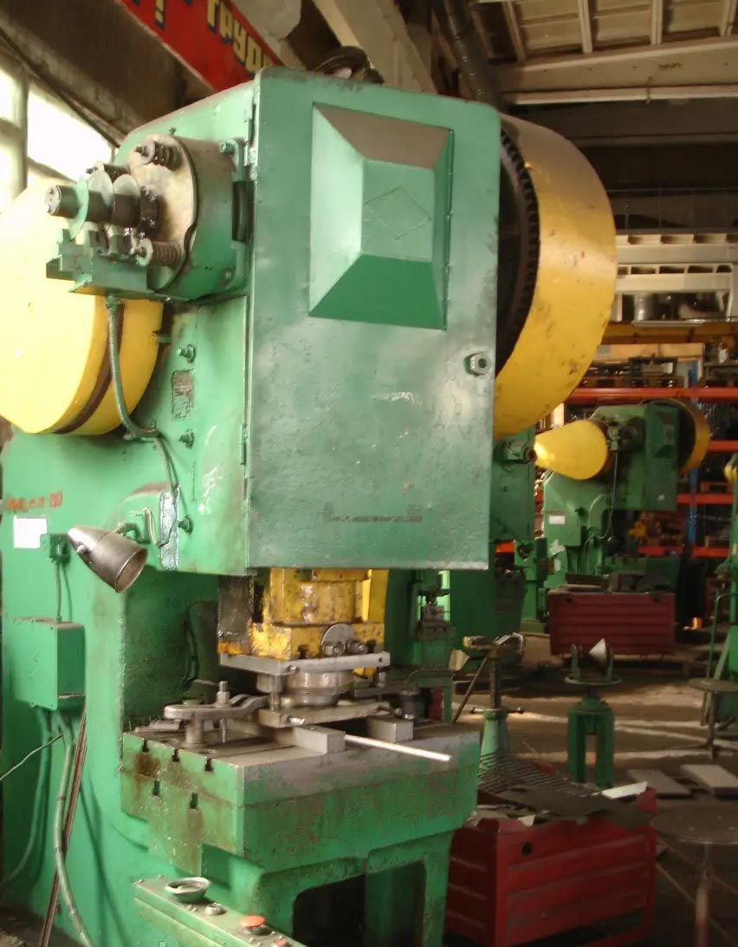
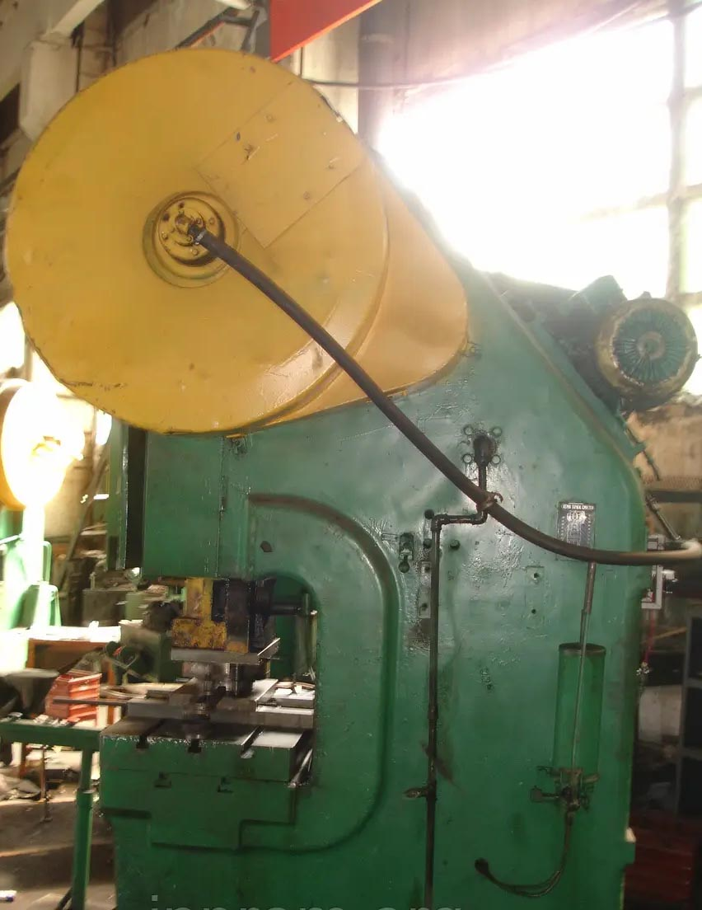

The press consists of the following main components:
- bed
- drive
- clutch-brake
- eccentric shaft
- slider
- slider balancer
- air distributor

CRANK PRESS KE2130 (100 TONS)

The KE 2130 single crank open tilting press with a force of 1000 kN is designed for various cold forming operations: notching, punching, bending, shallow drawing and other cold forming operations. Due to its versatility, the press is used in almost all industries. The press can be used at machine-building, repair and other plants.
The main technical data is shown in Table 1
Table 1
Parameter name | Data
Rated force, kN | 1000
Adjustable slider stroke, mm  largest  smallest | 10  130
Number of strokes per minute | 100
Frequency of single strokes from the button per minute | 55
Table dimensions, (width, length) mm | 630 х 950
The largest distance between the table and the slider in its lower position at the largest stroke, mm | 400
Distance adjustment value between the table and the slider, mm. | 100
Dimensions of the hole in the table, mm
from left to right | 420
from front to back | 280
diameter | 360
Thickness of the under-stamp plate, mm | 100
Distance from the slider axis to the bed, mm | 340
Distance between bed posts in the light, mm | 400
Overall dimensions, mm
Length  width  height | 1740±50  2310±50  3210±50
Weight, kg | 9600±
Electrical equipment
Electric motor  power, kW  speed, min-1 | 5AI160M8U2  11  720
Current type of the supply network | Variable, three-phase
Current frequency, Hz | 50
Voltage, V | 380
Power circuit voltage, V | 380
Control circuit voltage, V | ~110; -24
Voltage of the alarm circuit, V | Built-in in the control system "SOLO 3"
Operating mode of the circuit: | single stroke; continuous strokes; manual rotation; adjustment (push)

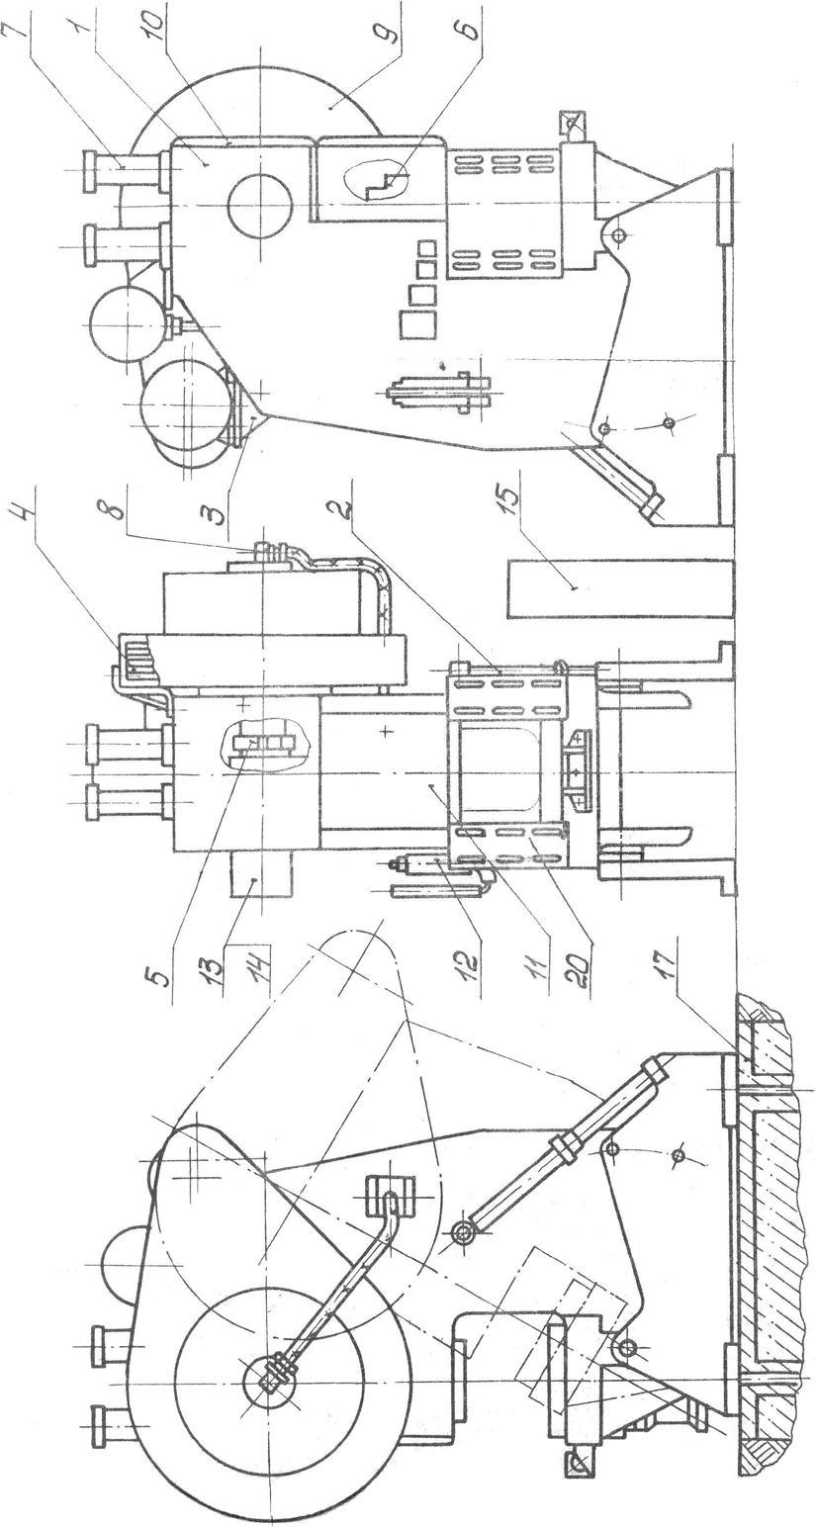
Fig. 1 General view of the press.
The list of press components is given in Table 2
Table 2

Pose. | Name of the machine | Designation
1 | Frame | КЕ2130-11-001
2 | Tilt mechanism | КЕ2130-15-001
3 | The drive | КЕ2130-21-001
4 | Installation of the clutch-brake | КЕ2130-22-001
5 | Eccentric shaft | КЕ2130-27-001
6 | The slider | КЕ2130-31-001
7 | Slider balancer | КЕ2130-34-001
8 | Air duct | КЕ2130-42-001
9 | Flywheel guard | КЕ2130-71-001
10 | Upper guard | КЕ2130-75-001
11 | Slider guard | КЕ2130-76-001
12 | Oil line | КЕ2130-83-001
13 | Command apparatus | КЕ2130-45-001
14 | Fencing of the control panel | КЕ2130-72-001
15 | Electrical equipment | КЕ2130-91-001
17 | Foundation | КЕ2130-01-001

Components of the press
The press frame is cast iron of open type. The slider is oriented in the frame by two wedge guides. The left guide is adjusted by a clamping head and a tightening bolt, and is tightened with nuts after adjustment. The right guide is fixed and cannot be adjusted. For pushing out the products in the upper part of the die, the frame has stops with adjustable screws. The bed can be tilted around the pin at an angle of 10, 20, 30º by a tilting mechanism.
The frame is fixed relative to the posts in the specified positions on both sides with the help of axles and nuts.
Tilting mechanism
Tilting of the bed is carried out by rotating the tie rod, after loosening the pin nut and removing the axles.
Work on the press without fixing the bed in intermediate tilt positions is not allowed. After fixing the bed, be sure to unload the tilt mechanism screw from the weight of the bed, making sure that the axles are lying on the surface of the racks and take the entire load, and then tighten the axle nuts.
Drive.
The press is driven by an electric motor through a V-belt transmission, a flywheel with a built-in brake clutch to an eccentric shaft to a slider. The electric motor is mounted on swinging sub-motor brackets. The belt tension is controlled by changing the center distance of the V-belt transmission using a pin and nuts.
The belt tension is controlled by a dynamometer. At a pulling force of 0.05 kN, the deflection is 11 mm.
Installation of the brake clutch.
The brake clutch is mounted on the flywheel using sectors, a bracket and pins.
The shaft is eccentric.
The eccentric shaft assembly consists of an eccentric shaft mounted in bronze bushings. Adjustment of the slider stroke is carried out by changing the total eccentricity during the rotation of the eccentric sleeve. To adjust the stroke, loosen the nut with the locking screw and disengage the bushing by turning the nut toward you (5...5.6 turns). Use a crowbar to turn the bushing in accordance with the selected amount of travel and re-engage it with the shaft by turning the nut away from you until it stops. After that, tighten the nut with a screw.
Slider.
The slider reciprocates along the bed guides. The stamping space is adjusted by rotating the stem with a ratchet mechanism consisting of a stylus, ratchet and pin, and a crowbar. The direction of rotation is indicated on the plate mounted on the body. The lower limit of adjustment is limited by the lock.
When the adjustment is complete, the pin must be returned to the neutral position. Before adjusting the stamping space, loosen the connecting rod with the nuts and tighten it again to the limit after adjustment. Adjustment of the gap in the ball joint of the rod thrust bearing is achieved by turning the nut, and the following sequence must be observed
a) make sure that there is pressure in the air duct system;
b) tighten the nut all the way into the ball surface of the stem;
c) unscrew the nut by 10º (15 mm along the chord of the nut's outer diameter), which ensures a gap in the ball joint of 0.05 mm;
d) fix the position of the nut, lock it with a bolt. The slider is equipped with a bar to push the products out of the upper half of the die. Adjust the ejection torque using the adjusting screws of the stops.
Adjustment of the ejector must be combined with the adjustment of the die space so that the ejector bar does not end up in the position of the location when the slider moves up.
To prevent the press from being overloaded by force, a breakable fuse is integrated in the slider. To replace a blown fuse, bring the pressure in the balancers to 0. Remove the cover, pull out the fuse with the stand and replace it, and reassemble the parts in the reverse order.
The fuse must be manufactured in strict accordance with the drawing in this manual. After replacing the fuse. After replacing the fuse, check the clearance in the ball joint of the lower connecting rod support and adjust it if necessary.
Slider balancer.
The slider balancer is used to select the backlash in the slider-connecting rod-shaft system, reduce power consumption and prevent the slider from falling in emergency cases.
The air under the pressure of 0.45-0.50 MPa enters the cavity "B" through the pipe bore. 1". The slider is connected to the balancer by a rod connected to the balancer rod with a nut, cotter pins, lock nut and a socket.
Answer. "D", covered with a mesh, is used for filling the oil and communicating with the atmosphere of the cavity "D" during the operation of the balancer.
Command apparatus.
The arrow is an indicator of the upper position of the slider depending on the set stroke value. The slider is stopped in the upper position by proximity switches, in the slot of which flags rotate.
The flags are fixed with screws through a clamp and a sleeve. After fixing the flags, the screws are tightened with nuts. Set the flags according to the diagram in the circuit diagram.
A pointer is provided for determining the approximate angle of rotation of the command unit shaft depending on the amount of travel.

CRANK PRESS AKKD212803 (63T)

Purpose, scope of application
KD2128 single-crank open, non-tilting, single-headed presses are designed for manufacturing parts by cold sheet metal stamping operations: bending, notching, punching, shallow drawing, etc., including as part of automated systems.
Mechanical presses KD2128 are used at enterprises of various industries, in workshops and at cold sheet metal forming sites. They are widely used in any type of production: small batch, serial, mass production.
Operating principle and design features of the KD2128 press
The press bed is a cast iron box-shaped frame that can withstand all the forces that occur during stamping.
The slider is made of high-strength cast iron, box-shaped, with prismatic double-sided guides. The left guide is adjustable. The slider is equipped with an overload safety device and a wedge device for removing the press from the split. The slider stroke is adjustable. A cam engagement is introduced in the adjustment mechanism to reduce the time for readjustment. Pneumatic balancers are provided to eliminate the influence of the weight of the slider and the upper half of the die on the operation of the presses, as well as to prevent the slider from arbitrarily lowering in emergency situations. The space between the stamps is adjustable. The presses are equipped with a pneumatic blower, and a pneumatic cushion can be installed. The products are removed from the die on the dip and in the gap between the press stands.
The slider is driven by an electric motor through a V-belt transmission, a flywheel with a built-in brake clutch and an eccentric shaft.
The clutch-brake is a rigidly locked, multi-disc, friction, pneumatically activated clutch; it is mounted in the flywheel.
The control unit's electrical circuit is contactless and duplicated. The control unit provides control of the braking distance and lubrication system control.
Electrical interlocks and guards ensure reliable operation and safe maintenance of the presses.
Centralized pulse lubrication.
The control is push-button:
- two-handed synchronous with hand lock
- without hand lock
- with the help of a pedal
Operating modes: single, automatic, setup strokes.
The presses are manufactured with parameters according to TU2.041.182-85.
The presses are designed to operate in the following modes:
- Single stroke - two-handed synchronous control by buttons or foot pedal
- Autorobot - two-handed synchronous control by buttons
- Setup - two-handed synchronous control of the buttons
- Manual turning - with the main drive motor disconnected and the handwheel stopped
Note. At the customer's request, it is possible to set the AUTO mode with pedal control.
The presses are equipped with:
- breakable fuse in the slider;
- wedging device;
- ejector in the slider;
- centralized lubrication system.
The press can be equipped with an electropneumatically operated protective screen.
Features of the press design:
- The frame is cast iron, box-shaped, aged to relieve internal stresses, high rigidity, and maintains accurate parameters over a long service life.
- Rigidly interlocked clutch-brake ensures reliable stopping of the slider at the VMT
- Convenient adjustment of the optimal clearance between the working disks as they wear out
- Slider balancers designed to eliminate the influence of the weight of the slider and the upper half of the die on the press operation and to prevent the slider from arbitrary lowering in emergency cases (connecting rod screw or studs breakage)
- Overload safety device
- Unwedging device for removing the press from the cut
- Central lubrication system for the main friction pairs
- Electrical interlock for safe operation
- Non-contact control box
- Mechanized closed height adjustment
To drive the working bodies of the press, we use:
- purified compressed air with a pressure of at least 0.5 MPa
- alternating three-phase current with a voltage of 380 V, frequency of 50 Hz (voltage and frequency can be changed by agreement with the customer)
General information
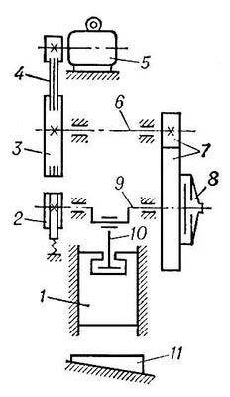

Kinematic diagram of the crank press:
1. slider
2. brake
3. flywheel
4. V-belt transmission
5. electric motor
6. transmission shaft
7. toothed gear
8. coupling
9. crank shaft
10. connecting rod
11. plate for fixing the die matrix
A crank press is a machine with a crank mechanism designed for stamping various parts.
The working part (tool) of the press is a stamp, the fixed part of which is attached to the table, the movable part - to the press slider. The slider is moved by a crank mechanism. In one revolution of the crank, the connecting rod makes a full stroke, during which stamping takes place as the slider moves forward.
The press force is generated by the torque transmitted to the crank shaft by the electric drive. The drive consists of an electric motor, a handwheel, a clutch, a brake, and a reduction gear that transmits rotation to the crankshaft. The electric motor rotates the flywheel, which generates torque on the crank shaft due to the force of inertia. The press can operate in single stroke mode, i.e., with the clutch disengaged after each complete stroke, or in automatic mode, when the clutch is on all the time.
The most important characteristics of the press that determine its technological capabilities:
- table dimensions
- slider stroke
- rated force
- number of slider strokes per minute in automatic mode
Crank presses of various designs are used for bulk and sheet metal stamping.

Overall dimensions of the single crank press KD2128

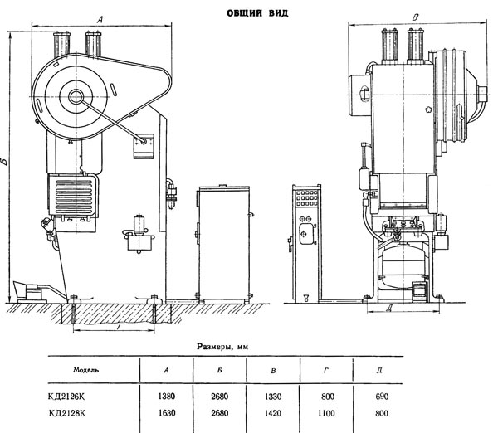

Mounting and connecting bases for single crank press KD2128
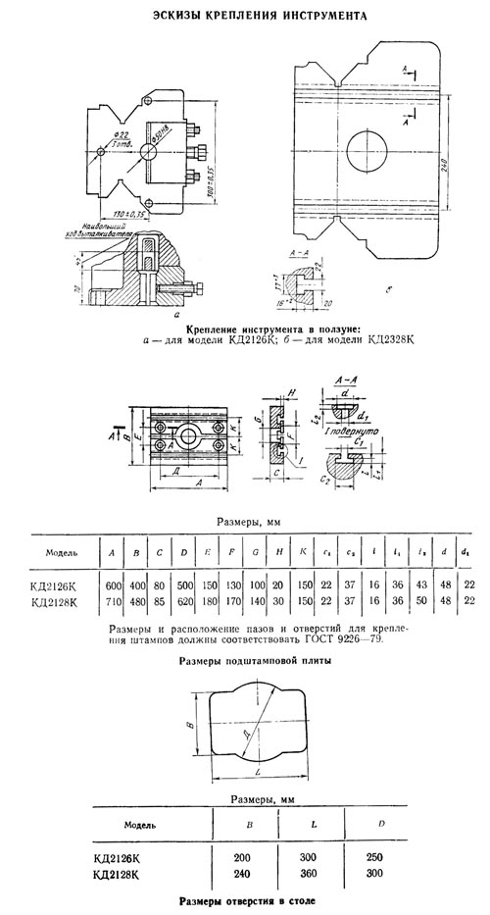
General view of the single crank press KD2128
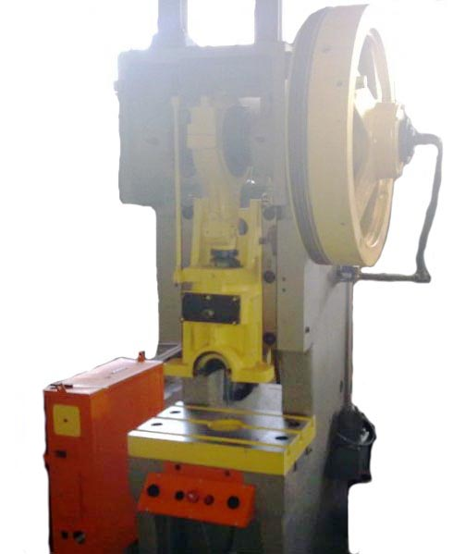

Controls of single crank press KD2128
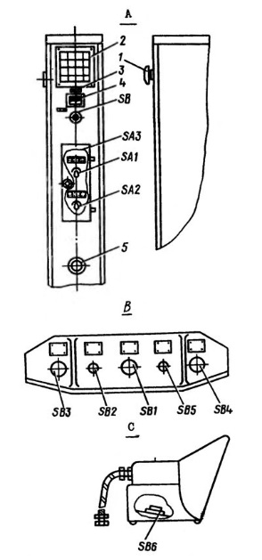

Controls of the presses:
A - control box;
B - control post;
C - pedal
1 - handle of the input switch;
2 - alarm panel;
3 - plate with a symbol;
4 - stroke counter;
5 - pedal connection plug;
SAI - switch of the operating mode;
A2 - control method switch;
SA3 - switch of the protective screen operation mode;
SBI - General Stop button (red);
SB2 - button for switching on the main drive (green);
SB3, SB4 - two-handed operation button (black);
SB5 - AUTOMOBILE STOP button (red);
SB6 - pedal control button (black);

Technical characteristics of the single crank press KD2128
Main parameters
Rated press force, kN (t) | 630
Maximum stroke of the slider (rod), mm | 10..100
Frequency of continuous slider strokes, 1/min | 90
Frequency of single slider strokes from the button, 1/min | 45
Table dimensions, mm | 480 х 710
Dimensions of the hole in the table, mm | 240 х 360
Diameter of the hole in the table, mm | 300
Maximum distance between the table and the slider in its lower position - closed height of the press, mm | 240
Distance from the rod axis to the bed (overhang), mm | 260
Distance adjustment value between the table and the slider, mm | 80
Distance between the bed posts in the light, mm | 340
Thickness of the under-stamp plate, mm | 80
Dimensions of the bottom surface of the slider, mm | 310 х 370
Maximum stroke of the ejector in the slider, mm | 50
Height of the table above the floor level, mm | 840
Type of brake clutch | UA3144
Electrical equipment
Number of electric motors | 1
Electric motor of the main drive, kW | 8,3
Dimensions and weight of the press
Press dimensions (length, width, height), mm | 1450 х 1730 х 2880
Weight of the press, kg | 5890

DOUBLE CRANK PRESS ARS-250 (250T)

Stamping presses for metal with productivity model ARS-250
Description of the equipment
The high-precision metal stamping presses with a capacity of 250 tons of the ARS series are equipped with a multi-directional mobility system in which connecting rods are installed between double cranks. These connecting rods are used to relieve the load from two work centers - the slider and the die plate. The design of these stamping presses helps to avoid forward leaning, which is the main cause of defects in stamping. Thanks to the special design, the press is characterized by high precision and low vibration. This makes the stamping press suitable for high-precision pressing with multiple workstations.

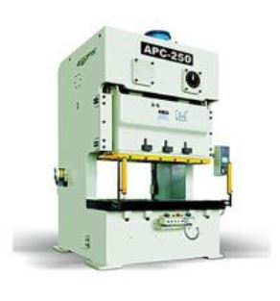

Features.
- High stability of the bed: the materials used for the bed of the 250-ton stamping press are plates made of high-quality welding steel. These plates undergo an annealing process to relieve internal stresses, ensuring high and stable stamping accuracy.
- The high-precision stamping press has a leading machine control center, ensuring high and stable stamping accuracy.
- The high-precision stamping press with a capacity of 250 tons is equipped with two balancing devices, ensuring stable operation of the equipment.
- For safety and ease of operation, this press has a tolerance of 0.1 mm.
- The crankshaft, gears, connecting rods and other components are subjected to hard anodizing, grinding and other treatments to ensure that the parts have high physical and chemical properties.
- The 250-ton capacity stamping press is equipped with a clutch, brake, double solenoid valve (clutch control by air supply or restriction), overload protection, etc. to ensure safe and accurate operation of the press.

General dimensions of the equipment
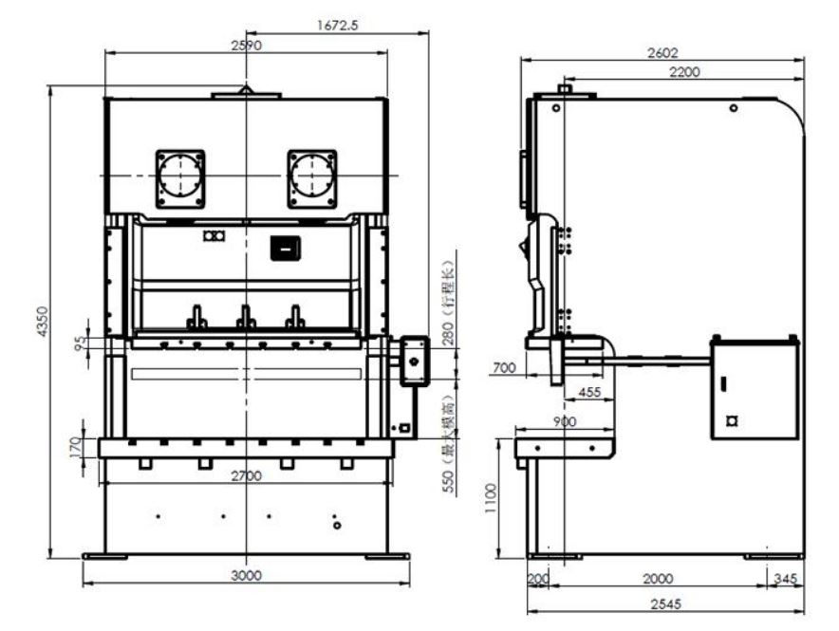

Standard configuration
- Friction clutch-brake
- Selection / switching / adjustment / safe running / continuous operation
- Anti-skid protection device
- Device for detecting errors during feeding
- Digital display of die height (unit of measurement: 0.1 mm)
- Cumulative counter (6-digit)
- Service counter (6-digit)
- Electronic cam-type rotary switch (for 6 connections)
- Air supply device 1/2 "secondary circuit"
- Power outlet (only applicable for 110 V single phase network)
- Yiduan standard operating system
- Oil pressure overload protection device
- Double solenoid valve
- Electric slider adjustment device
- Electric lubrication device
- Counter with presetting (6-digit)
- Stroke duration counter (6-digit)
- Air supply device 1/2 "primary circuit"
Additional equipment
- "Wet" brake clutch
- Motor with adjustable speed
- Photoelectric protection device
- Reverse conversion device for the main motor
- Stroke limiter and safety latch
- Magnetic valve with adjustable connection
- Device for quick die change
- Lower die clamp
- Lever for die shift
- Automatic feeding device
- CNC feed guide wheel
- Straightening device
- Die shock absorber
- Touch screen
- Upper slider feeding device
- Foot switch
- Two-handed T-type work platform
- Anti-vibration base
- Upper die clamp
- Lifting device for dies
- Basic equipment of the bed
- CNC feeding and straightening device
- Feeding and straightening device

Operational characteristics
High-strength steel frame. Thanks to its frame made of high quality steel plate, this stamping press is highly stable and robust, ensuring precise and reliable production. The frame has an optimized working area with an increased width, which allows for a wide range of stamping operations. This press is widely used in production.
Stability in operation. To ensure stability during operation, this stamping press is equipped with two balancing units and a high-sensitivity clutch/brake system.
High sensitivity overload protection (HOLP)
The overload protection system of this double crank press operates within milliseconds and protects both the machine and the workpiece. In the event of an overload, even on one side of the press, the oil pressure in the cylinder is quickly released by a magnetic valve and the machine stops working. The combination of a locked oil chamber and a unique two-valve pressure switch ensures a high level of reliability and allows the machine to be restarted quickly by moving the slider to the center, which automatically switches on the pump and restores the hydraulic pressure to the required level.

Technical parameters of the double crank press
Name | Unit of measurement. | APC-250
Model |  | V | H
Force | Tons | 250
Point of maximum force, mm | mm | 7 | 3.5
Piston stroke | mm | 280 | 170
Adjustable speed | Stroke/min | 20-35 | 30-60
Stamp height | mm | 550 | 605
Slider adjustment | Mm | 120
Area of the punching plate | mm | 2700×900×170
Slider area | Mm | 2100×700×95
Main engine | kW ×P | 22×4
Weight of the press | tons | 45.5
Air pressure | kg / cm 2 | 5
Press accuracy |  | JIS(CNS) class 1
Cushion of the die |  | Two plates and two cylinders
Productivity | Tonnes | 14×2
Air pressure | kg / cm 2 | 6
Piston stroke | Mm | 100
Dimensions of the die cushion | mm 2 | 640×470×2

HYDRAULIC PRESS YAN 32-160 (160T)

Hydraulic press model YAN 32-160 with a force of 160 tons is designed for pressing - pressing, piercing, calibrating, bending, sheet metal stamping without deep drawing. With the right table installed, the press can be used for straightening.
The presses can be used in both production and repair departments and workshops. The design of the press provides for the possibility of integrating it into automatic lines.
The press bed is C-shaped, the working area is accessible from three sides, which is convenient during operation and when replacing machine tooling and dies.
The high technical performance of this press and its wide range of applications are due to the built-in hydraulic drive with a force of 160 tons. A hydraulic tank is located on the frame. A piston-type cylinder is located on the top of the frame. The cylinder is filled with oil. Structurally, the press does not differ from other analogs. Among the advantages of working with this model of press equipment are relatively low noise and good performance. Transportation does not cause unnecessary problems. The vertical hydraulic press is controlled from the control panel and joystick.
Basic equipment
-press assembly;
-electric control cabinet;
-Optical protection system for the working area;
-Lattice fence of the working area;
-SPARE PARTS;
-Operating manual, passport
Additional equipment
- Type of control - mechanical (operating modes: adjustment, single stroke, semi-automatic);
type of control - electric (operating modes: adjustment, single stroke, semi-automatic, automatic)
-the table is correct;
-adjustment devices
Devices and parts that make up the press.
As mentioned above, the main part of the press is a metal frame. Its structure is welded with one vertical post and two consoles. The cylinder, secured with a split-ring nut, is placed at the base of the higher console. A slider is attached to the lower end (part of the cylinder). It serves as the basis for a dynamic bar that moves on the surface of the bed. This bar prevents the slider from changing its position relative to the vertical axis. Above the cylinder is a filling valve, which is attached to the corresponding tank. On the reverse side of the slider is a bracket with a screen for controlling the proximity switches that restrain the slider.
On the right side of the body is a protected cabinet with electrical equipment, under which is a plate, with the help of electrical equipment the press can be effectively controlled. On the cabinet itself, there is a pressure gauge on which you can observe the current pressure and make adjustments to the press operation according to its indicators. The device has a manual control option. The parts necessary for its implementation are installed at the base of the lower console. The main pipeline serves as the bed filling, which allows you to connect the hydraulic filler to the pressure gauges and cylinders. To comply with safety standards, the working area can be protected by removable grilles that use a photobarrier in their design.

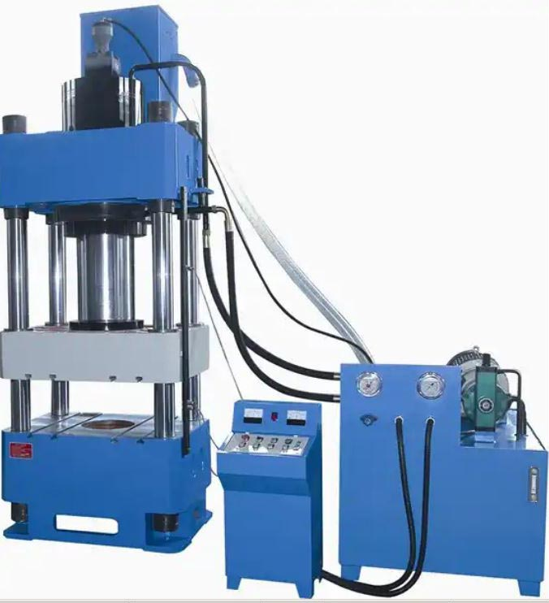
Hydraulic press YAN 32-160

Quality and guarantees. The creation of a press is associated with compliance with a huge number of rules and regulations. The mechanism is built from high-quality European parts and undergoes a multi-stage inspection system. Only a small part of this check is testing the press in normal conditions. For the most part, the production of the device is considered successful after it has been proven that the machine is capable of maintaining its power and performance even in the most extreme conditions, and has a highly reliable system of protection against malfunctions. At the very beginning, the machine is checked:
- the flatness of the table and the bottom of the slider for alignment;
- the perpendicularity of the slider route (from the starting position down);
- parallelism of the aforementioned surface of the bottom of the slider to the table plane;
- the axis (the center point of the slider opening) must be parallel to the trajectory of the slider;
- safety equipment for the electrical and hydraulic systems must be in top condition.

Technical characteristics of the press
Rated press force, kN | 1600
Slider stroke, mm | 500
Maximum distance between table and slider, mm | 750
Table dimensions, mm | 800×630
Slider speed, not less than, mm/s
at idle stroke | 160
during the working stroke | 16
during rotary stroke | 180
Type of control system | Electrically controlled or mechanical
Drive power, kW | 15
Overall dimensions, mm | 1250×2090×3500
Weight of the press, kg | 7400

The device and operation of the YAN 32-160 press and its components (see Fig. 1, 2).
All components of the YAN 32-160 press are mounted on the frame 1. The welded frame has upper and lower consoles and a vertical rack with an oil tank in the middle part of the slot. Hydraulic unit 2 is installed on top of the tank. A working cylinder 3 is fixed in the upper console.
A filling valve is installed at the upper end of the cylinder, which is connected to the filling tank 4, which is mounted on the upper sheet of the frame. A slider is bolted to the lower end of the cylinder rod, which has a guide bar on the frame that prevents the slider and rod from rotating around the vertical axis.
On the right side of the press stand is an electrical cabinet with a push-button panel and pressure gauges. Electrical equipment is located inside the cabinet and along the press.
The lower console of the press is equipped with a plate for fixing the tool or a straightening table 5, on which the straightening device can be installed. An adjustable two-button control panel is mounted on the front of the lower console.
A lever control handle is mounted on the right side of the lower console.
Inside the frame there are lever control units and pipeline 7 connecting the hydraulic unit with cylinders and pressure gauges.
An oil cooler coil 6 is installed in the lower part of the oil tank.
An autonomous group of photoprotection units is installed on the press. The photoprotection consists of two brackets and two steel grids mounted on the side sheets of the bed, fastened with brackets and a rod to each other. Two illuminators and two light receivers are mounted on the front brackets.
Photo protection should be used for additional protection of operating personnel during two-handed operation and, if necessary, one-handed operation for all press operating modes. When photo protection is activated, the intersection of light beams in the adjustment mode stops the slider from moving downward, and in the push-button semi-automatic and automatic control modes, it enables the slider to reverse and stop in its original position.
The electrical circuit has a blocking device that immediately shuts down the input automatic machine if the door of the electrical cabinet is opened.
Figure 1. General view of the press, side view
-bed
-hydraulic unit
-working cylinder
-filling tank
-Plate for fixing the tool
-oil cooler coil
-pipeline
Figure 2. General view of the press
The hydraulic system of the press consists of the following main components:
-Main working cylinder
-Tank
-Filling valve
-Hydraulic unit
-Pipeline
-Oil tank integrated into the frame

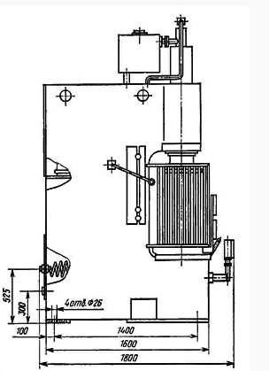

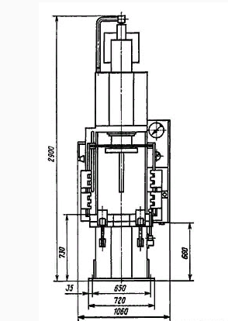

The hydraulic diagram, description of the hydraulic unit structure, its operation, and operating instructions are given in the hydraulic unit manual.
The working bodies of the cylinder, pumps and hydraulic equipment are constantly lubricated with oil and do not require special lubrication. The motor supports, lever axles, guides and bearings of the gate device are lubricated with thick grease using grease guns and a brush.
Press operating modes
1 adjustment mode,
2 semi-automatic,
3 automatic.
1. The press control option called "Manual mode" is qualitatively different from the others. Thanks to this option, a person can thoroughly control the operation of the press, performing the required number of manipulations in a certain period of time. Here, the mechanical work of a person is important, who gradually changes the position of the control handle, from the initial position downward. The limit switch is the limit position of the handle and indicates the end of the device operation. The working stroke of the slider starts after the above procedure, it indicates the start of the electromagnet operation. The slider moves in the direction from the bottom to the top, and when it reaches the uppermost point, it stops automatically, but if necessary, it can be stopped after crossing the line of the middle position on its way. The amount of travel of the handle allows you to control the speed of the slider at the highest possible level.
2. Often, the complexity of the task makes it possible to use a semi-automatic mode of operation, in which production starts by pressing the "Run" button. In this mode, you do not need to hold down the slider buttons all the time. After the slider has moved from the upper (starting) position to the lower position, it moves back independently according to an algorithm that later stops the slider at the uppermost point. To achieve this effect, it is enough to release the buttons on the press. After performing this action in manual mode, there is no such effect, and the slider will not move up.
3. The debugging mode remains very situational. In fact, it is needed exclusively for adjusting the level of the circuit breakers located at the end of the slider's "path". This means that in the absence of pressure on the button, the slider freezes, and only a second press can make it move further. There is simply no accelerated running option in this mode.

Climatic version
- for temperate, cold climates (basic)
- tropical (on special request)

Maintenance, operation and repair instructions
To prevent malfunctions and premature wear of press parts, keep all components clean. All components should be inspected at least once a month. The oil in the hydraulic system should be changed every six months.
The following types of scheduled maintenance are established:
- shiftly maintenance (SM) before the start of the work shift and during the shift during breaks for organizational reasons;
- daily scheduled maintenance, performed during the off-shift, and in case of three-shift operation - during specially established breaks in the operation of the equipment;
- monthly maintenance, which is scheduled for the weekend after the end of the month of equipment operation since the previous one;
- Inspection, which is carried out according to the schedule of the preventive maintenance system in order to identify the scope of work to be performed during the next scheduled maintenance.

BENCH PRESS JB04-2 (2T)

JB04-2T electric bench press with manual control, with a force of 2 tons.
The JB04 series bench presses are small-sized precision punching equipment used in the production of watches, tools, electronics, cars, motorcycles, computers, threads, cameras, jewelry, lamps and lanterns, hardware, clothing, caps and shoes. It is suitable for processing metal and non-metal sheets, strips and coils by cutting, punching, bending riveting and forming.
The machine is small and lightweight, easy to operate with high production efficiency. It is especially suitable for factories located in tall buildings.
JB04-2T is a high quality electric tabletop crank press with pedal, with a maximum force of 2 tons, designed for notching, punching, bending, shallow drawing and other cold stamping operations with the removal of stamped parts on the failure.

Technical features
- JB04-2T is a high-quality mechanical clutch crank press with a maximum force of 2 tons.
- The press is designed for notching, punching, bending, shallow drawing and other cold stamping operations with the removal of stamped parts to the dip.
- The sturdy cast frame reduces vibration in operation at high speeds.
- The eccentric shaft is made of high-quality structural steel.
- The press stroke is activated manually.
The press is operated manually.
This press uses a solid cast frame to reduce vibration, and other parts are made of high quality structural steel.
JB04-2T can be used for single stroke operation.
Structure.
The JBO4 series press consists of a frame, transmission, carriage, manipulator, etc.
1. Frame
The lifting mechanism consists of a handwheel, a lifting screw and a frame. The mechanism can be moved by rotating the handwheel to adjust the gate height.
Four fixing nuts on the back of the frame are used to fix the frame to the rack to avoid loosening or even moving the frame during operation and, as a result, damaging dies and parts.
2- Transmission
The flywheel is driven by the motor via V-belts. A rigid clutch consisting of a roller, hex cam, clutch, clutch sleeve and bushing drives the slider up and down repeatedly by means of a crankshaft and connecting rod.
The adjusting screw can be adjusted to achieve stability and smoothness of the crankshaft movement and to overcome the flywheel inertia when stopped.
3. Slider
The slider is the main punching part driven directly by the crankshaft. It consists of a connecting rod, a spherical head set screw, a slider, and left and right guides. The slider moves in reciprocal relation to the precise direction of the guides carrying the die to achieve stamping.
The rod clamping plates and two socket head screws that unscrew under the caliper are used to secure the die rod. The square head screw is only used for mounting and dismounting the die stem.
When the locking nut is loosened, a small adjustment of the shutter height can be made by turning the adjusting screw. The maximum adjustment range is 10 mm.
The four square head screws on both sides of the shutter are designed to adjust the gap between the guides and the shutter with sufficient precision to ensure the best possible working condition of the shutter. The screws are normally adjusted and secured after the fact. To avoid affecting accuracy, do not adjust or loosen the screws at will.

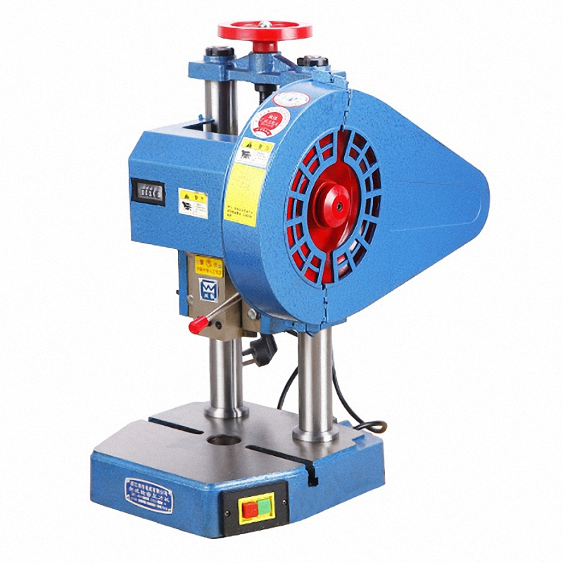

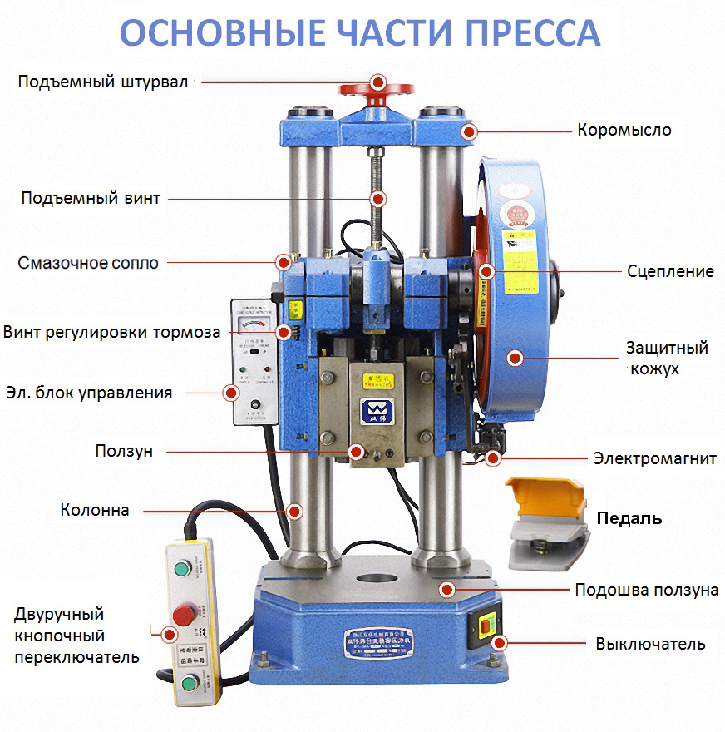

Technical characteristics of the press
Model: | JB04-2T
Nominal pressure | 20 kN
Stroke of the stem | 40 mm
Maximum number of strokes per minute | 220 strokes
Maximum closed height | 240 mm
Mold opening size | Ø25 x 40 mm
Slider sole size | 320×300 mm
Distance between columns | 127 mm
Depth of entry | 65 mm
Voltage | 220/380 В
Motor power | 450 W
Overall dimensions (L×W×H）. | 520×420×710 mm
Weight - Net / Gross | 130/150 kg

PNEUMATIC BENDING MACHINE KAY-1607

Getting to know the product

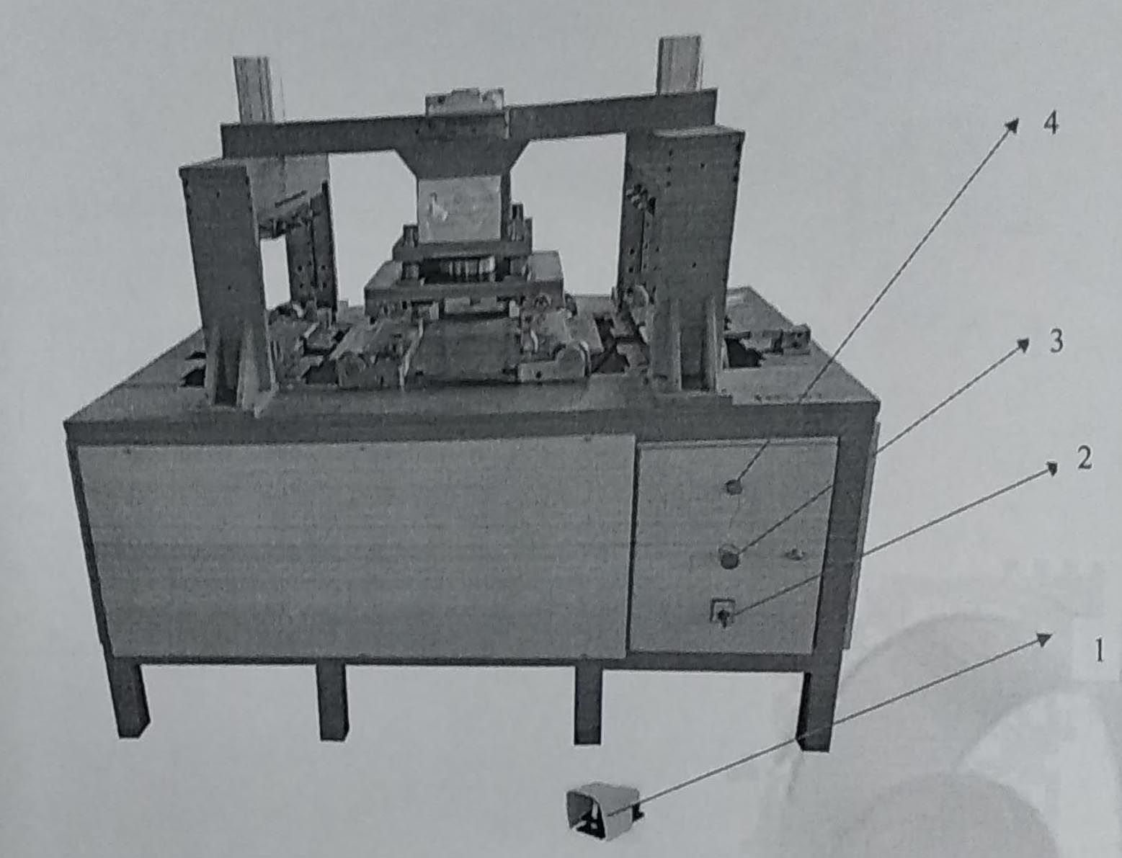

1) Equipment composition
1 - start button
2 - necessary connection to the power supply (on/off)
3 - emergency stop
4 - power indicator

2) Transportation and placement of the machine
2.1. Transportation
a) To transport the machine safely, use a forklift or crane.
b) Before transporting the machine, it must be returned to its original position.
c) If the machine is transported using the forks A, it must be transported from the bottom.
d) The manufacturer is not liable for malfunctions caused by improper transportation.
2.2. Placement of the machine
a) Place the machine on a level surface. A stand should be placed at the side and rear of the machine with a distance of at least 1 meter.
b) The floor must be level. Adjustment should be made using the screw on the machine.
c) The place where the machine is located must be free from moisture and must be closed.
d) The electrical panel must be located near the place where the machine is installed.
e) The place where the machine is installed must have adequate lighting, not too hot and not too dusty.
f) No other personnel must be present in the vicinity while the machine is in operation. All health and safety measures must be taken.

3) Power requirements
a) Make the electrical connection using the terminal block. Directly to the main power panel. Do not use plugs and sockets.
b) The electrical voltage must be suitable for the machine. 50 Hz, 230 V
c) The electrical installation must comply with the standards. All connections must be made by authorized persons and must be monitored at all times.
d) A 20 ampere circuit breaker and a suitable fuse must be used in the power supply.
e) The manufacturer is not responsible for malfunctions that may occur due to connection errors and voltage changes.
f) The ground connection must be made without fail.

4) Operation of the machine
a) Check the electrical connections of the machine.
b) Check the air pressure at the machine inlet.
c) Place the sheet metal in the desired position on the machine.
d) Turn on the main power supply.
e) Check that the power indicator light is on.
f) Check the surroundings of the machine. No one other than the operator should be present. The safe distance should be at least 3 meters.
g) Press the start button. The machine will then start working automatically.
h) Do not touch any moving parts while the machine is running.
i) If a problem occurs during operation, press the emergency stop button immediately. The entire system will be stopped by this button.
j) When the problem is corrected, deactivate the emergency stop button and press the restart button. The entire system will return to its original position.

5) Safety precautions during operation
a) The operator who will operate the machine must be trained accordingly.
b) The operator must observe all warnings and precautions stated in this manual before starting work.
NOTE: Use the emergency stop button only in case of danger. Stop the machine using the Stop button. Turn the Stop button clockwise to return it to its original position, and then return the machine to its original position using the Reset button. You can continue working with the Start button.

6) Warnings
a) Read the operating instructions carefully before operating the machine.
b) The machine may only be used by trained personnel.
c) Do not approach the machine during operation. Keep a safe distance of at least 3 meters.
d) Perform all checks before starting work. Check the safety precautions.
e) In case of emergency, use the emergency stop button.
f) Do not use the machine in very hot, humid or dusty areas:
g) Check the electrical connections before starting work.
h) No pieces of sheet metal must be placed on the machine.
i) The operator must never leave the machine during operation.
j) There should not be too much material around the machine. It should be a suitable environment for emergency intervention.
k) The electrical panel of the machine must not be opened by anyone other than an authorized person.

7) Maintenance and repair instructions
a) Check the oil level in the air pressure regulator before starting work. If it is low, add oil.
b) Check the connections in the pneumatic system.
c) Check the electrical wiring. Check the grounding line.
г) After every 2500 hours of operation, lubricate the bearings and bearing assemblies operating on the machine.

8) Malfunctions and possible solutions

Fault | Causes of malfunction | Suggested solution
The pneumatic pistons do not work. | Low air pressure at the inlet. The power supply may have failed. | Check the air inlet pressure. It is either low or high. Report the malfunction to the responsible person.
The power indicator does not light up. | The power input may be defective | Make a malfunction report to authorized persons.
The start button does not work | The button may be defective. The emergency stop button is pressed. Or the reset button is not pressed | Defective button, replace with a new one. The system is reset by pressing the reset button.

PNEUMATIC BENDING MACHINE KAY-1602

Getting to know the product
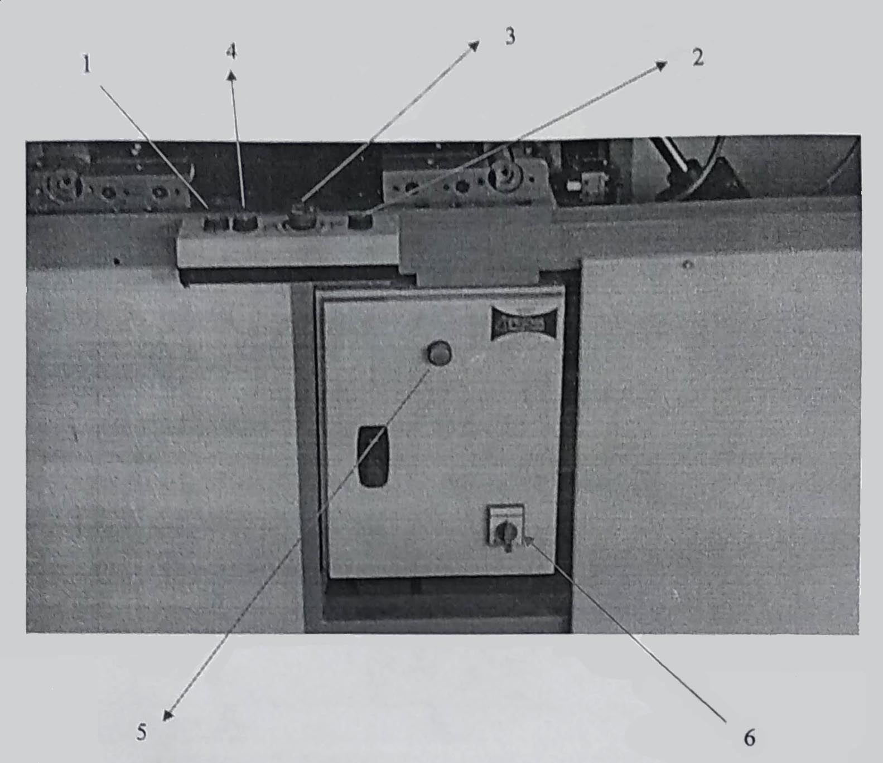

1) Equipment composition
I - First start button
2 - Second start button
3 - Emergency stop
4 - Reset button
5 - Power indicator
6 - Required electrical input (on/off)

2) Transportation and placement of the machine
2.1. Transportation
a) For safe transportation of the machine, a forklift or crane must be used.
b) Before transporting the machine, it must be returned to its original position.
c) If the machine is to be transported with a forklift, it must be transported from below.
d) The manufacturer is not liable for malfunctions caused by improper transportation.
2.2. Placement of the machine
a) The machine should be placed on a level surface. A stand should be placed at the side and rear of the machine with a distance of at least 1 meter.
b) The floor must be level. Adjustment should be made using the screw feet on the machine.
c) The place where the machine is located must be free from moisture and must be closed.
d) The electrical panel must be located close to where the machine is installed.
e) The place where the machine is installed must be equipped with adequate lighting, not too hot and dusty.
f) No other personnel must be present in the vicinity when the machine is in operation. All health and safety measures must be taken.

3) Power requirements
a) Make the electrical connection using the terminal block. Directly to the main power panel. Do not use plugs and sockets.
b) The electrical voltage must be suitable for the machine. 50 Hz, 230 V
c) The electrical installation must comply with the standards. All connections must be made by authorized persons and must be monitored at all times.
d) The power supply must use a 20 ampere circuit breaker and a suitable fuse.
e) The manufacturer is not responsible for malfunctions that may occur due to connection errors and voltage changes.
f) An earth connection must be made.
i) The operator must not leave the machine while it is in operation.
j) There should never be too many materials around the machine. It should be a suitable environment for emergency intervention.
k) The electrical panel of the machine must not be opened by anyone other than an authorized person.

4) Operation of the machine
a) Check the electrical connections of the machine.
b) Check the air pressure at the machine inlet.
c) Place the sheet metal in the desired position on the machine.
d) Turn on the main power supply.
e) Check that the power indicator light is on.
f) Check the surroundings of the machine. No one other than the operator should be present. The safe distance should be at least 3 meters.
g) Press the start button. The machine will then start working automatically.
h) Do not touch any moving parts while the machine is running.
i) If a problem occurs during operation, press the emergency stop button immediately. The entire system will be stopped by this button.
j) When the problem is corrected, deactivate the emergency stop button and press the restart button. The entire system will return to its original position.

5) Safety measures during operation
a) The operator who will be working on the machine must be trained accordingly.
b) Before starting work, the operator must observe all warnings and precautions stated in this manual.
NOTE: Use the emergency stop button only in case of danger. Stop the machine using the Stop button. Turn the Stop button clockwise to return it to its original position, and then return the machine to its original position using the Reset button. You can continue working with the Start button.

6) Warnings
a) Read the operating instructions carefully before operating the machine.
b) The machine may only be used by trained personnel.
c) Do not approach the machine during operation. Keep a safe distance of at least 3 meters.
d) Perform all checks before starting work. Check the safety precautions.
e) In case of emergency, use the emergency stop button.
f) Do not use the machine in very hot, humid or dusty areas:
g) Check the electrical connections before starting work.
h) No pieces of sheet metal must be placed on the machine.
i) The operator must never leave the machine during operation.
j) There should not be too much material around the machine. It should be a suitable environment for emergency intervention.
k) The electrical panel of the machine must not be opened by anyone other than an authorized person.

7) Maintenance and repair instructions
a) Check the oil level in the air pressure regulator before starting work. If it is low, add oil.
b) Check the connections in the pneumatic system.
c) Check the electrical wiring. Check the grounding line.
d) After every 2500 hours of operation, lubricate the bearings and bearing assemblies operating on the machine.

8) Malfunctions and possible solutions
Fault | Causes of the malfunction | Suggested solution
The pneumatic pistons do not work. | Low air pressure at the inlet. The power supply may have failed. | Check the air inlet pressure. It is low if it is high. Report the malfunction to the responsible person.
The power indicator does not light up. | The power input may be defective | Make a malfunction report to authorized persons.
The start button does not work | The button may be defective. The emergency stop button is pressed. Or the reset button is not pressed. | Defective button, replace with a new one. The system is reset by pressing the reset button.

TRIMMING MACHINE EMK-600 KAY-1606

It is a cutting and bending machine designed for face cutting, circumferential cutting, bending, folding and assembling without the need for any shape on vertical and horizontal surfaces of metal skirts.

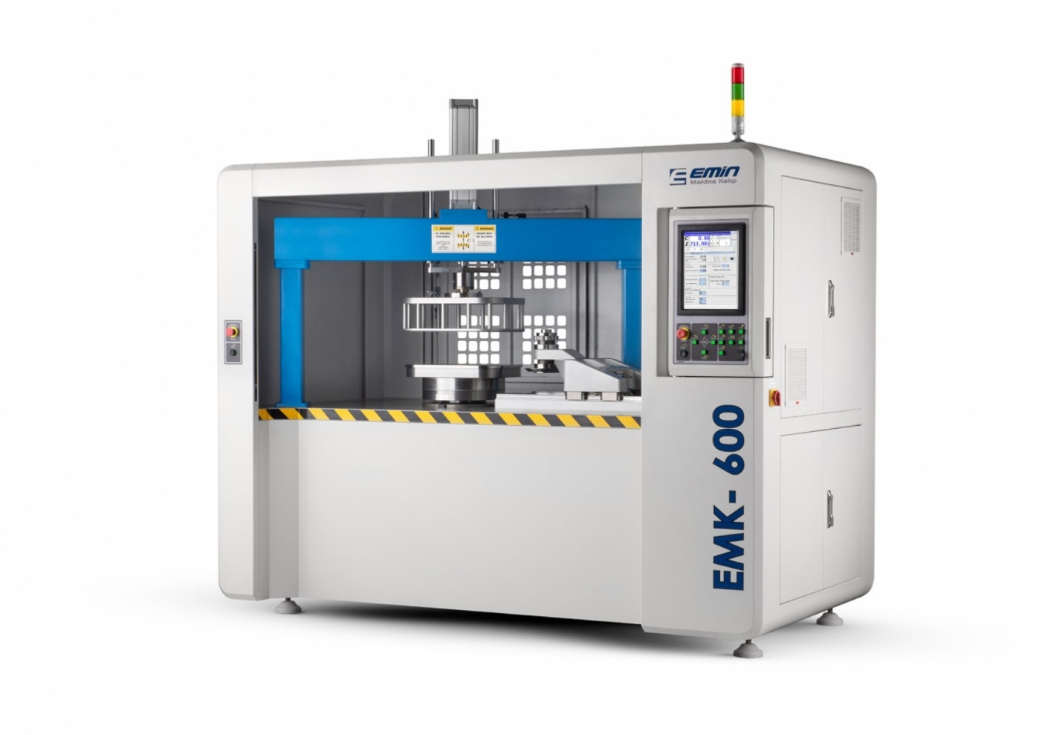

Machine features and general information about the model: EMK-600
Alternating current: 380-400V Phase / Phase: 3P
Frequency: 50 Hz
Power: 11 kW to
Air 6.5 Bar
Weight 1800Kg

With the EMK-600, you can easily perform perimeter cutting, bending and flashing operations on vertical and horizontal surfaces of parts made by the drawing machine method. You can accurately and quickly process many parts used in household appliances, automotive, defense, and medical industries.

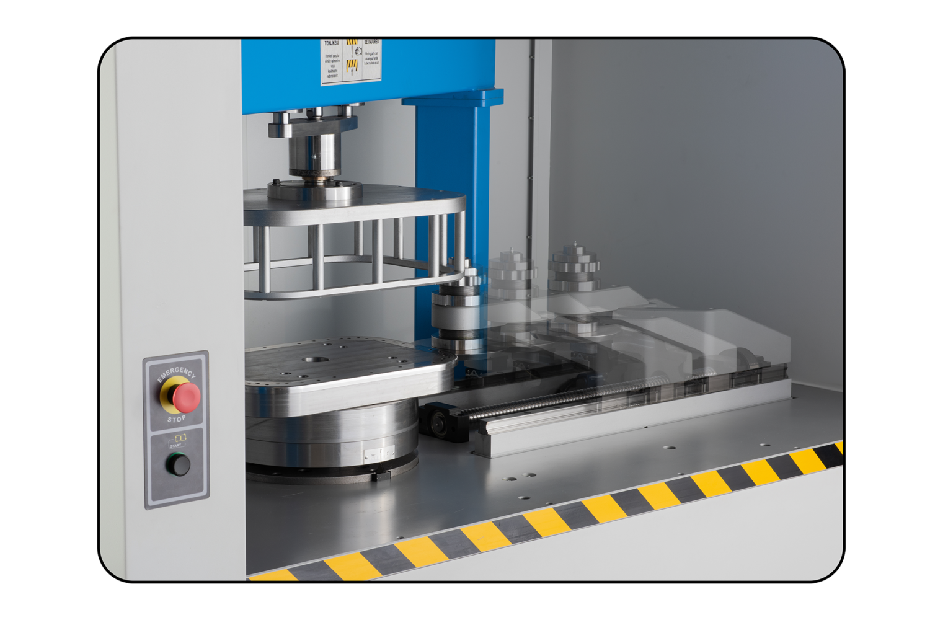
In addition to technical assistance and the supply of spare parts, we provide professional consulting support in metal forming technology.
We offer our expertise in all of the following areas as a service to our customers.
- Assisting the customer in selecting the best equipment for their specific application.
- Custom manufacturing for special requests.
- On-site testing of new equipment to optimize the production efficiency of the customer's specific products.
- Staff training to ensure full understanding of applications, as well as tips and tricks for installation and programming.
- Fast and complete assistance in the supply of spare parts subject to wear and tear.
- Online consultations on technical issues, sending questions and requests, receiving a response in real time.

If a light barrier is installed in front of the working area, an object entering the working area will immediately stop the machine and prevent possible accidents at work.
Whether a structure is in good working order or not is determined by its strength. The same principle applies to skirt cutting machines. The strength of the base and the design of the column determine the machine's performance. The cast cutting trolley and important cast parts in the updated gearbox group ensure higher wear resistance. All castings are tested for bending and vibration resistance before and after machining.
Maximum speed and precision were achieved by combining CAM software developed by our engineers for the Emk-600, high-precision transmission and Siemens Motion Control.
To ensure smooth and precise motion control. The EMK-600 uses the latest generation of servo motors.
Thanks to software enhancements, your machine runs faster and more accurately than ever before.
The 15-inch color LCD touchscreen display is designed for industrial use.
It has a wide viewing angle. It is easy to read in bright light.
The integrated USB port allows for the use of flash memory and external drives.
All common functions on the control panel are clearly labeled for operator convenience.
Routing is accomplished at the touch of a button.
Thanks to the EMK-600's central lubrication system, it automatically lubricates areas that can be worn by friction at regular intervals. The automatic lubrication system measures the amount of lubricant while the machine is running and distributes it to the guides and screw shafts. This ensures that all important elements are always properly lubricated.
The system minimizes lubrication problems and reduces the environmental impact. You can define the lubrication interval depending on the operating situation on the interface screen.
With the EMK-600, you can easily perform cutting, bending, and folding operations on vertical and horizontal surfaces of drawn parts.
You can process many parts used in the home appliance, automotive, heavy metal, and medical industries with sensitivity and speed.

STRIP CUTTER RS-1250E

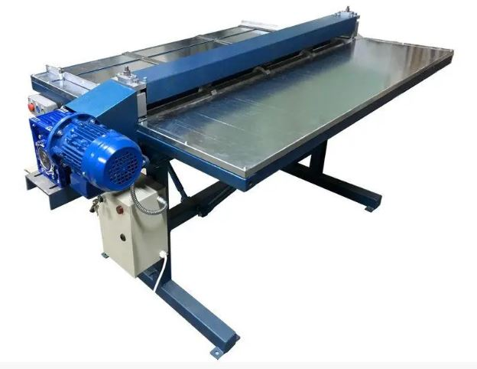
The RS 1250 longitudinal metal cutting machine (strip cutter, slitter) is designed for longitudinal cutting of sheet metal from coils into strips of a given width. This slitter is used in preparatory work to prepare billets for further bending or rolling on rolling mills. Initially, sheet metal is delivered to warehouses in coils (coils) weighing from 3 to 10 tons. In this form, the metal cannot be lifted without special lifting mechanisms, which makes it difficult to process it further. With the help of a metal uncoiler and this longitudinal metal cutting machine, the metal from the coil is cut into strips of a certain length and width and can be easily transported to other processing shops. This machine can cut metal of unlimited length, with a maximum metal thickness of 1 mm.
A cutting roller knife can be fitted to the machine for cross-cutting metal. The cut-off roller knife can cut metal up to 0.8 mm thick. For more productive crosscutting of metal, a manual or electric guillotine is used. The design of the strip cutter is such that it is possible to add cutting rollers to this machine and cut the metal into more strips. The cutting knives are made of tool steel with subsequent hardening and grinding, which ensures high quality and durability of the product. Metal cutting speed is up to 10 m/min.
Special devices called coil winders are used to wind the metal into strips after disbanding.
The machine for longitudinal cutting of metal is preferably used in networks with a voltage of 380 V, but on special order it is possible to make a machine with a 220 V supply.
As manufacturers of this equipment, we provide full warranty and post-warranty service for our machines. All spare parts and working units for our machines for longitudinal cutting of metal are available in our warehouse or are manufactured as soon as possible.

Technical characteristics
Maximum dimensions of the processed sheet, mm
Length | unlimited
Width | 1250
Thickness
carbon sheet steel | 1,0
stainless steel sheet | 0,5
sheet copper | 1,0
sheet aluminum | 1,2
Number of simultaneous cuts for sheet steel up to 0.55 mm thick | 4
Cutting speed, m/min. | 9±10%
Characteristics of electrical equipment
power supply current | variable, three-phase
frequency, Hz | 50±1
voltage, V | 380±5%
electric motor power, kW | 0,75
synchronous rotor speed of the electric motor, rpm | 1400
Overall dimensions, mm
length | 1700
width | 1300
height | 1000
Weight, kg | 250

Structure and operation of the machine
The RS-1250 release machine consists of the following main parts:
1. Support frame
2. Frame with working shafts
3. Machine drive
4. Material feeding table
5. Receiving table
6. Control cabinet
7. Push-button control post
8. Protective covers

SPOT WELDING MACHINE KAY-1610

Technical description of the welding machine
The economic service life of the spot welding machine is ten (10) years.
This equipment (Class A equipment) is intended for use in an industrial environment.
In the case of use in home, office and light industrial environments; Electromagnetic compatibility with other devices may be difficult to achieve due to the radiation carried out at the end.
Spot welding machine; two sheet metal plates or wire material are made to be joined together.
Interlacing mode: spot welding machine the rest of the material between the two jaws, spot welding the ends of the transformer, forms a short circuit on the material due to the high temperature released, based on the welding principle.
Between the jaws of the machine, the product to be boiled is a poor conductor, making it easier for the product to be boiled to boil.
Because when the current flows through the jaws, the product between the jaws will resist against the flow flowing under poor conductivity conditions, and because of this, heat will escape more easily and the material will boil more easily.
If the product to be welded is a good conductor, it will offer little resistance to the current flowing between the jaws and therefore no heat will be released.
The spot welding machine with official and technical specifications is generally used by control panel manufacturers, steel door manufacturers, home appliance manufacturers, natural gas clamp manufacturers, chandelier manufacturers, wire grille manufacturers, home appliance manufacturers, or companies

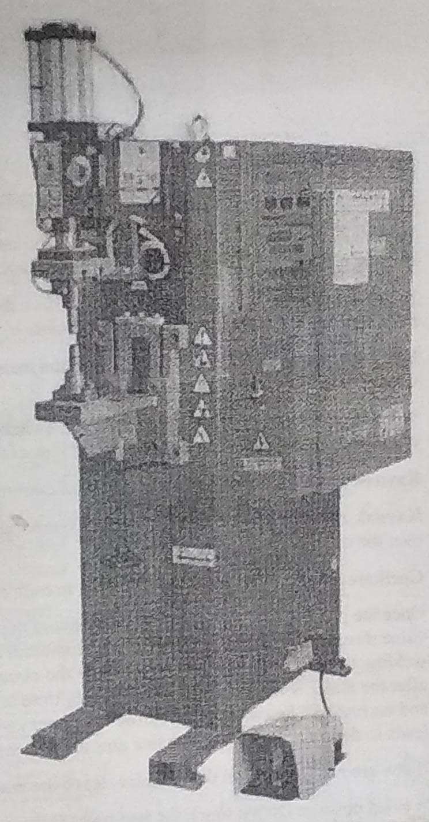

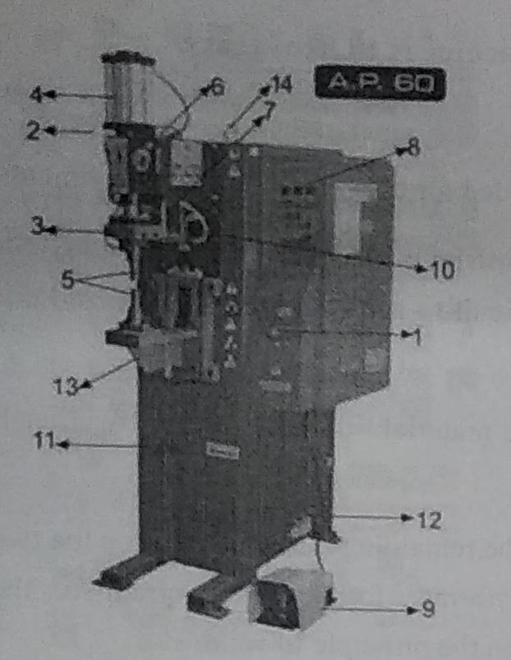

Body parts of welding machines

1. Power switch of the mother
2. Regulator
3. The upper jaw
4. Pneumatic piston
5. Lower and upper electrode
6. Selenoid valve
7. Movable copper tape
8. The control unit
9. Foot pedal
10. Water outlet hose for jaws
11. Table setting handwheel
12. Cooling water inlet and outlet pipes
13. Table
14. Hook for transportation

Technical characteristics of the spot welding machine

Product name | Dik punta kaynak makinesi
Rated power | 22 KW
System voltage | 380 - 400V / 50Hz
Rated current | 60 А
Mains fuses | 125 А
Cooling method | Su sogutma
Cooling water Input heat | 15-30°C
Cooling water Inlet flow | 2-8 bar
Air pressure | 2-7 bar
Electrode pre-pressure force | 780 N/bar
Weight | 310 kg ± 30 kg
Size | 524x9l5x 1550x225 mm

TABLE THREADING MACHINE SWJ 12

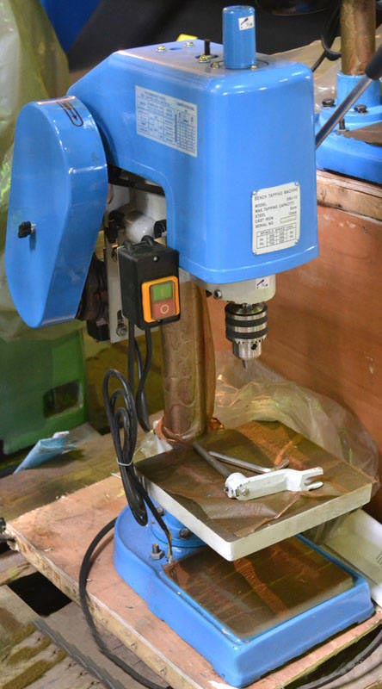
Description:
The machine is designed for cutting internal threads in a hole using a tap on a workpiece fixed on the machine table. The machine is characterized by simplicity of design, reliability and efficiency. The speed of the machine is changed by tilting the belt on the pulleys. Mechanical control of the spindle pinion with one handle: reverse is automatically activated by a friction clutch that switches the direction of spindle rotation in the direction of the spindle feed control handle. The machine's friction-belt drive system dampens the load on the tool and allows it to vary its speed when cutting small threads.

- Threading head with V-belt drive and one control handle.
- Movement of the retractable foam.
- Threading is carried out along adjustable stops that limit the spindle travel to the length of the thread to be cut.
- The cutting tool (tap) is inserted manually.
- The automatic reversal of the direction of rotation during the reverse stroke is accomplished by means of special couplings.
- Electrical equipment with safety shutdown device to ensure safety.

Technical characteristics:
Model | SWJ-12
Maximum thread diameter to be cut, mm | М12
Maximum distance from spindle to table, mm | 295
Maximum distance from the spindle to the plate, mm | 375
Spindle overhang, mm | 127
Spindle pinola stroke, mm | 40
Spindle taper | Morse B18
Number of spindle speeds in each direction | 2
Speed values right/left, rpm | 480; 850 /580; 1050
Rack size, mm | 60
Desktop size, mm | 200х200
Plate size, mm | 385х215
Motor power, kW | 0,55
Connection, V/Hz | 220/50
Total height of the machine, mm | 815
Dimensions in the package, mm | 580x370x900
Net/gross weight, kg | 73/93

Basic equipment of the machine:
- 3-cam drill chuck with key;
- adapter sleeve for the chuck to the spindle cone;
- instruction manual.
Additional equipment:
- vice
- cutting tools: cutters, drills, taps, etc.

VERTICAL DRILLING MACHINE 2N135

Purpose and scope of application
The 2H135 vertical drilling machine, with a nominal drilling diameter of 35 mm, is used at enterprises with single and small-scale production and is designed to perform the following operations: drilling, reaming, countersinking, countersinking, reaming, threading and end trimming with knives.
The 2H135 machine allows machining parts in a wide range of sizes from various materials using tools made of high-carbon and high-speed steels and hard alloys.

Operating principle and design features of the 2H135 machine
The machines are equipped with mechanical spindle feed with manual control of work cycles.
The machines are equipped with a reversing device for the main motion electric motor, which allows threading with machine taps with manual spindle feed."
The drill is of category 4 according to GOST 15150-69.

Working space dimensions of the 2H135 drilling machine

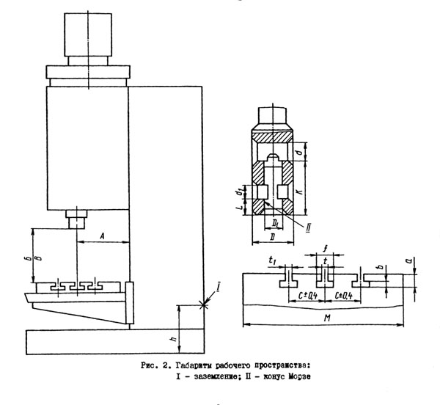
Dimensions of the working space of the 2H135 drilling machine

Model of the machine | Morse cone | А | Б | В | D | D₁ | М
2Н135 | 4 | 300 | 750 | 30 | 60 | 31,267 | 450

General view of the 2H135 drilling machine

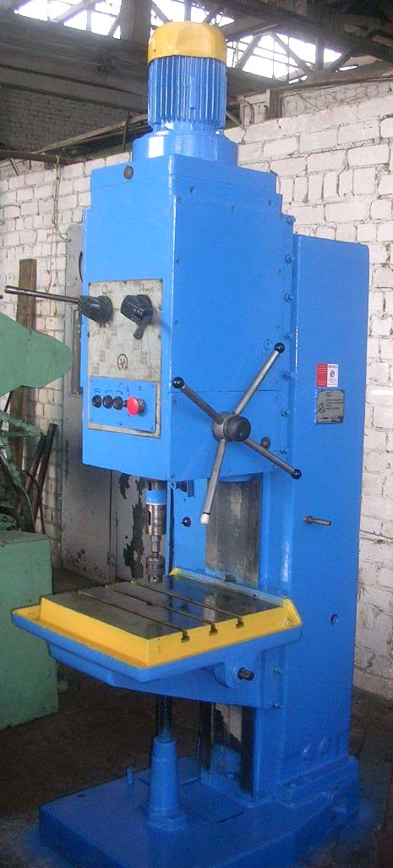
Location of the main parts of the 2H135 drilling machine
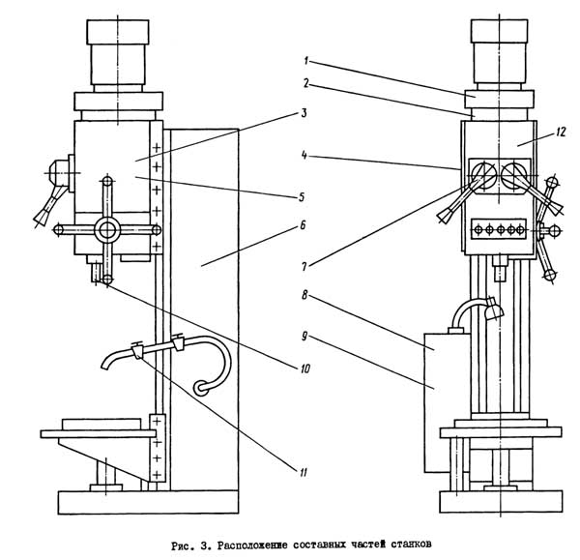

Designation of the main parts of the 2H135 drilling machine
1. Drilling machine drive - 2H135.21.000
2. Machine speed box - 2H135.20.000
3. Oil plunger pump - 2H125.24.000 for the machine 2H125
4. Oil plunger pump - 2H135.24.000
5. Feed box - 2H135.30.000
6. Column, table, plate - 2H135.10.000 - 2H135.10.000
7. Speed and feed control mechanism - 2H135.25.000
8. Electrical cabinet - 2H125.72.000
9. Electrical equipment - 2H135.94.000 2H135.94.000
10. Spindle assembly - 2H135.50.000
11. Machine cooling system - 2H135.80.000
12. Drilling head - 2H135.40.000

Description of the main components of the 2H135 drilling machine
Gearbox of the 2H135 drilling machine
Gearbox and drive. The gearbox communicates different speeds to the spindle by means of movable blocks. The box shaft supports are placed in two plates - upper and lower, fastened together by four ties. The gearbox is driven by a vertically mounted electric motor through an elastic clutch and a gear transmission. The last shaft of the gearbox, the sleeve, has a spline hole through which the rotation is transmitted.
The rotation is transmitted to the feed box via a gear pair.
The gearbox, as well as all the drill head assembly units, is lubricated by a plunger pump mounted on the bottom plate. The operation of the pump is controlled by a special grease gauge on the front of the motor plate.

Mechanism for controlling speeds and feeds of the 2H135 drilling machine
Mechanism for switching speeds and feeds of the 2H135 drilling machine
Mechanism for switching speeds and feeds. Speeds are switched by a handle that has four positions in a circle and three along the axis, feeds are switched by a handle that has three positions in a circle and three positions along the axis. The handles are located on the front side of the drilling head. The speeds and feeds to be switched on are indicated on the plates.

Feed box of the 2H135 drilling machine
The feed box. The mechanism is mounted in a separate housing and installed in the drilling head. Nine different feeds are provided by moving two triple blocks of gears. The feed box is mounted in the bore of the upper worm support of the feed mechanism. A clutch transmitting rotation to the worm is mounted on the last shaft of the box.

Drilling head of the 2H135 machine
The drilling head is a box-section casting in which all the main assembly units of the machine are mounted: a speed box, a feed box, a spindle, a feed mechanism, a spindle counterweight and a mechanism for switching speeds and feeds.

The feed mechanism, which consists of a worm gear, a horizontal shaft with a rack and pinion gear, a limb, cam and ratchet overrunning clutches, and a handwheel, is an integral part of the drilling head.
The feed mechanism is driven by the feed box and is designed to perform the following operations
- manually bringing the tool to the workpiece;
- switching on the working feed;
- manual feed advance;
- turning off the working feed;
- manual retraction of the spindle upwards;
- manual feed used for threading.

Column, table, plate. The column of the machine is a cast iron casting. The drilling head and table are manually moved along the dovetailed column guides. The machine table has three T-shaped grooves. An electric pump is installed on the base plate, and a coolant reservoir is located inside the plate.

Location of controls of the 2H135 drilling machine

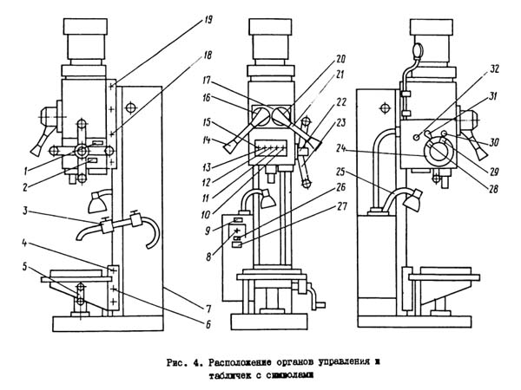

List of controls of the 2H135 drilling machine
1. Plate - "Filling"
2. Plate - "Drain"
3. Cooling switch on tap
4. Bolts for adjusting the table wedge and drilling head
5. Handle for moving the table and drilling head
6. Table and drill head clamping screws
7. Plate - "Grounding"
8. Input switch
9. Plate - "Main switch"
10. Signal button STANDARD ON
11. Button to enable right spindle rotation
12. Button for switching on the left spindle rotation
13. Button for enabling the spindle swing movement when switching speeds and feeds
14. Handle for switching speeds
15. Stop button
16. Plate - "Rotation speed"
17. Sign - "Change speed only when stopped"
18. Table and drill head clamping screws
19. Bolts for adjusting the table wedge and drilling head
20. Plate - "Feed rate, mm per revolution"
21. Handle for switching feeds
22. Button for switching on manual feed
23. Hand wheel of the feed mechanism
24. Limb for counting the depth of processing
25. Light switch for the lighting
26. Plate - "Cooling"
27. Switch of the cooling pump
28. Cam for setting the working depth
29. Cam for setting the depth of the thread to be cut
30. Lever for automatic reversal of the main drive when the set thread depth is reached
31. Lever for disconnecting the mechanical feed when the set machining depth is reached
32. Square for manual movement of the drilling head

Technical characteristics of the 2H135 machine

Parameter name | 2Н135
Main parameters of the machine
The largest drilling diameter in steel 45, mm | 35
Smallest and largest distance from spindle end to table, mm | 30...750
Smallest and largest distance from the spindle end to the plate, mm | 700...1120
Distance from the vertical spindle axis to the rack guides (overhang), mm | 300
Working table
Maximum load on the table (in the center), kg
Dimensions of the working surface of the table, mm | 450 х 500
Number of T-slots Dimensions of T-slots | 3
Maximum vertical movement of the table (Z-axis), mm | 300
Table movement per one revolution of the handle, mm
Spindle
Maximum movement (setting) of the spindle head, mm | 170
Maximum movement (stroke) of the spindle, mm | 250
Spindle movement per one division of the gauge, mm | 1,0
Spindle movement per one revolution of the handwheel-handle, mm | 122,46
Spindle speed, rpm | 31,5...1400
Number of spindle speeds | 12
Maximum permissible torque, Nm | 400
Spindle cone | Morse code 4
Mechanics of the machine
Number of steps of working feeds | 9
Limits of vertical working feeds per spindle revolution, mm | 0,1...1,6
Control of work cycles | Manual
Maximum permissible feed force, kN | 15
Dynamic spindle braking | Є
Drive
Electric motor of the main movement drive, kW | 4,0
Electric coolant pump Type | Х14-22М
Machine size
Machine dimensions, mm | 2535 x 825 x 1030
Machine weight, kg | 1200

GRINDING AND SHARPENING MACHINE 3B634

Purpose, scope of application
The double wheel grinding machine 3B634 is designed for the following operations
- sharpening of high-speed cutters and cutters equipped with carbide inserts up to 100 mm high
- sharpening of drills with a diameter of 12...50 mm;
- sharpening of metalworking tools;
- deburring, chamfering and other locksmithing work;
- grinding parts with an abrasive belt;
- polishing of parts
It is not recommended to use the machine for deburring cast and welded parts.

General view of the grinding machine

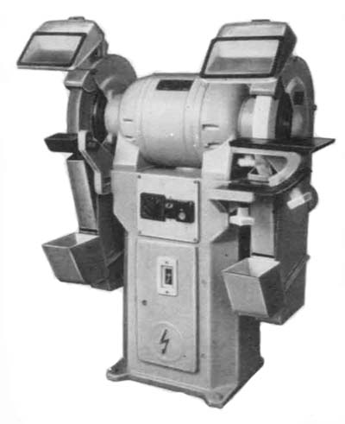

Design features and operating principle of the 3B634 machine
The main part of the 3B634 grinding machine is the grinding head. A two-speed electric motor is mounted in the head, the shaft of which is the spindle of the machine. The stator, rotor, and fan impeller are housed in a housing with two covers that hold the spindle ball bearings. The ball bearing supports are twin angular contact ball bearings of high precision No. B36209L with selected axial backlash. Axial labyrinth seals are made on the outer sides and grease grooves on the inner sides.
The electric motor is cooled by air circulation, for which purpose the head support covers have windows connecting the internal cavities of the frame and head. The head covers have two pins for attaching protective guards and some devices (for polishing, belt grinding, etc.). The head is fastened to the frame by means of studs.
The frame is a cast iron casting with an electrical cabinet placed in it. A panel with electrical equipment is mounted inside the frame. Access to the electrical equipment is possible due to the presence of an opening in the front wall, which is hermetically sealed with a door.
Grinding wheels of the types PP 400 x 50 x 203 (flat straight profile) and PV 400 x 60 x 203 (flat with a dent) are installed on the machine. The wheels are mounted on adapter flanges attached to the tapered part of the spindle. The adapter flanges have three breadcrumbs on the outside that are used to balance the abrasive discs.
The abrasive discs are enclosed by protective covers made of sheet steel.
The front wall of the cover has a slot for accessing the abrasive disc. A visor is located in the upper part of the opening, which maintains a gap of no more than 6 mm between the visor and the abrasive disc, and a sliding flap for dust extraction is located in the lower part of the opening. When installing the drill sharpening device, the flap is fully retracted into the hood. The side wall of the guard is hinged to the housing and can be quickly swung out to allow for the change and inspection of the abrasive disc.
A dust collector is located at the bottom of the guard and collects up to 40 percent of the dust that is sucked out of the machine's work area. The dust collector must be cleaned of accumulated dust at least once per shift.
The hood is equipped with a connection to the exhaust system. A sleeve for mounting the protective screen is welded to the top of the casing.
The protective shield is manufactured together with the luminaires. For ease of use, the shield can be rotated by 15° relative to the horizontal axis. The lamps have two lamps that provide good illumination.
The machine is equipped with a rotary table and a tutorial for sharpening cutters and cleaning parts. The rotary table is a steel plate attached with screws to a cast-iron bracket that can move along a curved guide. This allows the table to be tilted in relation to the face of the abrasive disc. The table guide is attached to the arm, which is in turn attached to the bed. The two horizontal movements of the table compensate for wear on the wheel's face and side surface.
The grinding wheel is a steel part with two working surfaces: flat and curved. It is recommended to use the flat working surface when grinding parts that have a reference plane. If you need to grind a curved surface of a workpiece without a good reference plane or if you need to frequently adjust the angle of the tool, you should use the curved work surface of the tool. The textbook is mounted to the bracket in such a way that it can move in a circle, vertically, and rotate around the axis. Ensure that the gap between the wheel and the tool is no more than 3 mm.

Location of the components of the grinding machine

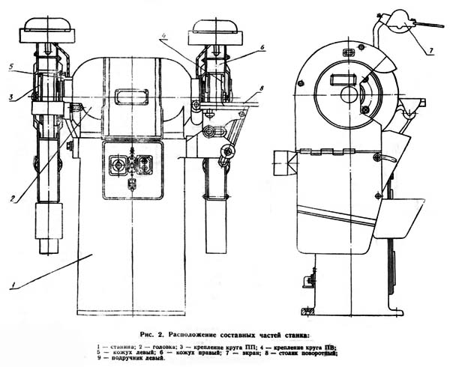

List of components of the grinding machine
1. Frame
2. Head
3. Fastening of the PP wheel (flat grinding wheel with a straight profile)
4. Attachment for the PV disc (flat abrasive disc with a one-sided groove)
5. Left hand guard
6. Right hand guard
7. Screen
8. Rotary table
9. Left handbook

List of controls of the grinding machine

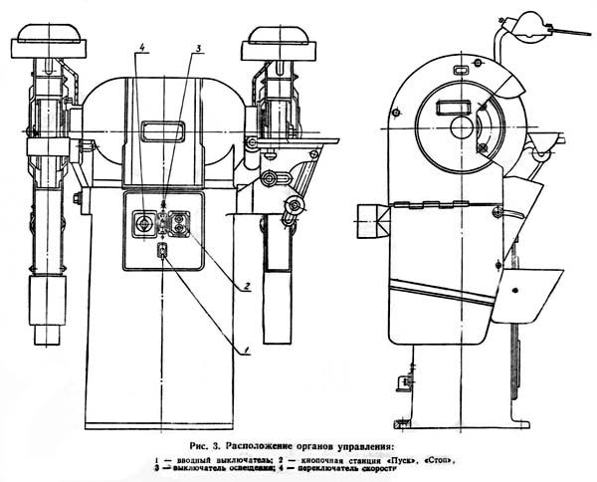

1. input switch
2. button station "Start", "Stop"
3. light switch
4. speed switch

Technical characteristics of the 3B634 grinding machine

Parameter name | 3Б634
Abrasive disc
Number of abrasive discs | 2
Type of abrasive discs | PP 400x50x203 PV 400x50x203
Outer diameter of the wheel, mm | 400
Wheel height, mm | 50
Seating diameter of the wheel, mm | 203
Height of centers from the base, mm | 900
Recommended height of the cutters to be sharpened, mm | 6-100
Diameter of drills to be sharpened, mm | 6-60
Angle at the top of the drill, deg | 70-140
Rear angle, degrees | up to 20
Angle of rotation, deg | +20..-1
Diameter of the contact roller, mm | 400
Width of the abrasive belt, mm | 80
Length of the abrasive belt, mm | 3000
Tension force of the abrasive belt, N | up to 1000
The largest diameter of the polishing wheel, mm | 400
Maximum height of the polishing wheel, mm | 55
Hole diameter of the polishing wheel, mm | 50
Spindle type
Rotation speed, 1/min | 720/ 1440
Maximum cutting speed, m/s | 15/ 30
End of the grinding spindle (diameter/length), mm | 40/ 40
Electrical equipment
Electric drive motor, kW | 3,2/ 5,3
Dimensions and weight of the machine
Machine dimensions (length, width, height), mm | 1000 x 665 x 1230
Machine weight, kg | 425

ELECTROMECHANICAL GUILLOTINE SCISSORS ND3314G

Guillotine NK3418 is a sheet metal crank shear with an inclined cutting tool. It is designed for cutting metal in sheets with a tensile strength of up to 500 MPa.
This guillotine is the latest generation machine with an innovative kinematic scheme and a new design. It is actively used at aircraft, machine-building, agricultural machinery and shipbuilding enterprises, as well as in other areas of modern industry.
These guillotine shears can automatically set the gap between the rear mechanized stop and the cutting blades, which allows the operator to set the required parameters of the products to be cut from his workstation using a digital meter mounted on the front of the unit.

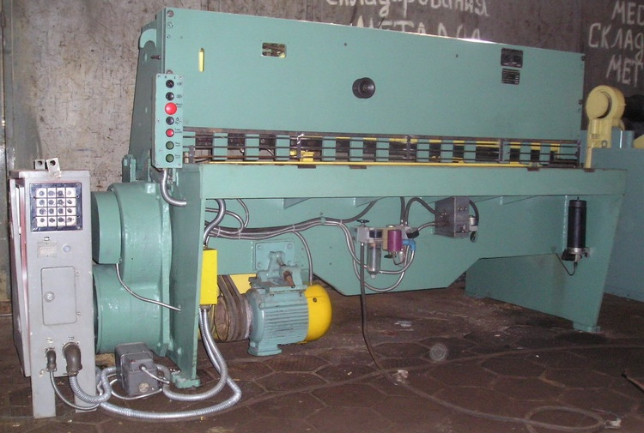

The guillotine has the following key technical characteristics:
- 17500 kgf - maximum cutting force;
- 6.3 mm and 2000 mm - the maximum thickness and width of the metal sheet to be cut, respectively, with a resistance (temporary) of no more than 500 MPa;
- 920 mm - distance from the top of the knife (fixed) to the floor;
- 700 mm - the maximum length of the strip that can be cut when using the rear stop of the guillotine;
- 1 degree 30 minutes - angle of inclination of the knife (movable);
- 4250 kg - weight of the unit;
- 1620 mm - height above the floor level.
The overall dimensions of the machine are as follows:
- 1600 mm - without front-to-back extension;
- 2065 mm - with a front-to-back extension;
- 2780 mm - from left to right.

The electrical equipment installed on the guillotine shears has the following technical parameters:
- number of electric motors - 2;
- mains and electric drive current - three-phase alternating;
- voltage - 380 V (power circuit), 110 V (control circuit), 24 V (circuit for lighting the metalworking line);
- frequency - 50 Hz;
- number of lighting points - 3;
- principle of operation of the rear stop drive - push;
- motor power: main drive - 8.5 kW, rear stop - 0.37 kW, total - 8.87 kW.
The electric scissor drive operates in the following modes: push, continuous and single strokes, and manual rotation.

The design of the machine consists of three assembly units, each of which has autonomous control and individual drives:
- rear stop
- main chain;
- sheet support.
The main chain contains an electric motor connected to the flywheel by a V-belt transmission, as well as to the input shaft of a cylindrical two-stage gearbox (through a special brake clutch). The eccentric shaft is rigidly connected to the gear wheel (output) in a scissor joint. The connecting rods mounted on the eccentric shaft interact with the knife and pressure beam via levers. These three elements form an assembly unit that is mounted on the eccentric axes of the frame by means of hinges.
When the clutch-brake and motor are engaged, this unit (commonly referred to as the cutting mechanism) moves as a whole along a predetermined path until the beam (pressure beam) comes into contact with the hot-rolled or cold-rolled sheet to be cut. After that, the knife beam starts to move straight along the guides, the gap between the knives is set automatically by the device depending on the thickness of the sheet. When the metal comes into contact with the cutting tool, its force increases, part of which (about 25%) is transferred to the pressure beam via levers.

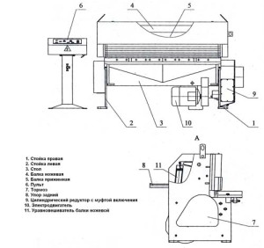

The rear stop chain consists of an electric motor connected to a worm gearbox (with its high-speed shaft) by a V-belt transmission. The gearbox also has two sprockets. One of them is connected by a chain drive to the indicator of the width of the strip to be cut, and the other is connected to the shaft that rotates the drive screws connected to the stop beam. The latter can be adjusted to the desired strip size more accurately if you use manual rotation (using a handwheel) of the motor shaft.
The sheet support for the NK series guillotine shears has five rotary flags that are mounted on an axis that can be rotated in the desired direction if necessary. The holder is driven by a reversible pneumatic cylinder, which is controlled by a pneumatic distributor.
Important elements of the guillotine - a brief overview
The main components of the metal cutting device under consideration include the following structural elements:
- Frame. It is made of all-welded steel and consists of a traverse, two posts, a tie rod and a table. All the units and assembly units of the guillotine are mounted on this unit. The fixed lower knife is located in the table recess, and the main shaft is located in the frame posts. The cut-off products are removed through the slide, and the cutting mechanism is attached to the frame with eyelets.
- Gearbox. It is mounted on the drive shaft (rolling bearings are used). The gearbox has disks made of aluminum material that fit into the grooves of proximity switches.
- Scissor drive. It is mounted on the traverse. Its task is to turn on the motor, on the shaft of which there is a pulley connected to the flywheel by V-belts.
- Cutting devices. This mechanism consists of a screed, a knife and pressure beam, and a special stand. A compound knife is located in the guides of this device.
- Clutch-brake. It has drive disks that connect it to the bracket and flywheel. The clutch is mounted on the drive gear shaft (at its very end, where there is an involute spline).
- Rear stop. It is attached to the beam rib with four bolts and consists of two brackets. They are equipped with traveling screws (they are connected by bevel gears and an intermediate shaft), the task of which is to adjust the gaps.
- Front stop. It has rollers and extensions, along the grooves of which the pressure bar moves, which makes it possible to perform high-quality and efficient release of cold- or hot-rolled metal sheets.
- Side stop. It is necessary to stop and guide (parallel) the workpiece into the cutting area. If you use a side stop and a building stop at the same time, the accuracy of material processing increases significantly.
The machine is controlled by a switch panel located in a separate special box and a control panel. At the same time, all regulating, protective and starting equipment is mounted in the box without exception. The control cabinet allows you to select one of the guillotine operating modes:
- "Single stroke"
- "Push";
- "Continuous stroke";
- Manual rotation.
It should be noted that the guillotine shears with a sheet support can only be operated when the Single Stroke mode is enabled.
To protect the equipment, microswitches are installed in the guillotine, which automatically block the operation of the machine in the event of
- critical decrease in air pressure in the relay system;
- Pneumatic valve is stuck;
- opening of the protective grid;
- the rear stop approaches the movement limits.

COMPRESSOR K-50-8 REMEZA

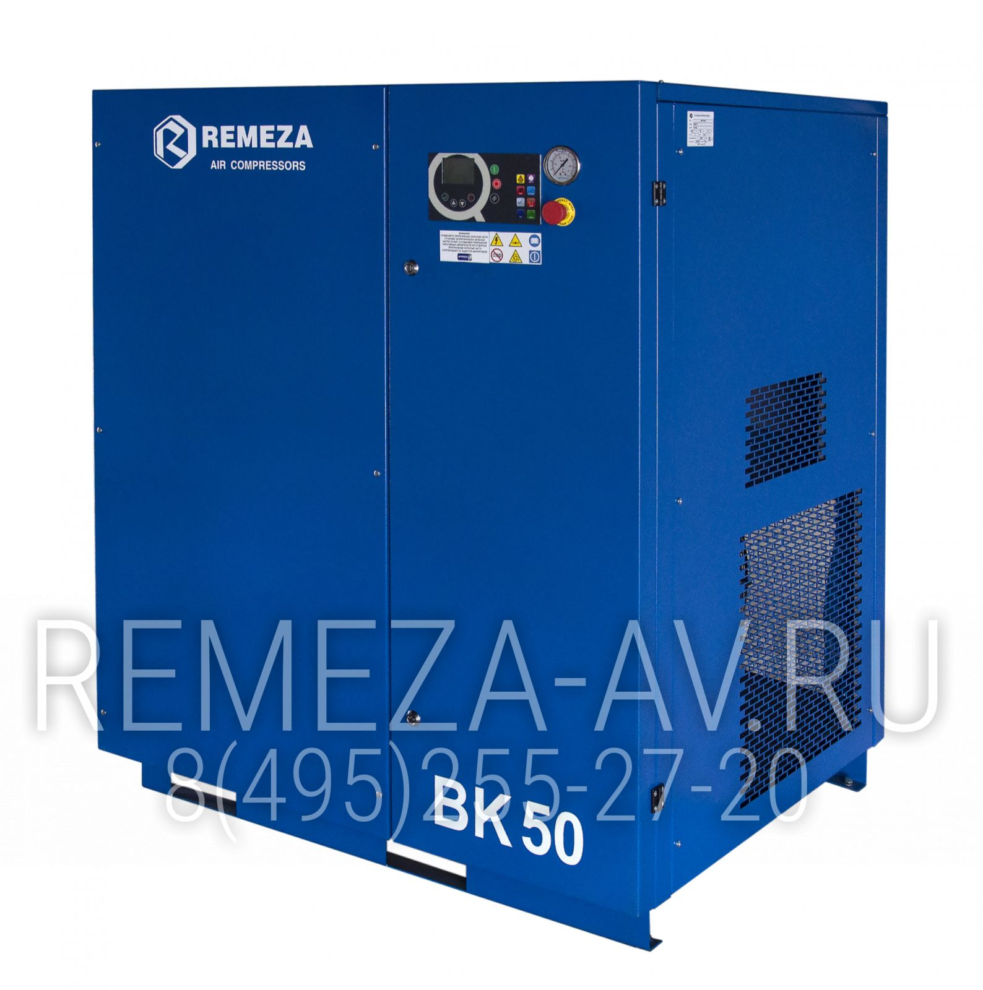

Description.
Reliable electric compressor Remeza VK50-8 with a capacity of 37 kW with a belt drive of the compressor unit. The compressor has a modern 3-phase electric motor that provides long-term and stable operation in any of the most difficult conditions, is capable of providing a continuous cycle of work in various industries: light, chemical, metallurgical industries and other enterprises.
The compressor has a high performance, is assembled from the best components of European manufacturers and meets all European quality standards. A lockable door is provided for access to the compressor unit, engine and other components. The compressor is connected to the pipeline using a flexible reinforced hose.

Accessories:
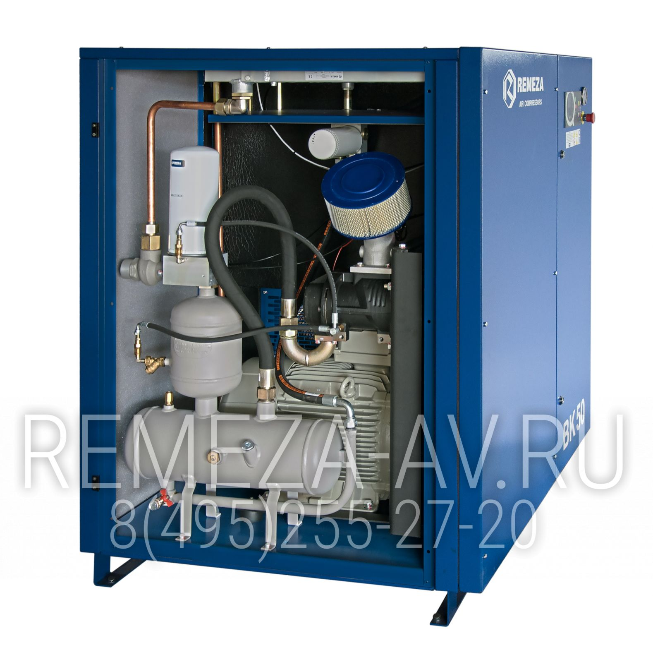
Screw compressor unit
Screw compressor units GHH-RAND and Rotorcomp (Germany) are among the leaders in the global compressor market in the development and production of screw units.
- They are designed for continuous operation up to 24 hours a day in various operating conditions.
- They are developed, designed and manufactured using the most advanced modern technologies on modern high-quality equipment.
- Guaranteed reliable long-term trouble-free operation.
- Service life of up to 100,000 hours.
Electric motor
Asynchronous three-phase electric motors by ABB (Switzerland) and Siemens (Germany), protection class IP55, insulation class F.
- High efficiency.
- High reliability, long service life, ease of operation.
- Globally recognized quality.
Efficient oil separation system
It is used to separate compressed air and compressor oil. This way, the oil is returned to the cooling circuit and the purified air is sent to the pneumatic line.
- The residual oil content is 1-3 mg/m3.
- Primary separation in the oil tank using centrifugal forces.
- Secondary separation, high-efficiency filter separator.
Frequency converter
A frequency converter is a static converting device designed to change the speed of rotation of AC induction motors.
Main advantages:
- Reduced energy costs.
- Ability to adjust performance over a wide range.
- Increased motor life.
- Starting currents are close to the rated current.
- AirMaster Q1 multifunctional controller
Programmable microprocessor control unit compatible with computer systems. Information about the compressor status is displayed on the backlit LCD display.
- Graphical interface.
- Decoding of parameters and errors.
- Error and event log with time and date reference.
- Automatic start-up of the compressor unit according to the set schedule.
- Remote control of compressor operation.
- Energy-saving operation mode.
- Protection and shutdown in case of emergency.
- Control of operating time, operating mode and stop time and indication of the need for maintenance.
Maintenance
Quick access to components is provided by removing quick-release panels with one turn of the wrench. The replacement of the oil filter and separator filter, which are located outside, minimizes the work, which significantly reduces the labor intensity of work and equipment downtime.
The oil level is monitored through a special inspection window, which is located on the outside of the compressor panel for user convenience. Thus, this important parameter can now be monitored without additional time and effort.
Periods of maintenance (maintenance)
First maintenance (run-in) after the first 500 hours of compressor operation: Change the oil filter and oil.
- Every 2000 hours: Change the air filter.
-Every 4000 hours: Change oil, oil filter, air filter, separator.
-Every 8000 hours: Drive belts.

TECHNICAL CHARACTERISTICS
Manufacturer | Remeza
Productivity | 6000 l/min
Engine power | 37 kW
Working pressure | 8 atm
Power supply | 380 В
Type of compressor | Screw type
Type of drive | Strap
Type of motor | Electric
Three-phase | yes
The noise level | 75 dB
DIMENSIONS
Length | 1260 mm
Width | 1235 mm
Height | 1380 mm
Weight | 785 kg
ADDITIONAL INFORMATION
Availability of frequency converter | yes
Mobile | No
Pressure gauge | yes
Type of cooling | air
Output connector | 1 l inch
Manufacturer | Belarus
WARRANTY
Manufacturer's warranty | yes
Warranty period | 12 months

